Software Specification Document

OpenOffice.org
Touchpoints to new Templates

Specification Status
Last Change | Jun 20, 2008
Status
Abstract
To ease the access to new templates on a template web site in OpenOffice.org the 'Templates and Documents' dialog will have an additional link pointing to this web site.
Furthermore the Start Center will be enhanced by an icon pointing to the same template web site.

i-Team Members
Role | First Name, Last Name, Initials | E-Mail Address
I-Team Lead | Peter.Burow, PB | pb@openoffice.org
Specification Author | Bettina Haberer, BH | bh@openoffice.org
User Experience | Bettina Haberer, BH | bh@openoffice.org
Development | Peter.Burow, PB | pb@openoffice.org
Development | Philipp Lohmann, PL | pl@openoffice.org
Quality Assurance | Stefan Baltzer, SBA | sba@openoffice.org
Documentation | Uwe Fischer, UFI | ufi@openoffice.org
Other roles | <First Name, Last Name (Initials)> | <User@openoffice.org>
<State reason here, if one role is not represented in i-Team.>

Contents
Abstract 1
i-Team Members 1
References and Reference Documents 3
Acronyms and Abbreviations 3
1 Detailed Specification 4
1.1 The 'Templates and Documents' Dialog with an additional Touchpoint 4
1.2 Pointing from the Start Center to further Templates Online 5
2 Migration 6
3 Configuration 6
4 File Format 6
5 Open Issues 6
Document Change History 6

References and Reference Documents
Reference Document | Check | Location (URL)
Specification Process Entry Check |  | N/A
Product Requirement, RFE, issue [Required] |  | Issue 90034, 90035
Product Concept Document |  | <Please enter location here>
Competitive Analysis |  | <Please enter location here>
IDL Specification |  | <Please enter location here>
Test Case Specification [Required] |  | http://qa.openoffice.org/ooQAReloaded/TestcaseSpecifications/OpenOffice.org_3.0/Global/touchpoints_to_new_templates.html
Software Specification Rules | N/A | N/A
<Other, e.g. references to related specs>
Acronyms and Abbreviations
Acronym / Abbreviation | Definition
<WYSIWYG> | <What You See Is What You Get>

Detailed Specification

The 'Templates and Documents' Dialog with an additional Touchpoint
The current 'Templates and Documents' dialog will be enhanced by an additional link pointing to the template web site at http://extensions.services.openoffice.org/taxonomy/term/36 . As this needs more space the dialog will get enhanced in the hight accordingly.
This URL will be visible in the tip help at mouse over this link.
At click on the link the template web site opens. The 'Templates and Documents' dialog will close automatically when the link is clicked. As currently the dialog is closed at the moment, a template is opened, this behaviour is consistent.

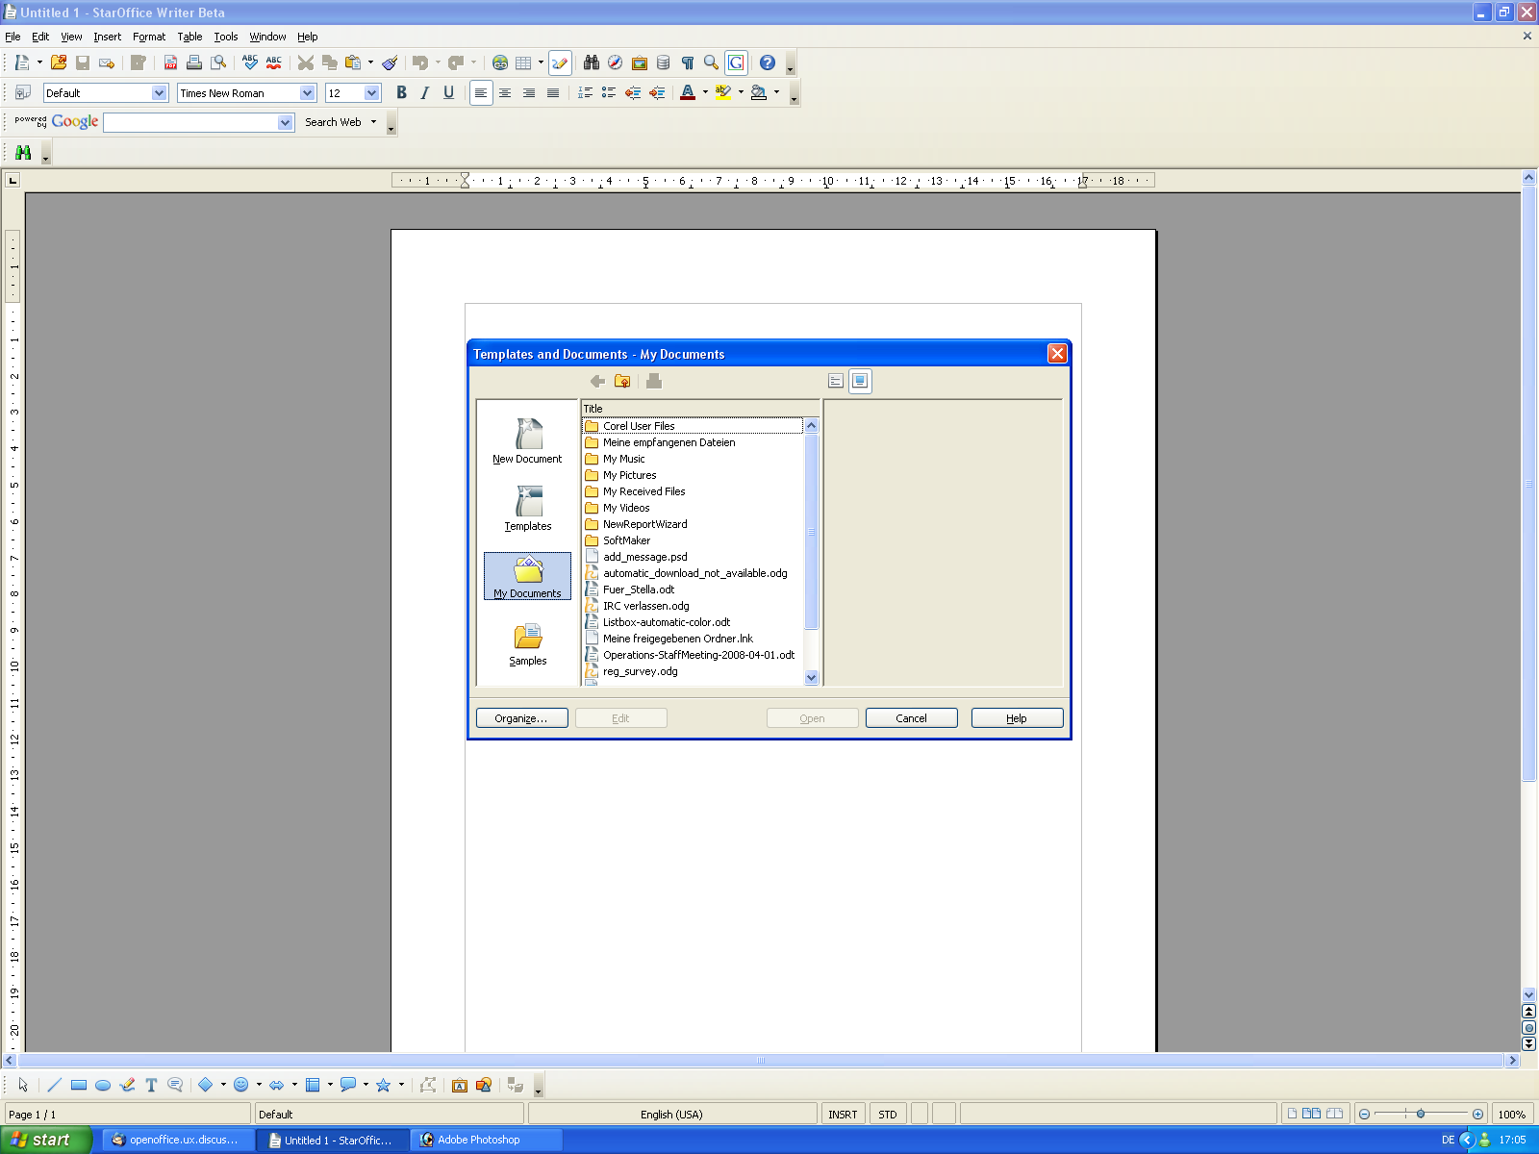
Figure 1: The 'Templates and Documents' dialog with an additional link to templates online.
Get more templates online...

- Link Properties |  | Comment
Enabled: | Yes
Disabled: | No
Press: | Calls the template web site web site listing the available templates.
Link Text: | Get more templates online... | EN-US
Tip Help Text: | http://extensions.services.openoffice.org/taxonomy/term/36

Pointing from the Start Center to further Templates Online
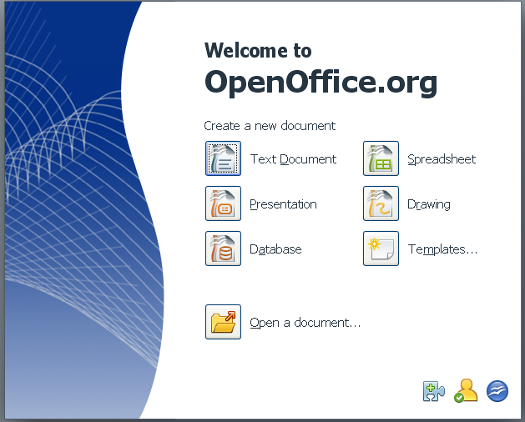
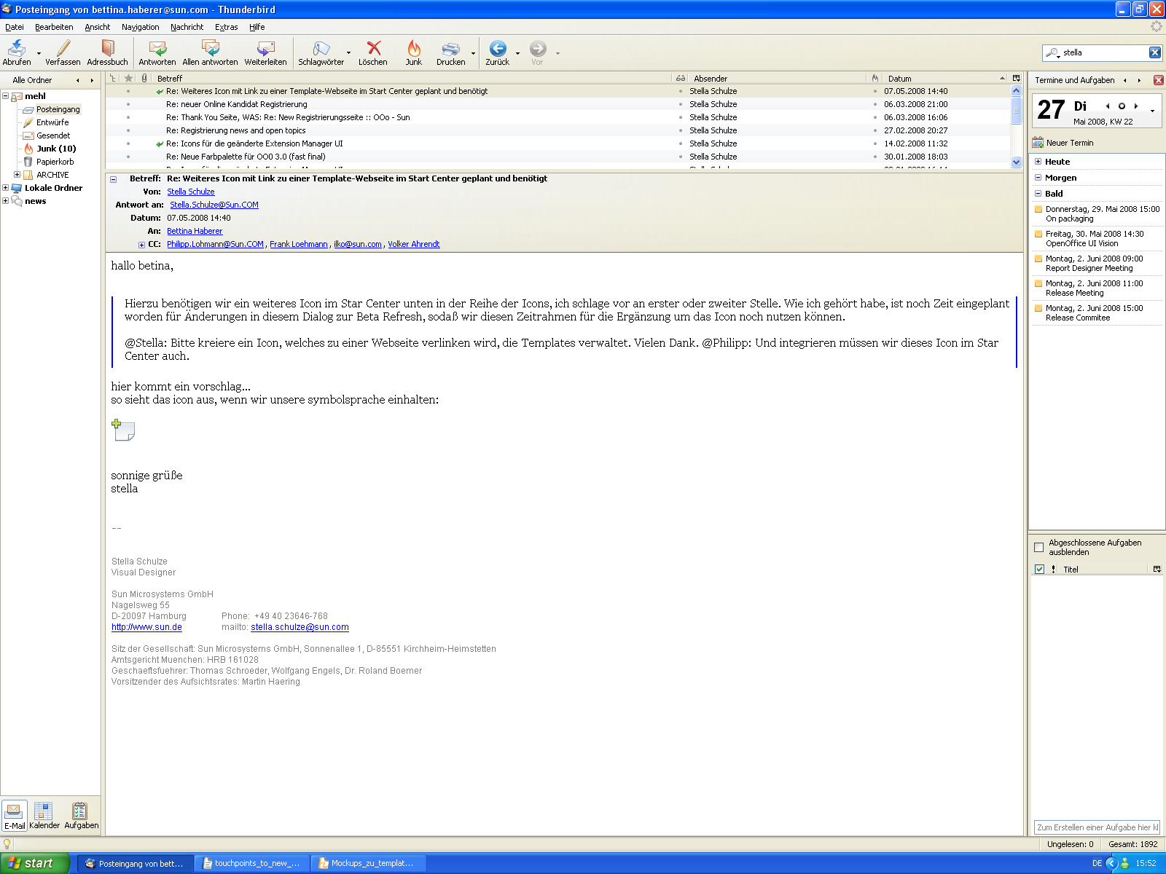
Figure 2: The start center showing an additional icon pointing to the template web site.

- Icon Properties |  | Comment
Enabled: | Yes
Disabled: | No
Press: | Calls the template web site web site listing the available templates.
Tip Help Text: | Get more templates for %PRODUCTNAME | EN-US
Icon:

The new icon is positioned at the left side of the extensions icon at the bottom of the dialog.

At click on the 'Get more templates for OpenOffice' icon the template web site opens. At the moment a downloaded template opens as document in the appropriate OpenOffice.org application, the start module becomes closed automatically.

Migration
Not relevant.

Configuration
Not relevant.

File Format
Not relevant.

Open Issues
Issue | Initials | Date
<State Issue here, State “None”, if all issues are solved> |  | <Format: Dec 31, 2000>
<...>

Document Change History
Rev. | Change | Initials | Date
1 | Initial Specification | BH | 27.05.2008
2
3
<...>

