Software Specification Document

OpenOffice.org Calc
Options Dialog

Specification Status
Last Change | Nov 16, 2007
Status
Abstract
This specification documents changes made to the Calc options dialog.

i-Team Members
Role | First Name, Last Name, Initials | E-Mail Address
I-Team Lead | Niklas Nebel (NN) | niklas.nebel@sun.com
Specification Author | Frank Loehmann (FL) | frank.loehmann@sunc.com
User Experience | Frank Loehmann (FL) | frank.loehmann@sunc.com
Development | Niklas Nebel (NN) | niklas.nebel@sun.com
Quality Assurance | Frank Stecher (FST) | frank.stecher@sun.com
Documentation | Uwe Fischer (UFI) | uwe.fischer@sun.com
Other roles | <First Name, Last Name (Initials)> | <User@openoffice.org>
<State reason here, if one role is not represented in i-Team.>

Contents
Abstract 1
i-Team Members 1
References and Reference Documents 3
Acronyms and Abbreviations 3
1 Detailed Specification 4
1.1 View Tab Page 5
1.1.1 Default Zoom Behavior 5
2 Migration 5
3 Configuration 5
4 File Format 6
5 Open Issues 6
Document Change History 6

References and Reference Documents
Reference Document | Check | Location (URL)
Specification Process Entry Check |  | N/A
Product Requirement, RFE, issue [Required] |  | 24372
Product Concept Document |  | <Please enter location here>
Competitive Analysis |  | <Please enter location here>
IDL Specification |  | <Please enter location here>
Test Case Specification [Required] |  | Sheetzoom.html
Software Specification Rules | N/A | N/A
<Other, e.g. references to related specs>
Acronyms and Abbreviations
Acronym / Abbreviation | Definition
<WYSIWYG> | <What You See Is What You Get>

Detailed Specification
The following specified changes apply to the OpenOffice.org Calc Options dialog. The dialog can be called by the Tools-Options menu from an open Calc document. The dialog consists of tab pages to configure the behavior of OpenOffice.org Calc.
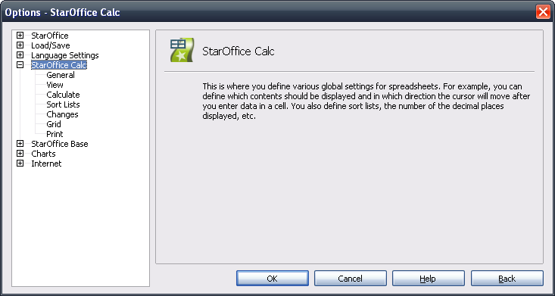Illustration 1: Titel page of the Tools-Options Dialog

View Tab Page

Default Zoom Behavior
The zoom behavior of can be configured. Calc synchronizes the zoom factor for all sheets by default. If un-checked, the zoom factor will be changed for the selected table(s).
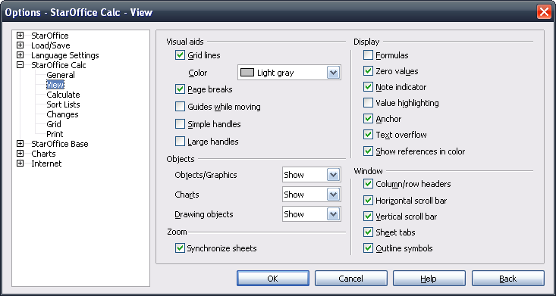Illustration 2: View tab page

- “Zoom” - Label Properties |  | Comment
Label: | Zoom | EN-US

- Synchronize sheets” - CheckBox Properties |  | Comment
Enabled: | always
Disabled: | never
Checked: | by default
CheckBox Label: | Synchronize sheets | EN-US

Migration
None.

Configuration
The new configuration entry is "org.openoffice.Office.Calc/Layout/Zoom/Synchronize".

File Format
The sheet zoom is stored as part of the application settings in the <office:settings> element in settings.xml.

Open Issues
Issue | Initials | Date
<State Issue here, State “None”, if all issues are solved> |  | <Format: Dec 31, 2000>
<...>

Document Change History
Rev. | Change | Initials | Date
1 | Initial specification | FL | November 02, 2007
2 | Configuration, file format | NN | November 12, 2007
3 | Set to standard and add test spec. | FL | November 16, 2007
<...>

