Software Specification Document

OpenOffice.org Calc
Sum Button Enhancements

Specification Status
Last Change | Sep 25, 2007
Status
Abstract
A large competitor has the Sum button placed in Standard toolbar. So most new Calc users are used to this location and search for it there first when they start to work with Calc. Furthermore the Sum sign in Formula bar did not look like a button to press on (they told us when they discovered the functionality in Calc at a later point).
i-Team Members
Role | First Name, Last Name, Initials | E-Mail Address
I-Team Lead | <First Name, Last Name (Initials)> | <User@openoffice.org>
Specification Author | <First Name, Last Name (Initials)> | <User@openoffice.org>
User Experience | <First Name, Last Name (Initials)> | <User@openoffice.org>
Development | <First Name, Last Name (Initials)> | <User@openoffice.org>
Quality Assurance | <First Name, Last Name (Initials)> | <User@openoffice.org>
Documentation | <First Name, Last Name (Initials)> | <User@openoffice.org>
Other roles | <First Name, Last Name (Initials)> | <User@openoffice.org>
<State reason here, if one role is not represented in i-Team.>

Contents
Abstract 1
i-Team Members 1
References and Reference Documents 3
Acronyms and Abbreviations 4
1 Detailed Specification 5
2 Migration 7
3 Configuration 7
4 File Format 8
5 Open Issues 8
Document Change History 8

References and Reference Documents
Reference Document | Check | Location (URL)
Specification Process Entry Check |  | N/A
Product Requirement, RFE, issue [Required] |  | i60408
Product Concept Document |  | <Please enter location here>
Competitive Analysis |  | <Please enter location here>
IDL Specification |  | <Please enter location here>
Test Case Specification [Required] |  | <Please enter location here>
Software Specification Rules | N/A | N/A
<Other, e.g. references to related specs>
Acronyms and Abbreviations
Acronym / Abbreviation | Definition
<WYSIWYG> | <What You See Is What You Get>

Detailed Specification
Proposal:
- Step A (next release): Change look of Function toolbar like shown in attachment "new_sum.png"
- Step B (upcoming releases): Add new AutoSum button to Standard toolbar and change Function bar to show gradient and 2D look like any other toolbar.

Current Function Tooolbar
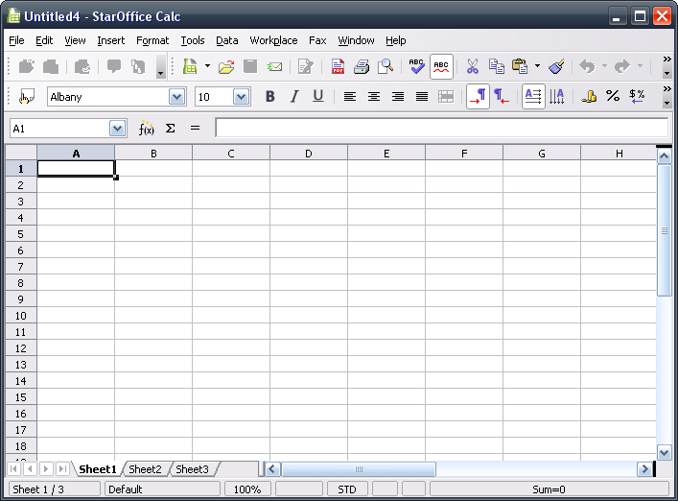Illustration 1: Current Situation in Calc

Proposed Change for Toolbar
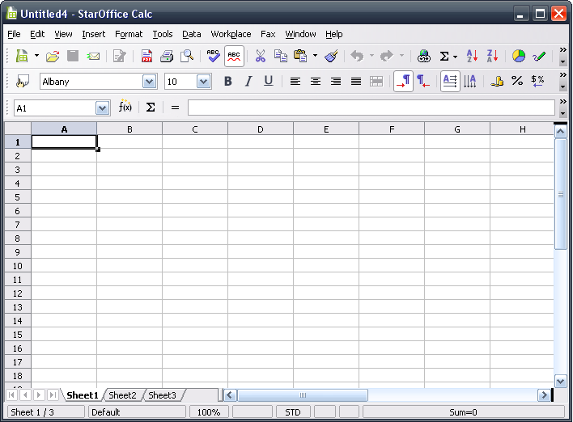Illustration 2: Proposal for Step A - New Updated Version

Migration
<Start typing here ----- If this part is irrelevant state a reason for its absence!>

Configuration
<Start typing here ----- If this part is irrelevant state a reason for its absence!>

File Format
<Start typing here ----- If this part is irrelevant state a reason for its absence!>

Open Issues
Issue | Initials | Date
<State Issue here, State “None”, if all issues are solved> |  | <Format: Dec 31, 2000>
<...>

Document Change History
Rev. | Change | Initials | Date
1 |  |  | <Format: Dec 31, 2000>
2
3
<...>

