Software Specification Document

OpenOffice.org Calc
Solver Implementation

Specification Status
Last Change | Feb 5, 2008
Status
Abstract
OpenOffice.org lacks of a solver implementation. A solver allows to solve equations with multiple unknown variables. The following specification defines the user interface and interaction to implement a solver for OOo Calc. The UI design is capable to cover more than one solver engine. Solver engines could be installed as an extension provided by any OOo vendor using the newly introduced solver interface.
i-Team Members
Role | First Name, Last Name, Initials | E-Mail Address
I-Team Lead | Niklas Nebel (NN) | niklas.nebel@sun.com
Specification Author | Frank Loehmann (FL) | frank.loehmann@sun.com
User Experience | Frank Loehmann (FL) | frank.loehmann@sun.com
Development | Niklas Nebel (NN) | niklas.nebel@sun.com
Quality Assurance | Frank Stecher (FST) | frank.stecher@sun.com
Documentation | Uwe Fischer (UFI) | uwe.fischer@sun.com

Contents
Abstract 1
i-Team Members 1
References and Reference Documents 3
Acronyms and Abbreviations 3
1 Detailed Specification 4
1.1 Main Menu Integration 4
1.2 Solver Dialog 5
1.2.1 Empty Solver Dialog 5
1.2.2 Strings and Properties 5
1.3 Interaction Description 9
1.3.1 Solver Dialog 9
1.3.1.1 Shrink Mode of Dialog 9
1.3.1.2 Shrinked Mode of Dialog 9
1.3.1.3 Delete Row Buttons 10
1.3.1.4 Options Button 11
1.3.1.5 Close Button 11
1.3.1.6 Solve Button/Solving Process 11
1.3.2 Scroll Bar in Limiting Conditions Section 14
1.3.3 Saving the Solver Model 14
1.4 Option Dialog for Solver 15
1.4.1 Solver Engines Installed 15
1.4.2 Strings and Properties 15
1.4.3 User Interaction 16
1.4.3.1 Edit Values from Settings List Box 16
1.4.3.2 Floating Point Numbers 17
1.4.3.3 Integer Values 17
2 Migration 18
3 Configuration 18
4 File Format 18
5 Open Issues 18
Document Change History 19

References and Reference Documents
Reference Document | Check | Location (URL)
Specification Process Entry Check |  | N/A
Product Requirement, RFE, issue [Required] |  | 8808
Product Concept Document |  | <Please enter location here>
Competitive Analysis |  | <Please enter location here>
IDL Specification |  | <Please enter location here>
Test Case Specification [Required] |  | http://www.openoffice.org/nonav/issues/showattachment.cgi/51378/Calc_Solver.html
Software Specification Rules | N/A | N/A
Acronyms and Abbreviations
Acronym / Abbreviation | Definition
Solver | In computing, goal seeking is the ability to calculate backward to obtain a valid input. For example, given the desired goal gross margin = 50% and the range of possible inputs, goal seeking attempts to obtain the optimum input. This can also be called what-if analysis or back-solving.

Detailed Specification
This specification describes the new Solver functionality in detail. It contains interaction description, control properties, dialog mock-ups and strings used within the user interface.

Main Menu Integration
The solver functionality is located in the Tools menu in Calc. This menu entry calls the Solver dialog.
- “Tools” - Menu Properties |  |  |  |  | Comment
Menu Title: | Tools |  |  |  | EN-US
Menu Position: | Calc Main Menu
Menu Items:
Items | Sub Items | Sub Items | KBD Shortcuts | Icon | Comment
----------- |  |  |  |  | already present
Goal Seek... |  |  |  |  | already present
Solver... |  |  |  |  | Calls the Solver dialog.
Scenarios... |  |  |  |  | already present
----------- |  |  |  |  | already present

Solver Dialog
The following mock-ups show the new Solver dialog in it's different states. The Solver dialog is mode less and offers no Cancel button to withdraw changes. The dialog behaves the same like other Calc dialogs offering a Shrink button. The mode less state is important to be able to shrink the dialog to make cell references without leaving the Solver dialog.

Empty Solver Dialog
The empty Solver dialog looks like the following mock-up.
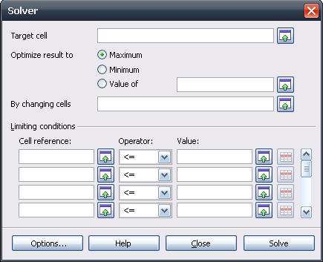Illustration 1: Initial empty Solver dialog

Strings and Properties
The following table define the strings and properties of the controls used in the Solver dialog.
- “Solve” - Dialog Properties |  | Comment
State: | Non modal
Type: | Dialog
Closable: | Yes
Resizable: | No
Titel: | Solver | EN-US
- “Target Cell” - TextField Properties |  | Comment
Enabled: | Always
Read Only: | No
Initial String:
String Preselected: | No
Caret Position: | 0
Characters Not Allowed:
Echo characters (Password Field) | No
TextField Label: | Target cell | EN-US
- “Shrink” - Button Properties |  | Comment
Enabled: | Always
Press: | The Solver dialog shrinks. See 1.3.1.2 Shrinked Mode of Dialog for details.
$FIELDNAMEPLACEHOLDER | See corresponding text field label. None if label is empty.
Button Label: | None | EN-US
Button Icon: | Already present shrink icon.
- “ Optimize result to” - Label Properties |  | Comment
Label: | Optimize result to | EN-US
- “Optimize result to” - RadioButton Properties |  | Comment
Enabled: | Always
Selected: | By default
RadioButton Label: | Maximum | EN-US
- “Optimize result to” - RadioButton Properties |  | Comment
Enabled: | Always
Selected: | -
RadioButton Label: | Minimum | EN-US
- “Optimize result to” - RadioButton Properties |  | Comment
Enabled: | Always
Selected: | If the following text field gets selected.
RadioButton Label: | Value of | EN-US
- “Value of” - TextField Properties |  | Comment
Enabled: | Always
Read Only: | No
Initial String:
String Preselected: | No
Caret Position: | 0
Characters Not Allowed:
Echo characters (Password Field)
Other: | Value of radio button gets set automatically, if a text or a reference gets entered to the text field.
TextField Label: |  | EN-US
- “Shrink” - Button Properties |  | Comment
Enabled: | Always
Press: | The Solver dialog shrinks. See 1.3.1.2 Shrinked Mode of Dialog for details.
$FIELDNAMEPLACEHOLDER | See corresponding text field label. None if label is empty.
Button Label: | None | EN-US
Button Icon: | Already present shrink icon.
- “By changing cells” - TextField Properties |  | Comment
Enabled: | Always
Read Only: | No
Initial String:
String Preselected: | No
Caret Position: | 0
Characters Not Allowed:
Echo characters (Password Field)
TextField Label: | By changing cells | EN-US
- “Shrink” - Button Properties |  | Comment
Enabled: | Always
Press: | The Solver dialog shrinks. See 1.3.1.2 Shrinked Mode of Dialog for details.
$FIELDNAMEPLACEHOLDER | See corresponding text field label. None if label is empty.
Button Label: | None | EN-US
Button Icon: | Already present shrink icon.
- “Limiting conditions” - Label Properties |  | Comment
Label: | Limiting conditions | EN-US
- “Cell Reference” - TextField Properties |  | Comment
Enabled: | Always
Read Only: | No
Initial String:
String Preselected: | No
Caret Position: | 0
Characters Not Allowed:
Echo characters (Password Field)
TextField Label: | Cell reference: | EN-US
- “Shrink” - Button Properties |  | Comment
Enabled: | Always
Press: | The Solver dialog shrinks. See 1.3.1.2 Shrinked Mode of Dialog for details.
$FIELDNAMEPLACEHOLDER | See corresponding text field label. None if label is empty.
Button Label: | None | EN-US
Button Icon: | Already present shrink icon.
- “Operator” - DropDown Listbox Properties |  | Comment
Enabled: | Always
Max. Row Count: | 5
Rows Visible: | 5
Items: | - <=  - =  - >=  - Integer  - Binary | [Int]  0 or 1 [Int]
Item Selected: | 1.
Sorting by  Drag & Drop: | Disabled
DropDown  ListBox Label: | Operator: | EN-US
- “Value:” - TextField Properties |  | Comment
Enabled: | Always
Read Only: | No
Initial String:
String Preselected: | No
Caret Position: | 0
Characters Not Allowed:
Echo characters (Password Field)
Other:
TextField Label: | Value: | EN-US
- “Shrink” - Button Properties |  | Comment
Enabled: | Always
Press: | The Solver dialog shrinks. See 1.3.1.2 Shrinked Mode of Dialog for details.
$FIELDNAMEPLACEHOLDER | See corresponding text field label. None if label is empty.
Button Label: | None | EN-US
Button Icon: | Already present shrink icon.

Interaction Description
This section describes the user interaction with the Solver dialog.

Solver Dialog
Filled with some demo data, the Solver dialog looks like the following mock-up. The data entered is saved for runtime for each document separately.
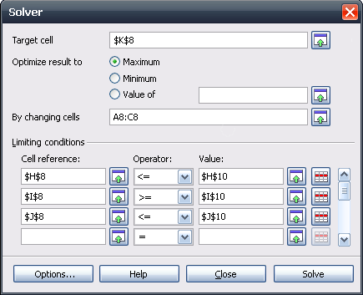Illustration 2: Solver dialog showing some demo data

Shrink Mode of Dialog

Shrink Buttons
The Solver Dialog offers several Shrink buttons:
These buttons set the input focus to the field on it's left, preselect it's content and shrink the dialog as shown in Illustration 3 below.

Auto Shrink
If the user clicks to the spreadsheet, the dialog gets minimized automatically.

Shrinked Mode of Dialog
The shrink mode allows to mark cells in the spreadsheet to add references to the selected cells without typing them manually. The shrinked Solver dialog shows a tip in the dialog title to state which field will be filled with the reference. The tip is empty, if the text field has no own label. The text field's content is shown in shrinked mode and the string is preselected.
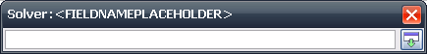Illustration 3: Shrinked Solver dialog. Placeholder gets replaced by a tip defined in the string tables below

Strings and Properties
- “Solver” - Dialog Properties |  | Comment
State: | Mode less
Type: | Dialog
Closable: | No | Behaves like maximize
Resizable: | No
Titel: | Solver: $FIELDNAMEPLACEHOLDER | EN-US
Other | Return key and dialog closer behave like the maximize key
- “Shrinked Solver” - TextField Properties |  | Comment
Enabled: | Always if dialog is shrinked
Read Only: | No
Initial String: | Empty or value of linked text field.
String Preselected: | No
Caret Position: | 0
Characters Not Allowed:
Echo characters (Password Field)
Other: | Text field shows cell reference currently selected in table.
TextField Label: |  | EN-US
- “Maximize” - Button Properties |  | Comment
Enabled: | Always if dialog is shrinked
Press: | See following interaction description.
Button Label: | Maximize | EN-US

Interaction Description of Shrinked Dialog
The Solver dialog gets maximized and the cell reference (if present) gets pasted to the linked text field, if the Return key, the dialog closer or the maximize button gets pressed. The focus is then set to linked text filed in maximized Solver dialog and it's context gets preselected. ESC in shrinked mode maximizes the dialog again an restores the value present before the dialog was shrinked.

Delete Row Buttons
The delete row buttons allow to delete the content of a row. If the rows below are filled, the rows move up by one row. Otherwise the content of the edit fields are erased and the operator drop down list box is set back to the initial “<=”.

Options Button
The Options calls the Options dialog shown in Illustration 7 on page 15 below. The Options dialog is shown on top of the Solver dialog and is modal.

Close Button
The Close button closes the dialog. The settings made inside the dialog are stored during runtime of OOo.

Solve Button/Solving Process
The Solve button starts the solver engine with the given restrictions and cell references. The following dialogs are shown to give the user feedback. Feedback consists of two steps. First solving in progress and result feedback afterwards. Result can also be that there is no solution for the given problem.

Solving in Progress
The following modal progress dialog is shown on top of the Solver dialog, if the Solve button has been pressed. The solving process cannot be interrupted, therefore the OK button and the dialog closer are disabled until solving has been finished.
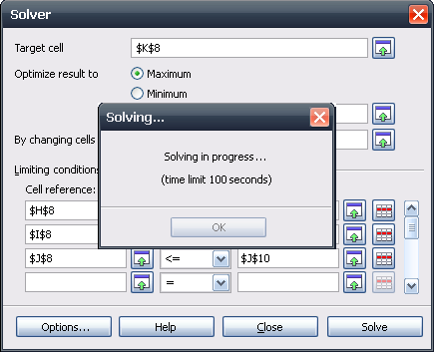Illustration 4: Feedback: Solving in progress
- “Solving...” - Dialog Properties |  | Comment
State: | Modal
Type: | Dialog
Closable: | Not during solving progress
Resizable: | No
Other: | OK and closer are disabled.
Titel: | Solving... | EN-US
- “Endless Progress...” - Endless Progress Control |  | Comment
Active: | During solving process
- “Solving in progress...” - Label Properties |  | Comment
Label: | Solving in progress... | EN-US
- “(time limit)” - Label Properties |  | Comment
Label: | (time limit $TIMELIMIT seconds) | EN-US (Optional, if provided by solver engine)
- “OK” - Button Properties |  | Comment
Enabled: | If solving has been finished.
Disabled: | If solving is in progress.
Press: | Close dialog.
Button Label: | OK | EN-US

No Solution Feedback
The process is aborted if no solution was found within the given time limit or if the problem is not solvable due to the given restrictions or tolerance level.
The Solving... dialog changes and shows the following text, if solving process runs for more than the defined time limit. The OK button and the dialog closer are enabled again.
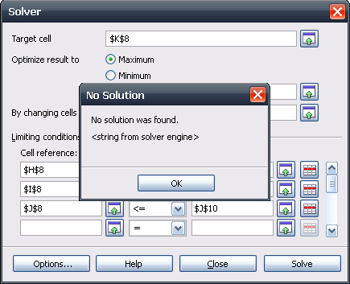Illustration 5: Feedback: Time limit exceeded
- “Solving Aborted” - Dialog Properties |  | Comment
State: | Modal
Type: | Dialog
Closable: | Yes
Resizable: | No
Other: | OK and closer are enabled again.
Titel: | No Solution | EN-US
- “Aborted string from solver component” - Label Properties |  | Comment
Text: | No solution was found. | EN-US
- “Aborted string from solver component” - Label Properties |  | Comment
Text from engine: 1: | The model is not linear. | EN-US
Text from engine: 2: | The epsilon level is invalid. | EN-US
Text from engine: 3: | The model is infeasible. Check limiting conditions. | EN-US
Text from engine: 4. | The model is unbounded. | EN-US
Text from engine: 5: | The time limit was reached. | EN-US

Result Feedback
The Solving dialog is closed if a proper solution was found by the solver. Then following Solver Result dialog is shown. The dialog allows to accept or withdraw the result and restore old values. In the first case the Solver dialog is closed by accepting the result. The Solver dialog stays open if the user decides to restore old values and withdraw the result,. This allows the user to change solver settings and restrictions and restart solving process.
Note: The result is shown in an edit field to allow the user to copy its content to clipboard.
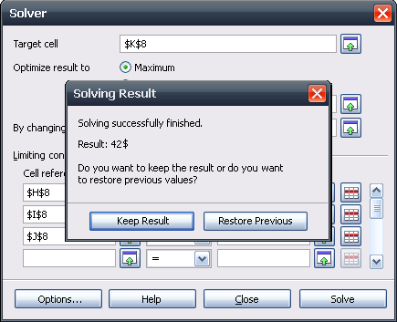Illustration 6: Feedback: Solver dialog plus Solving Result
- “Solving Result” - Dialog Properties |  | Comment
State: | Modal
Type: | Dialog
Closable: | Yes
Resizable: | No
Titel: | Solving Result | EN-US
- “Solving successfully finished” - Label Properties |  | Comment
Label: | Solving successfully finished. | EN-US
- “Result” - TextField Properties |  | Comment
Label: | $RESULT$UNIT | EN-US
- “Question” - Label Properties |  | Comment
Label: | Do you want to keep the result or do you want to restore previous values? | EN-US
- “Keep Solved Result” - Button Properties |  | Comment
Enabled: | Always
Press: | Solver Result and Solver dialog gets closed. Solving has been finished.
Other: | Button has default focus.
Button Label: | Keep Result | EN-US
- “Restore Previous Values” - Button Properties |  | Comment
Enabled: | Always
Press: | Solver Result dialog gets closed, but Solver dialog stays open.
Button Label: | Restore Previous | EN-US

Scroll Bar in Limiting Conditions Section
The scroll bar scrolls the data thru the four shown rows of controls. So the scroll bar can be used to create new rows by scrolling down. The behavior is similar to Calc table handling.

Saving the Solver Model
The solver model is not saved with the document but kept for runtime. In future version the solver model can be saved within the solvers target cell or the like.

Option Dialog for Solver
The following generic Option dialog is called if the Options... button in the Solver dialog is clicked. Initially the Calc solver offers only a single solver engine, therefore the Solver engine drop down list box is disabled. Solver engines could be installed as an extension provided by any OOo vendor.

Solver Engines Installed
The dialog title shows the name of the currently selected solver engine, if more than the default solver engine is installed. This name is also shown in the title of the Solver dialog
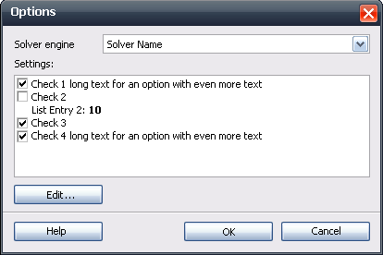Illustration 7: Options dialog with more than one solver engine installed

Strings and Properties
The following table shows the strings and properties for the Options dialog
- “Options” - Dialog Properties |  | Comment
State: | Modal on top of Solver dialog
Type: | Dialog
Closable: | Yes
Resizable: | No
Titel: | Options | EN-US
- “Solver engine” - DropDown Listbox Properties |  | Comment
Enabled: | If more than one solver engine is installed on the system.
Disabled: | In default configuration with just a single solver engine.
Max. Row Count: | 7
Rows Visible: | N <= 7
Items: | - $PRODUCTNAME Linear Solver | ????
Item Selected: | 1.
Sorting by  Drag & Drop: | Disabled
DropDown  ListBox Label: | Solver Engine | EN-US
- “Settings” - ListBox Properties |  | Comment
Enabled: | If the chosen solver can be configured
Max. Row Count: | 8
Rows Visible: | 8
Items: | - Checkbox: Assume variables as non-negative  - Checkbox: Assume variables as integer  - Integer: Solving time limit (seconds): $TIME  - Integer: Epsilon level (0-3): $LEVEL  - Checkbox: Limit branch-and-bound depth | false  false  100  0  True
Item Selected: | 1
Sorting by Drag & Drop: | Disabled
ListBox Label: | Settings: | EN-US
- “Edit...” - Button Properties |  | Comment
Enabled: | If an entry in the Settings list box is selected that allow to define or choose a value.
Press: | Show dialog to edit value. See following section for details.
Button Label: | Edit... | EN-US
- “Help” - Button Properties |  | Comment
Enabled: | Always
Press: | Calls help system
Button Label: | Help | EN-US
- “OK” - Button Properties |  | Comment
Enabled: | Always
Press: | Confirms settings and closes dialog.
Button Label: | OK | EN-US
- “Cancel” - Button Properties |  | Comment
Enabled: | Always
Press: | Withdraws changes made to settings and closes dialog.
Button Label: | Cancel | EN-US

User Interaction

Edit Values from Settings List Box
The Edit... button from the Options dialog gets enabled, if an item of the Settings list box is selected, which offers a value that can be changed. The button calls a dialog to change the value from a selected setting whereas the called dialog depends on the value character that can be changed.

Floating Point Numbers
The spacing between the label and the text field will be minimized automatically depending if the settings name uses one or two rows.
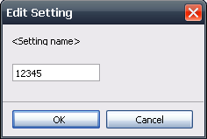Illustration 8: Edit Integer or Floating Point
- “Edit Floating Point Number Setting” - Dialog Properties |  | Comment
State: | Modal
Type: | Dialog
Closable: | Yes
Resizable: | No
Titel: | Edit Setting | EN-US
- “<Setting name>” - TextField Properties |  | Comment
Enabled: | Always
Read Only: | No
Initial String: |  | (default value of setting)
String Preselected: | Yes
Caret Position: | 0
Characters Allowed: | 1,2,3,4,5,6,7,8,9,0, ,”.”
TextField Label: | <See label from #3 of Options dialog.> | EN-US

Integer Values
The spacing between the label and the text field will be minimized automatically depending if the settings name uses one or two rows.
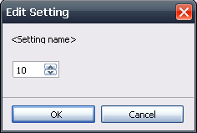Illustration 9: Edit small integer
- “Edit Integer Setting” - Dialog Properties |  | Comment
State: | Modal
Type: | Dialog
Closable: | Yes
Resizable: | No
Titel: | Edit Setting | EN-US
- “<Setting name>” - SpinField Properties |  | Comment
Enabled: | Always
Min. Value:
Max. Value:
Start Value: |  | Current setting
Steps: | 1
Measurement Unit: | -
SpinField Label: | <See label from #3 of Options dialog.> | EN-US

Migration
None. New feature.

Configuration
None.

File Format
None. Not stored within document in first implementation.

Open Issues
Issue | Initials | Date
What's about the feature to save the solver model on the target cell | FL | November 27, 2007
Handle solver model like a “formula”? (re-calc etc.) Request on loading or changing model relevant cells?! | FL | November 27, 2007
Save Scenario feature | FL | November 30, 2007
Build report about solving process | FL | November 30, 2007
Continue Solver run after solver run has been stopped due to a reached time or tolerance level. | FL | November 30, 2007
Add icons to notice dialogs | FL | December 18, 2007
Use edit field for result to be able to copy the result to the clipboard | FL | December 18, 2007
Add endless progress to solving dialog | FL | December 18, 2007

Document Change History
Rev. | Change | Initials | Date
1 | Initial Spec | FL | October 15, 2007
2 | Add Solver Mock-up | FL | October 19, 2007
3 | Update Solver Mock-up | FL | October 19, 2007
4. | Add 3 more dialog designs for discussion | FL | November 02, 2007
5. | Add 2 more variations from design c | FL | November 05, 2007
6. | Finalization of dialog mock-up version D+ | FL | November 15, 2007
7. | Add Interaction description | FL | November 22, 2007
8. | Solve process dialog added | FL | November 27, 2007
9. | Interaction, strings and properties | FL | November 28, 2007
10. | Work on iTeam feedback | FL | November 29, 2007
11. | New mock-ups for solving process | FL | December 03, 2007
12. | Settings | FL | December 03, 2007
13. | Feedback FST | FL | December 04, 2007
14. | Setting dialogs for integer | FL | December 06, 2007
15. | Feedback NN, TBO, FST | FL | December 06, 2007
16. | Feedback LHO | FL | December 10, 2007
17. | Remove endless progress from Solver dialog | FL | December 18, 2007
18 | Finalization | FL | December 19, 2007
19 | Add “Solver...” Main Menu Entry | FL | January 15, 2008
20 | Add link to test case spec. and set spec. to standard | FL | February 5, 2008

http://en.wikipedia.org/wiki/Goal_seeking
See 1.3.1.2 Shrinked Mode of Dialog for details.
Interruption of solving process is not possible due to technical limitations.

