Software Specification Document

OpenOffice.org
Bi-directional Writing in Charts

Specification Status
Last Change | Jan 20, 2009
Status
Abstract
For an Arabic version of OpenOffice.org it is necessary to allow control over the text direction for chart elements that do contain text.

i-Team Members
Role | First Name, Last Name, Initials | E-Mail Address
I-Team Lead | Ingrid Halama (IHA) | iha@openoffice.org
Specification Author | Ingrid Halama (IHA) | iha@openoffice.org
User Experience | Frank Loehmann (FL) | fl@openoffice.org
Development | Ingrid Halama (IHA) | iha@openoffice.org
Quality Assurance | Thomas Klarhöfer (TK) | kla@openoffice.org
Documentation | Uwe Fischer (UFI) | ufi@openoffice.org
Test Automation | Joerg Sievers (JSI) | jsi@openoffice.org

Contents
Abstract 1
i-Team Members 1
References and Reference Documents 2
Acronyms and Abbreviations 2
1 Detailed Specification 3
2 Migration 6
3 Configuration 6
4 File Format 7
5 Open Issues 7
Document Change History 7

References and Reference Documents
Reference Document | Check | Location (URL)
Specification Process Entry Check |  | N/A
Product Requirement, RFE, issue [Required] |  | 14365
Product Concept Document |  | <Please enter location here>
Competitive Analysis |  | <Please enter location here>
IDL Specification |  | <Please enter location here>
Test Case Specification [Required] |  | http://www.openoffice.org/nonav/issues/showattachment.cgi/58185/Bi-directional.htm
Software Specification Rules | N/A | N/A
<Other, e.g. references to related specs>
Acronyms and Abbreviations
Acronym / Abbreviation | Definition
<WYSIWYG> | <What You See Is What You Get>

Detailed Specification
All chart elements that can contain text get an additional list box 'Text direction' in their properties dialogs which allows to change the writing direction. These additional controls are visible only when complex text layout is enabled under Tools->Options->Language Settings->Languages.

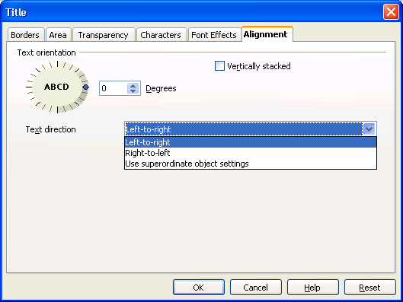
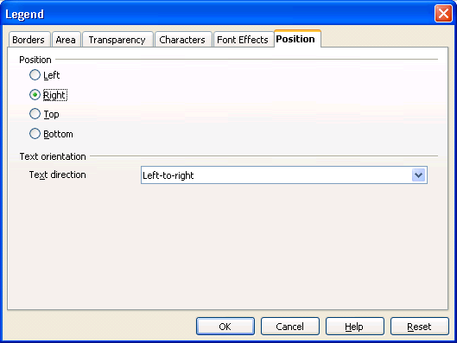

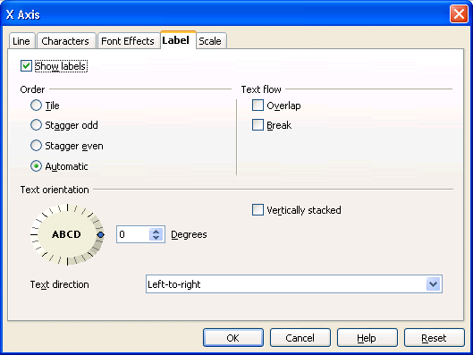

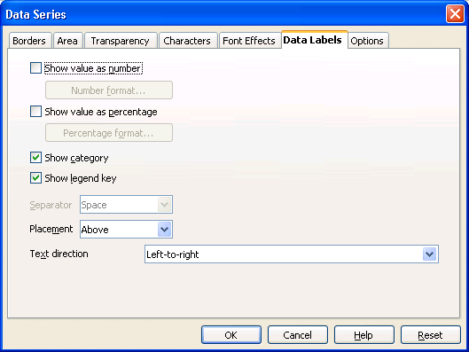
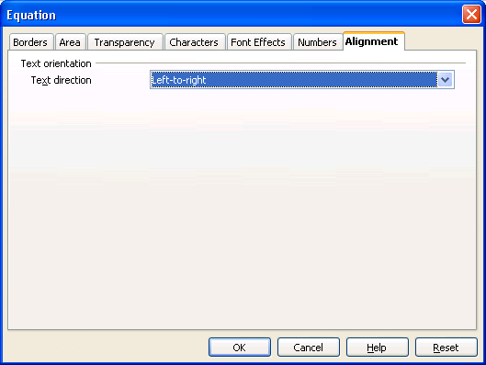

- “Alignmenet” - Label Properties |  | Comment
Label: | Alignment |  | EN-US
 | The alignment tab page in the equation properties dialog is visible only when complex text layout is enabled under Tools->Options->Language Settings->Languages

- “Text orientation” - Label Properties |  | Comment
Label: | Text orientation |  | EN-US

- “Text direction Listbox” - DropDown Listbox Properties |  | Comment
Enabled: | Enabled and visible when complex text layout is enabled under Tools->Options->Language Settings->Languages
Disabled: | The list box in the Data Series dialog is in addition disabled, if data labels are switched off (all check boxes unchecked).  The list box in the axis properties dialog is in addition disabled when the check box 'Show labels' is not checked.
Max. Row Count: | 3
Rows Visible: | 1
Items: | - Left-to-right ;  - Right-to-left ;  - Use superordinate object settings
Item Selected: | 3
Sorting by  Drag & Drop: | Disabled
Other:
DropDown  ListBox Label: | Te~xt direction |  | EN-US

Migration
No migration necessary.

Configuration
There is no information stored into the configuration for this feature.

File Format
The information is stored in the attribute style:writing-mode at the element <style:paragraph-properties> within the chart style that is attached to the according chart element.

Open Issues
Issue | Initials | Date
<State Issue here, State “None”, if all issues are solved> |  | Nov 4, 2008
<...>

Document Change History
Rev. | Change | Initials | Date
1 | Initial revision | IHA | Nov 4, 2008
2 | Added link to testcase specification and set to standard | IHA | Jan 20, 2009
3
<...>

