Software Specification Document

OpenOffice.org Impress
Redesign of Slide Layouts and Their Handling

Specification Status
Last Change | Jan 13, 2010
Status
Abstract
The goal for the redesign is to reduce the amount of slide layouts to a minimal set that still enables the user to work effectively and to offer this functionality in a more contextual way in order to increase efficiency. In plain words, changing slide layouts should be easier and hence faster to find and use. The use of the side pane must not be the default way for setting the slide layout. However, it should nevertheless be available as an option.
Furthermore the goal is to force usage of presentation layouts. Therefore any empty presentation will use layouts by default.
i-Team Members
Role | First Name, Last Name, Initials | E-Mail Address
I-Team Lead | Andreas Bartel (AB) | andreas.bartel@sun.com
Specification Author | Andreas Bartel (AB) | andreas.bartel@sun.com
User Experience | Frank Loehmann (FL) | frank.loehmann@sun.com
Development | Andre Fischer (AF) | andre.fischer@sun.com
Quality Assurance | Wolfram Garten (WG)  Christoph Lukasiak (CLU) | wolfram.garten@sun.com  christoph.lukasiak@sun.com
Accessibility | Wolfram Garten (WG) | wolfram.garten@sun.com
Documentation | Uwe Fischer (UFI) | uwe.fischer@sun.com
Other roles
<State reason here, if one role is not represented in i-Team.>

Contents
Abstract 1
i-Team Members 1
References and Reference Documents 3
Acronyms and Abbreviations 3
1 Detailed Specification 4
1.1 Motivation 4
1.2 Remark 4
1.3 Menu 4
1.3.1 Insert 4
1.3.2 Format / Slide Layout 5
1.4 Presentation Toolbar 6
1.5 Mouse Context Menu in Slide Pane 8
1.6 Mouse Context Menu in Slide View 9
1.7 Mouse Context Menu in Slide Sorter View 10
1.8 Task Pane 11
1.9 Short Term Alternatives for Menu-Entries 12
1.10 Default Layouts 13
2 Accessibility 13
3 Migration 14
4 Configuration 14
5 File Format 14
6 Open Issues 14
Document Change History 14

References and Reference Documents
Reference Document | Check | Location (URL)
Specification Process Entry Check |  | N/A
Product Requirement, RFE, issue [Required] |  | i107213
Accessibility Check [Required] |  | See section 2 Accessibility below
Product Concept Document |  | http://so-doc/Projects/Renaissance/1_Planning/Renaissance_UI_Complexity_Reduction_Impress.odt
Competitive Analysis |  | <Please enter location here>
IDL Specification |  | <Please enter location here>
Test Case Specification [Required] |  | <Please enter location here>
Software Specification Rules | N/A | N/A
<Other, e.g. references to related specs>
Acronyms and Abbreviations
Acronym / Abbreviation | Definition
<WYSIWYG> | <What You See Is What You Get>

Detailed Specification

Motivation
Currently, the only way to change the layout of a slide is to use the task pane. All other options merely call the task pane. In addition, the amount of available slide layouts makes picking out the desired one difficult since too many options have to be considered. This results from the fact that for each insert-object placeholder (represented as icons on a slide) such as table, image, OLE object etc. one specific slide layout is available.
The goal for the redesign is to reduce the amount of slide layouts to a minimal set that still enables the user to work effectively and to offer this functionality in a more contextual way in order to increase efficiency. In plain words, changing slide layouts should be easier and hence faster to find and use. The use of the side pane must not be the default way for setting the slide layout. However, it should nevertheless be available as an option.
Consequently, the available “Presentation” toolbar needs some adjustments as well as several mouse context menus in different views and the main menu entries to find in “Insert” and “Format”. The task pane is also subject to change.
Furthermore the goal is to force usage of presentation layouts. Therefore any empty presentation will use layouts by default.

Remark
The design of slide selection in all possible contexts is not final now. This is the reason why this specification does not contain any selected slides visuals.

Menu
There are two locations where slide layout can be changed in the menu. First resides in the “Insert” part, as the top entry. The second one is in the format part. Both can be extended with a preview of available slide layouts.

Insert

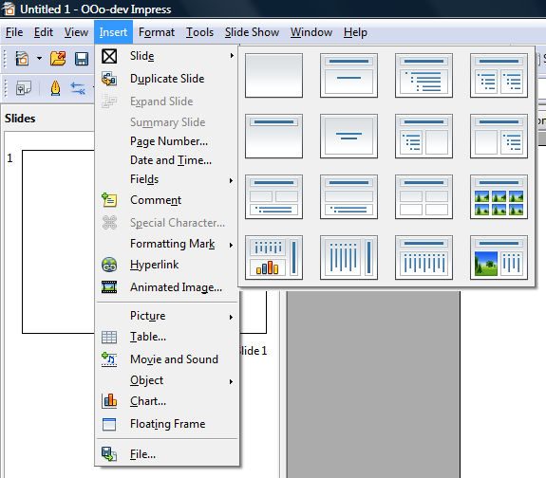Figure 1: Main Menu, Insert Slide

Format / Slide Layout
Forgot to put in “Reset Slide Layout” at the bottom of the preview.

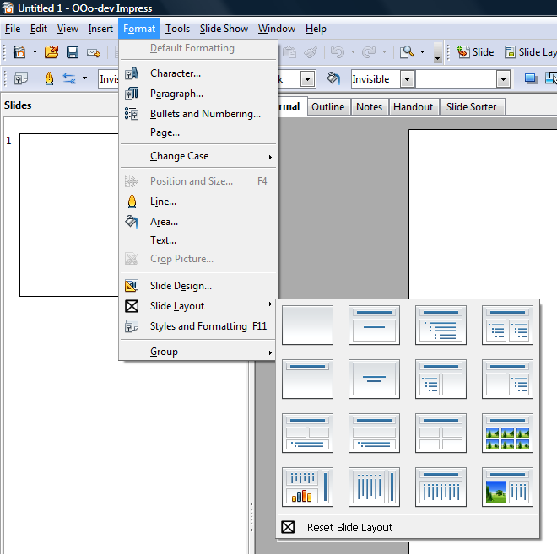Figure 2: Main Menu, Format, Slide Layout

Presentation Toolbar
We need to figure out how to make these toolboxes dockable in a similar way as with the shapes toolboxes that can be detached from their toolbar. Christian L. suggested also to add a click-and-release functionality as a trigger for the commands.
Commands in the order form left to right:
- Insert Slide
- Slide Layout
- Slide Design
- Slide Transition
- Start Presentation
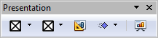Figure 3: Floating Presentation Toolbar
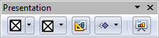Figure 4: Floating Presentation Toolbar, Mouse-Over Visuals
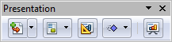Figure 6: Floating Presentation Toolbar, Mouse-Over Stati
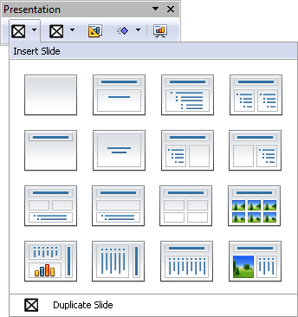Figure 5: Floating Presentation Toolbar, Insert Slide Toolbox
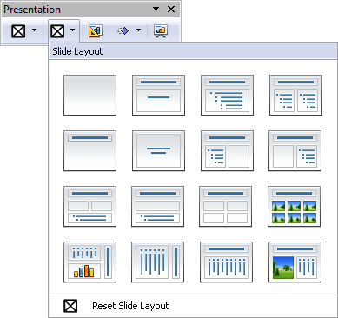Figure 7: Floating Presentation Toolbar, Slide Layout Toolbox

Mouse Context Menu in Slide Pane
Cut, copy and past move up the command hierarchy. This would be consistent with 99% of all other desktop applications. Commands do not disappear anymore. Instead, those that are not applicable in a given context will be visually “disabled” or grayed out.

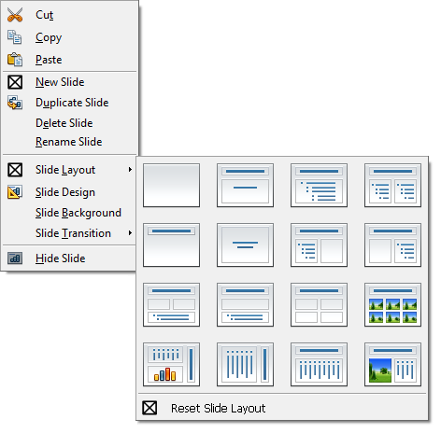Figure 8: Slide Pane View, Mouse Context Menu, Slide Layout

Mouse Context Menu in Slide View

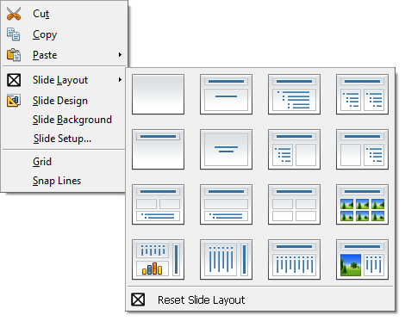Figure 9: Slide View, Mouse Context Menu, Slide Layout

Mouse Context Menu in Slide Sorter View
The mouse context menu is the slide sorter view resembles the same functionality as the mouse context menu in the slide pane (slides view) when applied on a slide (mouse cursor over a slide and right mouse button clicked).

Figure 10: Slide Sorter View, Mouse Context Menu, Slide Layout

Task Pane
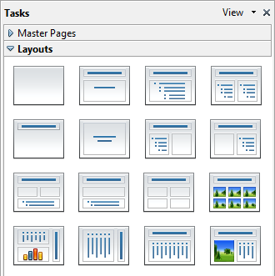Figure 11: Slide Layouts, Task Pane

Short Term Alternatives for Menu-Entries
Since it is not clear if we will be able to implement the designed solution for menu and mouse context entries, we have come up with an alternative that will still enable the user to change slide layouts directly from the context menu. This option will not have visual feedback via icons but will contain only slide layout labels to choose from.
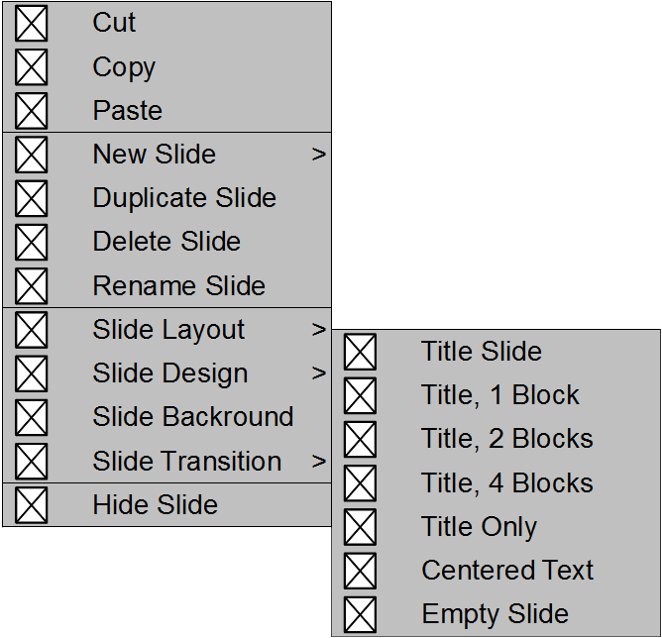Figure 12: Alternative Way to Change Slide Layouts from Context Menus

Default Layouts
The first slide of any newly created empty presentation will show the 'Title' layout. The second slide will be defaulted to 'Title, 1 Block' layout to force usage of presentation layouts.

Accessibility
Accessibility is the responsibility of the I-Team, beginning with UX, DEV and QA, to ensure that the following requirements are fulfilled:
- Is the feature fully keyboard accessible?
(Ex: “I can go everywhere and use every function using the keyboard only”)
<Start typing here>
- Have I specified visual alternatives for the case that the specified feature includes audio as output?
<Start typing here>
- Are text alternatives for all icons and graphics available?
<Start typing here>
- Don't provide important information in colors alone
(Ex: marking important information hard coded in red)
<Start typing here>
- Does the specified feature respect system settings for font, size, and color for all windows and user interface elements?
<Start typing here>
- Have I ensured that flash rates do not exceed 2 hertz for blinking text, objects, or other elements? In any case, try to avoid flashing UI elements
<Start typing here>
- Ensure that assistive technology(AT) (like ZoomText or Orca) is able to read everything.
<Start typing here>

Migration
<Start typing here ----- If this part is irrelevant state a reason for its absence!>

Configuration
<Start typing here ----- If this part is irrelevant state a reason for its absence!>

File Format
<Start typing here ----- If this part is irrelevant state a reason for its absence!>

Open Issues
Issue | Initials | Date
<State Issue here, State “None”, if all issues are solved> |  | <Format: Dec 31, 2000>
<...> |  | <Format: Dec 31, 2000>

Document Change History
Rev. | Change | Initials | Date
1 | Initial Specification | FL | Nov 25, 2009
2 |  |  | <Format: Dec 31, 2000>
3 |  |  | <Format: Dec 31, 2000>
<...> |  |  | <Format: Dec 31, 2000>

