Software Specification Document

OpenOffice.org Writer
Rework Simple Mail Merge Print Dialog

Specification Status
Last Change | Jul 3, 2007
Status
Abstract
The simple mail merge dialog is often used to print already present mail merge documents. The new mail merge wizard seems to be overloaded for those existing mail merge documents. The feature to save the mail merge in a single document is not implemented yet for this old dialog. This specification defines how this feature gets integrated into this dialog.
i-Team Members
Role | First Name, Last Name, Initials | E-Mail Address
I-Team Lead | Joost Andrae (JA) | joost.andrae@sun.com
Specification Author | Frank Loehmann (FL) | frank.loehmann@sun.com
User Experience | Frank Loehmann (FL) | frank.loehmann@sun.com
Development | Oliver Specht (OS) | oliver.specht@sun.com
 | Frank Schoenheit (FS) | frank.schoenheit@sun.com
Quality Assurance | Hasan Ilter (HI) | hasan.ilter@sun.com
 | Christoph Lukasiak | christoph.lukasiak@sun.com
Documentation | Uwe Fischer (UFI) | uwe.fischer@sun.com
Other roles | Kay Koll | kay.koll@sun.com
 | Rafaella Braconi | rafaella.braconi@sun.com

Contents
Abstract 1
i-Team Members 1
References and Reference Documents 3
Acronyms and Abbreviations 3
1 Detailed Specification 4
1.1 Default Dialog Status – Output on Printer 4
1.2 Default Dialog Status – Output to File Merge Down 6
1.2.1 Default Dialog Status for File Output 6
1.2.2 Dialog Status for File Output with Name from Database 7
1.3 Mail Merge Query Dialog 7
2 Migration 7
3 Configuration 8
4 File Format 8
5 Open Issues 8
Document Change History 8

References and Reference Documents
Reference Document | Check | Location (URL)
Specification Process Entry Check |  | N/A
Product Requirement, RFE, issue [Required] |  | 76853
Product Concept Document
Competitive Analysis
IDL Specification
Test Case Specification [Required] |  | http://www.openoffice.org/nonav/issues/showattachment.cgi/46469/MailMergeTestSpecification.html
Software Specification Rules | N/A | N/A
<Other, e.g. references to related specs>
Acronyms and Abbreviations
Acronym / Abbreviation | Definition
<WYSIWYG> | <What You See Is What You Get>

Detailed Specification
The simple Mail Merge dialog will be reworked to implement the possibility of a merge down to a single Writer document. The former dialog only offered the merge down to multiple documents. During the rework of the dialog, the positioning of the OK, Cancel and Help button changes.

Default Dialog Status – Output on Printer
The following mock-up shows the default settings of the dialog in the Records and Output section. The database beamer does not show it's default state.
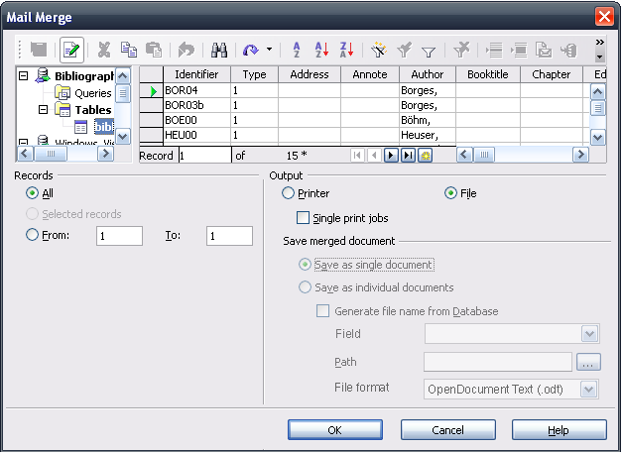Illustration 1: Simple Mail Merge Dialog – Default Settings

- “Save Merged Documents”- Label Properties |  | Comment
Label: | Save merged documents |  | EN-US
Label: | >German translation already in database< |  | DE

- “Save as single document” - RadioButton Properties |  | Comment
Enabled: | If the File radio in the output section is checked.
Selected: | By default
RadioButton Label: | Save as single document |  | EN-US
RadioButton Label: | >German translation already in database< |  | DE

- “Save as individual documents” - RadioButton Properties |  | Comment
Enabled: | If the File radio in the output section is checked.
Selected:
RadioButton Label: | Save as individual documents |  | EN-US
RadioButton Label: | >German translation already in database< |  | DE

- “Generate file name from database” - CheckBox Properties |  | Comment
Enabled: | If “Save as individual documents” is checked.
Checked: | Not checked by default.
CheckBox Label: | Generate file name from database |  | EN-US
CheckBox Label: | >German translation already in database< |  | DE

- “Field” - DropDown Listbox Properties |  | Comment
Enabled: | If “Generate file name from database” is checked.
Rows Visible: | 8
Items: | List of column headers will be created dynamically from currently selected database in database beamer above.
Item Selected: | First element.
Sorting by  Drag & Drop: | Disabled.
DropDown  ListBox Label: | Field |  | EN-US
DropDown  ListBox Label: | Feld |  | DE

- “Path” - TextField Properties |  | Comment
Enabled: | If “Generate file name from database” is checked.
Read Only: | No
Initial String: |  | empty
String Preselected: | No
TextField Label: | Path |  | EN-US
TextField Label: | Pfad |  | DE

- “...” - Button Properties |  | Comment
Enabled: | If “Generate file name from database” is checked.
Press: | Path picking dialog is called.
Button Label: | ... |  | EN-US
Button Label: | ... |  | DE

- “File Format” - DropDown Listbox Properties |  | Comment
Enabled: | If “Generate file name from database” is checked.
Rows Visible: | 8
Items: | Normal Writer file type list from Save as dialog plus PDF Exportfilter.
Item Selected: | “OpenDOcument Text (.odt)”
Sorting by  Drag & Drop: | Disabled.
DropDown  ListBox Label: | File format |  | EN-US
DropDown  ListBox Label: | Dateiformat |  | DE

Default Dialog Status – Output to File Merge Down

Default Dialog Status for File Output
If the File output is checked, the “Save merged document” section gets enabled and offers the choice between generating a single merge down document or to create a single document for each dataset. When confirming the Mail Merge dialog, a “Save as” dialog is shown to define file name and path. This Save as dialog offers all Writer file formats plus the PDF export filter.
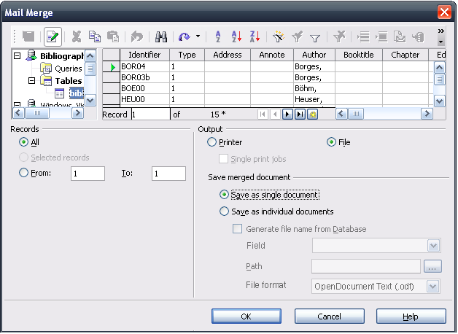Illustration 2: Simple Mail Merge Dialog – Save as Single Documents

Dialog Status for File Output with Name from Database
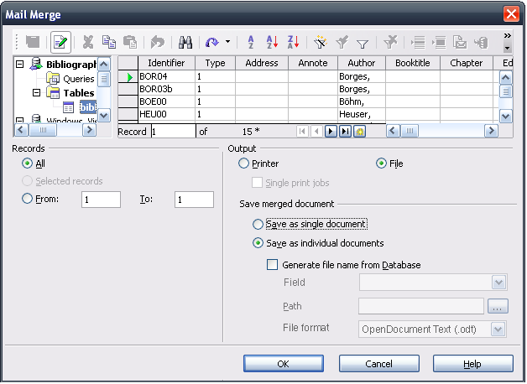Illustration 3: Simple Mail Merge Dialog – Save as Individual Documents

Mail Merge Query Dialog
If text in writer contains database fields, the following dialog is shown if the user wants to print out the document. The previous version of this query dialog showed a “Do not warn me again” check box, which got dropped in this reworked version, because if checked once in error, the mail merge wizard will not appear again.
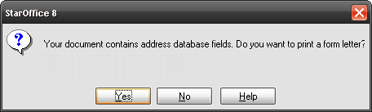Illustration 4: Removed check box in query dialog for printing form letters

Migration
Not relevant.

Configuration
Not relevant.

File Format
Not relevant.

Open Issues
Issue | Initials | Date
<State Issue here, State “None”, if all issues are solved> |  | <Format: Dec 31, 2000>
<...>

Document Change History
Rev. | Change | Initials | Date
1 | Initial Draft of Spec. | FL | May 03, 2007
2 | Second Draft of Spec. with string tables | FL | May 04, 2007
3 | Add File format LB | FL | June 6, 2007
4 | Set to Standard! | FL | July 3, 2007

