Software Specification Document

OpenOffice.org
Package Manager Renaming

Specification Status
Last Change | Jun 8, 2010
Status

Abstract
The term extension is more common than package or even package bundle. Therefore we should rename the Package Manager to Extension Manager and the term package to extension. This has to be done in the GUI as well as in the documentation and help system.

i-Team Members
Role | First Name, Last Name, Initials | E-Mail Address
Project Lead | Joachim Lingner (jl) | jl@openoffice.org
Specification Owner | Joachim Lingner (jl) | jl@openoffice.org
User Experience | Bettina Haberer (BH) | bh@openoffice.org
Development | Joachim Lingner (JL) | jl@openoffice.org
Quality Assurance | Jörg Skottke (JSK), Thorsten Bosbach (TBO) | jsk@openoffice.org, tbo@openoffice.org
Documentation | Uwe Fischer (UFI) | ufi@openoffice.org
Other roles | <First Name, Last Name (Initials)> | <User@openoffice.org>
<State reason here, if one role is not represented in i-Team.>

Contents
Abstract 1
i-Team Members 1
References and Reference Documents 3
Acronyms and Abbreviations 3
1 Detailed Specification 4
1.1 Menu Item 4
1.2 Extension Manager GUI 5
1.3 Filepicker dialog for adding extensions 6
1.4 Filepicker dialog for exporting extensions 7
1.5 Progress Dialog of Extension Manager 9
1.6 Error Messages of Extension Manager 12
1.7 Licensing 13
1.8 Export Basic Library Dialog 14
1.9 Filepicker Dialog for Exporting Basic Libraries as Extension 15
2 Migration 16
3 Configuration 16
4 File Format 16
5 Open Issues 16
Document Change History 16

References and Reference Documents
Reference Document | Check | Location (URL)
Specification Process Entry Check |  | N/A
Product Requirement,, RFE, issue (required) |  | i69568
Product Concept Document |  | <Please enter location here>
Competitive Analysis |  | <Please enter location here>
Test Case Specification (required) |  | qa/qatesttool/framework/basic/f_basic_package_export_import.bas  (just for the exported basic library)
Software Specification Rules | N/A | N/A
Specification Package Manager Graphical Interface |  | http://specs.openoffice.org/appwide/packagemanager/packagemanager_gui_spec.sxw
Specification unopkg Deployment Tool |  | http://specs.openoffice.org/appwide/packagemanager/unopkg_spec.sxw
Specification Basic Library Export |  | http://specs.openoffice.org/ide/BasicLibraryExportSpec.odt

Acronyms and Abbreviations
Acronym / Abbreviation | Definition

Detailed Specification
This specification contains changes to these specifications:
- Package Manager Graphical Interface
- unopkg Deployment Tool
- Basic Library Export

Menu Item
The menu item Tools | Package Manger... is to be renamed to Extension Manager.
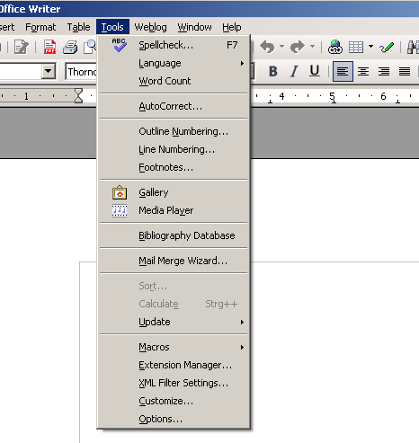Figure 1: Menu item

Table 1: User Interface elements of Figure 1
# | Type | Properties |  | Comment
<#> |  | Control Properties  Enabled: Yes
<#> |  | ~Extension Manager... | Ex~tension Manager...
Table 1: Changed menu entry

Extension Manager GUI
All entries in the Extension Manager dialog which refer to Packages have to be renamed.

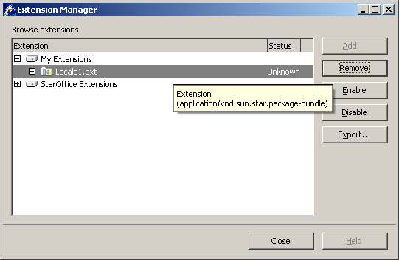Figure 2: Extension Manager

Table 2: User Interface elements of Figure 2
# | Type | Properties |  | Comment
<#> |  | Control Properties  Enabled: Yes
<#> |  | Extension Manager | Extension Manager |  | Title of the window
<#> |  | Control Properties  Enabled: Yes
<#> |  | String English  Browse extensions | String German  Extensions durchsuchen |  | Label above the list box
<#> |  | Control Properties  Enabled: Yes
<#> |  | String English  My Extensions | String German  Meine Extensions |  | top-level node of treelistbox denoting the user installation layer
<#> |  | Control Properties  Enabled: Yes
<#> |  | String English  %PRODUCTNAME Extensions | String German  %PRODUCTNAME Extensions |  | top-level node of treelistbox denoting the office installation layer (not modifyable)
<#> |  | Control Properties  Enabled: Yes
<#> |  | String English  Extension | String German  Extension |  | column header of treelistbox
<#> |  | Control Properties  Enabled: Yes
<#> |  | String English  Extension | String German  Extension |  | Extension type for extensions which contain multiple items bundled in one .oxt file.  The string is contained in a tooltip that appears over a selected .pkg, .oxt extension.
Table 2: Extension Manager

Filepicker dialog for adding extensions

All entries in the filepicker dialog which refer to packages have to be renamed.
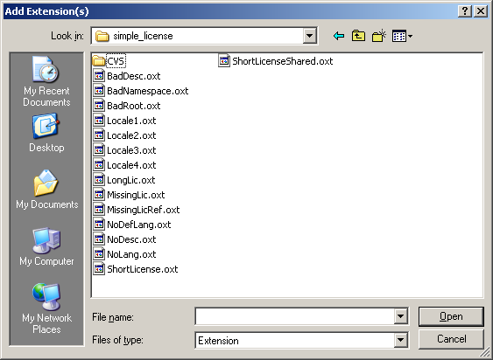Figure 3: Add file chooser

Table 3: User Interface elements of Figure 3
# | Type | Properties |  | Comment
<#> |  | Control Properties  Enabled: Yes
<#> |  | Add Extension(s) | Extension(s) hinzufügen |  | title for file-chooser dialog adding one or more packages
<#> |  | Properties
<#> |  | String English  Extension | String German  Extension |  | Entry in file type list box, which replaces “Uno Package Bundle”
Table 3: File chooser for adding extensions

Filepicker dialog for exporting extensions
All entries in the filepicker dialog which refer to packages have to be renamed.

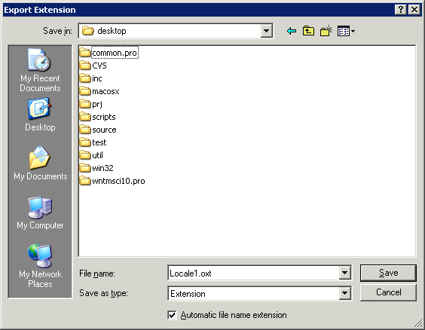Figure 4: Export file chooser

Table 4: User Interface elements of Figure 4
# | Type | Properties |  | Comment
<#> |  | Control Properties  Enabled: Yes
<#> |  | Export Extension | Extension exportieren |  | title for file-chooser dialog exporting a single extension
<#> |  | Properties
<#> |  | String English  Extension | String German  Extension |  | Entry in file type list box, which replaces “Uno Package Bundle”
Table 4: Export file chooser, single file

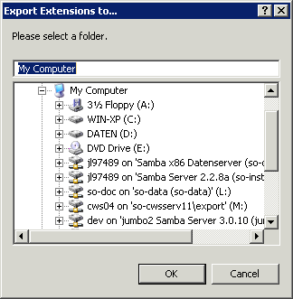Figure 5: Export file chooser, multiple files

Table 5: User Interface elements of Figure 5
# | Type | Properties |  | Comment
<#> |  | Control Properties  Enabled: Yes
<#> |  | Export Extensions to... | Extensions exportieren nach... |  | title for folder-chooser dialog exporting multiple extensions
Table 5: Export file chooser, multiple files

Progress Dialog of Extension Manager
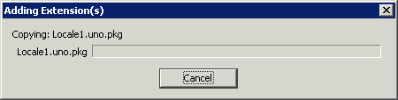Figure 6: Adding, step 1

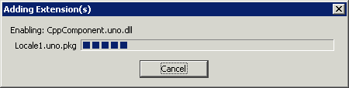Figure 7: Adding, step 2

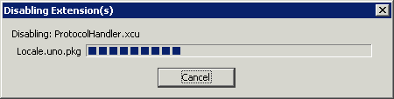Figure 8: Disabling

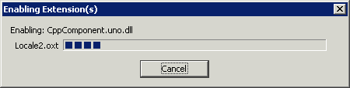Figure 9: Enabling
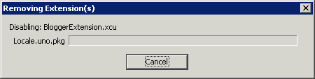Figure 10: Removing
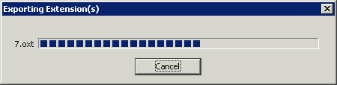Figure 11: Exporting

In the following table the place holder “<name>” is used (withoud quotes). It stands for a file name which appears in the dialog.
# | Type | Properties |  | Comment
Control Properties
Enabled: Yes
 |  | Adding Extension(s) | Extension(s) werden hinzugefügt | Title of the dialog that indicates the process of adding one or more extensions.  Figure 6 an 7
<#> |  | Control Properties  Enabled: Yes
<#> |  | String English  Removing Extension(s) | String German  Extension(s) werden entfernt | Title of the dialog that indicates the process of removing one or more extensions.  Figure 10
<#> |  | Control Properties  Enabled: Yes
<#> |  | String English  Enabling Extension(s) | String German  Extension(s) werden aktiviert | Title of the dialog that indicates the process of activating one or more extensions.  Figure 9
<#> |  | Control Properties  Enabled: Yes
<#> |  | String English  Disabling Extension(s) | String German  Extension(s) werden deaktiviert | Title of the dialog that indicates the process of deactivating one or more extensions.  Figure 8
<#> |  | Control Properties  Enabled: Yes
<#> |  | String English  Exporting Extension(s) | String German  Extension(s) werden exportiert | Title of the dialog indicating the process of exporting one or more extensions  Figure 11
<#> |  | Control Properties  Enabled: Yes
<#> |  | String English  Copying: <name> | String German  Kopiere: <Name> | The text shown above the progress bar when copying an extension or extension item.  Figure 6
<#> |  | Control Properties  Enabled: Yes
<#> |  | String English  Enabling: <name> | String German  Aktiviere: <Name> | The text shown above the progress bar when registering an extension or extension item.  Figure 7
<#> |  | Control Properties  Enabled: Yes
<#> |  | String English  Disabling: <name> | String German  Deaktiviere: <Name> | The text shown above the progress bar when deregistering/revoking an extension or extension item.  Figure 8, 10
Table 6: Progress dialog

Error Messages of Extension Manager
Table 7:
# | Type | Properties |  | Comment
<#> |  | Control Properties  Enabled: Yes
<#> |  | Cannot detect media-type: <File-URL> | Media-Typ konnte nicht ermittelt werden: <File-URL>
<#> |  | Control Properties  Enabled: Yes
<#> |  | String English  Error while adding: <Name> | String German  Fehler beim Hinzufügen von: <Name>
<#> |  | Control Properties  Enabled: Yes
<#> |  | String English  Error while removing: <name> | String German  Fehler beim Entfernen von: <Name>
<#> |  | Control Properties  Enabled: Yes
<#> |  | String English  Extension has already been added: <Name> | String German  Extension ist bereits vorhanden: <name> |  | Only occurs, when a whole extension is added and not when copying an extension item.
<#> |  | Control Properties  Enabled: Yes
<#> |  | String English  There is no such extension deployed. | String German  Extension ist nicht bekannt.
<#> |  | Control Properties  Enabled: yes
<#> |  | String English  An error occurred while enabling: <name> | String German  Fehler beim Aktivieren von: <Name>
<#> |  | Control Properties  Enabled: Yes
<#> |  | String English  An error occurred while disabling: <name> | String German  Fehler beim Deaktivieren von: <Name>
Table 7: Error messages

Licensing
Some extensions come with a license text which every user has to agree to. These extension cannot be installed in shared mode. If this is done then a warning box is shown. The string contains “Package” which needs to be replaced. To reproduce, try to install an extension as shared extension. The extension must contain a license text and require every user to agree to it.
Table 8:
# | Type | Properties |  | Comment
<#> |  | Control Properties  Enabled: Yes
<#> |  | The extension %NAME cannot be installed under \"%PRODUCTNAME Extensions\", because every user has to agree to the license agreement of the extension. The extension will not be installed. | Die Erweiterung %NAME kann nicht unter \"%PRODUCTNAME Extensions\" installiert werden, da jeder Anwender der Lizenz der Extension zustimmen muss. Die Erweiterung wird nicht installiert.
Table 8: License warning

Export Basic Library Dialog
The dialog can be reached by Tools | Macros | Organize Dialogs, Tab libraries, select a library, press Export.
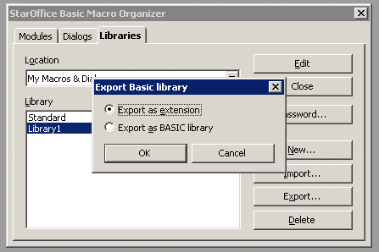Figure 12: Export Basic Library

Table 9: User Interface elements of Figure 12
# | Type | Properties |  | Comment
<#> |  | Control Properties  Enabled: Yes  Initially Selected: Yes  ToolTip Text: |  |  | The upper radio button.
<#> |  | Export as extension | Als Extension exportieren
Table 9: Library export

Filepicker Dialog for Exporting Basic Libraries as Extension
The dialog can be reached by Tools | Macros | Organize Dialogs, Tab “Libraries”, select a library, press “Export”, select “Export as extension” and press “Ok”.

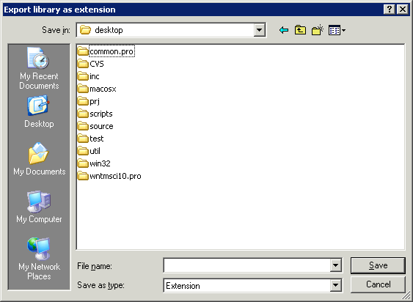Figure 13: Export library file chooser
Table 10: User Interface elements of Figure 13
# | Type | Properties |  | Comment
<#> |  | Control Properties  Enabled: Yes |  |  | Dialog title.
<#> |  | Export library as extension | Bibliothek als Extension exportieren
<#> |  | Control Properties  Enabled: Yes |  |  | Entry in file type list box, which replaces “Uno Package Bundle”
<#> |  | String English  Extension | String German  Extension
Table 10: File chooser for exporting a basic library

Migration
<Start typing here ----- If this part is irrelevant state a reason for its absence!>

Configuration
<Start typing here ----- If this part is irrelevant state a reason for its absence!>

File Format
<Start typing here ----- If this part is irrelevant state a reason for its absence!>

Open Issues
Issue | Initials | Date
<State Issue here, State “None”, if all issues are solved> |  | <Format: Dec 31, 2000>
<...>

Document Change History
Rev. | Change | Initials | Date
1 |  |  | <Format: Dec 31, 2000>
2
3
<...>

