Software Specification Document

OpenOffice.org 3.2
Rework on Transparent Selection

Specification Status
Last Change | Aug 5, 2009
Status
Abstract
The transparent selection, introduced in OpenOffice.org 3.0 didn't satisfy every user's expectations. This specification discusses the current mechanisms and possible enhancements.

i-Team Members
Role | First Name, Last Name, Initials | E-Mail Address
I-Team Lead | Armin Le Grand | aw@openoffice.org
Specification Author | Éric Savary | es@openoffice.org
User Experience | Armin Le Grand | aw@openoffice.org
Development | Armin Le Grand | aw@openoffice.org
Quality Assurance | Éric Savary | es@openoffice.org
Accessibility | Éric Savary | es@openoffice.org
Documentation | Uwe Fischer | ufi@openoffice.org

Contents
Abstract 1
i-Team Members 1
References and Reference Documents 3
Acronyms and Abbreviations 3
1 Detailed Specification 4
1.1 The reworked transparent selection 4
1.2 Discussion 4
1.3 Transparency Option UI 5
1.4 Transparency in Calc (i86069) 7
1.5 Transparency in Writer (i88893) 7
2 Accessibility 7
3 Migration 8
4 Configuration 8
5 File Format 9
6 Open Issues 9
Document Change History 9

References and Reference Documents
Reference Document | Check | Location (URL)
Specification Process Entry Check |  | N/A
Product Requirement, RFE, issue |  | i97672
Accessibility Check [Required] |  | See section 2 Accessibility below
Product Concept Document |  | <Please enter location here>
Competitive Analysis |  | <Please enter location here>
IDL Specification |  | <Please enter location here>
Test Case Specification [Required] |  | http://www.openoffice.org/nonav/issues/showattachment.cgi/63899/TCS_Transparent_Selection.htm
Software Specification Rules | N/A | N/A
Acronyms and Abbreviations
Acronym / Abbreviation | Definition
"XOR" | A logical operator which 'inverts' the target data. Applied to graphical content, it is usually 'inverting' the colors of an area. The color itself is seen as an RGB-value consisting of red, green and blue parts which have a range between 'on' and 'off', usually in some steps. By inverting a such organized color definition, the complement color in RGB color space is produced. Inverting again the same area restores the original content (that's the historical root of this operation for selection; the selection can be set and removed without the need to repaint the content)  An example: The is a reverse video text.
A11y | Accessibility
RGB | Red, Green, Blue
OOo | OpenOffice.org

Detailed Specification

The reworked transparent selection

For OOo 3.1, the selection in Writer was adapted to use overlay with transparency, similar to what was done in Calc before. That transparency is fixed (50% for Writer, 75% for Calc), the color is fetched from the system using the highlight/selection color. The old method of XO'ring (inverting) the selection was not dismissed, but re-implemented and is used when high contrast is used.

Discussion
While most users are very happy with the enhanced visualization, there were some comments/remarks regarding these change. There was the wish to be able to:
- get back the inverse selection as an option
- set an own value for the transparency
which are both valid requests. From usability standpoint the two central points for the selection are:
- Visibility of the selection
- Visibility of the selected content
With using the transparency, one may argue that (1) has lost contrast (compared with XOR, everything loses contrast), and that (2) go weaker, too. Both can be avoided by offering a possibility to fallback to inverse selection again, without the need to set the system to high contrast.
But there is a reason for the new selection: Using inverse (XOR) is no longer up-to-date, and nearly no application is using it nowadays. The contrast is the highest reachable, but for most people it is too extreme today, so that they are disturbed exactly by that high contrast when their eye focus changes between selected and non-selected parts of the document.
Thus, it is also necessary to enhance the selection visualisation with the transparency used. Unfortunately it is currently technically not possible to show the selection for OOo 'behind' the text (and – which is not consequent, but necessary – transparently 'over' objects) as many systems do nowadays. This would enhance (2) well. It's not possible since OOo does not simply call system methods to 'select' system text on one of the supported systems (do not forget, OOo is system independent, what comes for a price) and let the system do it; instead OOo creates the whole Application visualizations on it's own, and that's nothing You can change on the fly.
So, technically, we will have to live with the possibility to show the selection on the 'overlay' what means it is possible to paint something on top of the Application visualisation.
Enhancing (2) can be reached by using a relatively high transparency of e.g. 75% as Calc currently does. This ensures that the displayed content is/stays readable. The higher the transparency, the lesser the content gets manipulated by the selection visualization, the better (2) will be. On the other hand, this reduces (1). This again can be solves as Calc currently does it: Add a frame (a hairline) surrounding the selection, using the non-transparent selection color. This increases the contrast of the selection itself and enhances (1). Technically, it is topologically not easy to 'melt' e.g. A multiple selection in Calc or Writer by OR'ing all used selection areas, but we have the tools.
Another argument for adding the hairline frame is to have the same selection visualization in Calc and Writer; there is no reason to have different selections in one office application.
So, the proposed steps for enhancing the selection are:
- Add a section to tools/options/view TabPage for controlling the selection, named 'Selection'
- Do not add an extra selection color; be system conform and use the user-selected system selection color (like most well-formed applications do nowadays)
- Add a CheckBox to choose between transparent and old inverse selection visualization, called 'Transparency', defaulted to on (true). When on, use transparent selection, else use inverse selection
- Add a SpinField to choose transparency level in percent. The default will be 75%. This SpinField will be disabled when the CheckBox is switched off. The transparency level will be controllable between 10% and 90% since neither no transparency nor full transparency make sense
- The transparent selection will be enhanced by adding a hairline frame in non-transparent selection color around the geometrically merged selection areas
There were already experiments with this selection and it was received positively.
Another point came up what to do if the Option is not available on the System. There are three possibilities which all have advantages and disadvantages. The CheckBox may stay as is, be disabled (disable CheckBox and MetricField) or hidden (hide the whole group). Since there is already the 'Graphics output' section on this TabPage which has the same problem and uses the 'disable' solution. We opted to do this for the selection option, too.
Some more Infos when the option will be disabled (e.g. For documentation):
There are two reasons that the option can be disabled:
- System idependent: reason: When HighContrast is enabled
- System dependent reason: When the system supports no fast way to render transparency. Currently, this is the case for Unix-based systems when no Xrender extension is available.

Transparency Option UI
This new option can be found under "Tools – Options – View" (See Error: Reference source not found)
It introduces a new section called "Selection" which contains 2 controls:
- A "Transparency" check box - default = ON.
- A spin field (Internal name: "Transparency Level"):
  - default: 75%.
Illustration 1.1: Default transparency setting of 75% with a color RGB:(147,160,112)
  - Lower limit: 10%
Illustration 1.2: Transparency setting of 10% with a color RGB:(147,160,112)
  - Upper limit: 90%
Illustration 1.3: Transparency setting of 90% with a color RGB:(147,160,112)

Illustration 1.4: Transparency OFF: inverse(XOR) used.

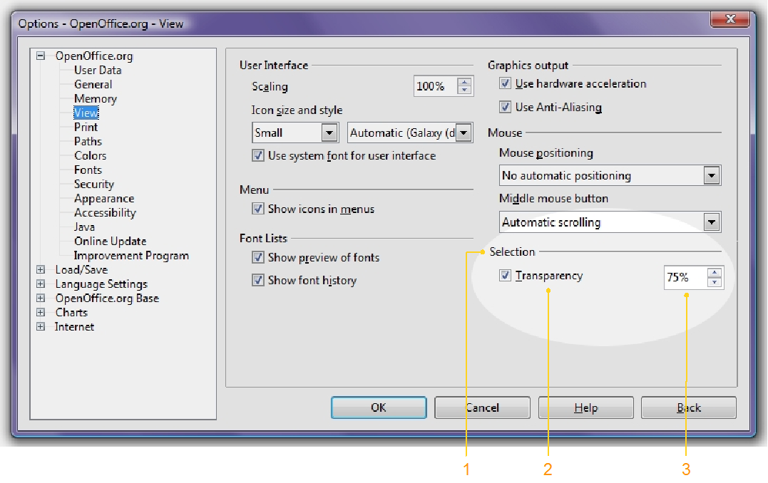Illustration 1.5: The Transparency Option under "Tools - Options - OpenOffice.org – View"
(See below a description of the controls)

- “Selection” - Label Properties |  | Comment
Label: | Selection | EN-US

- "Transparency” - CheckBox Properties |  | Comment
Enabled: | Depends on System's abilities for painting transparency fast
Disabled: | No
Tri-State: | No
Checked: | Yes
Other: | n/a
CheckBox Label: | Transparency | EN-US

- “Transparency level” - SpinField Properties |  | Comment
Enabled: | Depends on state (value and enable) of #2
Disabled: | No
Min. Value: | 10%
Max. Value: | 90%
Start Value: | 75%
Steps: | 1%
Measurement Unit: | %
SpinField Label: | None visible but Control name should reflect:  Transparency Level | EN-US

Transparency in Calc (i86069)
The selection transparency is currently at 75% in Calc and has a border. No changes needed.

Transparency in Writer (i88893)
The selection transparency is currently at 50% and has no border. The Transparency default will change to 75% and the border will be added. For multiple selection, one border for each single selection will be used; this will allow to visually identify multiple selection topology with a single look.

Accessibility
Accessibility is the responsibility of the I-Team, beginning with UX, DEV and QA, to ensure that the following requirements are fulfilled:
- Is the feature fully keyboard accessible?
(Ex: “I can go everywhere and use every function using the keyboard only”)
The controls in Tools - Options are accessible over the keyboard
- Have I specified visual alternatives for the case that the specified feature includes audio as output?
Doesn't apply
- Are text alternatives for all icons and graphics available?
Doesn't apply
- Don't provide important information in colors alone
(Ex: marking important information hard coded in red)
Doesn't apply
- Does the specified feature respect system settings for font, size, and color for all windows and user interface elements?
System color compliance and high contrast OK
- Have I ensured that flash rates do not exceed 2 hertz for blinking text, objects, or other elements? In any case, try to avoid flashing UI elements
Doesn't apply
- Ensure that assistive technology(AT) (like ZoomText or Orca) is able to read everything.
The controls in Tools - Options are accessible.

Migration
Not affected.

Configuration
The following items were added:
Configuration | Group | Setting | Type | Default | Comment
Common.xcs | Drawinglayer | TransparentSelection | Boolean | True | Short form:  This switch defines if for text/cell selections the old inverse or the new transparent selection is to be used.  Long form:  This switch defines if the selections in the applications (text or cells) are visualized using inverse (XOR) when set to false (the old selection method, also used when in high contrast mode) or a transparent overlay selection using the system's selection color.
Common.xcs | Drawinglayer | TransparentSelectionPercent | short | 75 | Short form:  Specifies the percent of transparency to use if transparent selection is used.  Long form:  Specifies the degree of transparency to be used when transparent selection is used. The value is a percent value. Since neither no transparency nor complete transparency makes sense, the value is limited to a range of 10% - 90%. If the given value is outside this range, it is cropped to it.

File Format
Not affected.

Open Issues
Issue | Initials | Date
i97672 : New transparent selection hardly visible | AW | 2009-07-29

Document Change History
Rev. | Change | Initials | Date
1 | Initial revision | ES | 2009-07-27
2 | Updated | AW | 2009-07-29
3 | Updated | ES | 2009-07-29
<...> | Finalized | ES | 2009-08-05

