Software Specification Document

OpenOffice.org
File Locking

Specification Status
Last Change | May 8, 2009
Status
Abstract
File locking is needed to control access to a document. If a file/document is locked, nobody else can change/delete the document. A file locking mechanism is offered by the operating system, but in some cases this mechanism does not/cannot work. Therefore OOo implements its own mechanism beside the one provided by the operating system. System and OOo file locking are combined. This allows OOo to have reliable locking even when the locking from the operating systems fails in some cases. Furthermore it allows OOo to see who has already opened the document.
i-Team Members
Role | First Name, Last Name, Initials | E-Mail Address
I-Team Lead | Mikhail Voitenko (MAV) | mikhail.voitenko@Sun.COM
Specification Author | Frank Loehmann (FL) | frank.loehmann@sun.com
User Experience | Frank Loehmann (FL) | frank.loehmann@sun.com
Development | Mikhail Voitenko (MAV) | mikhail.voitenko@Sun.COM
Quality Assurance | Thorsten Martens (TM) | thorsten.martens@sun.com
Documentation | Uwe Fischer (UFI) | uwe.fischer@sun.com

Contents
Abstract 1
i-Team Members 1
References and Reference Documents 3
Acronyms and Abbreviations 3
1 Usage Scenarios 3
1.1 Restricted Access on Document Level 3
1.1.1 Scenario A “Open Read-Only Copy” 3
1.1.2 Scenario B “Get Info when Unlocked” 3
1.1.3 Scenario C “Contact Current Editor” 3
1.1.4 Scenario D “Security” 4
1.1.5 Scenario E “Reliable File Locking” 4
1.2 Requirements Distilled from Above Scenarios 4
2 Application Wide File Locking 5
2.1 Workflow 5
2.1.1 File Open 5
2.1.2 File Save 5
2.2 Dialogs/User Interaction 6
2.2.1 Dialog #2.1: Document Locked by Other 6
2.2.2 Dialog #3.1 Overwriting a Locked Document 7
2.2.3 Dialog #3.1: Document Could Not be Saved 7
2.2.4 OOo File Locking Warnings/Queries 8
2.2.4.1 Document has Been Changed Until Opening 8
2.2.4.2 Document is Already Open on Another System by Same User 9
2.2.4.3 OOo Locking Failed 10
3 Migration 11
4 Configuration 11
5 File Format 11
6 Open Issues and Change History 12
Document Change History 12
7 Future Feature Description 13
7.1 Future Scenarios 13
7.2 Future Dialog Mock-ups 13

References and Reference Documents
Reference Document | Check | Location (URL)
Specification Process Entry Check |  | N/A
Product Requirement, RFE, issue [Required] |  | i95809
Product Concept Document |  | <Please enter location here>
Competitive Analysis |  | <Please enter location here>
IDL Specification |  | <Please enter location here>
Test Case Specification [Required] |  | http://www.openoffice.org/nonav/issues/showattachment.cgi/51910/TestCaseSpecification_Collaboration.htm
Software Specification Rules | N/A | N/A
Calc Collaboration |  | http://specs.openoffice.org/calc/features/Collaboration.odt
Acronyms and Abbreviations
Acronym / Abbreviation | Definition
<WYSIWYG> | <What You See Is What You Get>

Usage Scenarios
The following scenarios will help to build a list of requirements. There are three different higher level scenarios divided in sub scenarios.

Restricted Access on Document Level
Sharing a document on a file level basis. (file locking)
Sharing a document on a file level is the basic scenario. Often file locking on a system level does not work in certain environments. Thus a new mechanism is needed to ensure proper file locking on all systems and environments. This mechanism should support the following sub scenarios:

Scenario A “Open Read-Only Copy”
User A tries to open a document which is currently opened for editing (locked) by another person. Then user A wants to open a read-only copy of the document to read the document.

Scenario B “Get Info when Unlocked”
User B tries to open a document which is currently opened for editing (locked) by another person. Then the user want to be informed automatically as soon as the file is available for editing.

Scenario C “Contact Current Editor”
User C tries to open a document which is currently opened for editing (locked) by another person. Then the user want to contact the person currently locking the document, to find out when that person expects to have finished editing.

Scenario D “Security”
User D does not want to have her name shown when locking a file for editing.

Scenario E “Reliable File Locking”
User E opened a document for editing and then the application terminates. Another user tries to open the same file and gets a message that the file is locked by user E. Who can help?

Requirements Distilled from Above Scenarios
Each main requirement must be backed by a valid scenario.
- A file locking mechanism:
  - reliable (crash resistant locking mechanism)¹
  - and system independent¹
- Choice to open a read-only copy of a locked document.
- Choice to be informed if the document gets unlocked. <Target: Later>
- Be able to see who is currently locking the document for editing. Show:
  - full name (preferred if present) or system name
  - date stamp
  - time stamp
- In case that system file locking does not work, OOo needs to recognize and
inform user that:
  - file has been changed by third party application in meantime when saving
  - the file is currently opened by a third party application when loading
  - the file is currently opened by a third party application when saving
  - own file locking does not work due to server limitations

Application Wide File Locking
This section describes the workflow for the application-wide file locking mechanism for OpenOffice.org. The system file locking will be used in addition to the application-wide file locking to prevent conflicts with 3rd party applications and older versions of OOo (i.e. 2.x). The usage of the system file locking can be turned off by an invisible option in the configuration.

Workflow

File Open
The following graph shows the workflow when opening a file.
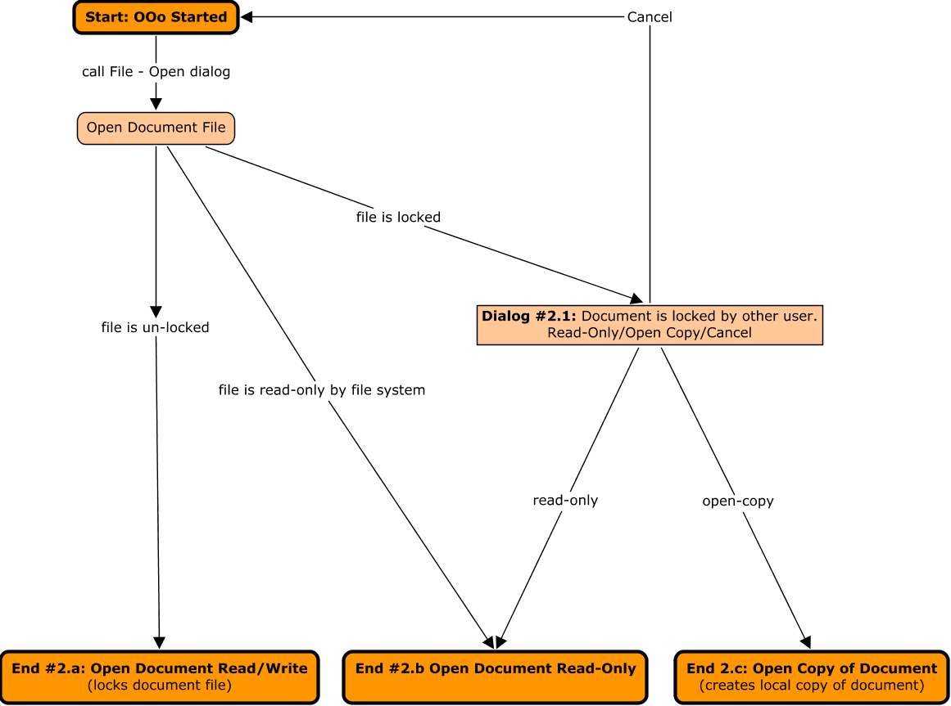
Illustration 1: Open OOo file

File Save
Saving a file currently locked by another user is not possible, regardless if the file is locked by own or system file locking.
The following graph shows the workflow when saving an ODF file.
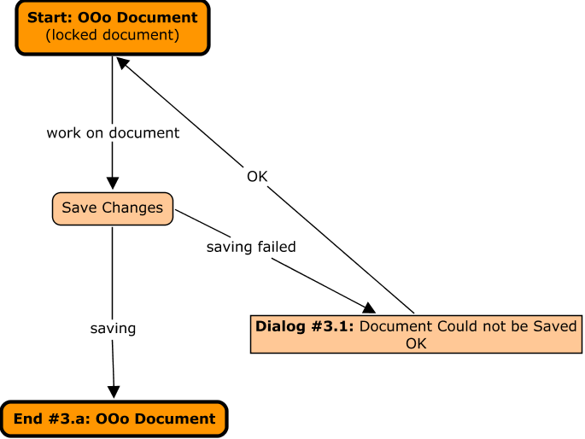
Illustration 2: File Save of a locked file
There are some cases that third party applications delete/change files if the system wide file locking is turned off. See 2.2.4 OOo File Locking Warnings/Queries on page 8 for warning/queries handling those special cases not shown in Illustration 2: File Save of a locked file.

Dialogs/User Interaction
Please see section above when one of the following dialog is shown during the collaboration scenarios.

Dialog #2.1: Document Locked by Other
The following dialog is shown, if a document is locked for editing by another user. The name of that user is shown, if the user meta data is available. Otherwise “Unknown User” is displayed. Then the user could open the document read-only-or open a copy of that document for editing.
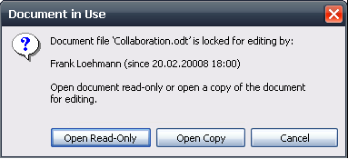Illustration 3: Document is in use when loading document
- “Document in Use: Open” - Dialog Properties |  | Comment
State: | Modal
Type: | Dialog
Closable: | Yes
Resizable: | No
Title: | Document in Use | EN-US
- “Note” - Text Properties |  | Comment
Label: | Document file '%DOCUMENTNAME' is locked for editing by:\n\n%FIRSTUSERNAME %LASTUSERNAME (since %LASTSAVEDDATE %LASTSAVEDTIME)\n\nOpen document read-only or open a copy of the document for editing. | EN-US
- “Open Read-Only” - Button Properties |  | Comment
Enabled: | Always
Disabled: | Never
Press: | Opens the document in read-only mode
Button Label: | Open Read-Only | EN-US
- “Open Copy” - Button Properties |  | Comment
Enabled: | Always
Disabled: | Never
Press: | Opens an unsaved and unmodified copy of the document
Button Label: | Open Copy | EN-US
- “Cancel” - Button Properties |  | Comment
Enabled: | Always
Disabled: | Never
Press: | Aborts loading process and closes dialog
Button Label: | Cancel | EN-US

Dialog #3.1 Overwriting a Locked Document
The following dialog is shown in case of trying to overwrite a currently locked file.
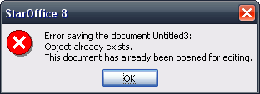Illustration 4: File exists

Dialog #3.1: Document Could Not be Saved
The following dialog is shown, if a document is locked for editing by another user when saving. The name of that user is shown, if the user meta data is available. Otherwise “Unknown User” is displayed. Then the user could decide to retry saving or save a copy of that document under a new file name or location. Save As... calls the the default Save As dialog showing the current file location. The file name is empty.
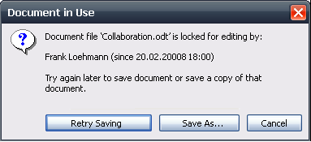Illustration 5: Document in use when saving document

OOo File Locking Warnings/Queries
OOo file locking could conflict with changes made to OOo locked document by third party applications. The following dialogs handle different case.

Document has Been Changed Until Opening
If a document is not locked by operating system and has been changed since it has been opened by OOo, then the following dialog is shown:
- “Document has been changed” - Query Dialog Properties |  | Comment
State: | Modal
Type: | Dialog
Closable: | Yes
Resizable: | No
Title: | Document Has Been Changed by Others | EN-US
- “Message Text” - Text Properties |  | Comment
Label: | The file has been changed since it was opened for editing in %PRODUCTNAME. Saving your version of the document will overwrite changes made by others./n/nDo you want to save anyway? | EN-US
- “Save ” - Button Properties |  | Comment
Enabled: | Always
Disabled: | Never
Press: | Save document
Button Label: | Save Anyway | EN-US
- “No” - Button Properties |  | Comment
Enabled: | Always
Disabled: | Never
Press: | Close dialog. Document will be left unsaved.
Button Label: | Cancel | EN-US

Document is Already Open on Another System by Same User
If the user tries to open a document, that she has already opened on another system, then following dialog is shown:

Load
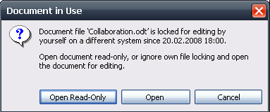Illustration 6: Document is in use by user on a different system

- “Document in Use: Open” - Dialog Properties |  | Comment
State: | Modal
Type: | Dialog
Closable: | Yes
Resizable: | No
Title: | Document in Use | EN-US
- “Note” - Text Properties |  | Comment
Label: | Document file '%DOCUMENTNAME' is locked for editing by yourself on a different system since %LASTSAVEDDATE %LASTSAVEDTIME\n\nOpen document read-only, or ignore own file locking and open the document for editing. | EN-US
- “Open Read-Only” - Button Properties |  | Comment
Enabled: | Always
Disabled: | Never
Press: | Opens the document in read-only mode
Button Label: | Open Read-Only | EN-US
- “Open Copy” - Button Properties |  | Comment
Enabled: | Always
Disabled: | Never
Press: | Ignores the locking and opens the document for editing
Button Label: | Open | EN-US
- “Cancel” - Button Properties |  | Comment
Enabled: | Always
Disabled: | Never
Press: | Aborts loading process and closes dialog
Button Label: | Cancel | EN-US

Save
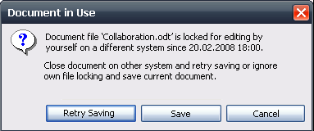Illustration 7: Document is in use by user on a different system

- “Document in Use: Open” - Dialog Properties |  | Comment
State: | Modal
Type: | Dialog
Closable: | Yes
Resizable: | No
Title: | Document in Use | EN-US
- “Note” - Text Properties |  | Comment
Label: | Document file '%DOCUMENTNAME' is locked for editing by yourself on a different system since %LASTSAVEDDATE %LASTSAVEDTIME\n\nClose document on other system and retry saving or ignore own file locking and save current document. | EN-US
- “Retry Saving” - Button Properties |  | Comment
Enabled: | Always
Disabled: | Never
Press: | Retries saving
Button Label: | Retry Saving | EN-US
- “Save” - Button Properties |  | Comment
Enabled: | Always
Disabled: | Never
Press: | Ignores the locking and saves the current document
Button Label: | Save | EN-US
- “Cancel” - Button Properties |  | Comment
Enabled: | Always
Disabled: | Never
Press: | Aborts loading process and closes dialog
Button Label: | Cancel | EN-US

OOo Locking Failed
If own locking mechanism does not work while opening or saving the document (as a new file), because the lock file could not be created, the following dialog is shown:
- “OOo Locking has Failed” - Notice Dialog Properties |  | Comment
State: | Modal
Type: | Dialog
Closable: | Yes
Resizable: | No
Title: | Document Could Not Be Locked | EN-US
- “Message Text” - Text Properties |  | Comment
Label: | The file could not be locked for exclusive access by %PRODUCTNAME, due to missing permission to created a lock file on that file location. | EN-US
- “OK” - Button Properties |  | Comment
Enabled: | Always
Disabled: | Never
Press: | Load/Save as document
Button Label: | OK | EN-US
- “Cancel” - Button Properties |  | Comment
Enabled: | Always
Disabled: | Never
Press: | Abort loading or saving as document.
Button Label: | Cancel | EN-US
- “Do not show again” - Checkbox Properties |  | Comment
Enabled: | Always
Disabled: | Never
Checkbox Label: | Do not show this message again. | EN-US

Migration
None. New feature.

Configuration
None.

File Format
None.

Open Issues and Change History
Issue | Initials | Date
Framework: file locking
Implement file locking based on separate lock file (i85794) | OC | I85794
Framework: temp file handling
File/Reload | OC | I86672
File/Save As... | OC
File Recovery | OC | I86677
File Recent documents | OC
Framework: control file handling
change extension for shared control file | OC | I86631
Right aligned buttons in message boxes does not work due to technical limitation. Should be extended, so that it would work in all dialogs build on message boxes (i.e. Calc Collaboration). | FL
Document Change History
Rev. | Change | Initials | Date
1 | Separate file locking from Calc collaboration specification | FL | November 18, 2008

Future Feature Description
Not implemented yet!

Future Scenarios
Not implemented yet!

Future Dialog Mock-ups
Not implemented yet!

Restricted Access on Document Level.
Scenario A “Open Read-Only Copy”.
Scenario B “Get Info when Unlocked”
Fehler: Referenz nicht gefunden
See also issue i95809

