Software Specification Document

OpenOffce.org
UCB: WebDAV over HTTPS

Specification Status
Last Change | Dec 6, 2007
Status
Abstract
The Web-based Distributed Authoring and Versioning (WebDAV) protocol is a extension based on the Hypertext Transfer Protocol (HTTP). Basically, it is use to edit and manage files on remote web servers.
Beside collaborative use because of features like locking and properties it is also be used as web-based file storage over the internet.
For security issues it is possible to encrypt the transport of WebDAV with HTTPS instead of HTTP. This document shows the integration of HTTPS and the handle of certificates in OpenOffice.
i-Team Members
Role | First Name, Last Name, Initials | E-Mail Address
I-Team Lead | Tobias Krause (TKR) | tkr@openoffice.org
Specification Author | Tobias Krause (TKR) | tkr@openoffice.org
Specification Author | Frank Loehmann (FL) | fl@openoffice.org
User Experience | Frank Loehmann (FL) | fl@openoffice.org
Development | Tobias Krause (TKR) | tkr@openoffice.org
Quality Assurance | Thorsten Matens (TM) | tm@openoffice.org
Documentation | Uwe Fischer (UW) | uw@openoffice.org

Contents
Abstract 1
i-Team Members 1
References and Reference Documents 3
Acronyms and Abbreviations 3
1 Detailed Specification 4
1.1 Website Certified by Unknown Authority (Later, see issue #84189, Dialog 1.2.3 is shown instead) 5
1.2 Dialog: Security Errors 6
1.2.1 Domain Name Mismatch 6
1.2.2 Server Certificate Expired (Later, see issue #84189 , Dialog 1.2.3 is shown instead) 8
1.2.3 Generic Certificate Validation Warning 9
1.3 View Certificate Dialog 11
1.4 HTTPS Proxy Settings 12
2 Migration 12
3 Configuration 12
4 File Format 12
5 Open Issues 13
Document Change History 13

References and Reference Documents
Reference Document | Check | Location (URL)
Specification Process Entry Check |  | N/A
Product Requirement, RFE, issue [Required] |  | 32935 (Web/DAV)  82890 (https proxy)  84189
Product Concept Document |  | <Please enter location here>
Competitive Analysis |  | <Please enter location here>
IDL Specification |  | <Please enter location here>
Test Case Specification [Required] |  | <Please enter location here>
Software Specification Rules | N/A | N/A
<Other, e.g. references to related specs>
Acronyms and Abbreviations
Acronym / Abbreviation | Definition
<WYSIWYG> | <What You See Is What You Get>

Detailed Specification
The Illustration 1 shows an overview about the mechanism of connecting via HTTPS. The HTTPS request and all WebDAV requests were handled by the Module NEON. If NEON is unable to verify the certificate its return an error code. In specially cases its possible that the user can decide if the connection continue.
Note: The WebDAV feature is only provided by OOo Own Save and Load dialogs. These have to activated in Tools-Options-General-Open/Save Dialogs-Use OpenOffice.org Dialogs.
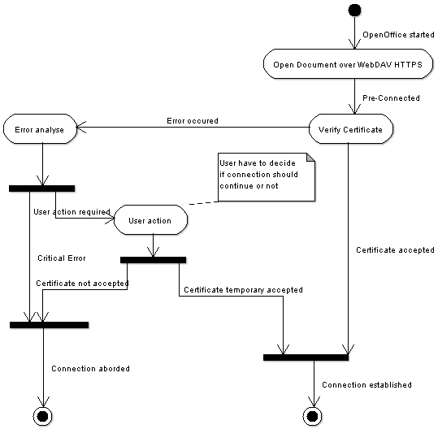Illustration 1: UML Activity Diagram of WebDAV over HTTP integration in OpenOffice
Following errors may occur while connecting:
- The certificate is not yet valid. (see Chapter 1.2.2)
- The certificate has expired. (see Chapter 1.2.2)
- The host name used for the session does not match the host name to which the certificate was issued. (see Chapter 1.2.2)
- The Certificate Authority which signed the certificate is not trusted on the current system. (see Chapter 1.1)

Website Certified by Unknown Authority (Later, see issue #84189, Dialog 1.2.3 is shown instead)
The following dialog is shown, if the certificate of the issuing authority is unknown for the local key store.
The user has the choice to
- accept the certificate for this session (default, #3)
- do not accept and disconnect from server (#4)
The Examine Certificate... button calls the View Certificate dialog described in 1.3 View Certificate Dialog below. The Help button (not shown in mock-up) call a help page describing how to add a certificate permanently to the system's key store.
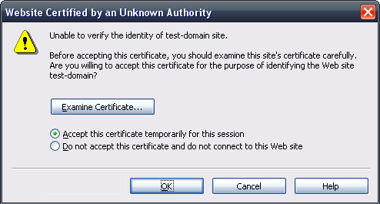Illustration 2: Certificate from an unknown authority (source Mozilla's Firefox; unix mock-up)
#5
#2
#3
#4
#6
#7
#8
#1
Tab Order | Comment
Examine Certificate..., #3, #4, Cancel, OK
- “Website Certified ...” Dialog Properties |  | Comment
State: | Modal
Type: | Dialog
Closable: | Yes
Resizable: | No
Titel: | Website Certified by an Unknown Authority |  | EN-US
- “Description” Text field Properties |  | Comment
Label: | Unable to verify the identity of "$DomainName" site./n/nBefore accepting this certificate, you should examine this site's certificate carefully. Are you willing to accept this certificate for the purpose of identifying the Web site "$DomainName"?
Read-only: | Yes
- “Accept ... temporarily” - RadioButton Properties |  | Comment
Selected: | By default
RadioButton Label: | Accept this certificate temporarily for this session
- “Do not accept ...” - RadioButton Properties |  | Comment
Selected: | Not by default
RadioButton Label: | Do not accept this certificate and do not connect to this Web Site
- “Examine Certificate..." - Button Properties |  | Comment
Enabled: | always
Disabled: | newer
Press: | View Certificate dialog is called like described in 1.3
Button Label: | Examine Certificate... | EN-US
- “Help" - Button Properties |  | Comment
Enabled: | always
Disabled: | newer
Press: | Calc the OOo help system and shows help on certificates
Button Label: | Help | EN-US
- “OK" - Button Properties |  | Comment
Enabled: | always
Disabled: | newer
Press: | Dialog gets confirmed with current setting (#3 or #4)
Button Label: | OK | EN-US
- “Cancel" - Button Properties |  | Comment
Enabled: | always
Disabled: | newer
Press: | The certificate will not be accepted and do not connect to this Web Site
Button Label: | Cancel | EN-US

Dialog: Security Errors

Domain Name Mismatch
The following security warning dialog is shown if the domain name in the certificate does not correspond with domain name used.
Tab Order | Comment
View certificate, Continue, Cancel Connection
Illustration 3: Domain Mismatch
#12
#13
#14
#11
#10
#9
- “Security Error” Dialog Properties |  | Comment
State: | Modal
Type: | Dialog
Closable: | Yes
Resizable: | No
Titel: | Security Warning: Domain Name Mismatch |  | EN-US
- “Description1” Text field Properties |  | Comment
Label: | You have attempted to establish a connection with "$IPAddress". However, the security certificate presented belongs to "$DomainName". It is possible, though unlikely, that someone may be trying to intercept your communication with this web site.
Read-only: | Yes
- “Description2” - Text field Properties |  | Comment
Label: | If you suspect the certificate shown does not belong to "$IPAddress", please cancel the connection and notify the site administrator.
Read-only: | Yes | EN-US
- “View Certificate..." - Button Properties |  | Comment
Enabled: | always
Disabled: | newer
Press: | The button calls the View Certificate dialog described in 1.2.1 View Certificate Dialog below.
Button Label: | View Certificate... | EN-US
- “Continue" - Button Properties |  | Comment
Enabled: | always
Disabled: | newer
Press: | The connection will be established.
Button Label: | Continue | EN-US
- “Cancel" - Button Properties |  | Comment
Enabled: | always
Disabled: | newer
Press: | The connection will be canceled.
Button Label: | Cancel Connection | EN-US

Server Certificate Expired (Later, see issue #84189 , Dialog 1.2.3 is shown instead)
The following security warning dialog is shown, if the certificate use has been expired.
Illustration 4: Certificate is expired
#16
#18
#15
#17
#19
#20
Tab Order | Comment
View certificate, Continue, Cancel Connection
- “Security Error” Dialog Properties |  | Comment
State: | Modal
Type: | Dialog
Closable: | Yes
Resizable: | No
Titel: | Security Warning: Server Certificate Expired |  | EN-US
- “Description1” Text field Properties |  | Comment
Label: | "$DomainName" is a site that uses a security certificate to encrypt data during transmission, but its certificate expired on $EXPIRING_DATE_TIME.
Read-only: | Yes
- “Description2” - Text field Properties |  | Comment
Label: | You should check to make sure that your computer's time (currently set to $DAY_NAME, $DAY_NO $MONTH_NAME $TIME) is correct./n/nWould you like to continue anyway?
Read-only: | Yes | EN-US
- “View Certificate..." - Button Properties |  | Comment
Enabled: | always
Disabled: | newer
Press: | The button calls the View Certificate dialog described in 1.2.1 View Certificate Dialog below.
Button Label: | View Certificate... | EN-US
- “Continue" - Button Properties |  | Comment
Enabled: | always
Disabled: | newer
Press: | The connection will be established.
Button Label: | Continue | EN-US
- “Cancel" - Button Properties |  | Comment
Enabled: | always
Disabled: | newer
Press: | The connection will be canceled.
Button Label: | Cancel Connection | EN-US

Generic Certificate Validation Warning
The following warning dialog is shown, if the certificate could not be validated without warnings already covered by 1.2.1 and 1.2.2. In this dialog the Cancel Connection button is preselected to break the user's interaction, to emphasise the importance of this warning.
Illustration 5: Certificate Validation Failed
#27
#26
#25
#24
#23
#22
#21
Tab Order | Comment
View certificate, Continue, Cancel Connection
- “Generic Security Warning” Dialog Properties |  | Comment
State: | Modal
Type: | Dialog
Closable: | Yes
Resizable: | No
Titel: | Security Warning: Certificate Validation Failed |  | EN-US
- “Description1” Text field Properties |  | Comment
Label: | The certificate could not be validated. You should examine this site's certificate carefully.
Read-only: | Yes
- “Description2” - Text field Properties |  | Comment
Label: | If you suspect the certificate shown, please cancel the connection and notify the site administrator.
Read-only: | Yes | EN-US
- “Description2” - Text field Properties |  | Comment
Label: | We recommend you that you cancel the connection.
Read-only: | Yes | EN-US
- “View Certificate..." - Button Properties |  | Comment
Enabled: | always
Disabled: | newer
Press: | The button calls the View Certificate dialog described in 1.2.1 View Certificate Dialog below.
Button Label: | View Certificate... | EN-US
- “Continue" - Button Properties |  | Comment
Enabled: | always
Disabled: | newer
Press: | The connection will be established.
Button Label: | Continue | EN-US
- “Cancel" - Button Properties |  | Comment
Enabled: | always
Disabled: | newer
Press: | The connection will be canceled.
Button Label: | Cancel Connection | EN-US

View Certificate Dialog
The View Certificate Dialog is re-used from document signatures project and is already present in current OOo. Please find details about this dialog in the Electronic Security specification.
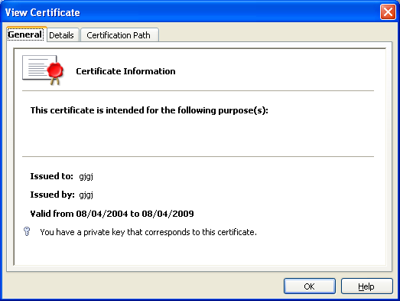Illustration 6: View Certificate Dialog from OOo

HTTPS Proxy Settings
The proxy settings tab page gets extended by a new setting for the HTTPS proxy. This allows to define a different proxy for HTTPS connections to be used by OOo or to go with operating system settings.
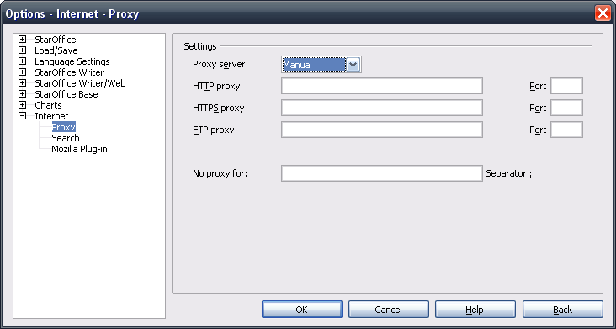Illustration 7: Proxy settings tab page in Manual setting mode
#34
- “HTTPS proxy” - TextField Properties |  | Comment
Enabled: | If Proxy Server drop down list box is set to Manual
Disabled: | If Proxy Server drop down list box is set to None or System
Read Only: | No
Caret Position: | 0
TextField Label: | HTTP~S proxy | EN-US

Migration
None. New feature.

Configuration
None.

File Format
Not file format relevant.

Open Issues
The following issues have to fixed in a later time frame, due to limited resources.
Issue | Initials | Date
Get rid of static openssl libraries (Issues: 82786) | FL | October 22, 2007
Error Msg after HTTPS (WebDAV) connection cancelled or aborted (Issue: 82787) | FL | October 22, 2007
The way of perceive certificates is not user-friendly (Issue: 82789) | FL | October 22, 2007
Document Change History
Rev. | Change | Initials | Date
1 | Add draft of accept certificate dialog | FL | September, 17, 2007
2 | Add dialogs for 1.2 and activity diagram exchanged | TKR | September, 25, 2007
3 | Work on structure of specification | FL | September 27, 2007
4 | Work on mock-ups | FL | October 4, 2007
5 | Add open issues | FL | October 22, 2007
6 | Add HTTPS dialog | FL | October 23, 2007
7 | Limited feedback of certificate status due to a program error in an underlying library. Therefore some dialogs have been disabled for the current version, because nobody can guarantee that the feedback given by these dialogs is proven. | FL | December 06, 2007

On Windows systems the system key store is used. On Unix systems the Mozilla keystore is used instead, due to missing system key store.
http://specs.openoffice.org/appwide/security/Electronic_Signatures_and_Security.sxw

