Software Specification Document

OpenOffice.org
Online Update: Notification of Extensions

Specification Status
Last Change | 01.11.07
Status

Abstract
In OpenOffice.org the user is notified about available updates for his installed extensions by bubble notification.
The user does not need to proactively open the appropriate dialog to check for extension updates. After a mouse click on the notofication icon the extension updates will be visible in the 'Extension Update' dialog.
The user will also be notified about the found extension updates after OpenOffice.org has been started, until the updates are installed.

i-Team Members
Role | First Name, Last Name, Initials | E-Mail Address
Project Lead | Oliver Braun (obr) | obr@openoffice.org
Specification Owner | Bettina Haberer (bh) | bh@openoffice.org
User Experience | Bettina Haberer (bh) | bh@openoffice.org
Development | Dirk Völzke (dv) | dv@openoffice.org
Development | Oliver Braun (obr) | obr@openoffice.org
Quality Assurance | Olaf Felka (of) | of@openoffice.org
Documentation | Uwe Fischer (ufi) | ufi@openoffice.org
Other roles
<State reason here, if one role is not represented in i-Team.>

Contents
Abstract 1
i-Team Members 1
References and Reference Documents 3
Acronyms and Abbreviations 3
1 Detailed Specification 4
1.1 Bubble notification of extensions 4
1.2 The manual checking for extension updates 5
1.2.1 The 'Extension Update' dialog after click on the notification icon 5
1.3 The 'Online Updates Options' dialog 6
2 Testing / special cases 8
3 Migration 8
4 Configuration 8
5 File Format 8
6 Open Issues 8
Document Change History 9

References and Reference Documents
Reference Document | Check | Location (URL)
Specification Process Entry Check |  | N/A
Product Requirement, RFE, issue (required) |  | 82851
Product Concept Document |  | <Please enter location here>
Competitive Analysis |  | <Please enter location here>
Test Case Specification (required)
Software Specification Rules | N/A | N/A
<Other, e.g. references to related specs>

Acronyms and Abbreviations
Acronym / Abbreviation | Definition
<WYSIWYG> | <What You See Is What You Get>

Detailed Specification

Bubble notification of extensions
When extension updates have been found, at least one after an automatic check, the notfication icon appears and the user is notified by the bubble as shown in figure 1.
The notification bubble will disappear after 10 seconds but will reappear while the mouse is over the notification icon.
A click on the notification icon opens the 'Extension Update' dialog stand alone as shown in figure 2.

Figure 1: Notification about extension updates.
String Table 1 Figure 1
Item | English | German | Comments
Notification bubble | Updates for extensions available | Updates für Extensions verfügbar
Notification bubble | Click here for more information. | Klicken Sie hier, um mehr Information zu erhalten.

The automatic check for updates is conducted for both, the OpenOffice.org product update and the extension updates at the same time. By default this happenes weekly. As long as the extension updates have not been installed, the notification will be carried out again after the next OpenOffice.org start.
As for the extensions it is checked for local and shared extensions at the same time.
As long as a download and installation of extension updates is running, a new update, found at the same time, will not be notified. That will happen according the same method as for product updates.

The manual checking for extension updates
When the user chooses Tools / Extension Manager.../ Updates... the 'Extension Update' dialog opens as shown in figure 2. If extension updates are found, they are listed in this dialog and the user can install them. For detailed information have a look at the specification online_update_for_extensions.

The 'Extension Update' dialog after click on the notification icon

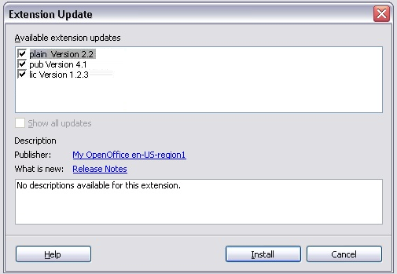Figure 2: The extension update dialog showing available updates of the installed extensions.

The 'Online Updates Options' dialog
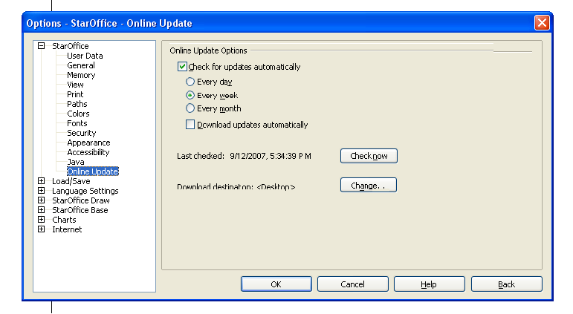Figure 3: The adjusted online update dialog under Tools / Options.

Table 2: User Interface elements of figure 3

# | Type | Properties |  | Comment
8 |  | Control Properties  Enabled: yes  Initially Selected: no
8 |  | String English  Every da~y | String German  Jeden ~Tag |  | The english word 'day' needs to be written in lower case
9 |  | Control Properties  Enabled: yes  Initially Selected: yes
9 |  | String English  Every ~week | String German  Jede ~Woche |  | The english word 'week' needs to be written in lower case
10 |  | Control Properties  Enabled: yes  Initially Selected: no
10 |  | String English  Every ~month | String German  Jeden ~Monat |  | The english word 'month' needs to be written in lower case
<#> |  | Control Properties  Enabled: yes  Initially Checked: no  TriState: no
<#> |  | String English  ~Download updates automatically | String German  Updates automatisch ~herunterladen

Both buttons, 'Check now' and 'Change...' are implemented as dynamically movable, means, if the date string or download destination path gets longer than the default place, the buttons automatically move accordingly to the right.

The option 'Download updates automatically' is conducted only for product updates.

The dependency of the two options 'Check for updates automatically' and 'Download updates automatically' is shown in the following table:
 | Default | Unchecking the option 'Check for updates automatically' and the result
Check for updates automatically | enabled and checked | keeps enabled
Every day | enabled | gets disabled and can show the former status (selected or unselected)
Every week | Enabled and selected | gets disabled and can show the former status (selected or unselected)
Every month | enabled | gets disabled and can show the former status (selected or unselected)
Download updates automatically | enabled and unchecked | gets disabled and shows the former status (checked or unchecked)

Testing / special cases
There are some side effects to be considered during testing:
- If there are updates for both, the office and for an extension, only the office update will be notified.
- After updating all extensions, the notification icon should disappear, updating only some should not change the notification.
  - There should be no difference, wether the update was done in the update dialog started from the notification icon or from the extension manager or with unopkg.
- Removing an extension, for which an update exists should remove the notification icon, too.
- When the user checks manually for updates via extension manager / updates, the notification icon should appear when the user doesn't install all found updates or cancels the update.
- When the user has write access to the shared extension layer, both user and shared extension manager should be queried for updates, otherwise only the user layer will be queried.
- If the office has been installed without the online update feature, no notification icon should appear.

Migration
<Start typing here ----- If this part is irrelevant state a reason for its absence!>

Configuration
<Start typing here ----- If this part is irrelevant state a reason for its absence!>

File Format
<Start typing here ----- If this part is irrelevant state a reason for its absence!>

Open Issues
Issue | Initials | Date
Merge the dialogs 'Check for Updates' and 'Extension Update' to one new user interface: Not possible for the target 2.4.
81174: Message refering to shared extensions comes up in wrong case
74231: Wrong button focus in message box for extension installation
75009: Install by doubleclick shows progress bar first before message box
Message 'Before updating a shared extension,
make sure no further instances of OpenOffice.org are running.' annoying at notification an extension update

Document Change History
Rev. | Change | Initials | Date
1 | Added some test cases | DV | 01.11.2007
2
3
<...>

The 'Extension Update' dialog comes up stand alone without the Extension Manager dialog.

