Software Specification Document

OpenOffice.org
Extension Manager UI Change

Specification Status
Last Change | Jun 21, 2010
Status
Abstract
The user interface of the current Extension Manager will be changed to ease the usability with the aim, that each user can work easily with this UI. Especially the need to differentiate between user extensions and shared extensions will be eased by an appropriate interface design.

i-Team Members
Role | First Name, Last Name, Initials | E-Mail Address
I-Team Lead | Dirk Völzke, DV | dv@openoffice.org
Specification Author | Bettina Haberer, BH | bh@openoffice.org
User Experience | Bettina Haberer, BH | bh@openoffice.org
Development | Dirk Völzke, DV | dv@openoffice.org
Quality Assurance | Jörg Skottke, JSK | jsk@openoffice.org
Documentation | Uwe Fischer, UFI | ufi@openoffice.org
Other roles | <First Name, Last Name (Initials)> | <User@openoffice.org>
<State reason here, if one role is not represented in i-Team.>

Contents
Abstract 1
i-Team Members 1
References and Reference Documents 3
Acronyms and Abbreviations 3
1 Detailed Specification 4
1.1 The new User Interface of the Extension Manager 4
1.1.1 User scenarios 6
1.1.2 The new User Interface in general 7
1.1.2.1 Order and Selection of installed Extensions 7
1.1.3 Extension Title and Version 8
1.1.4 Link 8
1.1.5 Description Text 8
1.1.6 Icons 8
1.1.6.1 Icon Position 8
1.1.7 Buttons 8
1.1.8 Selection Mode 8
1.1.9 Progress Bar 9
1.1.9.1 Cancel Button besides the Progress Bar 9
1.1.10 Context Menu 9
1.1.11 The Tab Order in the Dialog 9
1.1.12 Showing a Warning in Case of Unknown Status 10
1.1.13 Installing Extensions as Root 10
1.1.14 Adding extensions file picker 11
1.1.15 Changes for OpenOffice.org 3.3 12
2 Migration 13
3 Configuration 13
4 File Format 13
5 Open Issues 13
Document Change History 13

References and Reference Documents
Reference Document | Check | Location (URL)
Specification Process Entry Check |  | N/A
Product Requirement, RFE, issue [Required] |  | Issue 83902
Product Concept Document |  | <Please enter location here>
Competitive Analysis |  | <Please enter location here>
IDL Specification |  | <Please enter location here>
Test Case Specification [Required] |  | Multiple automated tests
Software Specification Rules | N/A | N/A
<Other, e.g. references to related specs>
Acronyms and Abbreviations
Acronym / Abbreviation | Definition
<WYSIWYG> | <What You See Is What You Get>

Detailed Specification

The new User Interface of the Extension Manager

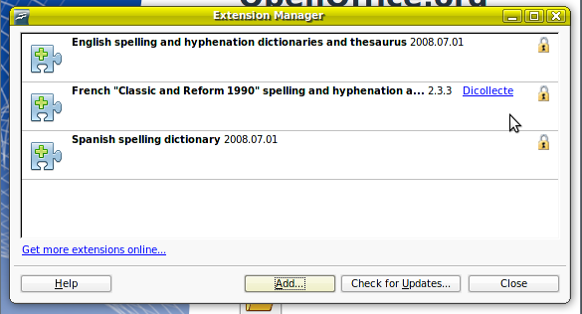Figure 1.1: The changed user interface of the extension manager.

The icon for shared extensions is currently a placeholder and will be exchanged by the final one soon.

“Extension Manager” - Dialog |  | Comment
State: | modeless
Type: | dialog
Closable: | yes
Resizable: | yes | Boundaries need to be defined!
Title: | Extension Manager | EN-US

“Add...” - Button Properties |  | Comment
Enabled: | yes
Disabled: | no
Press: | The file open dialog opens.
Button Label: | ~Add... | EN-US

“Check for Updates...” - Button Properties |  | Comment
Enabled: | yes | Was formerly labeled 'Updates...'
Disabled: | no
Press: | the 'Extension Update' dialog opens.
Button Label: | Check for ~Updates... | EN-US

“Close” - Button Properties |  | Comment
Enabled: | yes
Disabled: | no
Press: | The dialog becomes closed
Button Label: | Close | EN-US

“Help” - Button Properties |  | Comment
Enabled: | yes
Disabled: | no
Press: | The help opens at the chapter about the Extension Manager
Button Label: | ~Help | EN-US

“Options...” - Button Properties |  | Comment
Enabled: | When options are existing for the selected extension; | This button is not visible if no options can be changed
Press: | The options dialog for extensions opens
Button Label: | ~Options... | EN-US

“Disable / Enable” - Button Properties |  | Comment
Enabled: | In case it is no shared extension it is always enabled;  When the user has write permission for a shared extension; | This button changes between the two labels 'Disable' and 'Enable'
Disabled: | when the user has no write permission for a shared extension;
Press: | The extension becomes disabled / enabled
Button Label: | ~Disable | EN-US
Button Label: | ~Enable | EN-US

“Remove” - Button Properties |  | Comment
Enabled: | In case it is no shared extension it is always enabled;  When the user has write permission for a shared extension;
Disabled: | when the user has no write permission for a shared extension;
Press: | The selected extension becomes deinstalled.
Button Label: | ~Remove | EN-US

- ProgressBar Properties |  | Comment
Min. Value: | 0% | If percentage will be available for version 3.0
Max. Value: | 100%
ProgressBar Label: | Adding extension name |  | EN-US  'extension name' is a placeholder for the display name of the extension.
ProgressBar Label: | Disabling extension name
ProgressBar Label: | Enabling extension name
ProgressBar Label: | Removing extension name

- “Cancel” - Button Properties |  | Comment
Enabled: | yes | Appearing together with the progress bar.
Press: | At click the started action, means adding, disabling, enabling, removing becomes canceled
Button Label: | Cancel | EN-US

A link to the extension repository is also part of the Extension Manager. It is already specified in the specification http://specs.openoffice.org/appwide/packagemanager/link_to_extensions_services_openoffice_org.odt, but for the sake of completeness it's description will be added here:

Item | English
Link Control | Get more extensions online...
At mouse over this link the URL to the extension repository becomes visible as tool tip.
The unvisited link changes it's color to read, when it is visited. When the dialog is closed, the link again shows the unvisited status. The link is accessible by the tab key.

User scenarios
- The user wants to add an extension to enhance his Office with further function by a few mouse clicks.
In OpenOffice.org 2.4 he needs first to decide between the appropriate top level node 'My Extensions' and 'OpenOffice.org Extensions' and then select one of both top level nodes to get the button 'Add...' enabled before he can install a further extension.
In OpenOffice.org 3.0 he just opens the Extension Manager and clicks on the button 'Add...' to install a further extension.
- The user wants to update his installed extension(s) from within the same UI.
In OpenOffice.org 2.4 the user click on the 'Updates...' button and perhaps wonders, why the shared extensions have not been updated. In the new user interface installed shared extensions are visible as such by an appropriate icon. The user quicker realizes such extensions in the list.
- The user wants to change the options (if existing) of an extension. Options can be modified with each write right. After click on this button the Options dialog for installed extensions opens and the user can change them according his needs. If no options for the extension are existing no 'Options' button appears.
- The user wants to have the opportunity to disable an extension he installed.
In case the extension is visible as disabled (disabled programmatically out of any reason), the extension name and description are grayed and the buttons are disabled.
- The user should be able to remove the extension he installed.

The new User Interface in general
This UI eases the overview of information per extension.
No tree list is needed any more as the visual differentiation between two top level nodes has been removed. And no further files like dll, xcu etc. will be listed for an extension.
Furthermore the number of buttons has been reduced: The export function will be removed.
'Enable' and 'Disable' buttons will be merged to one button changing it's label accordingly.
Only a selected extension shows the buttons 'Options...', Disable / Enable, 'Remove', the general button area becomes more clear by this behaviour and so the function of these buttons is at hand when needed.
The area-size of a single extension changes dynamically. When selected it's height gets enhanced showing the available text and buttons.
The extensions are divided by a horizontal gray line.
Appropriate icons make visible the current status of the extension.
Publisher links, if existing, will be added also.
The alignment of the buttons corresponds to the workflow, which needs to cover the use cases.

In the new user interface the first entry is selected by default. The button focus is on the close button.
Following issues concerning the appearance of extensions will be changed in OpenOffice.org 3.0:
- The extensions appears with it's display name.
- The files like dlls, xcu etc. hanging below an extension as in the versions <= OpenOffice.org 3.0 will be removed and thus no more visible in the Extension Manager.

Order and Selection of installed Extensions
In the opened dialog the first listed extension on top is selected. The installed extension(s) will appear in alphabetical order. The last new installed extension becomes selected in the open Extension Manager dialog. The last made selection in the Extension Manager keeps persistent during the session.
As long as an extension is selected and an action is started on this selection, no further selection of another extension is possible.

Extension Title and Version
The extension title is the display name followed by the version number of the extension. If the extension name gets too long it becomes truncated by ellipses.

Link
It should be possible to put a link about the publisher besides the extension name and version.

Description Text
The description of an extension is one short concise sentence (see spec packagemanager_gui chapter 6.13) appearing in the line under the extension name. Thus this description will not appear as a tip help on the extension name.

Icons
An icon for marking extensions as shared will be shown.
Furthermore a warning icon in case the extension status is unknown will appear. These two status icons will have the size of 16x16 pixel.
The new UI will show the standard icon for each extension, which does not include an own icon.
Now an extension can have it's own icon, which will be placed in front of the extension name in a size of 32x32 pixel.

Icon Position
The icon of the extension will be positioned in front of the extension name.
The status icons will be positioned at the right side as shown in figure 1.
The status icons will appear in the order warning, shared. If only one of both icons is displayed, each keeps it's position.

Buttons
- Buttons in the general area:
  - Check for Updates...: At click on the Check for Updates... button all extensions will be updated.
  - Add...: At click on that button further extensions can be installed.
  - Help button
  - Close button
- Buttons per selected extension:
  - Options...: If options are existing for an extension, the selected extensions has available an options button.
  - Disable / Enable: The button changes it's label accordingly.
  - Remove: At click on this button the extensions becomes deinstalled.

Selection Mode
In the new user interface there will be no more need for a multi-selection. Only the update function applies to all extensions without the need to select all of them.

Progress Bar
A progress bar appears as shown in figure 1. This progressbar shows progress at adding, removing, enabling and disabling an extension. The progress bar will always appear complete, even if the time period is very short. Besides the progress bar the current action is visible as label. In case the text becomes too long, it will be shown shortened by ellipsis. If a percentage value will be available, it can be shown at the right side of the progress bar, if not available it is visible without a percentage value. Currently the progress for updating an extension is running within an own dialog and will be adjusted in a next version.

Cancel Button besides the Progress Bar
At the moment the progress bar appears, at the right side of the progress bar a cancel button appears also to enable canceling the started action. After the action has been finished or canceled, the progress bar and cancel button disappear.
Pressing the button while installing, removing, disabling, and enabling should cancel the operation and restore the previous state of the extension. For example, when an extension is installed, the user presses 'Remove' and then 'Cancel', then the extension should still be there and function.

Context Menu
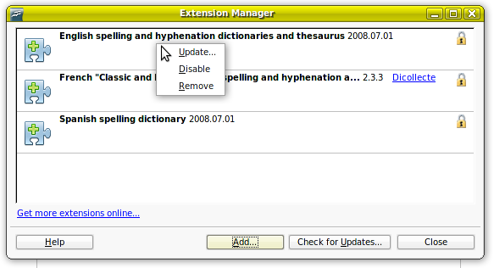Illustration 1.1: The reduced and reordered context menu of a selected extension.
The context menu of a selected extension becomes reduced: The former entry 'Export...' is removed. Furthermore the order of the context menu entries changes as visible in figure 2.

The Tab Order in the Dialog
- Options...
- Disable / Enable
- Remove
- Help
- Add...
- Check for Updates...
- Close

Showing a Warning in Case of Unknown Status
The warning icon named in paragraph 1.1.6 appears in case the status of the installed extension is unknown, means not recognized as enabled or disabled. To assure that the user has the opportunity to realize this error, it should be visible independent of being selected or not.
Thus in case an extension with status unknown is not selected, it's content will be displayed as follows:
- Extension name
- the error string 'Error: The status of this extension is unknown'
- the description of the extension is not shown
In case an extension with status unknown is selected, it's content will be displayed as follows:
- Extension name
- the error string 'Error: The status of this extension is unknown'
- the description of the extension is shown, because in that case there is enough space to display all parts.

Installing Extensions as Root
When a user with root rights clicks the 'Add'-button to install an extension, the 'Add Extension(s)' file dialog opens. After click on the 'Open' button the following warning alert appears:
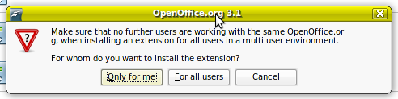Illustration 1.2: Alert at adding an extension with root rights.
In case the 'Only for me' button is clicked, the extension is installed into the user layer and thus only available for that one user, who installed it. In case the 'For all users' button is clicked, the extension is installed into the shared layer and thus available for all users. The button with the label 'Only for me' is defaulted, as an installation only for the user, who installs, occurs more often.

“Make sure...” - Label Properties |  | Comment
Label: | Make sure that no further users are working with the same %PRODUCTNAME, when installing an extensions for all users in a multi user environment.\n\nFor whom do you want to install the extension? | EN-US

“Only for me” - Button Properties |  | Comment
Enabled: | Yes
Press: | The extension is installed into the user layer.
Button Label: | ~Only for me | EN-US

“For all users” - Button Properties |  | Comment
Enabled: | Yes
Press: | The extension is installed into the shared layer.
Button Label: | ~For all users | EN-US

“Cancel” - Button Properties |  | Comment
Enabled: | Yes
Press: | Alert becomes closed
Button Label: | Cancel | EN-US

Adding extensions file picker
The Extension Manager File Picker remembers the last path from where an extension was installed. By default the file filter is set to “Extensions” This only works for the OpenOffice.org file picker. The path spec is undefined if the path does no longer exist / has been removed between two installation attempts.

Changes for OpenOffice.org 3.3
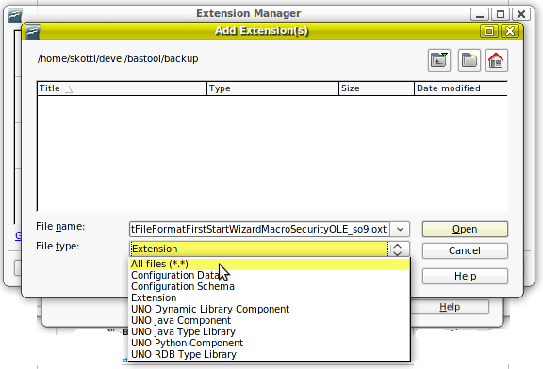Figure 1.2: Extension filters
There are now bundles extensions. Those are extensions which come with the office and will be installed together with the office. Those extensions are read-only, you have to use the office installer to add or remove those extensions. You can't use the extension manager to remove those extensions.
Shared ( and bundled ) extensions can no longer be disabled from inside the extension manager.
You can install an extension for the current user or for all users ( if you have sufficient access privileges ) even when this extension already is installed as bundled extension. The version installed for the user hides the one installed for all users which itself hides the bundled one regardless of the version of the extension. When you disable an user extensions which is installed for all users or as bundled extension, too, both, the disabled user extension and the shared extension will be shown in the extension manager.
You now can install updates for bundled and shared extensions, even if you don't have access rights for the shared part of the office. Those updates will be installed for the current user only. For more information have a look at the Developer's Guide.
It is now possible to install an extension for all users, which requires every single user to accept the license. When a user starts the office for the first time after such an extension has been installed for all users, he will be asked to accept the license. When the license is not accepted, the extension will be disabled. The extension marks this extension with an warning icon and the discription will whoe the text: The extension <name> has been disabled, because the license hasn't been accepted yet. Clicking the 'enable' button will bring up the accept license dialog again.
On startup of the office, the extension manager will perform some checks. Newly installed or removed bundled extensions will be added or removed to the extension repositiory, some extesnion version checking will be done, when the office version has changed and some extensions might reqire an additional display of the license. During the processing of these task some extra progress text will be displayed just below the progressbar of the startup screen.

Migration
<Start typing here ----- If this part is irrelevant state a reason for its absence!>

Configuration
<Start typing here ----- If this part is irrelevant state a reason for its absence!>

File Format
<Start typing here ----- If this part is irrelevant state a reason for its absence!>

Open Issues
Issue | Initials | Date
81884 (Remove the files hanging under an extension) needs to be fixed as this UI change depends on that task.  http://qa.openoffice.org/issues/show_bug.cgi?id=81884 |  | Nov 10, 2008
74742 Progressbar does not show constant progress
74744 Add percent value to progress bar
Drag and drop of extensions into the extension manager will be evaluated for a later version.
90436 Change “Get more extensions here” to “Get more extensions online” to keep consistency with the new touchpoints | Jsk | Nov 10, 2008

Document Change History
Rev. | Change | Initials | Date
1 | Added modifications introduced with CWS extmgrui06 | JSK | Nov 10, 2008
2 | Replaced a number of outdated mockups | JSK | Nov 11, 2008
3 | Added some changes for OpenOffice.org 3.3 | DV | Jun 21, 2010
<...>

