Software Specification Document

OpenOffice.org
OpenOffice.org Calc
Print Dialog

Specification Status
Last Change | Feb 26, 2008
Status
Abstract
The Print dialog in Calc gets extended by a new possibility to define what part of the spreadsheet has to be printed. In the current version the print setting "print only selected sheets" is located in the Options dialog of the Print dialog and got defaulted for OOo 2.3. This raised several new issues around print output is empty when the corresponding table was not selected in the spreadsheet and the setting itself was overseen/unknown in the Options dialog.
Furthermore the "Sort" option is defaulted to on and is always enabled in all OOo Print dialogs. This makes it easier to print multiple copies of a document.
i-Team Members
Role | First Name, Last Name, Initials | E-Mail Address
I-Team Lead | Niklas Nebel (NN) | niklas.nebel@sun.com
Specification Author | Frank Loehmann (FL) | frank.loehmann@sun.com
User Experience | Frank Loehmann (FL) | frank.loehmann@sun.com
Development | Peter Burow (PB)  Philipp Lohmann (PL) | peter.burow@sun.com  philipp.lohmann@sun.com
Quality Assurance | Frank Stecher (FST) | frank.stecher@sun.com
Documentation | Uwe Fischer (UFI) | uwe.fischer@sun.com

Contents
Abstract 1
i-Team Members 1
References and Reference Documents 3
Acronyms and Abbreviations 3
1 Detailed Specification 4
1.1 Change for All OOo Applications 4
1.1.1 Print Dialog 4
1.1.2 Printer Settings Dialog (Issue: 86329) 4
1.1.3 Platform Dependent Changes 5
1.1.3.1 Mac Platform Only 5

1.2 Enhancements for Calc 7
1.3 Enhancements for Impress 9
1.3.1 Print Dialog 9
1.3.2 Print Options Dialog 11
2 Migration 12
3 Configuration 12
4 File Format 12
5 Open Issues 12
Document Change History 12

References and Reference Documents
Reference Document | Check | Location (URL)
Specification Process Entry Check |  | N/A
Product Requirement, RFE, issue [Required] |  | 82071, 63977
Product Concept Document |  | <Please enter location here>
Competitive Analysis |  | <Please enter location here>
IDL Specification |  | <Please enter location here>
Test Case Specification [Required] |  | http://www.openoffice.org/nonav/issues/showattachment.cgi/49787/Calc_print_dialog.html
Software Specification Rules | N/A | N/A
Acronyms and Abbreviations
Acronym / Abbreviation | Definition
<WYSIWYG> | <What You See Is What You Get>

Detailed Specification
The changes to the Print dialog are divided to an application depended Calc part and a common part valid for all OOo applications.

Change for All OOo Applications

Print Dialog
The default for the Collate feature is set to on and the check box will not get disabled at any time.
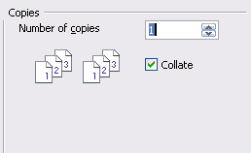Illustration 1: Collate setting is defaulted to on

Printer Settings Dialog (Issue: 86329)
The Print Setup dialog gets extended by a Options... button. This button calls the Printing Options dialog for the current document. It is the same dialog called by the Options... button in the Print dialog.
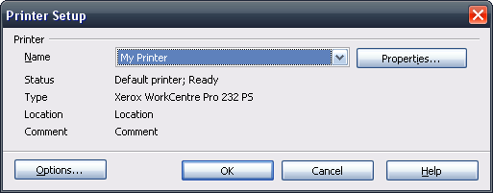Illustration 2: Printer settings dialog with Options button
- “Options...” - Button Properties |  | Comment
Enabled: | Always
Disabled: | Newer
Press: | Calling print options for current document
Button Label: | Options... | EN-US

Platform Dependent Changes

Mac Platform Only

Tools-Options-General Dialog (Issue: 86329)
The Mac printing behavior requires a method to choose between the system and the OOo printing dialog. All other platforms will not offer this new method.
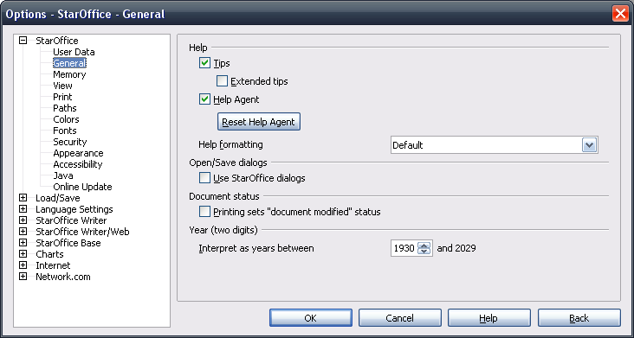Illustration 3: All platforms
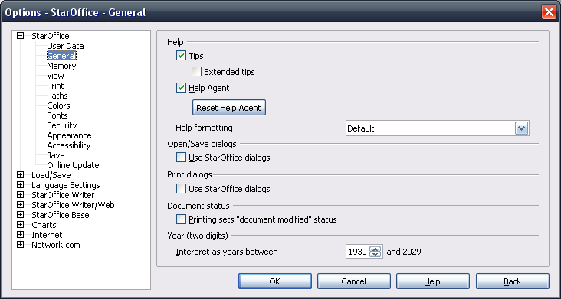Illustration 4: Mac only
- “Print Dialogs” - Label Properties |  | Comment
Label: | Print dialogs | EN-US
- Use OOo Dialogs” - CheckBox Properties |  | Comment
Enabled: | Always
Disabled: | Never
Tri-State: | Never
Checked: | -
CheckBox Label: | Use %PRODUCTNAME dialogs | EN-US

Print Progress Dialog
The following dialog is shown when the document is being prepared for printing with the native print dialog on the Mac platform.
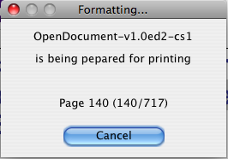Illustration 5:
Changed text to windows pendant:
- “Formatting....” - Dialog OR Window Properties |  | Comment
State: | Modal
Type: | Dialog
Closable: | Yes
Resizable: | no
Titel: | Formatting... | EN-US
- “Printer Text” - Label Properties |  | Comment
Label: | is being prepared for printing | EN-US

Enhancements for Calc
The Option Print only selected sheets is directly shown in the Print dialog. The Print range section gets splitted into a Print and Print range section. The default in the Print section depends on the setting in the print Options. Print only selected sheets sets the default to Selected sheets. Otherwise All sheets is the default.
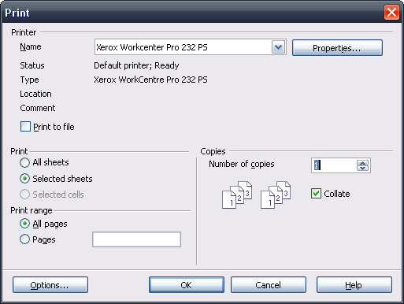Illustration 6: Enhanced Print dialog for Calc

- “Print” - Label Properties |  | Comment
Label: | Print | EN-US
- “Print” - RadioButton Properties |  | Comment
Enabled: | always
Disabled: | never
Selected: | If Calc printing option Print only selected sheets is un-checked.
RadioButton Label: | All sheets | EN-US
- “Print” - RadioButton Properties |  | Comment
Enabled: | always
Disabled: | never
Selected: | If Calc printing option Print only selected sheets is checked.
RadioButton Label: | Selected sheets | EN-US
- “Print” - RadioButton Properties |  | Comment
Enabled: | If a selection of cells is present in the spreadsheet
Disabled: | If no selection of cells is present in the spreadsheet
Selected: | -
RadioButton Label: | Selected cells | EN-US
- “Print range” - Label Properties |  | Comment
Label: | Print range | EN-US
- “Print Range” - RadioButton Properties |  | Comment
Enabled: | always
Disabled: | never
Selected: | by default
RadioButton Label: | All pages | EN-US
- “Print Range” - RadioButton Properties |  | Comment
Enabled: | always
Disabled: | never
Selected: | -
RadioButton Label: | Pages | EN-US

Enhancements for Impress
The Print dialog for Impress allows to select the content being printed directly on the Print dialog, instead of calling the Options dialog.
Furthermore the handout printing gets extended to easily adjust the layout used for printing. This section is only enabled, if Handouts is selected for printing. A preview bitmap shows how the layout and order will look like when printing these handouts.

Print Dialog
Illustration 7: Impress Print dialog (default settings)
Illustration 8: Impress Print Dialog with “Handouts” selected for printing
- “Print” - Label Properties |  | Comment
Label: | Print content | EN-US
- “Print” - DropDown Listbox Properties |  | Comment
Enabled: | Always
Max. Row Count: | 4
Rows Visible: | 4
Items: | - Slides  - Handouts  - Notes  - Outline
Item Selected: | 1.
Sorting by  Drag & Drop: | No
DropDown  ListBox Label: | Content | EN-US
- “Handout options” - Label Properties |  | Comment
Enabled: | If “Handout” is selected
Label: | Handout options | EN-US
- “Print” - DropDown Listbox Properties |  | Comment
Enabled: | If “Handout” is selected
Max. Row Count: | 9
Rows Visible: | 7
Items: | - 1  - 2  - 4  - 6  - 9
Item Selected: | 4.
Sorting by  Drag & Drop: | No
DropDown  ListBox Label: | Slides per page | EN-US
- “Order” - Label Properties |  | Comment
Label: | Order | EN-US
- “Order” - RadioButton Properties |  | Comment
Enabled: | If “Handout” is selected
Selected: | Yes
RadioButton Label: | Horizontal | EN-US
- “Order” - RadioButton Properties |  | Comment
Enabled: | If “Handout” is selected
Selected: | No
RadioButton Label: | Vertical | EN-US

Print Options Dialog
The Contents section gets removed from the Print Options dialog. The layout will be changes as shown in the following mock-up.
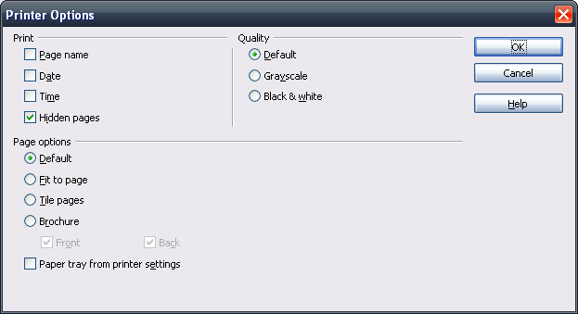Illustration 9: Print Options Dialog

Migration
None.

Configuration
None.

File Format
None.

Open Issues
Issue | Initials | Date
Print selected sheets setting in printing option (called from the Print dialog) should be removed. The Tools-Options setting should stay. | FL | November 1, 2007

Document Change History
Rev. | Change | Initials | Date
1 | Initial specification (draft) | FL | October 16, 2007
2 | Update of Print dialog mock-up | FL | October 16, 2007
3 | Finalization | FL | November 1, 2007
4 | Standard | FL | November 21, 2007
5 | Add new Print dialog for Impress (Handouts) | FL | January 15, 2008
6. | Final Impress Print dialogs | FL | January 16, 2008
7. | Printing Options dialog | FL | January 16, 2008
8. | Update of Impress Print dialog | FL | January 16, 2008
9 | Printer Settings dialog | FL | February 22, 2008
10 | Print progress for Mac | FL | February 26, 2008

