Software Specification Document

OpenOffice.org Calc
Text to Columns

Specification Status
Last Change | Aug 10, 2007
Status
Abstract
Comma separated values (CSV) can already be imported from files and the clipboard., but CSV data inside cells could not be transformed into columns directly. This spec defines the new feature Text to Columns that uses the already existing Text import (CSV) dialog and transforms CSV data inside cells to columns.
i-Team Members
Role | First Name, Last Name, Initials | E-Mail Address
I-Team Lead | Niklas Nebel (NN) | niklas.nebel@sun.com
Specification Author | Frank Loehmann (FL) | frank.loehmann@sun.com
User Experience | Frank Loehmann (FL) | frank.loehmann@sun.com
Development | Thomas Benisch (TBE) | thomas.benisch@sun.com
Quality Assurance | Frank Stecher (FST) | frank.stecher@sun.com
Documentation | Uwe Fischer (UFI) | uwe.fischer@sun.com

Contents
Abstract 1
i-Team Members 1
References and Reference Documents 3
Acronyms and Abbreviations 3
1 Detailed Specification 4
1.1 Text to Columns Feature Description 4
1.2 Menu Integration 5
1.3 CSV Dialog 6
1.4 Undo/Redo 6
1.5 Preconditions and Warnings 7
1.5.1 Preconditions 7
1.5.2 Over Write Cell Data Warning 7
2 Migration 7
3 Configuration 7
4 File Format 7
5 Open Issues 8
Document Change History 8

References and Reference Documents
Reference Document | Check | Location (URL)
Specification Process Entry Check |  | N/A
Product Requirement, RFE, issue [Required] |  | i4040
Product Concept Document |  | <Please enter location here>
Competitive Analysis |  | <Please enter location here>
IDL Specification |  | <Please enter location here>
Test Case Specification [Required] |  | Test Case Specification
Software Specification Rules | N/A | N/A
<Other, e.g. references to related specs>
Acronyms and Abbreviations
Acronym / Abbreviation | Definition

Detailed Specification

Text to Columns Feature Description
The feature Text to Columns transforms CSV data inside a selection of cells to n columns in the same row. The following illustrations show the data before and after the function Text to Columns has been called.
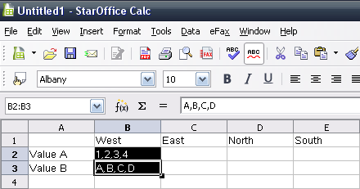Illustration 1: Before: Selected CSV data in cells B2 and B3
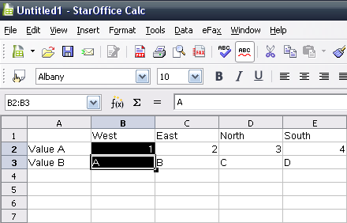Illustration 2: After: Text to Columns transformed the CSV data to the columns A toE

Menu Integration
The Data menu gets extended by a new Text to Columns... entry. The entry is placed right above the Consolidate... menu entry.
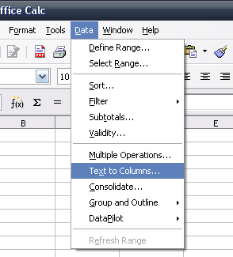Illustration 3: Data - Text to Columns...
Menu Position: | Above “Consolidate...”
Menu Items:
Items | Sub Items | Sub Items | KBD Shortcuts | Icon | Comment
Te~xt to Columns..., Daten in Spalten...

CSV Dialog
The Text Import dialog is used to transform the comma separated values (CSV) from a cell to columns. Therefore the dialog gets a new title when called by the menu entry Data – Text to Columns.... Furthermore the Import section gets disabled. The default focus is set to the OK button.
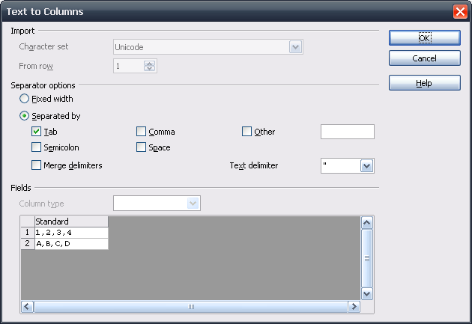Illustration 4:

- “Text to Columns” - Dialog OR Window Properties |  | Comment
Titel: | Text to Columns |  | EN-US
Titel: | Text in Spalten |  | e.g. DE

Undo/Redo
The Text to Columns function can be undone/redone. The undo/redo history list uses the following string:
- “sText to Columns” - Dialog OR Window Properties |  | Comment
Titel: | Text to Columns |  | EN-US
Titel: | Text in Spalten |  | e.g. DE

Preconditions and Warnings

Preconditions
The feature has some preconditions to work correctly. The menu entry Text to Columns is disabled, if on of the following is true:
- Empty Cell
If the cell at the cursor position is empty.
- Selection is empty
If the selected cells are empty.
- More than one column is selected
If the selected cells from more than one columns are selected.
- Multiple cells Selections
In case of a mulitselction of cells.

Over Write Cell Data Warning
If the Text to Columns function transforms the CSV data to columns already containing data, the following already present notice dialog is called.
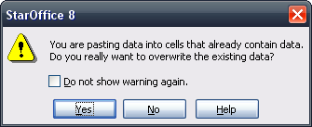Illustration 5: Overwrite present data?

Migration
None, new feature.

Configuration
None.

File Format
None, new UI feature.

Open Issues
Issue | Initials | Date
<State Issue here, State “None”, if all issues are solved> |  | <Format: Dec 31, 2000>
<...>

Document Change History
Rev. | Change | Initials | Date
1 | Initial Spec | FL | July 26, 2007
2 | Finalization | FL | August 02, 2007
3 | Set status to standard | TBE | August 10, 2007

