Software Specification Document

OpenOffice.org Writer
Compatibility Options

Specification Status
Last Change | Jul 5, 2007
Status
Abstract
Allow configuration of behavior when a line break is inserted
This specification handles all newly introduced compatibility options in an own section.
i-Team Members
Role | First Name, Last Name, Initials | E-Mail Address
I-Team Lead | Peter Burow (PB) | peter.burow@sun.com
Specification Author | Frank Loehmann (FL) | frank.loehmann@sun.com
User Experience | Frank Loehmann (FL) | frank.loehmann@sun.com
Development | Peter Burow (PB) | peter.burow@sun.com
Quality Assurance | Stefan Baltzer (SBA) | stefan.baltzer@sun.com
Documentation | Uwe Fischer (UFI) | uwe.fischer@sun.com
<State reason here, if one role is not represented in i-Team.>

Contents
Abstract 1
Allow configuration of behavior when a line break is inserted 1
i-Team Members 1
References and Reference Documents 3
Acronyms and Abbreviations 3
1 Detailed Specification 4
1.1 Configuration Setting for Justified Text Behavior 4
2 Migration 4
3 Configuration 5
4 File Format 5
5 Open Issues 5
Document Change History 5

References and Reference Documents
Reference Document | Check | Location (URL)
Specification Process Entry Check |  | N/A
Product Requirement, RFE, issue [Required] |  | 45491
Product Concept Document |  | <Please enter location here>
Competitive Analysis |  | <Please enter location here>
IDL Specification |  | <Please enter location here>
Test Case Specification [Required] |  | http://qa.openoffice.org/ooQAReloaded/TestcaseSpecifications/OpenOffice.org_2.3/Word_Processor/Compatibility_Options.html
Software Specification Rules | N/A | N/A
<Other, e.g. references to related specs>
Acronyms and Abbreviations
Acronym / Abbreviation | Definition
<WYSIWYG> | <What You See Is What You Get>

Detailed Specification

Configuration Setting for Justified Text Behavior
Current versions of OOo Writer will always add spacing between words in hard wrapped lines of a justified paragraph to stretch the words over the whole width of that paragraph. This function is need for a better compatibility with the competition, so the default of this setting is checked (on). This setting will be saved with document in the .odt text document format aka ODF. This setting cannot be saved in old .sxw text documents, so this setting is always unchecked (off) for .sxw documents.
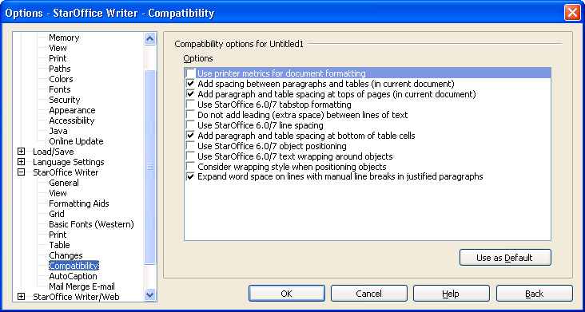
- “Justified Text” - CheckBox Properties |  | Comment
Enabled: | Always
Disabled: | Never
Tri-State: | Never
Checked: | Value read/saved from .odt document and checked by default. Unchecked for all .sxw files.
CheckBox Label: | Expand word space on lines with manual line breaks in justified paragraphs |  | EN-US
CheckBox Label: | Wortabstände in Zeilen mit manuellem Zeilenumbruch im Blocksatz ausdehnen |  | DE

Migration
Old SXW files cannot store this new attribute, so it will be lost in saving in SXW format.

Configuration
None.

File Format
None.

Open Issues
Issue | Initials | Date
<State Issue here, State “None”, if all issues are solved> |  | <Format: Dec 31, 2000>
<...>

Document Change History
Rev. | Change | Initials | Date
1 | Initial Spec. | FL | July 3, 2007
2 | Set to Standard | FL | July 5, 2007

OOo 2.2.1

