Software Specification Document

OpenOffice.org Writer
Block Selection of Text

Specification Status
Last Change | Nov 6, 2007
Status
Abstract
The block selection feature adds an additional selection mode to Writer. When this selection mode is active, the text inside a rectangular selection gets multi selected by Writer. This is useful i.e. if an OCRed text has to be further edited.
i-Team Members
Role | First Name, Last Name, Initials | E-Mail Address
I-Team Lead | Andreas Martens | andreas.martens@sun.com
Specification Author | Frank Loehmann | frank.loehmann@sun.com
User Experience | Frank Loehmann | frank.loehmann@sun.com
Development | Andreas Martens  Oliver Specht | <see above>  oliver.specht@sun.com
Quality Assurance | Éric Savary | eric.savary@sun.com
Documentation | Uwe Fischer | uwe.fischer@sun.com
Other roles | - | -

Contents
Abstract 1
i-Team Members 1
References and Reference Documents 3
Acronyms and Abbreviations 3
1 Detailed Specification 4
1.1 Block Selection Creation 4
1.1.1 Special situations 4
1.2 Block Selection Behavior 4
1.3 Pasting a Block Selection 5
1.4 User Interface 6
1.4.1 Edit Menu Extension 6
1.4.2 Status Bar 7
2 Migration 7
3 Configuration 7
4 File Format 7
5 Open Issues 7
Document Change History 7

References and Reference Documents
Reference Document | Check | Location (URL)
Specification Process Entry Check |  | N/A
Product Requirement, RFE, issue [Required] |  | http://qa.openoffice.org/issues/show_bug.cgi?id=1596
Product Concept Document |  | <Please enter location here>
Competitive Analysis |  | <Please enter location here>
IDL Specification |  | <Please enter location here>
Test Case Specification [Required] |  | http://www.openoffice.org/nonav/issues/showattachment.cgi/49473/block_selection_tp.html
Software Specification Rules | N/A | N/A
Acronyms and Abbreviations
Acronym / Abbreviation | Definition
<WYSIWYG> | <What You See Is What You Get>

Detailed Specification

Block Selection Creation
A block selection contains one or more selections of text. Each (sub-)selection contains a part of one paragraph line. All selections fits into a given rectangle.
When block selection is activated (see User Interface) this rectangle text can be defined in two ways.
Moving the text cursor with the cursor keys (cursor up, down, right, left, home, end, page up, page down) and pressing the <Shift> key creates a (rectangular) selection.
Examples: If the text cursor is before the “S” and will be moved behind the “E” (with <Shift> pressed), the yellow highlighted text would be selected. If the selection starts behind the “B” and finishes before the “F”, the blue highlighted text would be selected.
XX XXXXX Start XXXXX XXXXXX XXX. XXXX XXXX'X XXXX XXXX. XXX XXXXX XX Begin XXXXXX XXX XXXX XXXX XX XXXXX XXX XX XXXX XXXXXXXX XXXX XX XXXX? XXX XX XXXX XXXXXXXXXX XXX XXXXXX, XXXX XXXXX XX XXXXXXXXX XXXXXXX XX FinishXXX XXX XX XXX XXXXX'X XXXXXX XXXX XXXX XX XXX XXXXX XX'X XXXXXX End? XXXXXX XX XXXX XXXXXX XXX XXXX, XXXXXXXX XXXXXXX XXXX XXX XXXX XXXX XXX XXXX, XXXX XXX XXXX, XXXX XXXX XXX XXXXX. XXXXX XXXX XXXX XXXX XXX XXXX?
Pressing the left mouse button and moving the mouse while holding the button pressed creates a (rectangular) selection as well.
Regardless if the rectangle has been created by the mouse or the cursor keys, characters will be part of the selection, if they overlap to the rectangular as well in X- as well in Y-direction.
In text writing direction (X in horizontal, Y in vertical text layout) the center of the character has to be inside the rectangle, in the other direction (Y in horizontal, X in vertical text layout) the smallest overlapping (one pixel) is enough. In other words: a character will be selected if at least one pixel of its middle axis overlaps with the rectangle.
E.g.: If any part of the red line overlaps with the block selection rectangle, the character will be part of the block selection:

Special situations
If the block selection starts before a table it is not possible to get the end point into the table, if the keyboard is used. If the end of the selection is behind the table the text portions inside the table will be selected if they are covered by the selection rectangle.
If the block selection starts inside a table, the end point will stay in this table, too. All text portions inside the rectangle will be added to the selection.
If a block selection starts in a page header or footer, the end point will stay in this header/footer.
If a block selection starts in a footnote, the end point will stay in this footnote.

Block Selection Behavior
A block selection behaves like a multi selection. The selected text can be modified or deleted if no part is in an protected area. The block selection can be copied into the clipboard.
There is one difference to a multi selection, pasting into a block selection will paste the clipboard content in every part of the block selection. E.g. If your clipboard contains the word “hello” and you paste it when a block selection is active with three selections you will get “hello” three times.

Pasting a Block Selection
If the source of the internal clipboard has been a block selection, the pasting into Writer behaves different to a “normal” multi selection.
For every text portion contained in the clipboard a insert position is identified.
If nothing is selected, this happens in the following way. The first text will be inserted at the current cursor position. The second insert position is the position where the cursor would be placed if the user would press the <Cursor-Down> key. The third insert position would be calculate as if the <Cursor-Down> has been pressed twice etcetera.
If a single selection is active while pasting, first the deletion of the selected object will be executed then the insert positions will be identified like before.
If a multi selection or a block selection is active, the deletion will be executed as well. The deletion positions will used as insert positions for the (sub-)selections of the clipboard. If there are more insert positions than text portions in the clipboard, the text portions are inserted a second and more times if needed. If there are less insert positions than text portions the additional insert position will be identified by simulation of <Cursor-Down> from the last given insert position.
Example:
Given the following marked block selection has been copied into clipboard.
Paragraph: One
Paragraph: Two
Paragraph: Three
The clipboard contains three text portions ( “One”, “Two”, “Three” ).
Pasting into a text without selection, cursor position marked ( ):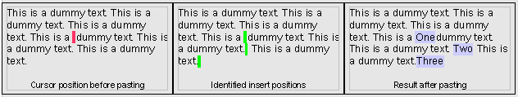
Pasting into a text with a single selection, selection marked ( ):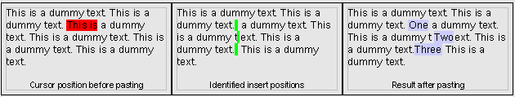
Pasting into a text with a multiselection( marked ), less selections than text portion in clipboard: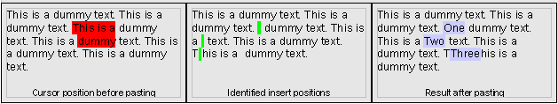

Pasting into a text with a multiselection( marked ), more selections than text portion in clipboard: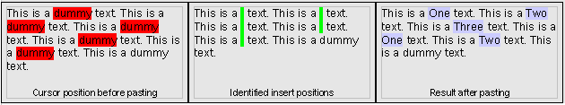

User Interface

Edit Menu Extension
The new text selection mode can be activated in the Edit menu of Writer. Windows version also supports the common short cut Alt-click to activate block text selection mode. Block mode will not be stored in configuration or document, so that the mode gets reseted on application restart and for any new document.
- “Edit - Selection” - Menu Properties |  |  |  |  | Comment
Menu Title: | Edit |  |  |  | EN-US
Menu Title: | Bearbeiten |  |  |  | DE
Menu Position: | Below „Select Text“
Menu Items:
Items | Sub Items | Sub Items | KBD Shortcuts | Icon | Comment
Selection Mode,  Selektionsmodus | Standard, Standard |  | Ctrl+Shift+F8 toggles between the modes. | <...> | Optional menu entries!  Alt-click activates block mode too (Windows only).
 | Block Area, Rechteckiger Bereich |  | Ctrl+Shift+F8 toggles between the modes.

Status Bar
The Writer status bar shows the current selection mode. The field toggles on mouse click.
Illustration 1: Status bar - block selection mode is active in Writer
- “Selection Mode” - Status Bar Toggle Field Properties |  | Comment
Enabled: | always
Disabled: | never
Items: | - STD ; STD  - EXT ; ER  - ADD ; ERG  - BLK ; BLK | EN-US, DE
Item Selected: | 1.
Other: | Tip Help?!

Migration
New feature no migration needed.

Configuration
Text selection mode will not be stored in configuration.

File Format
Text selection mode will not be stored in document.

Open Issues
Issue | Initials | Date
Tip Help on status bar control?! | FL | April 18, 2007

Document Change History
Rev. | Change | Initials | Date
1 | Initial draft | FL | April 18, 2007
2 | Detailed specification | AMA | May 21, 2007
3 | Strings changes | FL | May 25, 2007
4 | Pasting into a block selection | AMA | Oct 10, 2007
<...>

