Software Specification Document

OOo/StarOffice
Solid Dragging: Adapt Tools/Options/View dialog settings concerning 3D, AntiAliasing and DrawObject Interactions

Specification Status
Last Change | Dec 4, 2008
Status
Abstract
This Specification describes three single tasks which are so closely related, that i will describe them in a single specification. The following definitions of the three tasks will be used throughout the document:
- Remove no longer used 3D options
- Add a graphics output option for AntiAlialising support
- Unify object modification with full attributes
All three points will be covered by issues and discussed in detail below.

i-Team Members
Role | First Name, Last Name, Initials | E-Mail Address
I-Team Lead | Armin Le Grand (AW) | Armin.Le.Grand@sun.com
Specification Author | Armin Le Grand (AW) | Armin.Le.Grand@sun.com
User Experience | Frank Loehmann (FL) | Frank.Loehmann@sun.com
Development | Armin Le Grand (AW) | Armin.Le.Grand@sun.com
Quality Assurance | Wolfram Garten (WG) | Wolfram.Garten@sun.com
Documentation | Uwe Fischer (UF) | Uwe.Fischer@sun.com
Other roles | <First Name, Last Name (Initials)> | <User@openoffice.org>
<State reason here, if one role is not represented in i-Team.>

Contents
Abstract 1
i-Team Members 1
References and Reference Documents 3
Acronyms and Abbreviations 3
1 Detailed Specification 4
1.1 A: Remove no longer used 3D Options 4
1.2 B: Add a graphics output option for Anti-Aliasing support 4
1.3 C: Unify object modification with full attributes 4
1.3.1 Interaction changes in Detail 5
1.4 All together 6
1.4.1 Changes for Tools/Options/View TabPage 6
1.4.2 Changes for the Options Toolbar in Draw/Impress 7
2 Migration 8
3 Configuration 8
4 File Format 9
5 Open Issues 9
Document Change History 9

References and Reference Documents
Reference Document | Check | Location (URL)
Specification Process Entry Check |  | N/A
Product Requirement, RFE, issue [Required] |  | A: #i95644#,  B: #i95645#,  C: #i95646#
Product Concept Document |  | <Please enter location here>
Competitive Analysis |  | <Please enter location here>
IDL Specification |  | <Please enter location here>
Test Case Specification [Required] |  | <Please enter location here>
Software Specification Rules | N/A | N/A
<Other, e.g. references to related specs>
Acronyms and Abbreviations
Acronym / Abbreviation | Definition
AA | Anti-Alialised

Detailed Specification
As mentioned above, this specification covers three sub-tasks (named A, B and C and defined above) which will be handled by this single specification since they are all closely related and show up in the Tools/Options/View Dialog TabPage.

A: Remove no longer used 3D Options
This is quite straightforward. It's about options which are no longer used. Actually, the OpenGL support is not used since 2.0 due to too many driver problems with OpenGL libraries from all possible vendors. It used a fallback to the internal renderer since that time. We just had too many cases where OpenGL crashed (and with it the office), all not solvable by us. So the options 'Use OpenGL' and 'Optimized Output' are obsolete.
The 'Use Dithering' option was only useful with OpenGL and color depths with less than 24 bits or the old internal 3D renderer. The new 3D renderer internally always uses 24 bit color depth and dithering depends on the display optins when painting the resulting Bitmap. These are dithered nowadays anyways, so this works automatically what all in all makes this option obsolete.
The 'Object refresh during Interaction' option actually does something. When switched on, 3D interactions like rotating a 3D object are rendered in real-time to have an enhanced user interaction and better feedback. When switched off, the 3D interactions are executed using a wireframe overlay visualization instead. This will no longer be needed together with C since it describes a more general option to have this enhanced feedback for 2D and 3D objects and for object construction and modification.
All in all the whole '3D view' section can be removed in the TabPage.

B: Add a graphics output option for Anti-Aliasing support
For 3.1 it is planned to have the DrawingLayer visualization Anti-aliasing (AA), so we need an option to switch this on and off. In the dialog TabPage there is already the 'Graphics Output' section which currently contains the 'Use Hardware acceleration' switch. This controls if a hardware accelerated canvas shall be used for slideshow visualization.
This is the ideal place to add the second option 'Use Anti-Aliased visualization'. For 3.1 we will be able to offer this for nearly all systems we are running on. For windows we are currently working on a solution. For Sunray the problem is that it currently does not have a XRenderExtension for X, but the team is planning to offer one in the near future.
I suggest to activate that option by default, except if XRenderExtension is not available. I also suggest that this will be a local setting, not saved (and reloaded) with documents. The user will configure this to his local demand on his machine, he does not want to have this setting changed when he loads a document from someone else who e.g. might have AA switched on because he has a faster machine than the current user.
I also suggest to add a configuration entry for this to allow configuring an office differently in this point when needed.

C: Unify object modification with full attributes
Currently we have two mechanisms which partially go in that direction:
On the one hand there is the 'Object refresh during interaction' switch in the '3D view' section in the TabPage. This controls if interactions with 3D objects are shown during the interaction with fully rendered objects or with wireframe. This is only for 3D and only for interactions.
On the other hand we have the Options-Toolbar in Draw and Impress. There is a 'Create objects with attributes' switch button on it which controls if 2D and 3D object interactive creation is visualized by showing the full object or a wireframe representation, but only for object creation.
Both functionalities should be unified to allow the user to switch between full object visualisation or wireframe visualization for all object interactions. There is no reason neither to handle 2D and 3D objects nor to handle creation and modification differently.
I suggest to reuse the existing button and slot, but to rename it to 'Modify object with attributes'.
When switched on, create 2D and 3D objects with full attributes (exactly as currently), but also modify objects (2D and 3D) with full attributes. This would mean to show a 50% transparent copy of the object during interactions which changes during the interaction and is above all other objects (on the overlay). At interaction end, this visualization representation would be removed and the modified object would be refreshed which changed attributes. This mechanism will be fast enough since it will work on the overlay (thus no repaints for the rest of the visualization is needed). This is also what our competitors do.
When switched off, object creation and modification will be visualised using wireframe (as is the default currently).
This button is currently defaulted to 'off' which means wireframe mode. I suggest to change the default to 'on' and add a configuration entry to be able to configure this differently when needed.

Interaction changes in Detail
The form of interaction depends on various factors, the object selected, the interaction chosen and the interaction phase. Here i will list the interactions as complete as possible.
The option 'Modify objects with Attributes' will by default be enabled. For Draw/Impress, the default for the button will be enabled, too. In Draw/Impress, it is possible to switch on/off that option using the button. For Calc, Writer and other Applications (report designer, basic UI editor, etc...) the option will be switched on by default and can be deactivated in the configuration using the 'SolidDragCreate' boolean switch which is 'true' by default in Common.xcs schema (in the 'Drawinglayer' group).
When the 'Modify objects with Attributes' option is switched off, all works as before, all interactions will be visualized using a wireframe preview (more precise: the black/white patterned lines). HighContrast will work as before, too. When HighContrast is on, all interactions will fallback to wireframe.
When switched on, object creation will work as before when the old option was switched on: The object will be directly constructed using all current creation attributes. It will be created above all other objects and without transparency. There is no need to use transparency here, new objects are always created on top of all other objects.
When modifying objects, a full, 50% transparent preview of the modified object(s) will be used. It will be shown as long as the interaction is active. It will go away when either the interaction is ended by interrupting it (ESC) or by ending it positively. When ending it positively, the original object will be modified. The up-to-ten used interaction visualization objects will have given a precise preview of what will happen when the interaction is ended positively.
For SdrDragMove, SdrDragResize and SdrDragShear the interaction visualization objects will show all objects during interaction. Not each single object is shown with 50% transparency, but all with a single 50% transparency, so that the overlappings shown in the preview are correct. The preview is not simply scaled, this would not work with thick lines and/or text which is not scaled and would not give a correct preview (to see this, use fat lines). When connectors are connected to objects in interaction, these connectors are also part of the preview and will exactly show their resulting path at each state of the interaction. When 'Guides When Moving' in the options Toolbar is on, those guides will shown together with the interaction preview (as before). These guides stay in wireframe mode for better visualization.
For SdrDragMirror only the interaction object(s) are mirrored, also with full preview.
No changes for SdrDragGradient.
For SdrDragCrook and SdrDragDistort a combination of wireframe and interaction preview is used. In that interactions, a grid in wireframe is used for better orientation what happens. That orientation stays in wireframe and is placed behind the transparent preview.
No changes SdrDragCrop, it uses fallback to wireframe. It makes no sense to show a 50% transparent cropped image on top of the original, this will just show no change.
SdrDragObjOwn: This describes all changes in point mode (F8). For AutoShapes, this includes the movement of control points, but also is used for interactive edge rounding, circle segment definitions and polygon point editing.
AutoShapes show the exact result of the applied interaction when control points are moved.
For interactive edge rounding also an exact preview is shown now.
When editing connectors, a combination is used. The connector itself is shown with full object preview, the drop targets are shown as wireframe (as before).
Dragging GluePoints in GluePoint mode now shows the dragged GluePoints in full preview mode.
For polygon editing, some extra wireframe helper information is shown besides the modified curve part when control points are edited. This is needed to have a feedback for the modified control vectors, especially when those have C1 or C2-continuity (the other side moves with the modified side). Tis also guarantees to see something when the polygon has no linestyle.
For 3D creation, nothing has changed. For interactions, there is a slight difference to 2D. Since 3D needs to be rendered completely anyways, the 50% copy above the existing scene is not used, but (as before when the old option was active) the full change is visualized during the interaction.

All together
Taking all three points together defines all needed UI changes. These will be for the Tools/Options/View TabPage and for the Options Toolbar in Draw/Impress.

Changes for Tools/Options/View TabPage
The TabPage currently looks like this (DEV300 m34):
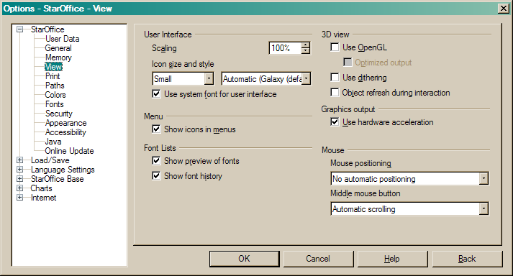

After the change, it should look like this:
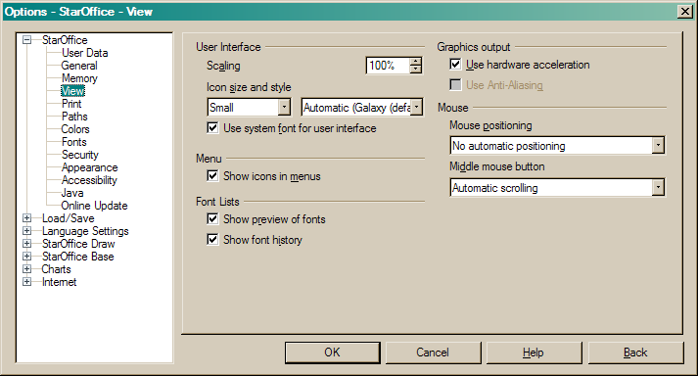

Changes for the Options Toolbar in Draw/Impress
The Toolbar's visualisation will be unchanged, just to make clear which button we are talking about:

I already talked to Stella Schulze (STS) and informed her that we may need a better visualisation. For the change itself, we may just keep the button as it is.

Migration
There is no saved configuration which needs to be migrated.

Configuration
As already mentioned, the following properties will be added:
Configuration | Group | Setting | Type | Default | Comment
Common.xcs | Drawinglayer | SolidDragCreate | Boolean | True | Short form:  This switch determines if DrawingLayer Interactions show Wireframe or Full-Object preview.  Long form:  This switch decides if Interactions in the DrawingLayer are visualized using Wireframe or Full-Object previews. If false, only Wireframe will be used. If true, Full-Object preview which gives a much better feedback about the object interaction will be used. This mode is used for modification and creation of objects. During interaction, a geometric copy of the object(s) is shown with 50% transparence in the foreground. That copy shows exactly what You will get when You end the interaction.
Common.xcs | Drawinglayer | AntiAliasing | Boolean | True | Short form:  This switch determines if DrawingLayer based views use AntiAliasing.  Long form:  This switch allows to switch DrawingLayer based views to be rendered using AntiAliasing or not. Of course this takes only effect when AntiAliasing is supported for the System OOo is running on.

File Format
FileFormat is not influenced.

Open Issues
Issue | Initials | Date
#i95644# | AW | <Format: Dec 31, 2000>
#i95645# | AW
#i95646# | AW

Document Change History
Rev. | Change | Initials | Date
1 | Rework and addons for C | AW | November 22, 2008
2 | Final | AW | December 4, 2008
3
<...>

