Software Specification Document

OpenOffice.org 2.0.4 and higher
OpenOffice.org NetBeans Integration: component wizard

Specification Status
Last Change | Feb 26, 2007
Status | - PRELIMINARY  status is the initial conception of a specification.  - STANDARD  A specification with status Standard is considered to be stable and has the approval of the i-Team.  - OBSOLETE  An Obsolete specification is a specification that has been identified unnecessary. For example due to; technology changes or changes in other standards or specifications.

Abstract
The intention of the OpenOffice.org NetBeans Integration: component wizard is to implement a simple to use wizard, as part of the OpenOffice.org extensions, for creating program extensions for OpenOffice.org. Since the component wizard is the most comprehensive of all the wizards of the extension project, it enhances the readability to have an own specification paper for it.
i-Team Members
Role | First Name, Last Name, Initials | E-Mail Address
Project Lead | Jürgen Schmidt (jsc) | Juergen.Schmidt@sun.com
Specification Owner | Steffen Grund (sg) | Steffen.Grund@sun.com
User Experience
Development | Steffen Grund (sg) | Steffen.Grund@sun.com
Quality Assurance | Thorsten Bosbach (tbo) | Thorsten.Bosbach@sun.com
Documentation
Other roles
Based on a verbal agreement between Lutz Höger and Jürgen Schmidt, we decided that a team member of the office user experience team isn't necessary because this specification is off topic of normal office features and address developers only and provides an integration in an external application (NetBeans IDE).

Contents
Abstract 1
i-Team Members 1
References and Reference Documents 3
Acronyms and Abbreviations 4
1 Detailed Specification 5
2 Migration 7
3 Configuration 7
4 File Format 8
5 Open Issues 8
Document Change History 8

References and Reference Documents
See New IDL Type Wizard specification, spec_openoffice-netbeans-integration-new-idl-type.odt on the UI for new file types.

Reference Document | Check | Location (URL)
Specification Process Entry Check |  | N/A
Product Requirement,, RFE, issue (required) |  | <Please enter location here>
Product Concept Document |  | <Please enter location here>
Competitive Analysis |  | <Please enter location here>
Test Case Specification (required) |  | <Please enter location here>
Software Specification Rules | N/A | N/A
<Other, e.g. references to related specs>

Acronyms and Abbreviations
State any acronyms and or abbreviations used in this specification in the table below.
Acronym / Abbreviation | Definition
SDK | Software Development Kit
deploy/deployment | Means the installation of office extension packages into an office installation
nbm | NetBeans module/plugin, comparable with an office extensions package, means a plugin extending the base functionality of NetBeans with some new functions.

Detailed Specification
This project type creates an adapted J2SE class library project with special support for an UNO component library and an office extension package. The wizard collects information about services and additional optional interfaces which should be implemented and generates a complete code skeleton with already implemented component helper functions and default implemented interface methods.
UI for collecting all relevant information
- Panel 1: “Name and Location”
This panel asks for basic information and presents some overview of the created files (this panel looks similar in Add-In, Component and Add-On wizards):
  - Name of the project - a directory with this name will be created
  - Name of the main class of the Component
  - Java package - these will also be created as directories
  - Project Location - where the project will be stored
  - Project Folder – a view of the structure that will be created
  - Created files – a list of some created files including their location – cannot be complete, because the amount of files is dependent on the settings in panel 2.
- Panel 2: “Define Service”
This panel serves a double function: in the upper half the interfaces and service that the component implements can be specified, taken from the Office or from the own design, which is available in the lower half of the panel.
From the second panel, It is possible to create idl types as part of the implementation. Supported types are:
- Services
- Interfaces
- Structs
- PolyStructs
- Exceptions
- Enumeration
- Constants
For each type there is a dialog to create an own idl file.

User Interface

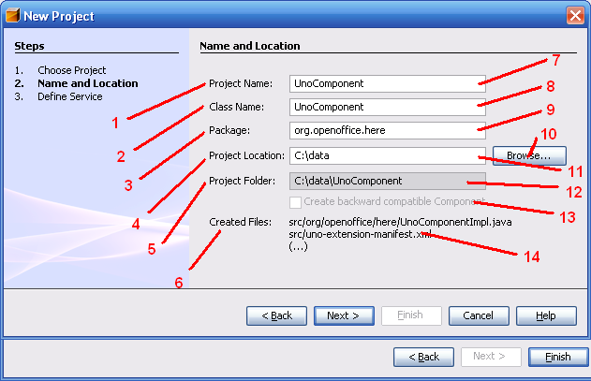Figure 1: Name and Location of the component

Table 1: User Interface elements of Figure 1
# | Type | Properties |  | Comment
1 |  | Control Properties  Enabled: Yes
1 |  | String English  Project Name: | String German  <not localized>
2 |  | Control Properties  Enabled: Yes
2 |  | String English  Class Name: | String German  <not localized>
3 |  | Control Properties  Enabled: Yes
3 |  | String English  Package: | String German  <not localized>
4 |  | Control Properties  Enabled: Yes
4 |  | String English  Project Location: | String German  <not localized>
5 |  | Control Properties  Enabled: Yes
5 |  | String English  Project Folder | String German  <not localized>
6 |  | Control Properties  Enabled: Yes
6 |  | String English  Created Files | String German  <not localized>
7 |  | Control Properties  Enabled: Yes  Editable: Yes  Initial Text Inside Field: UnoComponent<nuber>  Drag Enabled: No  Initial Caret Position: 0  Characters Allowed: allowed for file names  Characters not Allowed: forbidden for file names  Selection Starts:  Selection Ends:  Selected Text:  ToolTip Text:  A11Y Text:  Other...:  Password Field Properties  Echo Character:  Other...: |  |  | The initial value of the field is UnoComponent + a number to guarantee that the name is unique
7 |  | String English | String German
8 |  | Control Properties  Enabled: Yes  Editable: Yes  Initial Text Inside Field: <same as #7>  Drag Enabled: No  Initial Caret Position: 0  Characters Allowed: file names  Characters not Allowed: file names  Selection Starts:  Selection Ends:  Selected Text:  ToolTip Text:  A11Y Text:  Other...:  Password Field Properties  Echo Character:  Other...: |  |  | This text field has the same entry as #7, unless it is edited.
8 |  | String English | String German
9 |  | Control Properties  Enabled: Yes  Editable: No  Initial Text Inside Field: org.openoffice.here  Drag Enabled: No  Initial Caret Position: 0  Characters Allowed: chars for file names  Characters not Allowed: chars for file names  Selection Starts:  Selection Ends:  Selected Text:  ToolTip Text:  A11Y Text:  Other...:  Password Field Properties  Echo Character:  Other...: |  |  | The package for the Java class.
9 |  | String English | String German
10 |  | Control Properties  Enabled: Yes  Icon: No  Resizeable: No  Has Menu: No  Menu Items:  ToolTipText: |  |  | Opens a file chooser dialog, provided by Java.
10 |  | String English  Browse... | String German  <not localized>
11 |  | Control Properties  Enabled: Yes  Editable: No  Initial Text Inside Field: <user home>  Drag Enabled:  Initial Caret Position:  Characters Allowed: path  Characters not Allowed: path  Selection Starts:  Selection Ends:  Selected Text:  ToolTip Text:  A11Y Text:  Other...:  Password Field Properties  Echo Character:  Other...:
11 |  | String English | String German
12 |  | Control Properties  Enabled: Yes  Editable: No  Initial Text Inside Field: <created project folder>  Drag Enabled: No  Initial Caret Position: 0  Characters Allowed:  Characters not Allowed:  Selection Starts:  Selection Ends:  Selected Text:  ToolTip Text:  A11Y Text:  Other...:  Password Field Properties  Echo Character:  Other...:
12 |  | String English  <Enter String Here> | String German  <Enter String Here>
13 |  | Control Properties  Enabled: No  Initially Checked: No  TriState: No  ToolTip Text:  Other...: |  |  | Not yet implemented
13 |  | String English  Create backward compatible Component | String German  <Enter String Here>
14 |  | Control Properties  Enabled: Yes  Editable: No  Linewrap: On  Maximum Row Count:  Visible Row Count: 8  Display Hori. Scrollbar: as needed  Display Vert. Scrollbar: as needed  Initial Text Inside Field: <created files, as far as possible>  Drag Enabled: No  Caret position:  Characters Allowed:  Characters not Allowed:  Selection Starts:  Selection Ends:  Selected Text:  A11Y Text:  ToolTip Text:  Other...:
14 |  | String English | String German

Table 2: Tab order of Figure 1
Tab Order | Comment
#7, #8, #9, #11, #10

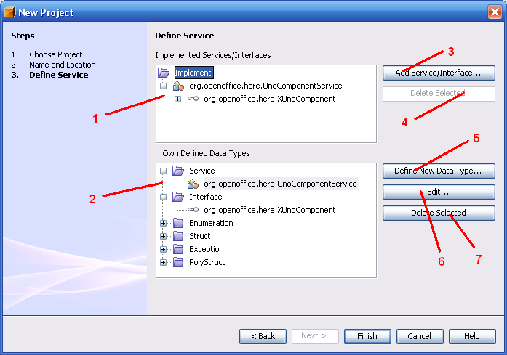Figure 2: Implementation and idl types

Table 3: User Interface elements of Figure 2
# | Type | Properties |  | Comment
1 |  | Control Properties  Features: BeanTreeView provided by NetBeans. Shows the services and interfaces that the Component implements. As well as own designed types, types from the Office are also possible.
1 |  | String English | String German
2 |  | Control Properties  Features: BeanTreeView provieded by NetBeans. This view shows all possible data types that can be created for the Component.
2 |  | String English | String German
3 |  | Control Properties  Enabled: Yes  Icon: No  Resizeable: No  Has Menu: No  Menu Items:  ToolTipText: |  |  | Opens “Add Service or Interface” dialog, where the service(s) and interface(s) that are implemented can be selected. The selected item in #1 determines the point where the Service/Interface is added (as long as it's allowed)
3 |  | String English  Add Service/Interface... | String German
4 |  | Control Properties  Enabled: as needed  Icon: No  Resizeable: No  Has Menu: No  Menu Items:  ToolTipText: |  |  | Deletes the selected Interface or Service from the “Implemented” list; is disabled when not possible
4 |  | String English  Delete Selected | String German
5 |  | Control Properties  Enabled: Yes  Icon: No  Resizeable: No  Has Menu: No  Menu Items:  ToolTipText: |  |  | Opens “Create data type” dialog. The selected point in #2 determines, what type will be created.  See New IDL Type Wizard specification for details on the following UI.
5 |  | String English  Define New Data Type... | String German
6 |  | Control Properties  Enabled: as needed  Icon: No  Resizeable: No  Has Menu: No  Menu Items:  ToolTipText: |  |  | Edit the selected data type again with the “Create data type” dialog; if none selected, button is disabled
6 |  | String English  Edit... | String German
7 |  | Control Properties  Enabled: as needed  Icon: No  Resizeable: No  Has Menu: No  Menu Items:  ToolTipText: |  |  | Delete the selected data type; is disabled if none selected
7 |  | String English  Delete Selected | String German

Table 4: Tab order of Figure 2
Tab Order | Comment
#1, #3, #4, #2, #5, #6, #7

Migration
<Start typing here ----- If this part is irrelevant state a reason for its absence!>
Describe in this section the migration path. For example, if changes introduces a new functionality which is not covered by older versions of the product. Check:
- Did I specify the incompatible or removed configuration settings?
- Did I specify all newly needed, or removed files, modules?
- Did I specify how users are affected by this change?

Configuration
<Start typing here ----- If this part is irrelevant state a reason for its absence!>
If a setting (this includes also user interface settings) has to be stored in the configuration check the following:
- Did I state the default, where setting has to be stored (configuration path)?
- Did I specify which data type it is?
- Did I specify when the setting is activate (restart of application, for all new documents/windows after the change, or also for all opened documents/windows)
- If it is a new / incompatible setting did I specify a migration path?
Example
Configuration | Group | Setting | Type | Default | Comment
Writer.xcs | Print | EmptyPages | Boolean | True | specifies the default for XYZ

File Format
<Start typing here ----- If this part is irrelevant state a reason for its absence!>
If this functionality changes the file format it has to be described here:
- which elements, attributes or/and properties are affected,
- how it will affect older revisions of the file format
- Export/Import-transformation to older revisions, if incompatible changes are needed
Example
File | Section | Setting | Type | Comment
settings.xml | ooo:configuration-settings | PrintEmptyPages | Boolean | specifies the default for XYZ

Open Issues
Questions and unsolved will arise during the creation process of the specification. Make sure that no open issue are left, when the specification gets the state “Standard”
Issue | Initials | Date
<State Issue here, State “None”, if all issues are solved> |  | <Format: Dec 31, 2000>
<...>

Document Change History
Rev. | Change | Initials | Date
1 |  |  | <Format: Dec 31, 2000>
2
3
<...>

