Accessibility Issues
OpenOffice 2.0.1 / StarOffice 8 PP1

Document - ID | Specification Owner | Last Change | Status
 | Frank Loehmann | 08. July 05 | Draft
Conforms to
Applies to | All Applications
Task ID(s) | <Required - Tasklist comma separated.>
Category | Feature

Abstract
OOo 1.1 does not save versions of a document to the newly saved document when Save as functionality is used. This becomes a problem when the document converter, to convert old OOo 1.1 .SXW files to the new OOo 2.0 .ODT (OpenDocument Format), or the document recovery function is used, because then all versioning information gets lost. Loosing versions on saving a document via Save as menu command instead is still intended and also documented in help. Thus the saving behavior for documents is changed that only the Save As... command will delete versions on saving, all others will not.
i-Team Members (The specification owner is part of the i-Team)
 | Name | E-mail Address
User Experience | Frank Loehmann (FL) | frank.loemann@sun.com
Development | div
Quality Assurance | Éric Savary | erci.savary@sun.com
Documentation | Uwe Fischer (UFI) | uwe.fischer@sun.com

Approved for Implementation
 | Approved by | Date
User Experience | Frank Loehmann | 07.07.05
Development
Quality Assurance
Documentation
String Review

Document Change History
Rev. Level | Change | Initials | Date
1.0 | Initial Draft | FL | 08. July 05

Contents
1 Requirements and Dependencies 1
2 Competitive Analyses 1
3 Detailed Specification 1
4 Future Tasks 1

Naming of drawing objects (Writer /Calc)
In OOo 2.0 ungrouped drawing objects could not be named in Writer and Calc. Draw/Impress already allows to name single drawing objects. So Calc and Writer will change their current behavior the the one already implemented by Draw/Impress.
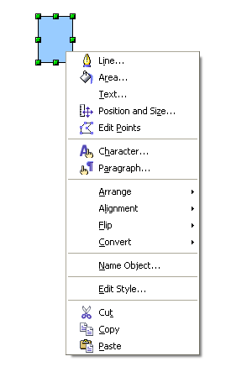Illustration 1: Context menu for a single Drawing object in Draw / Impress
Please note that the context menu of a multi selection of drawing objects or grouped drawing objects must not contain the naming entry until the objects all belong to the same group.
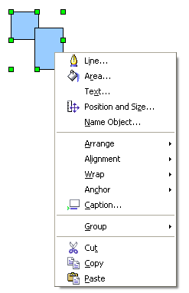Illustration 2: OOo 2.0 Writer naming of single objects
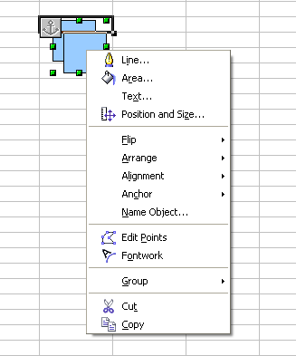Illustration 3: Naming of grouped drawing objects in OOo 2.0 Calc. Context menu entry "Name Object..." is on a false position.
Strings for Context Menu Entry
Item | English | German | Comments
Menu entry | ~Name Objects... |  | Posit

Draw

Impress

String list
-none-

Future Tasks
none

