Software Specification Document

OpenOffice.org
Option Dialog

Specification Status
Last Change | May 8, 2008
Status
Abstract
This specification documents all changes made to the implementation of Options dialog.
i-Team Members
Role | First Name, Last Name, Initials | E-Mail Address
I-Team Lead | Frank Loehmann (FL) | frank.loehmann@sun.com
Specification Author | Frank Loehmann (FL) | frank.loehmann@sun.com
User Experience | Frank Loehmann (FL) | frank.loehmann@sun.com
Development | Andreas Bregas (AB) | andreas.bregas@sun.com
Quality Assurance | Joerg Skottke | Joerg.skottke@sun.com
Documentation | Uwe Fischer (UFI) | uwe.fischer@sun.com
Other roles | <First Name, Last Name (Initials)> | <User@openoffice.org>
<State reason here, if one role is not represented in i-Team.>

Contents
Abstract 1
i-Team Members 1
References and Reference Documents 3
Acronyms and Abbreviations 3
1 Detailed Specification of the Dialog 4
1.1 Application Wide Section 4
1.2 Load/Save Section 4
1.2.1 General 4
1.2.2 VBA Properties 4
1.3 Language Settings Section 6
1.4 Writer/Web Section 6
1.5 Writer Section 6
1.6 Calc Section 6
1.7 Impress Section 6
1.8 Draw Section 7
1.9 Base Section 7
1.10 Chart Section 7
1.11 Internet Section 7
2 Migration 7
3 Configuration 7
4 File Format 7
5 Open Issues 7
Document Change History 7

References and Reference Documents
Reference Document | Check | Location (URL)
Specification Process Entry Check |  | N/A
Product Requirement, RFE, issue [Required] |  | <Please enter location here>
Product Concept Document |  | <Please enter location here>
Competitive Analysis |  | <Please enter location here>
IDL Specification |  | <Please enter location here>
Test Case Specification [Required] |  | <Please enter location here>
Software Specification Rules | N/A | N/A
- Set default file format specification
- ODF 1.2 migration specification
- Modularized Options Dialog
Acronyms and Abbreviations
Acronym / Abbreviation | Definition
<WYSIWYG> | <What You See Is What You Get>

Detailed Specification of the Dialog
The Options dialog is separated for the single modules of OOo. Please see
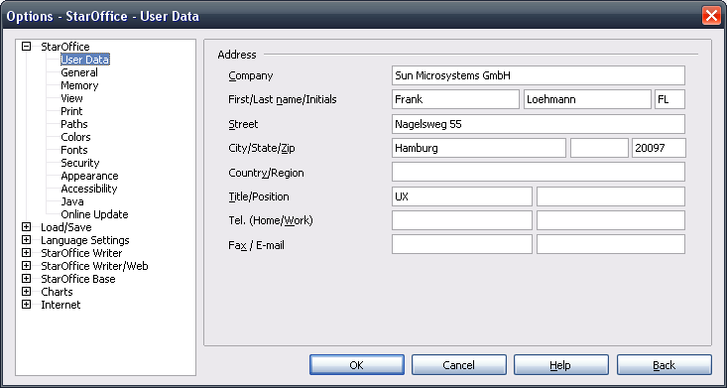Illustration 1: Options dialog called from Writer

Application Wide Section
<see current implementation in product>

Load/Save Section

General
Please see following specifications for details:
- Set default file format specification
- ODF 1.2 migration specification

VBA Properties
The VBA properties page looks like follows:
- “Load basic code” Option
If checked the VBA code is loaded on importing Microsoft Office Documents, but each code line is marked as a comment. If unchecked the VBA code will not be imported. Default is checked.
  - Executable code (only enabled if “Load basic code” option is checked.
If checked, the VBA code is not marked as a comment and thus it could be executed. This is only possible for Excel VBA code today. Default is unchecked.
- “Save original basic code” Option
If checked this option ensures that the original VBA code will be stored unchanged to the document on exporting to the Microsoft Office format. Thus all changes made in OOo will be withdrawn if this option is unchecked. Default is checked.
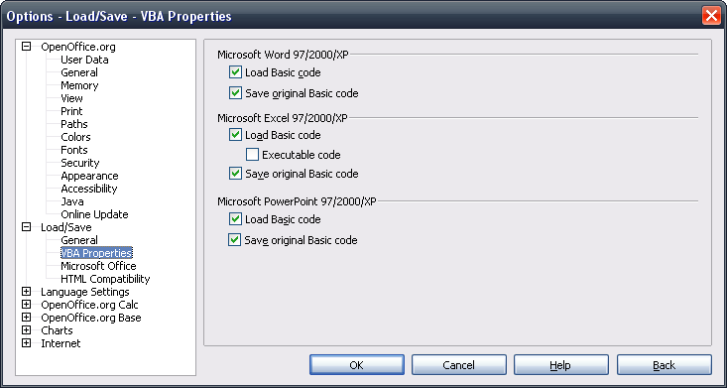Illustration 2: Mock-up of VBA Properties Page
- “Word” - Label Properties |  | Comment
Label: | Microsoft Word 97/2000/XP | EN-US
- “Word” - CheckBox Properties |  | Comment
Enabled: | Always
Disabled: | Never
Checked: | By default
CheckBox Label: | Load Basic code | EN-US
- “Word” - CheckBox Properties |  | Comment
Enabled: | Always
Disabled: | Never
Checked: | By default
CheckBox Label: | Save original Basic code | EN-US
- “Excel” - Label Properties |  | Comment
Label: | Microsoft Excel 97/2000/XP | EN-US
- “Excel” - CheckBox Properties |  | Comment
Enabled: | Always
Disabled: | Never
Checked: | By default
CheckBox Label: | Load Basic code | EN-US
- “Excel” - CheckBox Properties |  | Comment
Enabled: | If #5 is enabled
Disabled: | If #5 is disabled
Checked: | Unchecked by default
CheckBox Label: | Executable code | EN-US
- “Excel” - CheckBox Properties |  | Comment
Enabled: | Always
Disabled: | Never
Checked: | By default
CheckBox Label: | Save original Basic code | EN-US
- “PowerPoint” - Label Properties |  | Comment
Label: | Microsoft PowerPoint 97/2000/XP | EN-US
- “PowerPoint” - CheckBox Properties |  | Comment
Enabled: | Always
Disabled: | Never
Checked: | By default
CheckBox Label: | Load Basic code | EN-US
- “PowerPoint” - CheckBox Properties |  | Comment
Enabled: | Always
Disabled: | Never
Checked: | By default
CheckBox Label: | Save original Basic code | EN-US

Language Settings Section
<see current implementation in product>

Writer/Web Section
<see current implementation in product>

Writer Section
<see current implementation in product>

Calc Section
<see current implementation in product>

Impress Section
<see current implementation in product>

Draw Section
<see current implementation in product>

Base Section
<see current implementation in product>

Chart Section
<see current implementation in product>

Internet Section
<see current implementation in product>

Migration
None.

Configuration
<Start typing here ----- If this part is irrelevant state a reason for its absence!>

File Format
<Start typing here ----- If this part is irrelevant state a reason for its absence!>

Open Issues
Issue | Initials | Date
<State Issue here, State “None”, if all issues are solved> |  | <Format: Dec 31, 2000>
<...>

Document Change History
Rev. | Change | Initials | Date
1 | Initial Spec. | FL | May 5, 2008
2
3
<...>

