Software Specification Document

OpenOffice.org
Online Update for Extensions

Specification Status
Last Change | 2008-02-26
Status

Abstract
Extensions are often improved over a period of time. That is, publishers ship new versions of the same extension with added functionality and/or bug fixes. Currently users must update their extensions manually, that is, find out where to get an update, get the update, remove old extensions, install the new extension. This feature will make updating easier. Users can run the update mechanism from the Extension Manager. A dialog will show available updates and the user will be able to choose which to install.

i-Team Members
Role | First Name, Last Name, Initials | E-Mail Address
Project Lead | Joachim Lingner (JL) | jl@openoffice.org
Specification Owner | Joachim Lingner (JL) | jl@openoffice.org
User Experience | Bettina Haberer (BH) | bh@openoffice.org
Development | Joachim Lingner (JL), Stephan Bergmann (SB), | jl@openoffice.org, sb@openoffice.org
Quality Assurance | Jörg Skottke | jsk@openoffice.org
Documentation | Uwe Fischer | ufi@openoffice.org
Other roles | <First Name, Last Name (Initials)> | <User@openoffice.org>
<State reason here, if one role is not represented in i-Team.>

Contents
Abstract 1
i-Team Members 1
References and Reference Documents 3
Acronyms and Abbreviations 3
1 Detailed Specification 4
1.1 Version Information of Extensions 4
1.1.1 Displaying the Version 4
1.2 Extension Identifier 4
1.3 Comparing Extensions 5
1.4 Extensions with different Localizations 5
1.5 Finding Update Information 5
1.5.1 Referencing Update Information in Extensions 5
1.5.2 Build-In Reference to Update Information 6
1.6 Update Information 6
1.6.1 Update Information File (the .update.xml) 6
1.6.2 The “Atom” file 6
1.7 Changes to description.xml 7
1.8 Extension Manager Dialog Changes 7
1.9 Enabling Updates 9
1.10 Running the Update Procedure 9
1.11 Extension Updates Dialog 10
1.11.1 Displaying the Publisher and the Release Notes of an Extension 19
1.12 Downloading Updates Progress Dialog 20
1.12.1 The Update of a Web Based Extension 26
1.12.2 The Work Flow of the Web Based Extension Update 27
1.12.3 Several open dialog windows at the Web Based Extension Update 28
1.13 Warning at manipulating a shared extension 28
2 Migration 29
3 Configuration 29
4 File Format 29
5 Open Issues 29
Document Change History 30

References and Reference Documents
Reference Document | Check | Location (URL)
Specification Process Entry Check |  | N/A
Product Requirement,, RFE, issue (required) |  | 70481
Product Concept Document |  | <Please enter location here>
Competitive Analysis |  | <Please enter location here>
Test Case Specification (required)
Software Specification Rules | N/A | N/A
<Other, e.g. references to related specs>

Acronyms and Abbreviations
Acronym / Abbreviation | Definition
extension | Formally known as UNO Package Bundle. A file containing UNO components, Basic scripts, configuration data, etc.
Extension Manager | Formally known as Package Manager.
user extension | An extension that can only be used by the user who installed is also called a “user extension”. This is the case when the extension is installed under the “OpenOffice.org Extensions” node in the Extension Manager dialog or when the switch “--shared” is not used when adding the extension in the console using “unopkg add”.
shared extension | An extension which is installed by one user an which can then be used by all users is also called a “shared extensions”. This is the case when the extensions is installed under the “My Extensions” node in the Extensions Manager dialog or when the switch “--shared” is used when adding the extensions in the console (unopkg add –shared file)

Detailed Specification
This feature will only be available in the GUI. That is, updates are not supported when using unopkg add.

Version Information of Extensions

Displaying the Version
The textual version representation found in the description.xml is displayed in the Extension Manager dialog. If no version is specified then an empty string is displayed.

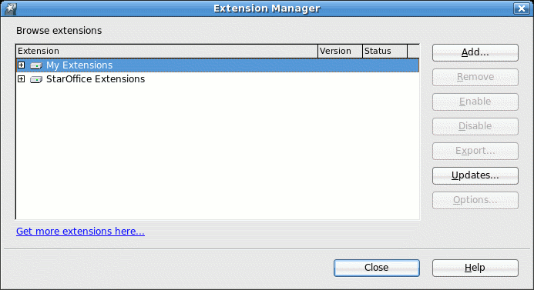
Figure 1: The Extension Manager with a “version” column

String List for figure 1
Item | English | German | Comments
Column Label | Version | Version

Extension Identifier
See issue 69910 for the specification of extension identifiers. The general introduction of extension identifiers (i.e., to support different extensions that happen to have the same file name) will be done independent of the introduction of online update for extensions. However, as extension identifiers are also needed for the online update of extensions (in the update.xml format), they are also already allowed in description.xml:
- Extension file example.oxt contains no identifier entry in its description.xml:
  - Corresponding example.update.xml must contain <identifier value="org.openoffice.legacy.example.oxt"/>.
- Extension file example.oxt contains <identifier value="example-domain.example"/> in its description.xml:
  - Corresponding example.update.xml must contain <identifier value="example-domain.example"/>.
  - However, unless issue 69910 is fixed, you still cannot deploy another extension with the same filename alongside example.oxt.

Comparing Extensions
In order to decide which Extensions are allowed as update one has to find a way to compare extensions. Two extensions are instances of the same product if and only if they have identical identifiers. Two extensions that are instances of the same product relate to one another according to the ordering relation between their versions. That is, two extensions with the same identifier and version are the same, no matter what the filename is.

Extensions with different Localizations
It is imaginable that an extension is delivered in different language versions. If the publisher wants that, an english version is to be updated by a german version, then both extensions must have the same extension identifier. If they have different extension identifiers than the installed version cannot be updated with the german extension.

Finding Update Information
Update information are kept in xml files which are kept on a server. The location of this information can be kept in the extensions and there can be a preprogrammed location.

Referencing Update Information in Extensions
The description.xml can contain one or several URLs to sources where update information can be obtained. The information obtained from theses URLs must be the same. The second, third, etc. URL are used as mirror URLs.
Example:
<?xml version="1.0" encoding="UTF-8"?>
<description xmlns="http://openoffice.org/extensions/description/2006"
xmlns:xlink="http://www.w3.org/1999/xlink">
<update-information>
<src xlink:href="http://extensions.openoffice.org/extension/
myextension.xml" />
<src xlink:href="http://mirror.extensions.openoffice.org/extension/
myextension.xml" />
</update-information>
</description>
The URL do not need to reference the xml file directly. Instead it could reference a cgi script, servlet, etc. But the HTTP response must be the xml file.
Please refer to the Developer's Guide for the latest information regarding the content of the description.xml (see chapter Extensions).

Build-In Reference to Update Information
OOo can obtain update information from one particular location. This location is determined by an URL contained in the version.(ini|rc) in the program directory. The URL is stored under the key “ExtensionUpdateURL”.
The build-in URL will be used if an extension does not define its own URL(s) in the description.xml. That is, there is no <update-information> element.

Update Information

The update information is contained in an “update information file”, which is an ordinary xml file. One update information file only contains information for exactly one version of on extension. However, several information files can be referenced by one “atom” xml file. Then the “atom” file must be referenced by the extensions rather then the actual update information file.

Update Information File (the .update.xml)
The update information file contains information about the available extension. It could be named according to this pattern:
<extension_file_name>.update.xml
For example, the update information file for the extension myextension.oxt is myextension.update.xml. The .oxt file extension is not used.
For information about the content of the update information refer to the Developer's Guide (see chapter Extensions).

The “Atom” file
The atom file serves two purposes:
- collecting multiple update information files for one or several extensions
- offering a layer of indirection. For example, an atom file could be the “entry” point for an extension update website. The atom file contains then the URL to the actual update information which are hosted on different servers.

Information about how the atom file is used with extensions can be found in the Wiki: http://wiki.services.openoffice.org/wiki/Update_Notification_Protocol

Changes to description.xml

Extensions can contain a license text which is presented to the user upon installation. This may be inappropriate when installing many extensions during an update operation, because the user may be confronted with several license dialogs. The publisher of the extension may also see it as sufficient if the user agrees to the license when he installs the extension for the first time. Therefore we offer a way to suppress the license during an update, by configuring the description.xml. This also effects a manual update in the same way.

For example, version 1 of extension A is installed and the user installs another version of A. It does not matter if the version is higher, less or the same. If the extension, that is to be installed is configured to not show the license dialog, then the license is not displayed.
To find out about the necessary changes to the descripion.xml refer to the Developer's Guide (see chapter Extensions).

Extension Manager Dialog Changes
The Extension Manager dialog will have an additional button “Updates...” and the context menus of the extensions will have an additional item “Update”.

Figure 2: The Extension Manager with an additional "Updates..." button.

Table 1: New user interface elements of figure 2
# | Type | Properties |  | Comment
<#> |  | Control Properties  Enabled: <Yes/No>  Icon: no  Resizeable: no  Has Menu: no  Menu Items: none  ToolTipText: none |  |  | Enabled according the cases described in 1.9
<#> |  | ~Updates... | ~Updates...

The context menu of a selected sinle extension includes a further entry for updating as shown in figure 3:

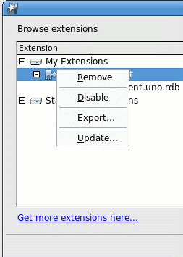
Figure 3: The enhanced context menu of an extension.

Table 2: New interface elements of figure 3
<#> |  | Control Properties  Enabled: yes
<#> |  | String English  ~Update... | String German  ~Update...

Enabling Updates

The update function is available for just one extension, which is triggered by an item of the context menu, or it is available for all extensions, which is triggered by the “Updates” button.
The menu item in the context menu is present iff the selection only consists of extensions (i.e., no top-level contexts, no sub-elements of extensions) and either a global predetermined update URL is available or at least one of the selected extensions has extension-specific update URLs.

The “Updates” button is enabled if
at least one extension is deployed and either a global predetermined update URL is available or at least one of the deployed extensions has extension-specific update URLs.
It does not matter if an extension is installed under “My Extensions” or “OpenOffice.org Extensions”.
The information whether a predetermined update URL is available is obtained from the Update Information Service.

Running the Update Procedure
The update procedure can be started either by the “Update” context menu item or the “Updates” button of the extension manager. The difference is that in the first case the “Extension Updates” dialog will display only updates for the selected extensions, whereas in the second case updates for all extensions are displayed. Therefore we will not make a distinction between the two cases.

In both cases the “Extension Updates” dialog will open.
- The user initiates the update by clicking the menu item “Update” in the context menu of an extension or by pressing the “Updates” button. Then the “Extension Updates” dialog is started.
- The Update Information Service is used to obtain update information for the extensions for which the “update check” is performed (either for all selected extensions or for all). During this time the “Extension Update” dialog shows a progress. The user can cancel this action by pressing the “Cancel” button.
- If no updates are available then the “Extension Updates” dialog shows a string telling the user exactly that. The user needs to close the dialog.
- If there is at least one update for a shared extension available and the current user has write access to the location of the shared extension then a message box will appear. See for more details. The user can only click “Ok” to close this message box.
- The “Extension Update” dialog will show only the latest version of an update and only if this version is in fact higher then the one of the installed extension. The dialog may contain entries which are not selectable and hence no automatic update is performed. This is the case when
- dependencies are not fulfilled
- insufficient user rights, that is, the current user does not have the file permissions to access the directory where shared extensions are stored.
- manual update necessary.
A combination of all three conditions is possible.
- When the user presses the “Download” button the “Download and Installation” dialog is displayed.
- All extensions which can be directly downloaded are downloaded now. The progress is shown in the “Download and Installation” dialog. If an extension could not be downloaded, then this is displayed in the dialog but the operation continues.
- After the last extension has been downloaded, the installation begins. First the already installed extensions, for which an update could be downloaded successfully, is removed. Then the update extension is installed. If an error occurred, the notice that the installation failed is displayed but the operation proceeds.
- If all updates have been processed the “Download and Installation” dialog shows that it has finished. The user can see if either everything is ok or if error occurred.
- Extensions, for which an update is available which needs manual installation, are marked accordingly in the Update dialog. After the “Download and Install" dialog is closed a web-browser is started which navigates to the web site where the user can eventually download the update. If there are only extensions where the updates need to be downloaded from a web site then the “Download and Install” dialog will not appear and the web browsers are opened when the “Update” dialog is closed by the “Ok” button.

Extension Updates Dialog

When the “Extension Updates” dialog is displayed, then immediately the search for updates is started. While the search continues a progress indicator is shown above the list box. In this case it is a throbber, as the “check for updates” operation is classified as an endless progress. The list of updates is continuously filled as new update information become available. As long as the search continues, the “Download and Install” button is disabled. The moment where the search has finished, the button becomes enabled and receives the focus.

States of enabling / disabling in the dialog Extension Update
Extensions | List box "Available extension updates" | Check box "Show all updates" | List box "Description"
not available | disabled | disabled | enabled, showing the string “No new updates are available.”
no installable extensions are available, but uninstallable | enabled | enabled | enabled, showing the string “No installable updates are available. To see all updates, mark the check box 'Show all updates.'”
only installable extensions are available | enabled | disabled
installable and uninstallable extensions and available | enabled | enabled

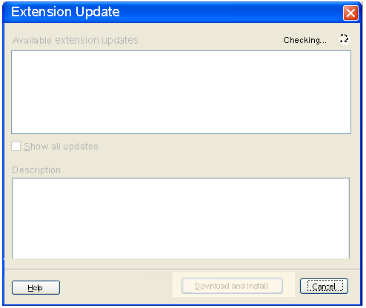Figure 4: The extension update dialog in check mode.

Table 3: String list figure 14
 | English | German | Comment
1 | Checking... | Suche läuft... | The label in the topright corner which indicates that there is an ongoing search for updates.

In case no update is available, the dialog shows the appropriate feedback:

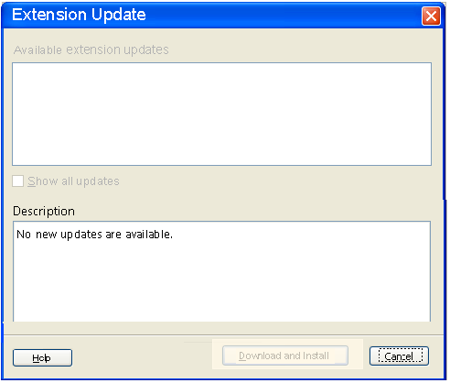Figure 5: The extension update dialog when no update is available

If no updates are available at all then the string specified below is displayed in the description field. The label description above the text area therefore gets enabled.

Taborder
- description field
- help button
- cancel button

Table 4: String list for figure 5
Item | English | German
Text label | No new updates are available. | Es sind keine neuen Updates verfügbar.
Text label | No installable updates are available. To see all updates, mark the check box 'Show all updates.'” | Es sind keine installierbaren Updates verfügbar. Um alle Updates angezeigt zu bekommen, wählen Sie 'Zeige alle Updates'.
Text label | You can unmark the extensions which you don't want to have downloaded and installed. | Sie können die Extensions abwählen, die nicht heruntergeladen und installiert werden sollen.

The following figure shows the case when updates for different extensions are available. The first listed extension in the Updates dialog has per default the focus, shown by the blue highlighted extension name.

The extension is visible by it's display name instead of the formerly used file name. As this dialog does currently not offer a version column, the extension's display name is followed by a blank and then the string 'Version', another blank and then the version number, example: Demo Extension Version 3.0.1

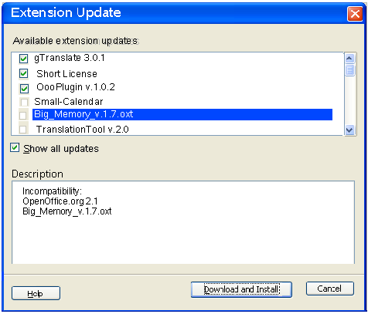
Figure 6: The update dialog showing all updates for the installed extension.
Version 3.0.1
Version 3.0.1
Version 4.5
Version 3.0.1
Version 3.0.1

The name of a listed extension, which cannot be installed (because e.g. of incompatibility, shared extension) nevertheless is enabled besides the disabled (and unmarked) check box.
The enabled checkboxes besides installable extensions are per default marked.
In case, that more extensions are listed than space is available, a vertical scrollbar appears enabling scrolling through the extensions.
Accordingly the ”Description” box gets a vertical scrollbar, if the info of a certain extension extends the available space.
As we show always the newest available update of an extension, older versions of an extension are not listed.
At selecting an extension name, the appropriate description, if available, is shown in the description field.
A multi-selection of extension names in this list is not possible.

The description field shows available descriptions of a certain selected extension. Currently it shows additional information in case the update cannot be installed. These are:
- There are unfulfilled dependencies. For example, the update depends on a newer version of OOo
- The user does not have the permission to update the extension. This is the case when the extension which is to be updated is a shared extension and the Extension Manager was started from within OOo, or unopkg gui was started while OOo was running. When using Windows Vista there is another message which is shown if the user is administrator but cannot install a shared extension because soffice was not started in administrator mode.

If none of 1–2 are true, the paragraph “No descriptions available for this extension.” is displayed. Otherwise, multiple paragraphs are displayed: First, the paragraph “The extension cannot be installed because:” is displayed. Next, if 1 is true, the paragraph “Incompatibility:” is displayed, followed by a paragraph each for each unsatisfied dependency, in no specific order, where each of them consists of the (English) dependency name preceded by two spaces. Next, if 2 is true, the paragraph “No write permission.” is displayed.
There are two reasons why determining whether an update for an extension is available can fail: First, when searching for updates for all deployed extensions (in contrast to only the extensions selected in the Extension Manager dialog), obtaining the list of extensions deployed in a context (either “My Extensions” or “OpenOffice.org Extensions”) can fail. Second, obtaining update information for a specific extension can fail.
For both not extension specific errors and extension specific errors, the “Description” box displays two paragraphs. The first paragraph is the localized “An error occurred:”. The second paragraph is some English, human readable error information. If no information can be obtained, the second paragraph is the localized “Unknown error.”. [TODO: In the future, this can be extended to display better, localized information (currently, simply a UNO Exception Message is displayed).]

The 'Show all updates' checkbox is per default unchecked. It is enabled / disabled depending on the available extension updates. Four different kinds of entries can fill the list box 'Available extension updates':
- Not extension specific error
  - column shows warning icon
  - column shows the localized “Error”;

- Extension specific error
  - column shows warning icon
  - column shows the extension name (the display name);

- Not downloadable update (manual download via web page)
  - column shows the enabled, checked checkbox
  - column shows the extension name (the display name) and update version of the extension an the string “browser based update”;

- Downloadable updates
  - column shows the enabled, checked checkbox
  - column shows the extension name (the display name) and update version of the extension;

Per default only the downloadable and not downloadable extensions (type 3 and 4) are listed.
When the check box 'Show all updates' is marked, the listbox is enhanced by those extensions in the order
-downloadable updates,
-not downloadable updates,
-not extension specific errors,
-extensions specific errors.

The warning icon, which appears in the first column
icon 12 pixel hight
icon hight contrast 12 pixel hight

The “Install” button is disabled:
- When no update is available;
- if only uninstallable updates are available;
- if none of the installable updates is marked;

Help

The help needs to explain all the differences between the extensions, which can be listed with different states in the listbox available extension updates.

Taborder
- Listbox 'Available extension updates'
- checkbox 'Show all updates'
- Listbox 'Description'
- Help
- 'Install'
- Cancel

Table 5: User interface elements of figure 6
# | Type | Properties |  | Comment
<#> |  | Control Properties  State: Modal  Closable: Yes  Resizable: NO  Always On Top: Yes  A11Y Text: none  HelpID: HID_DEPLOYMENT_GUI_UPDATE  Other...: none
<#> |  | Extension Update | Extension Update
<#> |  | Control Properties  Enabled: Yes
<#> |  | String English  D~escription | String German  ~Beschreibung
<#> |  | Control Properties  Enabled: Yes  Editable: No  Linewrap: On  Maximum Row Count: As needed  Visible Row Count: 5  Display Hori. Scrollbar: Never  Display Vert. Scrollbar: As needed  Initial Text Inside Field: none  Drag Enabled: No  Caret position:  Characters Allowed:  Characters not Allowed:  Selection Starts:  Selection Ends:  Selected Text:  A11Y Text:  ToolTip Text:  Other...:
<#> |  | String English  <Enter String Here> | String German  <Enter String Here>
<#> |  | Control Properties  Enabled: Yes  Icon: No  Resizeable: No  Has Menu: No  Menu Items: none  ToolTipText: none |  |  | The button is disabled when the extension manager was started by unopkg and there was no office (which was started by the same user) running at that time.
<#> |  | String English  ~Help | String German  ~Hilfe
<#> |  | Control Properties  Enabled: No  Icon: No  Resizeable: No  Has Menu: No  Menu Items: none  ToolTipText: none
<#> |  | String English  ~Install | String German  Installieren |  | No ellipses (...) are needed, because the next following step after pressing this button is an automatic one (start of download), so no further interaction is needed between  click on the button and start of the function => in such a case we don't use ellipses.
<#> |  | Control Properties  Enabled: Yes  Icon: No  Resizeable: No  Has Menu: No  Menu Items: none  ToolTipText: none
<#> |  | String English  Cancel | String German  Abbrechen
<#> |  | Control Properties  Enabled: No  Visible Row Count: 5  Item Selected: first item  Enable Sorting by DnD: No  A11Y Text: none  ToolTip Text: none |  |  | Contains the check boxes and extensions
<#> |  | String English  <Enter String Here> | String German  <Enter String Here>
<#> |  | Control Properties  Enabled: <Yes/No>
<#> |  | String English  ~Available extension updates | String German  ~Verfügbare Extension Updates |  | Beim englischen Label wird nur das erste Wort groß geschrieben, bitte String so belassen!
<#> |  | Control Properties  Enabled:  Initially Checked: No  TriState: No  ToolTip Text: none  Other...: none
<#> |  | String English  ~Show all updates | String German  ~Zeige alle Updates

I
Table 6: Strings displayed in the text area
 | English | German | Comment
1 | No description for this extension available. | Es ist keine Beschreibung für diese Extension verfügbar. | This string is shown if no other information is available that needs to be displayed.
2 | The extension cannot be updated because: | Die Extension kann nicht installiert werden wegen: | If there are reasons why the extension cannot be installed then this string is displayed first. That is, instead of #1
3 | Incompatibility: | Inkompatibilität: | In case an extension contains unsatisfied dependencies
4 | No write permission (shared extension). | Keine Schreibrechte (Shared Extension). | In case the user has no write access to directory of the shared extensions (office/share/uno_packages)
6 | Error | Fehler | Displayed in the “Available extension updates” list for a not extension specific error.
7 | An error occurred: | Es ist ein Fehler aufgetreten: | First paragraph of “Description” box for an error.
8 | Unknown error. | Unbekannter Fehler. | Default second paragraph of “Description” box for an error.
9 | "No write permission. %PRODUCTNAME needs to run as administrator.\n  Please follow these steps to update this shared extension:\n  1. Close Extension Manager dialog.\n  2. Exit %PRODUCTNAME.\n  3. Exit %PRODUCTNAME Quickstarter located in the tray area of Windows.\n  4. Run %PRODUCTNAME as administrator. In order to do this call the context menu of the %PRODUCTNAME program icon and choose \'Run as administrator\'.\n  5. Call the Extension Manager dialog and update this shared extension.\n"; |  | This string is only used on Windows Vista

After clicking the (enabled) ”Install” button the Extension Update-dialog closes and either the Download and Install” dialog (figure 9) opens or web browsers are started..

Displaying the Publisher and the Release Notes of an Extension
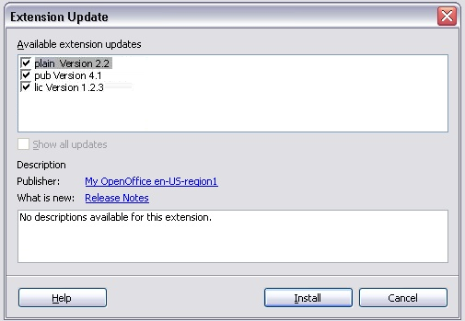Figure 7: Offering the publisher and release notes as links.

In a next version the description field will show some more description about a selected extension. The display name of the extension will be visible and furthermore the publisher of the extension (as link to the publisher's web site) and the release notes (as link to a web site containing the release notes).
At mouse over the links show the URL and they show the status of being entered / not being entered.
An URL, which is not entered, is blue. If the URL has been selected, it becomes red. The entered status keeps, as long as the dialog is open. If it is closed and opened again, the status of the URL is the default, means unentered (blue). As currently links are only educible in the dialog canvas, the publisher link and release notes link are not offered together with further description in the white description area.
To present the extension in a consistent way in both fields, the extension will be shown with it's display name also in the 'Available extension updates' field.

The information about the publisher and the release notes can be contained in the update information, which the Extension Manager obtains when the user triggers the update operation. The publisher name is localized. Then the update information may contain several publisher names in different languages. The Extension Manager will choose one name that matches most closely the locale of the office and displays it. The URL which is used for the publisher link is also language dependent. For example, if the update information contain a German and an English publisher name then there is a separate URL assigned to these names. Similarly the URLs to the release notes are also localized.For more information refer to the Developers Guide. [Link to Wiki Developers Guide not yet available].

In case the user has no write permission for the shared layer, a shared extension becomes only visible by checking 'Show all updates' in the extension update dialog. Even in that case the user should have the opportunity to see the publisher and release notes about this extension. Thus at selecting the shared extension both links should become visible.

 | English | Comment
2 | Publisher:
3 | What is new:

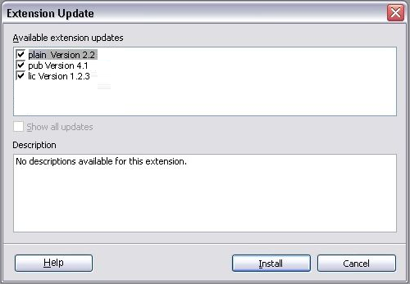Figure 8: In case no publisher and release notes are existing.

Downloading Updates Progress Dialog

After clicking the Download and Install button, the following dialog opens.

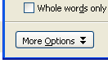

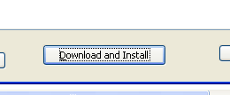
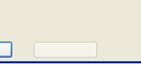

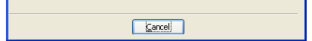
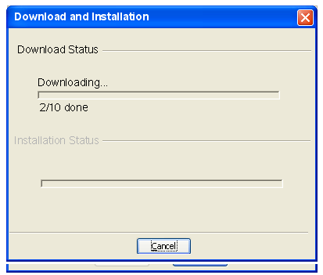
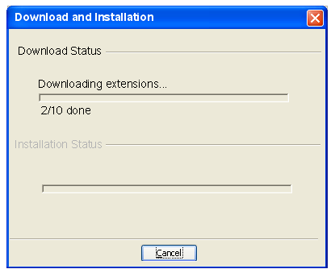

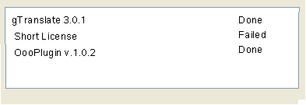
Figure 9: The progress of the download.
Details
OK
Abort Update
Details
Abort Update
OK
Big_Memory_v.1.7
Result
Downloading extensions...
Big_Memory_v.1.7
Cancel Update
OK

As long as the download and installation runs, the “OK” button is disabled. The “Cancel Update” button is enabled and has the focus for the “return” and “enter” key (default button).
Pressing the “Cancel Update” button will cancel the operation. If the button is being pressed at a time when installing is in progress, that is after completely downloading all extensions, then the current installation of the extension will be canceled and undone and no further updates are installed. All other extensions which have been installed before will remain unchanged. In other words, only the ongoing installation of a particular extension will be “rolled back”.
Errors which occur during downloading and installation are logged in the “Result” text area. The download and installation will go on nevertheless.

Table 7: User interface elements of figure 9
# | Type | Properties |  | Comment
<#> |  | Control Properties  State: modal  Closable: yes  Resizable: no  Always On Top: yes  A11Y Text: none  Other...:  HelpId: HID_DEPLOYMENT_GUI_UPDATEINSTALL
<#> |  | Download and Installation | Herunterladen und Installieren
<#> |  | Control Properties  Enabled: yes
<#> |  | String English  Downloading extensions... | String German  Herunterladen der Extensions... |  | This string is shown as long as the download is running. Then it changes dynamically to the string “Installing extensions...”
<#> |  | Control Properties  Enabled: yes
<#> |  | String English  Installing extensions... | String German  Installieren der Extensions...
<#> |  | Control Properties  Enabled: yes  Icon: no  Resizeable: no  Has Menu: no  Menu Items: none  ToolTipText: none |  |  | The button is disabled when the extension manager was started by unopkg and there was no office (which was started by the same user) running at that time.
<#> |  | String English  ~Help | String German  ~Hilfe
<#> |  | Control Properties  Enabled:  Icon: no  Resizeable: no  Has Menu: no  Menu Items: none  ToolTipText: none
<#> |  | String English  Cancel Update | String German  Update abbrechen
<#> |  | Control Properties  Enabled:  Icon: no  Resizeable: no  Has Menu: no  Menu Items: none  ToolTipText: none
<#> |  | String English  OK | String German  OK
<#> |  | Control Properties  Enabled: yes
<#> |  | String English  ~Result | String German  ~Ergebnis

The progress of downloading and installing happens within the same dialog. The names (display names) of the downloaded and installed extensions are displayed under the progress bar as shown in figure 9 and 10.
The progress bar shows the progress for the download of all extensions. The progress advances for every download and before the downloads starts. That this, when the first extension is being downloaded then the progressbar already shows a progress and when the last extension is being downloaded then the progressbar has already reached the maximum.
After the completion of the downloads the label “Downloading extensions” gets exchanged by the label “Installing extensions”. The label “Installing extensions” disappears, when the installations are complete.

Figure 10: The installation progress
Downloading extensions...
Big_Memory_v.1.7
Installing extensions...
Big_Memory_v.1.7
Installing extensions...

Stati of buttons

“Cancel Update” button: This button is the default button. When the dialog starts, the focus for “Return” and “Enter” is on this button. The actual keyboard focus is in the “Result” text area, so the user can scroll through the messages. During download and installation this button is enabled. After the installation has finished, this button becomes disabled.
“OK” button: Is disabled, as long as download and installation are running. After the installation has finished, this button becomes enabled and gets the focus.

Table 8: Tab order during downloading and installation (figure 9)
Tab Order | Comment
“Result” text area
“Help” button
“Cancel Update” button | This is the default button.

When the downloads and installations have been finished without errors, the dialog looks as below:

Figure 11: The installation has finished, an appropriate text appears.
OK
Abort Update
Abort Update
OK
Big_Memory_v.1.7
Cancel Update
Result
Installation finsihed
No errors.

Table 9: String list of figure 11
 | English | German | Comment
1 | Installation finished | Installation beendet

Table 10: Tab order of figure 11
Tab Order | Comment
“OK” button
“Result” text area
“Help” button

The following figure shows the dialog with the text area showing errors which may have occurred:

Figure 12: The enhanced dialog.
OK
Abort Update
Abort Update
OK
Big_Memory_v.1.7
Cancel Update
Result
Installation finsihed
No errors.

There are currently these errors:
- Error while downloading (see below)
- Error while installing (see below)
- License was declined (see below)

The error strings for case 1 and case 2 are composed of several strings taken from table 11. The message for an error during the downloads is composed of :
#1 +[ #3] + #4.
String 3 is optional. It is only used if there are more error information available.
The error message for case 2 is composed in this way:
#2 + [#3] + #4
String 3 is optional. It is only used if there are more error information available.

For example:

“Error while installing extension extension fail2.oxt. The error message is: An error occurred while enabling: t.rdb
The extension will not be installed.”

The error string for case 3 (license declined) is componsed of :
#5 + #4
Table 11: String list of figure 12
 | English | German | Comment
1 | Error while downloading extension %NAME. | Ein Fehler ist während des Herunterladens der Extension %NAME aufgetreten.
2 | Error while installing extension %NAME. | Ein Fehler ist während der Installation der Extension %NAME aufgetreten.
3 | The error message is: %MESSAGE | Die Fehlermeldung ist: | After this message the next string (4) shall be written in a new line because the %MESSAGE can be quite long and the next sentence may be overlooked.  %MESSAGE is not localized because it is taken from an Exception.
4 | The extension will not be installed. | Die Extension wird nicht installiert.
5 | The license agreement for extension %NAME was refused. | Die Lizensvereinbarung für Extension %NAME wurde abgelehnt.
6 | No errors occurred. | Es sind keine Fehler aufgetreten.

When an error occurs during installation, then it may happen that the previous version of the extension was already uninstalled. Because of the error the new version will not be installed. Therefore neither the old nor the new version is installed after the update operation. The user must then manually install the previous version again.
Currently the extension manager installs “damaged extensions”, for example, extensions with missing files. If the extension manager installs such an extension, then an update, which is damaged in the same way, will also be installed. If a damaged update is installed then the user must manually remove this extension and install the previous one.

The Update of a Web Based Extension

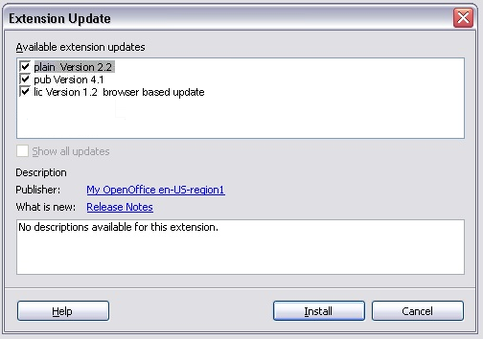Figure 13: An extension available as browser based update.

The figure 13 shows some further enhancements at the 'Extension Update' dialog.
In OpenOffice.org 2.4 it is possible to make visible extensions, which are updated via web, as e.g. the SunWeblogPublisher. Such an extension includes an URL, pointing to that web site, where the user has to do further interaction for an update. For updating such an extension the browser will start. The work flow of the update will be explained under 1.13.2.
The next change is the enlarged description box. This helps to have enough place to show the publisher and the link to the release notes and also further notes about errors, so that the user does not oversee such information. In case errors or other description text needs to be displayed of an extension together with the publisher and release notes, the description text appears under the publisher and release notes part and a line as seen in figure 12.
Table 12: String list of figure 13
 | English | German | Comment
1 | browser based update |  | The string appears besides the extension display name

The Work Flow of the Web Based Extension Update
When the user checks for extension updates by click on the Updates... button, the dialog 'Extension Update' opens.
For all installed extensions, which do not include web links, found updates are listed in that dialog.
At the moment the user starts the installation, the 'Extension Update' dialog is closed automatically and the download and installation starts. After the finish of installation the user closes this dialog.
Now the browser opens for updating the installed extensions, which include a web link. This means the browser opens as much new windows as the extensions to be updates have different links. The user now follows all required steps on the web page for updating that extension. After reopening the Extension Manager lists the new updates with new version numbers.
In case there are no “downloadable” extensions but others which need to be downloaded manually then the “Download and Install” window will not show. The web browser(s) will then be started immediately after pressing “Install” in the “Extension Update” dialog.

Several open dialog windows at the Web Based Extension Update
In case the Extension Manager (started from an office) and a further dialog as e.g. the 'Extension Update' or 'Add Extensions' dialog are open and the user furthermore starts the extension installation via system integration, e.g. Windows Explorer, a message appears explaining that the Extension Manager needs to be closed, before the installation can continue. [Note: not yet implemented]
The warning box message contains the following string:

String table
 | English | German | Comment
1 | You need to close the open Extension Manager to continue.

Warning at manipulating a shared extension
After the user has clicked the 'Update' button, the dialog 'Extension Update' opens. If updates for shared extensions are available , a warning box will appear, when the user clicks the 'Install' button. The warning box appearing in this case includes an OK button and a Cancel button. When the user presses 'OK' then the message box disappears and installation continues, otherwise the message box as well as the update dialog will be closed without updating anything.

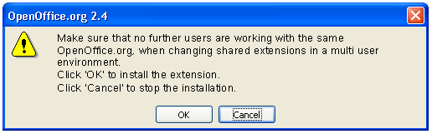
Figure 14: The warning box.
Click 'OK' to update the extensions.
Click 'Cancel' to stop updating the extensions.

 | English | German | Comment
1 | Make sure that no further users are working with the same %PRODUKTNAME, when changing shared extensions in a multi user environment./nClick 'OK' to update the extensions./nClick 'Cancel' to stop updating the extensions. |  | Was 'Before updating a shared extension, make sure that no further instances of %PRODUKTNAME are running.'

The message box is only displayed the first time the user presses the button during a session. If the same button is pressed again during the same session then the message box will not be displayed. For example, an extension is being installed under “OpenOffice.org Extensions” and no other share extension has been installed before while this office is running. The message box appears and the user either continues or cancels the action. While the office is still running he/she repeats this action. This time the message box will not be displayed. Also the user wants now to disable a previously installed share extension. When pressing the Disable button, the message box appears. But when he/she repeats this action for another shared extensions, then the message box will not appear anymore. Only after a restart of OOo, the message boxes will be displayed again when he respective button is being used for the first time..

An appropriate warning box appears, when an action is started on a selected shared extension in the Extension Manager. That is specified in the specification http://specs.openoffice.org/appwide/packagemanager/packagemanager_gui_spec.sxw.

Migration
<Start typing here ----- If this part is irrelevant state a reason for its absence!>

Configuration
<Start typing here ----- If this part is irrelevant state a reason for its absence!>
If a setting (this includes also user interface settings) has to be stored in the configuration check the following:
- Did I state the default, where setting has to be stored (configuration path)?
- Did I specify which data type it is?
- Did I specify when the setting is activate (restart of application, for all new documents/windows after the change, or also for all opened documents/windows)
- If it is a new / incompatible setting did I specify a migration path?
Example
Configuration | Group | Setting | Type | Default | Comment
Writer.xcs | Print | EmptyPages | Boolean | True | specifies the default for XYZ

File Format
<Start typing here ----- If this part is irrelevant state a reason for its absence!>

Open Issues
Issue | Initials | Date
Manual updates are currently not supported. That is, the extension manager will not display if a manual update is available. |  | <Format: Dec 31, 2000>
Shared extensions should become visible as such, e.g. by extending them with 'shared extension'. That would allow to let appear that message named in 1.14 only in case a shared extension is selected and not earlier, as it is currently the case.
The current solution showing a message box to let the user assure to close possible further instances is a temporarily one. Currently there is no opportunity to be aware of further open instances except of the own ones. This requires a further solution.
The message does currently not really help and is therefore not usable (BH).
A next issue is not to show any more the other entries (dll files, xcu-files...) under the *.oxt-file, as they don't really help the user.
Show the extensions display name instead of the file name. | 85373

Document Change History
Rev. | Change | Initials | Date
1 | small correction concerning description of suppress-on-update attribute. Description used wrong attribute name |  | Dec 20, 2006
2 | Fixed mockups to fit reality |  | Jul 20, 2007
3 | Changes according to i78688 and i79001 |  | Aug 13, 2007
4 | Correction concerning installation of shared extensions, when Extensions Manager was started from office. Changing chapter about build-in URL for update information. |  | Aug 29, 2007
5 | Adding web based update (i82775), release notes and publisher link (i81502), display name (i81326) |  | Nov 09, 2007
6 | Changing shared extensions as user with write rights: Changed the string for better understanding. |  | Feb 18, 2008

