Software Specification Document

OpenOffice.org
PDF Export Dialog

Specification Status
Last Change | Apr 5, 2007
Status

Abstract
OOo 2.0.3: The PDF Export dialog gets a bunch of additional options to control how the generated PDF document opens in Adobe Reader. They are layout and magnifications options, as well as options that control the user interface of Adobe Reader itself.
OOo 2.0.4: Security settings for PDF export dialog control the encryption level of the generated PDF. The idea is to implement encryption according to PDF version 1.4, in its basic incarnation.
OOo 2.2: Default zoom level and number of disclosed levels in bookmark hierarchy can be set.

i-Team Members
Role | First Name, Last Name, Initials | E-Mail Address
Project Lead | Philipp Lohmann /PL | pl@openoffice.org,
Specification Owner | Matthias Müller-Prove /MMP | mprove@sun.com,
User Experience | Matthias Müller-Prove /MMP | mprove@sun.com,
Development | Philipp Lohmann /PL  Giuseppe Castagno /beppec56 | pl@openoffice.org,  beppec56@openoffice.org,
Quality Assurance | Hasan Ilter /HI | hasan.ilter@sun.com,
Documentation | Uwe Fischer /UFI | uwe.fischer@sun.com,
Product Program Manager for Legal Aspects | Götz Wohlberg /GW | goetz.wohlberg@sun.com

Contents
Abstract 1
i-Team Members 1
References and Reference Documents 3
Acronyms and Abbreviations 3
1 Detailed Specification 4
1.1 Content of the PDF 4
1.2 Dialog 4
1.3 First Tab: General 4
1.4 Second Tab: Initial View 6
1.5 Third Tab: User Interface 12
1.6 Fourth Tab: Security Settings 15
1.6.1 Intro 15
1.6.2 Implementation 16
1.6.3 Some words on the passwords 16
1.6.4 Dialog Design 17
1.6.5 Password Dialog 20
1.6.6 Notes 20
1.6.7 Printing permissions 21
1.6.8 Configuration 21
2 Migration 21
3 Configuration 21
4 File Format 22
5 Open Issues 22
6 Competitive Analysis 23
6.1 OpenOffice.org 2.0.0 – 2.0.2 23
6.2 Adobe Acrobat 5 23
6.3 Adobe Acrobat 7 – German Version 24
7 Document Change History 24
7.1 Related PDF Specifications and Documents 25

References and Reference Documents
Reference Document | Check | Location (URL)
Specification Process Entry Check |  | N/A
Product Requirement,, RFE, issue (required) |  | OOo 2.0.3: i61139  OOo 2.0.4: i12626  OOo 2.2: i68581
Product Concept Document |  | <Please enter location here>
Competitive Analysis |  | see below
Test Case Specification (required) |  | http://www.openoffice.org/nonav/issues/showattachment.cgi/35389/pdf-export-test.html  http://www.openoffice.org/nonav/issues/showattachment.cgi/37957/pdf-export.html
Software Specification Rules | N/A | N/A
PDF Export OOo 2.0 |  | http://specs.openoffice.org/appwide/pdf_export/PDFExport.sxw
PDF Reference, third edition Adobe Portable Document Format Version 1.4

Acronyms and Abbreviations
Acronym / Abbreviation | Definition
OOo | OpenOffice.org
PDF | Portable Document Format
Permission password | Password of the document's owner, the person who can change the document permissions
Document Open Password | Password of the document's user, the person who can only “see” the document if she knows the user password.
iff | if and only if

Detailed Specification

Content of the PDF
Quote from PDF Export - UI specification v.1.0:
In general the content of the PDF file is equivalent to the output generated for printing. This means that invisible objects of a document are not part of the PDF file.

Dialog
The PDF Options dialog is a modal dialog.
Compared to OOo 2.0.0/2.0.2, the PDF Options dialog is expanded by 2 additional tabs. All controls of the former dialog are move to the first tab page of the new tab control.
The dialog has Export and Cancel buttons at the bottom. The online help can be called with the Help button at the bottom right of the dialog.
The settings made in the dialog are persistent from session to session. They are stored in OOo's configuration. The default values are defined in the string tables below.
The dialog always opens on the first tab page.

First Tab: General
Changes since 2.0.4:
- added option for exporting bookmarks or not
- added option to export form fields as PDF widget annotations or as simple print type fields (like in OOo 1.1)
- moved “Use transition effects” option to “Viewer preferences” tab page.
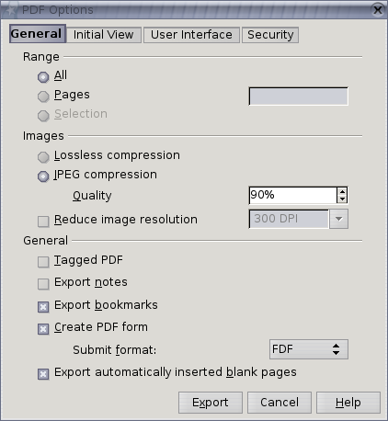Illustration 1: First Tab (snap shot; not final yet)

Table 1: User Interface elements of Figure Illustration 1: First Tab (snap shot; not final yet)
# | Type | Properties |  | Comment
<#> |  | Control Properties  State: modal  Closable: yes  Close Operation: Withdraw changes and close dialog  Is iconifiable: no  Is maximizable: no  Resizable: no  Always On Top: yes |  |  | dialog title
<#> |  | String English  PDF Options | String German  PDF Optionen |  | same as OOo 2.0.2
<#> |  | Control Properties  Icon: no  Enabled: yes
<#> |  | String English  E~xport | String German  Exportieren |  | same as OOo 2.0.2
<#> |  | Control Properties  Enabled: yes |  |  | tab title
<#> |  | String English  General | String German  Allgemein
<#> |  | Control Properties  Enabled: yes  Initially Checked: yes  TriState: no  ToolTip Text:  Other...:
<#> |  | String English  Export Bookmarks | String German  Lesezeichen exportieren
<#> |  | Control Properties  Enabled: yes  Initially Checked: yes  TriState: no  ToolTip Text:  Other...:
<#> |  | String English  Create PDF form | String German  PDF Formular erzeugen
<#> |  | Control Properties  Enabled: if “Create PDF form” is checked  Visible Row Count: 4  Item Selected: FDF  Enable Sorting by DnD: no  A11Y Text:  ToolTip Text:
<#> |  | String English  <Enter String Here> | String German  <Enter String Here>

Second Tab: Initial View
Comment: New for OOo 2.0.3
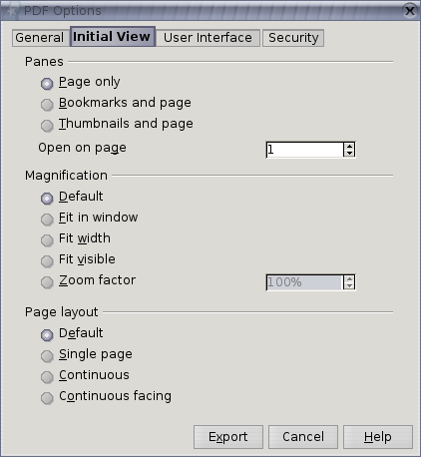Illustration 2: Second Tab

The option “First page is left” is only displayed in the dialog if “Tools-Options-Language Settings-Languages-Enabled for complex text layout” is marked.
If the option is marked than the PDF is displayed in the following way:
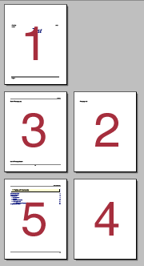Illustration 3: Page layout if first page is left

If the option is not visible and “Continuous facing” is marked, then the first page is displayed to the right.
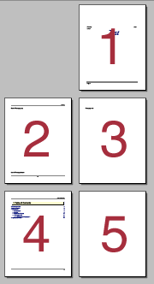Illustration 4: Page layout if "First page is left" is not marked or invisible
Changes since 2.0.4:
- added a zoom level option to “Magnification” section
- added an option to the “Panes” section to specify the first page that the reader application will show when it opens the exported PDF file.
The option “Open on page” defines the page that will be visible when the exported PDF document gets opened in the viewer application. (Comment: New for OOo 2.2)
If “Zoom factor” is selected, the initial zoom level of the PDF viewer application should be set to the specified value when the PDF file is opened. (Comment: New for OOo 2.2)

Table 2: User Interface elements of Figure Illustration 2
# | Type | Properties |  | Comment
<#> |  | Control Properties  Enabled: yes
<#> |  | String English  Initial View | String German  Anfangsdarstellung |  | tab title
<#> |  | Control Properties  Enabled: yes
<#> |  | String English  Panes | String German  Bereiche
<#> |  | Control Properties  Enabled: yes  Initially Marked: yes
<#> |  | String English  ~Page only | String German  Nur Seite
<#> |  | Control Properties  Enabled: yes  Initially Marked: no
<#> |  | String English  ~Bookmarks and page | String German  Lesezeichen-Fenster und Seite
<#> |  | Control Properties  Enabled: yes  Initially Marked: no
<#> |  | String English  ~Thumbnails and page | String German  Seiten-Fenster und Seite
<#> |  | Control Properties  Editable: yes  Enabled: yes  Minimum Value: 1  Maximum Value:  Start Value: 1  Steps: 1  Measurement unit: 1
<#> |  | String English  Open on page | String German  Öffnen auf Seite
<#> |  | Control Properties  Enabled: yes
<#> |  | String English  Magnification | String German  Vergrößerung
<#> |  | Control Properties  Enabled: yes  Initially Marked: yes
<#> |  | String English  ~Default | String German  Standard
<#> |  | Control Properties  Enabled: yes  Initially Marked: no
<#> |  | String English  ~Fit in window | String German  Fenstergröße
<#> |  | Control Properties  Enabled: yes  Initially Marked: no
<#> |  | String English  Fit ~width | String German  Fensterbreite
<#> |  | Control Properties  Enabled: yes  Initially Marked: no
<#> |  | String English  Fit ~visible | String German  Seitenbreite
<#> |  | Control Properties  Enabled: yes  Initially Selected: no
<#> |  | String English  ~Zoom factor | String German  Vergrößerungsstufe
<#> |  | Control Properties  Editable: yes  Enabled: iff “Zoom factor” is checked  Minimum Value: 50  Maximum Value: 1600  Start Value: 100  Steps: 1  Measurement unit: %  A11Y Text:  ToolTip Text:  Other...:
<#> |  | String English | String German
<#> |  | Control Properties  Enabled: yes
<#> |  | String English  Page layout | String German  Seitenlayout
<#> |  | Control Properties  Enabled: yes  Initially Marked: yes
<#> |  | String English  D~efault | String German  Standard
<#> |  | Control Properties  Enabled: yes  Initially Marked: no
<#> |  | String English  ~Single page | String German  Einzelne Seite
<#> |  | Control Properties  Enabled: yes  Initially Marked: no
<#> |  | String English  ~Continuous | String German  Fortlaufend
<#> |  | Control Properties  Enabled: yes  Initially Marked: no
<#> |  | String English  C~ontinuous facing | String German  Fortlaufend - Doppelseiten
<#> |  | Control Properties  Enabled: if and only if the option “Continuous facing” is marked  Initially Checked: no  TriState: no
<#> |  | String English  First page is ~left | String German  Erste Seite ist links

Third Tab: User Interface
Changes for OOo 2.2:
- added section “Transition effects” with option to use transition effects (moved from general page)
- added section “Bookmarks” with number of visible bookmark levels when the reader application opens the exported PDF file

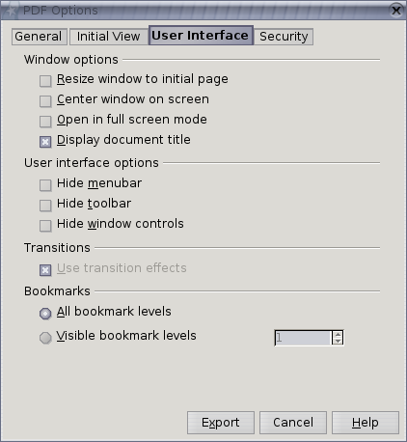Illustration 5: Third Tab

Table 3: User Interface elements of Figure Illustration 5
# | Type | Properties |  | Comment
<#> |  | Control Properties  ToolTip Text: <If needed Specify text here>  Acc. Descrip.: <If needed specify text here>  Acc. Text: <If needed specify text here>  Enabled: yes
<#> |  | String English  User Interface | String German  Benutzeroberfläche |  | tab title
<#> |  | Control Properties  ToolTip Text: <If needed Specify text here>  Acc. Descrip.: <If needed specify text here>  Acc. Text: <If needed specify text here>  Enabled: yes
<#> |  | String English  Window options | String German  Fensteroptionen
<#> |  | Control Properties  Enabled: yes  Initially Marked: no  TriState: no  ToolTip Text: <If needed specify tip here>  Acc. Descrip.: <If needed specify text here>  Acc. Text: <If needed specify text here>  Other...: <If needed specify here>
<#> |  | String English  ~Resize window to initial page | String German  Fenster an erste Seite anpassen
<#> |  | Control Properties  Enabled: yes  Initially Marked: no  TriState: no  ToolTip Text: <If needed specify tip here>  Acc. Descrip.: <If needed specify text here>  Acc. Text: <If needed specify text here>  Other...: <If needed specify here>
<#> |  | String English  ~Center window on screen | String German  Fenster auf Bildschirm zentrieren
<#> |  | Control Properties  Enabled: yes  Initially Marked: no  TriState: no  ToolTip Text: <If needed specify tip here>  Acc. Descrip.: <If needed specify text here>  Acc. Text: <If needed specify text here>  Other...: <If needed specify here>
<#> |  | String English  ~Open in full screen mode | String German  Im Vollbildmodus öffnen
<#> |  | Control Properties  Enabled: yes  Initially Marked: yes  TriState: no  ToolTip Text: <If needed specify tip here>  Acc. Descrip.: <If needed specify text here>  Acc. Text: <If needed specify text here>  Other...: <If needed specify here>
<#> |  | String English  ~Display document title | String German  Dokumenttitel anzeigen
<#> |  | Control Properties  ToolTip Text: <If needed Specify text here>  Acc. Descrip.: <If needed specify text here>  Acc. Text: <If needed specify text here>  Enabled: yes
<#> |  | String English  User interface options | String German  Benutzeroberflächenoptionen
<#> |  | Control Properties  Enabled: yes  Initially Marked: no  TriState: no  ToolTip Text: <If needed specify tip here>  Acc. Descrip.: <If needed specify text here>  Acc. Text: <If needed specify text here>  Other...: <If needed specify here>
<#> |  | String English  Hide ~menubar | String German  Menüleiste ausblenden
<#> |  | Control Properties  Enabled: yes  Initially Marked: no  TriState: no  ToolTip Text: <If needed specify tip here>  Acc. Descrip.: <If needed specify text here>  Acc. Text: <If needed specify text here>  Other...: <If needed specify here>
<#> |  | String English  Hide ~toolbar | String German  Werkzeugleisten ausblenden
<#> |  | Control Properties  Enabled: yes  Initially Marked: no  TriState: no  ToolTip Text: <If needed specify tip here>  Acc. Descrip.: <If needed specify text here>  Acc. Text: <If needed specify text here>  Other...: <If needed specify here>
<#> |  | String English  Hide ~window controls | String German  Fenstersteuerelemente ausblenden
<#> |  | Control Properties  Enabled: Yes
<#> |  | String English  Transition effects | String German  Übergangseffekte
<#> |  | Control Properties  Enabled: if document to be exported is a presentation  Initially Checked: yes  TriState: no  ToolTip Text:  Other...:
<#> |  | String English  Use transition effects | String German  Übergangseffekte benutzen
<#> |  | Control Properties  Enabled: yes
<#> |  | String English  Bookmarks | String German  Lesezeichen
<#> |  | Control Properties  Enabled: yes  Initially Selected: yes  ToolTip Text:
<#> |  | String English  ~All bookmark levels | String German  Alle Lesezeichenebenen
<#> |  | Control Properties  Enabled: yes  Initially Selected: no  ToolTip Text:
<#> |  | String English  ~Visible bookmark levels | String German  Aufgeklappte Lesezeichenebenen
<#> |  | Control Properties  Editable: yes  Enabled: iff “Visible bookmark levels” is selected  Minimum Value: 1  Maximum Value: 10  Start Value: 1  Steps: 1  Measurement unit: 1  A11Y Text:  ToolTip Text:  Other...:
<#> |  | String English | String German

Fourth Tab: Security Settings
Comment: New for OOo 2.0.4
Comment: The following sections are copied and edited from beppec56's spec draft v1.1 for security settings.

Intro
A PDF file can be encrypted to protect its content from unauthorized access.
The various aspects of the encryption and access control in a viewer are implemented through a software module called security handler.
There can be different security handler implementations, among them:
- Standard security handler. It permits access permissions and two passwords for a documents.
- Public key security handler. In this case the public key technology is used to encrypt a document and it's possible to specify a list of recipients, each list have its own access permissions. In this every list of recipients can be associated to different access permissions.
- Crypt filters (only PDF vers. 1.6). They permit a finer granularity over the document encryption. Every single stream can have its own filter.

Implementation
It's my opinion that currently only the Standard security handler should be implemented, for the following reasons:
- it gives two passwords protection with access permissions, sufficient for most uses;
- the building blocks needed are already present in OOo (MD5 digest, ARCFOUR cypher, the AES as specified on PDF v.1.6 is not yet available on OOo's source tree);
- the consumer applications (that is, the viewers) are all expected to support the Standard security handler;
- from what I'm seeing in issues i12626 and the other duplicates of it, it's what users request;
- it was relatively simple to implement in OOo (meaning that as of today I've already done most of the “grunt” work needed );
- keeping it to PDF v1.4, only ARCFOUR (RC4 compatible) encryption is provided.
For a detailed description of the encryption implementation, please see chapter 3.5 of PDF specification version 1.4.

Some words on the passwords
Implementing standard security means giving two access levels: owner and user and two different passwords, one for the owner permission level, the other for the user level.
The owner is defined as the person who can change the document permissions, so this password can be named “Permission password”; the user is defined as the person who can only “see” the document if she knows the user password, so we'll have a “Document Open Password”.
The PDF specification documents don't say anything about the passwords: you can leave the passwords blank (empty), I think that the encryption without at least the Permission Password is meaningless: you end up with a PDF document with fixed permissions, that can be changed simply by giving an empty Permission Password to the application used to edit the PDF.
MMP 7-Jul-2006: If just the Open Password is set, then you get a protected PDF that can only be opened by the person who knows the Open Password. This does make sense.
beppec56: true
If neither Open Password nor Permission Password is set, then you get an encrypted file without any security. This might make sense to prevent search engine tools from indexing your PDF file.
beppec56: Having neither open nor permission passwords set you end up with a file that has permission set as requested, but anyone can read it and anyone can modify those permission. This is an effect of the PDF spec implementation.
So if the search engines are smart enough to use the encryption PDF algorithm, they can easily index the PDF document by applying the algorithm with blank password. This worked so for a filter provided from Adobe years back.
MMP: // not sure if I still understand what I just wrote. It depends on the treatment of empty passwords.
beppec56: see rows 113 and 116 below.
Maybe, it's something that can be left to the user, a decision wether this PDF implementation permits empty or not Permission password should be made.
If the Document open password is left blank, than no Document open password will be needed to open the PDF, but the Permission password will still be needed to change the permissions.
That means a PDF file that can be opened by everyone.
If there is a Document open password but not a Permission password, then according to the PDF specification the Permission password is forced equal to the Document open password; that means there is a single password to operate on the document. (the same to open and change permissions)
The encryption is done “on the fly”, that is while exporting to PDF the file is encrypted; this may lead to a longer saving time when the file is saved as encrypted PDF compared to the non encrypted one, especially with huge files.

Dialog Design
The UI is basically built adding a tab to the dialog as it is in OOo 2.0.3.
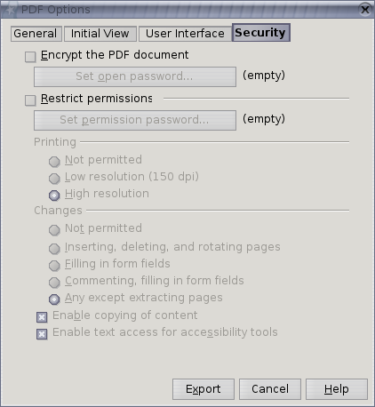Illustration 6: Password Security Tab (mockup, Jul 7, 2006

Comment. The dialogs box is 20 unit higher that the current one in OOo 2.0.3, whereas the width is the same.
Table 4: User Interface elements of Illustration 6
# | Type | Properties |  | Comment
1 |  | Control Properties |  |  | Tab page title
1 |  | String English  Security | String German  Sicherheit
2 |  | Control Properties  Enabled: yes  Initially Checked: no, and not persistent
2 |  | String English  ~Encrypt the PDF document | String German  PDF-Dokument ~verschlüsseln
3 |  | Control Properties  Icon: no  Enabled: iff #2 is marked
3 |  | String English  Set ~open password... | String German  Öffnen-~Passwort setzen
4 |  | Control Properties  Enabled: yes  Initially Checked: no, and not persistent
4 |  | String English  ~Restrict permissions | String German  ~Rechtevergabe
5 |  | Control Properties  Icon: no  Enabled: iff #4 is marked
5 |  | String English  Set ~permission password... | String German  R~echte-Passwort setzen
6 |  | Control Properties  Enabled: iff #4 is marked AND #5 is not empty
6 |  | String English  Printing | String German  Drucken
7 |  | Control Properties  Enabled: iff #4 is marked AND #5 is not empty  Initially Marked: no
7 |  | String English  ~Not permitted | String German  ~Nicht gestattet
8 |  | Control Properties  Enabled: iff #4 is marked AND #5 is not empty  Initially Marked: no
8 |  | String English  ~Low resolution (150 dpi | String German  N~iedrige Auflösung (150 dpi)
9 |  | Control Properties  Enabled: iff #4 is marked AND #5 is not empty  Initially Marked: yes
9 |  | String English  ~High resolution | String German  ~Hohe Auflösung
10 |  | Control Properties  Enabled: iff #4 is marked AND #5 is not empty
10 |  | String English  Changes | String German  Än~derungen
11 |  | Control Properties  Enabled: iff #4 is marked AND #5 is not empty  Initially Marked: no
11 |  | String English  No~t permitted | String German  Ni~cht gestattet
12 |  | Control Properties  Enabled: iff #4 is marked AND #5 is not empty  Initially Marked: no
12 |  | String English  ~Inserting, deleting, and rotating pages | String German  Einfügen, Löschen und Rotieren von ~Seiten
13 |  | Control Properties  Enabled: iff #4 is marked AND #5 is not empty  Initially Marked: no
13 |  | String English  ~Filling in form fields | String German  ~Formulare ausfüllen
14 |  | Control Properties  Enabled: iff #4 is marked AND #5 is not empty  Initially Marked: no
14 |  | String English  ~Commenting, filling in form fields | String German  ~Kommentieren und Formulare ausfüllen
15 |  | Control Properties  Enabled: iff #4 is marked AND #5 is not empty  Initially Marked: no
15 |  | String English  ~Any except extracting pages | String German  ~Alles, bis auf Extrahieren von Seiten
16 |  | Control Properties  Enabled: iff #4 is marked AND #5 is not empty  Initially Marked: yes
16 |  | String English  Ena~ble copying of content | String German  Inha~lt kopieren erlauben
17 |  | Control Properties  Enabled: iff #4 is marked AND #5 is not empty  Initially Marked: yes
17 |  | String English  Enable text access for acce~ssibility tools | String German  Mit Unterstützung der ~Zugänglichkeit
18 |  | Control Properties  Enabled: yes  Visible: iff password is empty |  |  | string behind the password buttons
18 |  | String English  (empty) | String German  (leer)

The Security panes behaves a little different than the other PDF Export panes. Not all settings are kept for later use (with other words: not all settings are stored in the configuration)
#2 (Encrypt) and #4 (Restrict permissions) are always unmarked if the PDF Export dialog comes up.
The passwords (related to #3 and #5) are always empty when the dialog comes up. The passwords need to be entered each time for encryption or restricting the permissions.
All other settings are kept in the configuration for a future use of the dialog.

Password Dialog
The Password dialog is used to set either the Open Password or the Permission Password – the title of the dialog reflects this. It is possible to enter an empty password.

Illustration 7: Password dialog (prototype June 2006)

Table 5: User Interface elements of Illustration 7
# | Type | Properties |  | Comment
<#> |  | Control Properties  State: modal  Closable: yes  Close Operation: do nothing  Is iconifiable: no  Is maximizable: no  Resizable: no  Always On Top: yes
<#> |  | String English  Set Open Password | String German  Öffnen-Passwort setzen |  | window title
<#> |  | Control Properties
<#> |  | String English  Set Permission Password | String German  Rechte-Passwort setzen |  | window title

If the Permissions Password dialog delivers an empty password, then the checkbox #4 Restrict Permissions is unmarked.

Notes
- beppec56: the password should need a double input, to confirm. I'm trying to figure out a way to do this.
MMP: I suppose this is not necessary. Passwords can be empty. The UI of the Security panel can deal with this situation.
- beppec56: how the passwords are saved in config ? Encrypted ? How ? Currently they are saved in clear text.
MMP: I suggest not to save them anywhere. (see above)
bepper56: OK.

The option described above can be mixed together.

Printing permissions
There is a permission selection that results in high or low resolution printing.
This behavior is honored by Acrobat reader only when printing in Windows. On Unix system the Acro reader prints only in high resolution, the behavior in Mac system is unknown to me. (see Appendix H, note 16 on PDF ref. V. 1.4 )
The High/Low resolution printing behavior is not honored at all by xpdf, gpdf and kpdf. That is they print always in high resolution, whatever the selection.

Configuration
Will be provided as soon as I'll have the English strings frozen, I'd like to use a similar text for the configuration item names.
MMP:

Migration
n/a

Configuration
The following configuration items affect PDF export and correspond to the UI controls in the dialog. The items are to be found at the path org.openoffice.Office/Common/PDF/Export
"UseLosslessCompression" oor:type="xs:boolean" default: false: Specifies if graphics are exported to PDF using a lossless compression eg. PNG or if they are compressed using the JPEG format.
"Quality" oor:type="xs:int" default: 90: Specifies quality of the JPG export. A higher value results in higher quality and file size.
"ReduceImageResolution" oor:type="xs:boolean" default: false : Specifies if the resolution of each image is reduced to the resolution specified by the property MaxImageResolution.
"MaxImageResolution" oor:type="xs:int" default: 300: If the property ReduceImageResolution is set to true all images will be reduced to the given value in DPI.
"UseTaggedPDF" oor:type="xs:boolean" default: false: Determines if PDF are created by using special tags also known as Tagged PDF.
"ExportNotes" oor:type="xs:boolean" default:false Specifies if notes are exported to PDF.
"ExportNotesPages" oor:type="xs:boolean" default:false: Specifies if notes pages are exported to PDF. (Notes pages are available in Impress documents only).
"ExportBookmarks" oor:type="xs:boolean" default:true Specifies if bookmarks are exported to PDF.
"OpenBookmarkLevels" oor:type="xs:int" default: -1: Specifies how many bookmark levels should be opened in the reader application when the PDF gets opened. -1 means all levels, non-negative numbers mean the respective number of levels.
"UseTransitionEffects" oor:type="xs:boolean" default: true: Specifies slide transitions are exported to PDF. This option is active only if storing Impress documents.
"ExportFormFields" oor:type="xs:boolean" default:true Specifies whether form fields are exported as widgets or only their fixed print representation is exported.
"FormsType" oor:type="xs:int" default: 0: Specifies the submitted format of a PDF form. Values are: "0" for FDF format,"1" for PDF format, "2" for HTML format, "3" for XML format
"IsSkipEmptyPages" oor:type="xs:boolean" default: false: Specifies that automatically inserted empty pages are suppressed. This option is active only if storing Writer documents.
"HideViewerMenubar" oor:type="xs:boolean" default: false: Specifies whether to hide the PDF viewer menubar when the document is active.
"HideViewerToolbar" oor:type="xs:boolean" default: false: Specifies whether to hide the PDF viewer toolbar when the document is active.
"HideViewerWindowControls" oor:type="xs:boolean" default: false: Specifies whether to hide the PDF viewer controls when the document is active.
"ResizeWindowToInitialPage" oor:type="xs:boolean" default: false: Specifies that the PDF viewer window is opened full screen when the document is opened.
"CenterWindow" oor:type="xs:boolean" default: false: Specifies that the PDF viewer window is centered to the screen when the PDF document is opened.
"OpenInFullScreenMode" oor:type="xs:boolean" default: false: Specifies that the PDF viewer window is opened full screen, on top of all windows.
"DisplayPDFDocumentTitle" oor:type="xs:boolean" default: true: Specifies that the title of the document, if present in the document properties, is displayed in the PDF viewer window title bar.
"FirstPageOnLeft" oor:type="xs:boolean" default: false: Used with the value 3 of the PageLayout property when the first page (odd) should be on the left side of the screen.
"InitialView" oor:type="xs:int" default: 0: Specifies how the PDF document should be displayed when opened. "0" meaning neither outlines or thumbnails, "1" meaning the document is opened with outline pane opened, "2" meaning the document is opened with thumbnail pane opened
"Magnification" oor:type="xs:int" default: 0: Specifies the action to be performed when the PDF document is opened, "0" meaning opens with default zoom magnification, "1" meaning opens magnified to fit the entire page within the window, "2" meaning opens magnified to fit the entire page width within the window, "3" meaning opens magnified to fit the entire width of its boundig box within the window (cuts out margins), “4” means with a zoom level given in the “Zoom” property.
“Zoom” oor:type=”xs:int” default: 100: Specifies the zoom level a PDF document is opened with. Only valid if "Magnification" is set to "4".
"PageLayout" oor:type="xs:int" default: 0: Specifies the page layout to be used when the document is opened, "0" meaning display the pages according to the reader configuration, "1" meaning display one page at a time, "2" meaning display the pages in one column, "3" meaning display the pages in two columns odd pages on the right, to have the odd pages on the left the FirstPageOnLeft properties should be used as well.
"InitialPage" oor:type="xs:int" default: 1: Specifies the page on which a PDF document should be opened in the viewer application.

File Format
n/a

Open Issues
Issue | Initials | Date
APOC settings | MMP | Mar 8, 2006

Competitive Analysis

OpenOffice.org 2.0.0 – 2.0.2
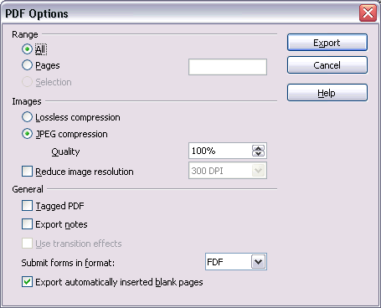Illustration 8: PDF Options Dialog in OOo 2.0.2

Adobe Acrobat 5
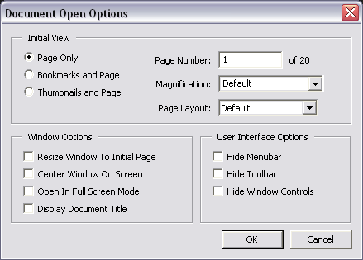Illustration 9: Document Options Dialog in Adobe Acrobat 5

Adobe Acrobat 7 – German Version
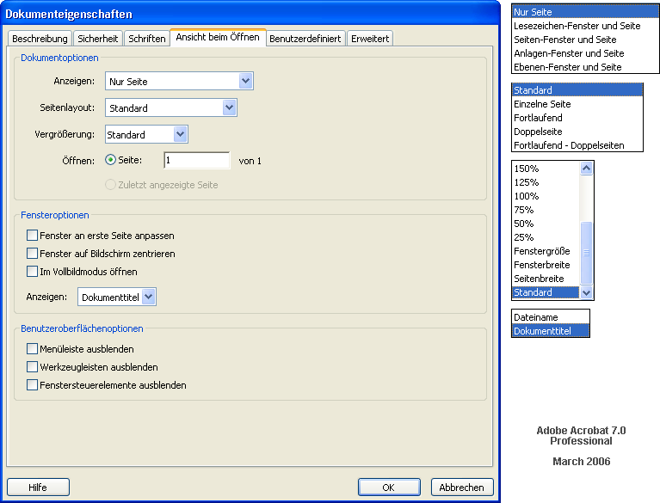Illustration 10: Document Properties Dialog of Adobe Acrobat 7 Professional

Document Change History
Rev. | Change | Initials | Date
1 | new spec and capture state of the patch as a starting point. | MMP | Mar 6, 2006
2 | completed i-Team | MMP | Mar 8, 2006
3 | added string tables for English  PL provided the configuration settings.  Mnemonics for English strings  removed Reset button  default values are defined in the string tables. | MMP | Mar 9, 2006
4 | Added German screen shot of Adobe Acrobat 7 to Competitive Analysis  Final proposal for English and German strings  “Main reading order for text” becomes a checkbox on the second tab.  Request for approval | MMP | Mar 10, 2006
5 | added latest screen shots; changed configuration too match new UI  word DirectionR2L should be changed to FirstPageOnLeft. | beppec56 | Mar 11, 2006
6 | approved by UFI, beppec56  Help button is bottom left  Changes in German strings “Benutzungs-” to “Benutzer-”  “First page is left” depends on CTL setting | MMP | Mar 13, 2006
7 | Help button is (and stays) bottom right | MMP | Mar 14, 2006
8 | review by Frank Loehmann  new default value for ExportNotes  UseTaggedPDF=true wouls increase the file size significantly. | MMP | Mar 15, 2006
9 | spec status change to “standard” | MMP | Mar 16, 2006
10 | test case URL added | MMP | Mar 30, 2006
11 | Incorporate beppec56's spec draft v1.1 for security settings  Adjust panel layout, terminology and interactive logic  Set Password dialog  German strings  Mnemonics for English and German strings | MMP | Jul 7, 2006
12 | added link toi Hasan's Test Description | MMP | Jul 31, 2006
13 | added new fields for bookmarks, form fields, zoom level and first page | PL | Oct 20, 2006
14 | Spec review by MMP, see tracked changes | MMP | Nov 6, 2006
15 | Add section of “past” PDF specifications and supporting documents below.  Quote general statement of PDF content in section 1.1 | MMP | Nov 13, 2006

Related PDF Specifications and Documents
PDF Export - UI specification v.1.0 , 29-Nov-2002, Ooo333 1.x / StarOffice 6.x
PDF Export - UI specification v.1.1 , 4-Nov-2003, OOo 1.1 / StarOffice 6.x
PDF Export Minutes, 28-Nov-2003
PDF Export 11-Oct-2005
Outline Style Font Quality for PDF Export
Acrobat7-Security.odg

File Menu

Acrobat Reader handles open bookmark levels “0” and “1” the same: the first level is visible

