Software Specification Document

OpenOffice.org Calc
Collaboration

Specification Status
Last Change | Jan 6, 2009
Status
Abstract
In a global world, collaboration becomes even more important. The collaboration feature for OOo allows to share and work simultaneously on a single spreadsheet. Furthermore it allows to share documents in any system environment and prevents documents from being overwritten by others (i.e. if the used file system does not support a reliable file locking).
i-Team Members
Role | First Name, Last Name, Initials | E-Mail Address
I-Team Lead | Thomas Benisch (TBE) | thomas.benisch@sun.com
Specification Author | Frank Loehmann (FL) | frank.loehmann@sun.com
User Experience | Frank Loehmann (FL) | frank.loehmann@sun.com
Development | Thomas Benisch (TBE) | thomas.benisch@sun.com
Quality Assurance | Oliver Craemer (OC)  Thomas Klarhoefer | oliver.craemer@sun.com  thomas.klarhoefer@sun.com
Documentation | Uwe Fischer (UFI) | uwe.fischer@sun.com

Contents
Abstract 1
i-Team Members 1
References and Reference Documents 4
Acronyms and Abbreviations 4
1 Usage Scenarios 4
1.1 Simultaneous Offline Access 4
1.1.1 Scenario G “Merge on Save as...” 4
1.1.2 Scenario H “Merge with...” 4
1.2 Simultaneous Online Document Access 5
1.2.1 Scenario I “Access Rights on Table Basis 1” 5
1.2.2 Scenario J “Access Rights on Table Basis 2” 5
1.2.3 Scenario K “Security 2” 5
1.2.4 Scenario L “Automatic Update on Re-Calc” 5
1.2.5 Scenario M “Automatic Update on Saving Document” 5
1.2.6 Scenario N “Periodic Merge” 5
1.2.7 Scenario O “Live Update” 5
1.2.8 Scenario P “Publish Versions” 5
1.2.9 Scenario Q “Who Is working on that document?” 5
1.2.10 Scenario R “Remove User from Shared Document” 6
1.2.11 Scenario S “Join Shared Document” 6
1.3 Requirements Distilled from Above Scenarios 6
2 Technical Limitations 8
2.1 General 8
2.2 Calc 8
2.2.1 Action Limitations 8
2.2.2 Format/Object Limitations 9
3 Detailed Specification 10
3.1 Workflow 10
3.1.1 Application Wide File Locking 10
3.1.2 Calc Collaboration 10
3.1.2.1 Activate Sharing for a Spreadsheet 11
3.1.2.2 Deactivate Sharing of a Shared Spreadsheet 12
3.1.2.3 File Open 13
3.1.2.4 File Close 14
3.1.2.5 File Save 14
3.2 Dialogs 15
3.2.1 Dialog #1.1: Share Document Dialog 15
3.2.2 Dialog #1.2: Save Dialog 17
3.2.3 Dialog #1.4: Save Spreadsheet to Activate Sharing 17
3.2.4 Dialog #4.1: Formatting and Drawing Could Not Be Saved in Shared Mode 18
3.2.5 Dialog #5.1: Resolve Conflicting Changes 19
3.2.6 Dialog #5.2: Locked Document Due to Merge in Progress 21
3.2.7 Dialog #5.3: Foreign Changes Have Been Added 22
3.2.8 Dialog #5.4: Loose Changes 22
3.2.9 Dialog #5.5: Document is No Longer Shared When Saving Document 23
3.2.10 Dialog #6.1 Shared Mode Could not be Disabled 24
3.2.11 Dialog #6.2: Disable Shared Mode and Save Document? 25
3.2.12 Dialog #7: Change Password of a Spreadsheet in Shared Mode 25
3.3 Main Menu Integration 26
3.4 Application Window Title 26
4 Migration 27
5 Configuration 27
6 File Format 27
7 Open Issues and Change History 28
Document Change History 29
8 Future Feature Description 30
8.1 Future Scenarios 30
8.1.1 File Save 30
8.2 Future Dialog Mock-ups 30
8.2.1 Dialog #3.1: Document Could Not be Saved 30
8.2.2 Dialog #6.2: Disable Shared Mode and Save Document? 31

References and Reference Documents
Reference Document | Check | Location (URL)
Specification Process Entry Check |  | N/A
Product Requirement, RFE, issue [Required] |  | 8811,i95809
Product Concept Document |  | <Please enter location here>
Competitive Analysis |  | <Please enter location here>
IDL Specification |  | <Please enter location here>
Test Case Specification [Required] |  | http://www.openoffice.org/nonav/issues/showattachment.cgi/51910/TestCaseSpecification_Collaboration.htm
Software Specification Rules | N/A | N/A
Module Name in Caption Bar specification |  | Http://specs.openoffice.org/appwide/module_name_in_caption_bar/module_name_in_caption_bar.odt
File Locking Specification |  | http://specs.openoffice.org/appwide/fileIO/File_Locking.odt
Acronyms and Abbreviations
Acronym / Abbreviation | Definition
<WYSIWYG> | <What You See Is What You Get>

Usage Scenarios
The following scenarios will help to build a list of requirements. There are three different higher level scenarios divided in sub scenarios.

Simultaneous Offline Access
Sharing of a document on content level without simultaneous access to the document. The following scenarios should be supported:

Scenario G “Merge on Save as...”
User G is on a business travel without file access to the servers of her company. Thus she receives a document by e-mail. She made changes to the document and stores the document on her notebook. When returning to her office she want to save the document on the file server, where the original document is stored. She is not sure if anybody else made a change to this document in the meantime when she was out of the office. Now she is not sure whether she should overwrite the file on the server.

Scenario H “Merge with...”
User H receives an e-mail with an attached document. This document is a branch of a document she has also edited on her laptop. Now she wants to merge these two documents, before she applies further changes.

Simultaneous Online Document Access
Simultaneous document sharing on a document content level. The following scenarios should be supported:
Base scenario for all following scenarios: User A, B and C are working on the same project. They use a spreadsheet to keep the financial aspects of their project always up-to-date. All project members have access to the file location of that spreadsheet and need simultaneous access to the file.
The data edited by the different users affects each other.

Scenario I “Access Rights on Table Basis 1”
Each user works on a single table of the shared spreadsheet. The project overview data condenses this data to a metric that can be viewed by the responsible project manager.

Scenario J “Access Rights on Table Basis 2”
Each user works on a single table of the shared spreadsheet. The project overview data condenses this data to a metric that can be viewed by the responsible project manager. This metric must be visible to the project manager only.

Scenario K “Security 2”
Each user works on a single table of the shared spreadsheet. The project overview data condenses this data to a metric that can be viewed by the responsible project manager only, because the data is sensible.

Scenario L “Automatic Update on Re-Calc”
She did not save the document since she opened it in the morning, but she calls the manual re-calc function of Calc, but the result still remains the same wrong value.

Scenario M “Automatic Update on Saving Document”
User M knows that other team members made changes to the shared spreadsheet. He saves the document containing his changes. After saving, the spreadsheet is up-to-date again and contains all other changes.

Scenario N “Periodic Merge”
User B want the spreadsheet to be updated/merged back automatically on a periodic basis.

Scenario O “Live Update”
User C wants the spreadsheet to be updated/merged live to all shared client documents.

Scenario P “Publish Versions”
User B wants to publish a special version of the document. Therefore the versions feature is used to set the version to be published. The team continues working on further versions in that spreadsheet, not visible to the outside until they get published.

Scenario Q “Who Is working on that document?”
User C wants to see who is working on the current document.

Scenario R “Remove User from Shared Document”
User C knows that user A is not working on the document, but he is still listed on that document for some reason. User C wants to remove A from the list of editors.

Scenario S “Join Shared Document”
User A wants to rejoin his version of the document to the shared spreadsheet again.

Requirements Distilled from Above Scenarios
Each main requirement must be backed by a valid scenario.
- Be able to see who is currently locking the document for editing. Show:
  - full name (preferred if present) or system name
  - date stamp
  - time stamp
- Be able to remove user from list of editors <Target: Later>
- Re join with a document to a shared document <Target: Later>
- Access control for spreadsheets on a table basis <Target: Later>
- Allow to compare documents before overwriting a document with the Save as... function. <Target: Later>
- Ability to merge a document on saving a file over an existing document file. <Target: Later>
- Allow to compare/merge current document with another document.
- Merge documents on saving:
  - merge documents automatically (option)
  - ask to resolve merge conflicts manually (option):
    - once per conflict
    - all own changes win
    - all other changes win
- Update local document:
    - automatically on saving
    - automatically triggered by a timer <Target: Later>
    - automatically (live) <Target: Later>
    - manually (request) <Target: Later>
      - when doing a manually triggered re-calc of the spreadsheet <Target: Later>
      - before printing <Target: Later>
      - before sending (File – Send) <Target: Later>
      - when reloading document
      - when exporting to a different file format
    - manually if requested by user (menu/button) <Target: Later>

Technical Limitations
Change tracking currently does not record all actions done while editing a spreadsheet. The collaboration feature uses change tracking to merge in locally made changes to the master document. Thus the collaboration feature strongly depends on the ability to track changes without losing actions. Therefore change tracking capabilities have to be extended or the user has to be prevented to take actions which would be lost on merging back the changes.

General
A password cannot be assigned/changed, if the file is in shared mode. If the user tries to change/assign the/a password, the following dialog is shown.

Calc

Action Limitations
The following actions are not supported when change tracking or collaboration is active. The corresponding UI will be disabled.
  - Edit/Paste Special...: shift cells down/right
  - Edit/Fill/Series...
  - Edit/Delete Cells...: shift cells up/left
  - Edit/Sheet/Move/Copy...
  - Moving of tables within the document (drag&drop)
  - Edit/Sheet/Delete...
  - Insert/Cells...: shift cells down/right
  - Format/Merge Cells
  - merging cells, cancelling the merging of cells
  - Data/Sort...
  - Sort Ascending/Descending
  - Data/Subtotals...
  - Data/Multiple Operations...
  - Apply multiple operations in columns or rows
  - Data/Consolidate...
  - The contents of the cells from several sheets will be combined in one place
  - Data/Group and Outline/Group
  - Define the selected cell range as a group of rows or columns
  - Data/Group and Outline/AutoOutline
  - Data/DataPilot/Start...
  - DataPilot tables
  - Data/DataPilot/Refresh
  - Data/DataPilot/Delete
  - DataPilot Filter
  - Data/Refresh Range
  - Update a data range that was inserted from an external database
  - Refresh Data Import

Format/Object Limitations
The following actions are not supported when change tracking or collaboration is active. However, they are not disabled. Any changes will be lost after saving.
- Formatting
- Drawing Objects
This is a critical issue, but UI cannot be disabled on all UI occurrences. Thus a dialog is shown as a work around if a spreadsheet gets opened in shared mode.

Detailed Specification

Workflow
Graphs of expected workflow for the OpenOffice.org collaboration feature.

Application Wide File Locking
See separate File Locking specification for details.

Calc Collaboration
This section describes the workflow for the content sharing for OpenOffice.org Calc. This collaboration feature is only available for Calc Spreadsheets. Thus only Calc spreadsheet files can be in shared mode.

Activate Sharing for a Spreadsheet
The following graph shows the workflow of activating the shared mode for a spreadsheet.
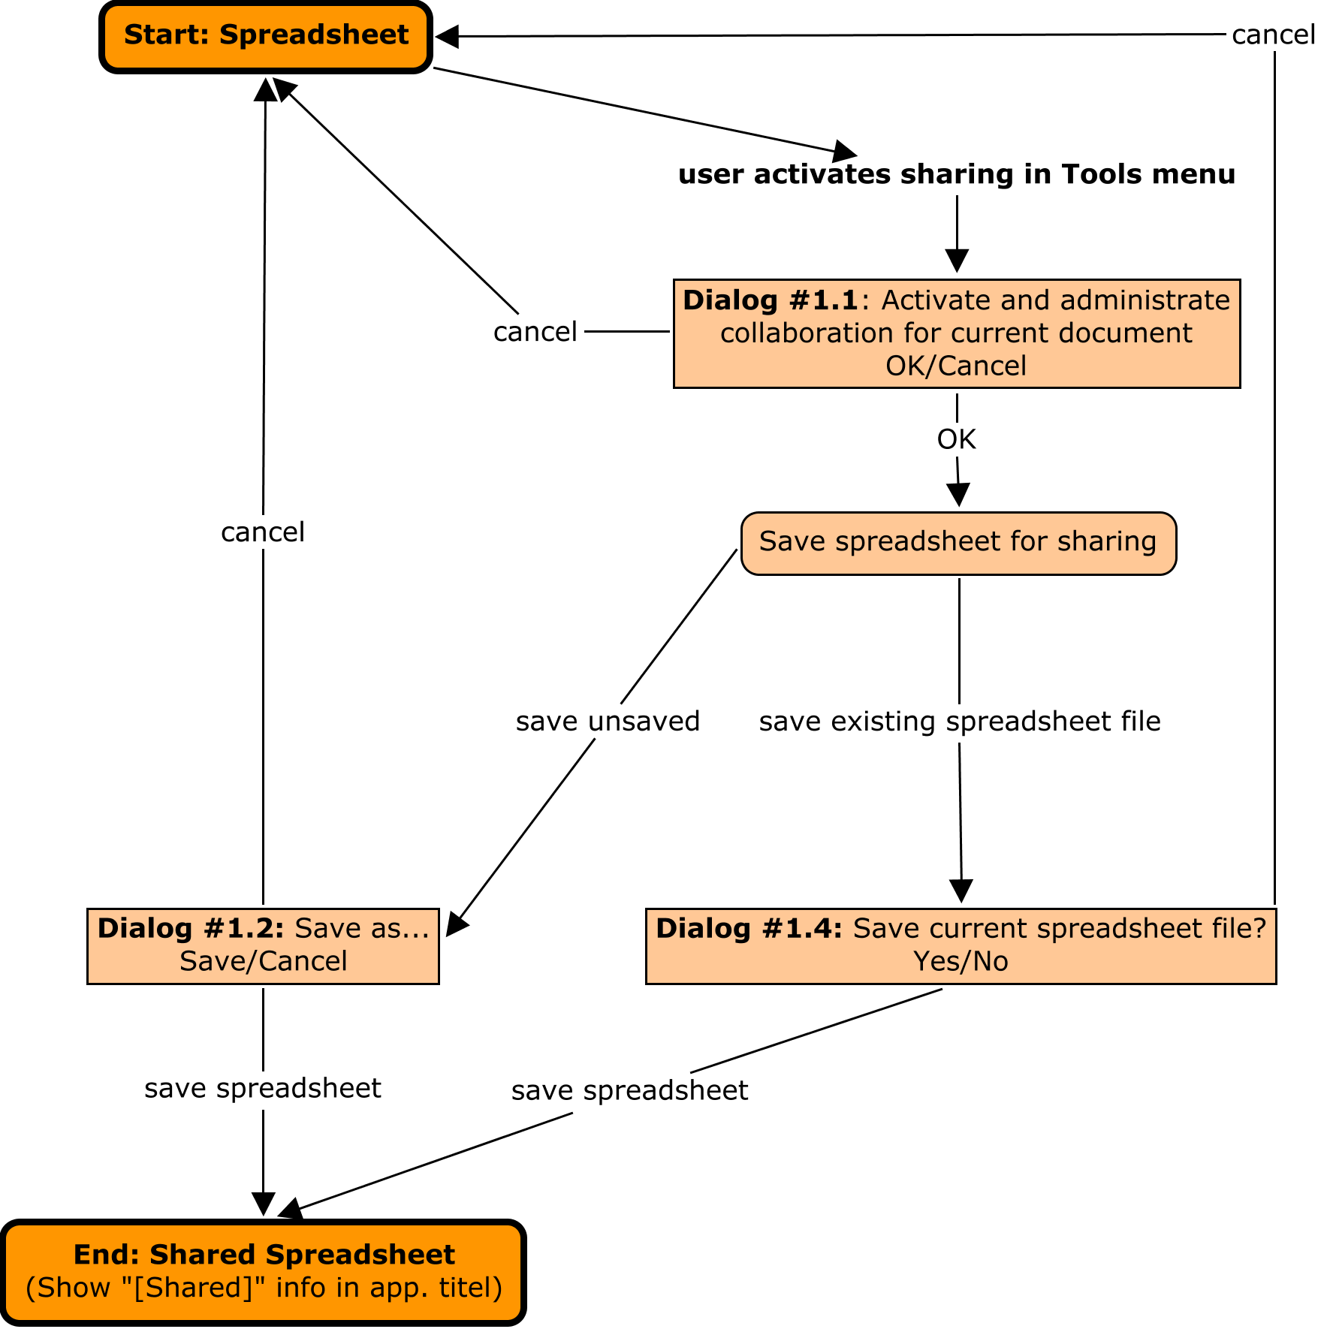Illustration 1: Workflow for activating the shared mode for a spreadsheet

Deactivate Sharing of a Shared Spreadsheet
The following graph shows the workflow of deactivating the shared mode of a shared spreadsheet.
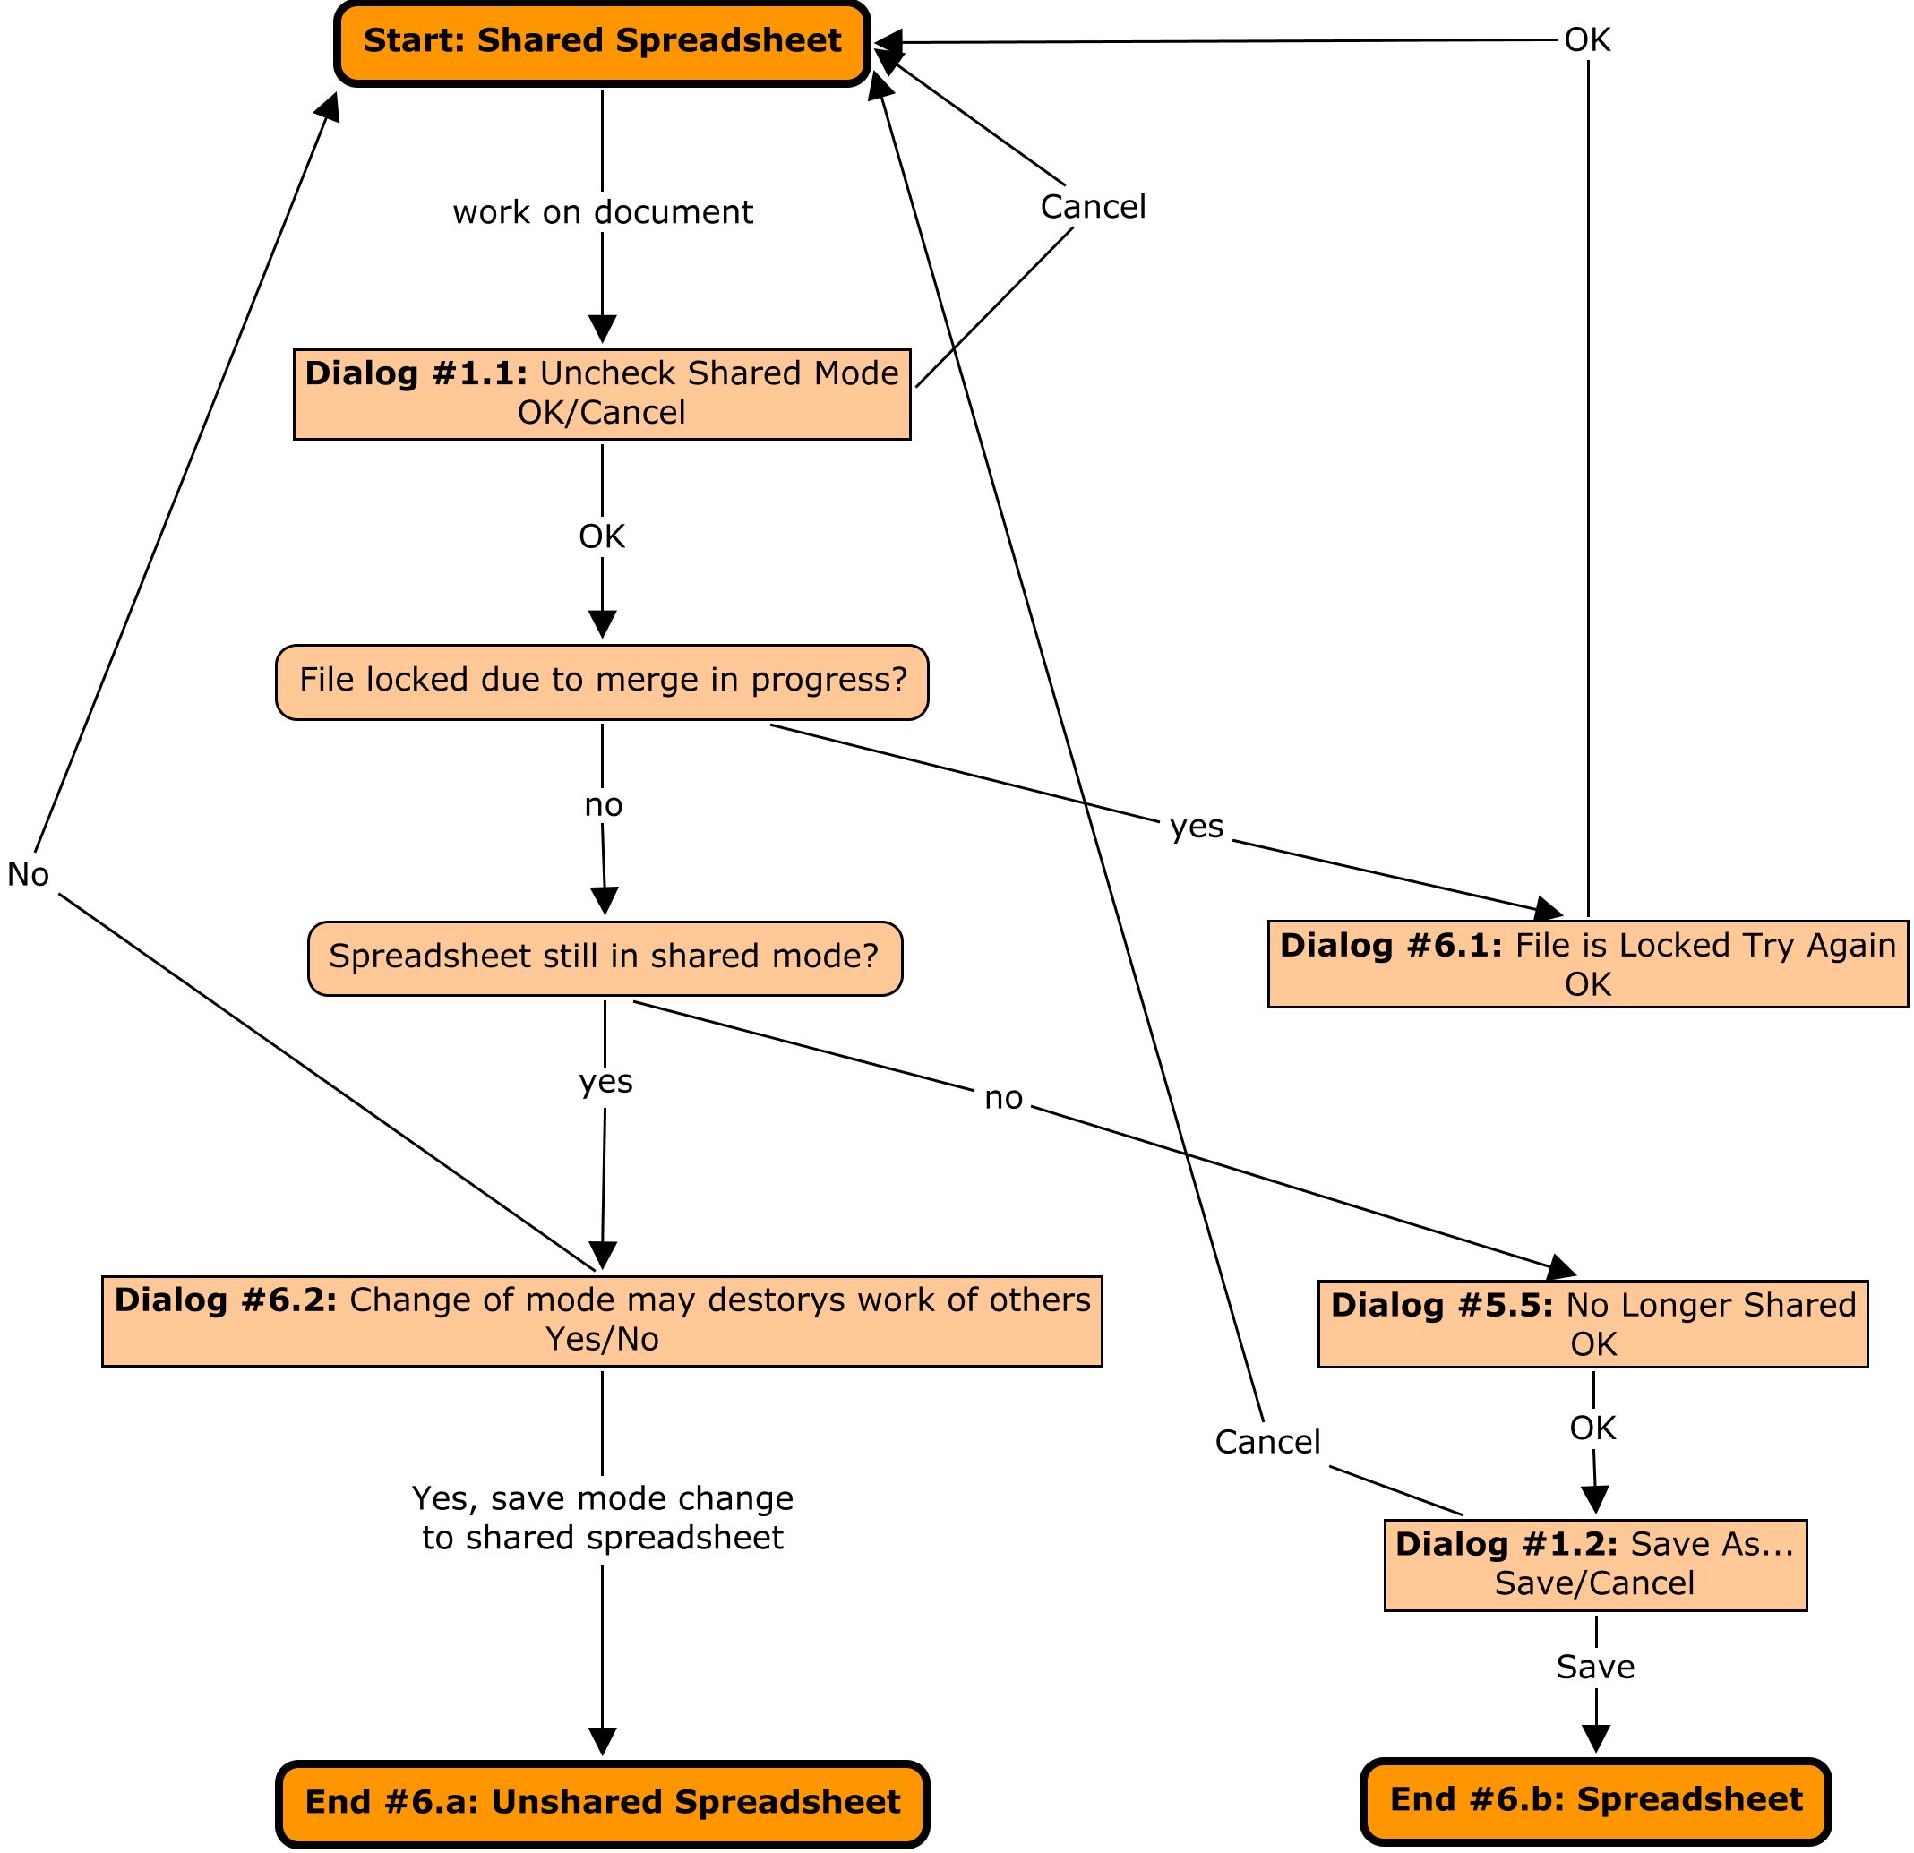Illustration 2: Deactivate sharing

File Open
The following graph shows the workflow when opening a spreadsheet file in shared mode.
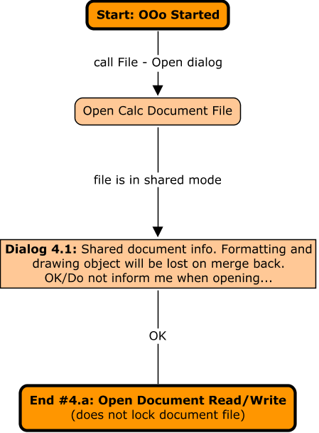Illustration 3: Open a shared spreadsheet

File Close
On a File-Close the File Save Scenario below is called, if the file is modified. An unmodified spreadsheet will be closed like any other document without a request.

File Save
The following graph shows the workflow when saving a spreadsheet file in shared mode.
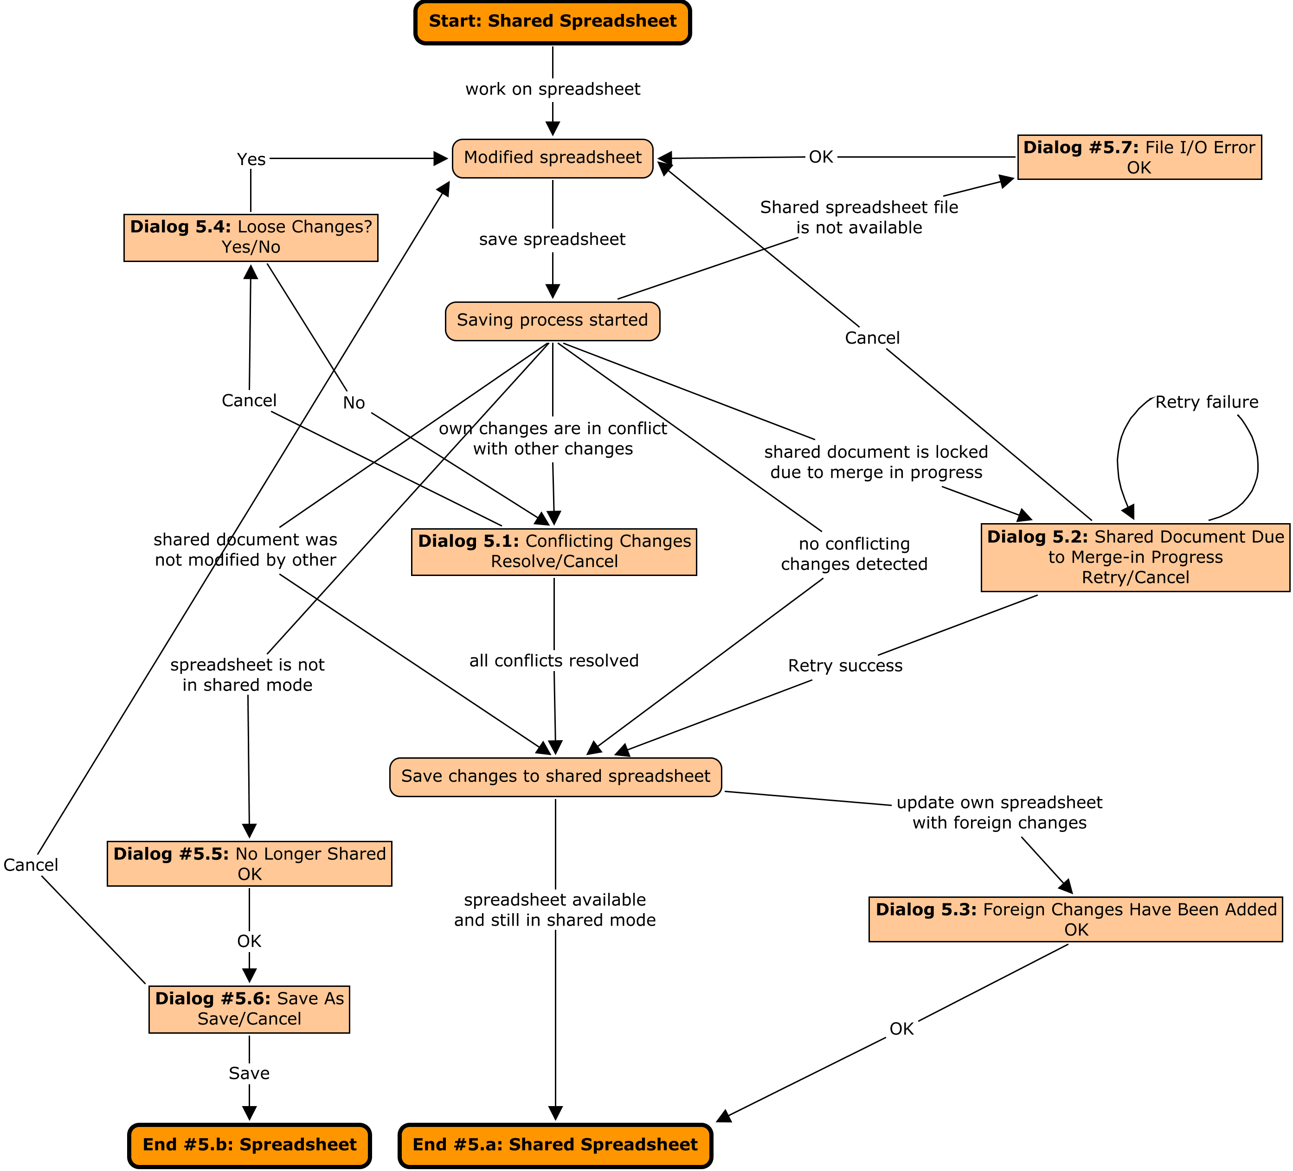Illustration 4: Save a shared spreadsheet

Dialogs
Please see Workflow section above when one of the following dialog is shown during the collaboration scenarios.

Dialog #1.1: Share Document Dialog
The following dialog is shown, if the menu entry Tools – Share Document is called.
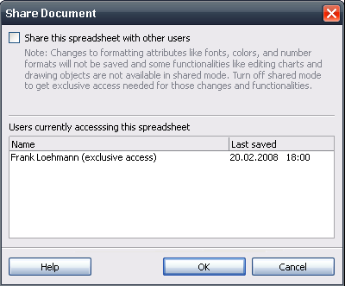Illustration 5: Exclusive access (default)
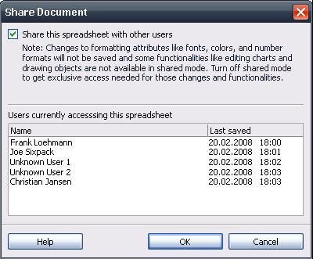Illustration 6: Shared mode for spreadsheet is active

If no user name can be determined the string “Unknown User”+” “+n is displayed.
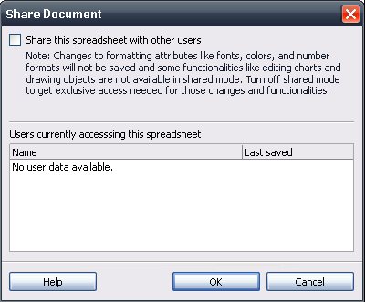Illustration 7: No user data available
- “Share Document” - Dialog Properties |  | Comment
State: | Modal
Type: | Dialog
Closable: | Yes
Resizable: | No
Titel: | Share Document | EN-US
- Share” - CheckBox Properties |  | Comment
Enabled: | Always
Disabled: | Newer
Tri-State: | Newer
Checked: | If checked by user
CheckBox Label: | Share this spreadsheet with other users | EN-US
- “Note” - Text Properties |  | Comment
Enabled | If check box #2 is checked
Label: | Note: Changes to formatting attributes like fonts, colors, and number formats will not be saved and some functionalities like editing charts and drawing objects are not available in shared mode. Turn off shared mode to get exclusive access needed for those changes and functionalities. | EN-US
- “Current Users” - ListBox Properties |  | Comment
Enabled: | Always
Disabled: | Newer
Max. Row Count: | -
Rows Visible: | See mock-up
Heading A | Name
Heading B | Accessed
Items: | List of users accessing the document (see mock-up) | EN-US, DE
String Added | (exclusive access) | Added to name if check box #2 is not checked
Item Selected: | None
Sorting by Drag & Drop: | No
ListBox Label: | Users currently accessing this spreadsheet | EN-US
- “No user data available” - Warning Text Properties |  | Comment
Visible | If no user data is available from file locking mechanism.
Label: | No user data available. | EN-US
- “Help” - Button Properties |  | Comment
Enabled: | Always
Disabled: | Newer
Press: | Help system is called showing help for collaboration feature
Button Label: | Help | EN-US
- “OK” - Button Properties |  | Comment
Enabled: | Always
Disabled: | Newer
Press: | Dialog gets confirmed and closed
Button Label: | OK | EN-US
- “Cancel” - Button Properties |  | Comment
Enabled: | Always
Disabled: | Newer
Press: | Withdraw changes and close dialog
Button Label: | Cancel | EN-US

Dialog #1.2: Save Dialog
The default Save as... dialog is shown to save the spreadsheet.

Dialog #1.4: Save Spreadsheet to Activate Sharing
The following dialog is shown, if the sharing mode is activated for a already present spreadsheet file.
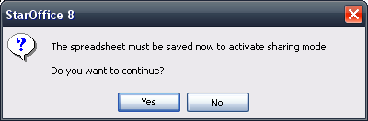Illustration 8: Save spreadsheet to activate sharing dialog
- “Save Spreadsheet to Activate Shared” - Notification Dialog Properties |  | Comment
State: | Modal
Type: | Notification Dialog
Closable: | Yes
Resizable: | No
Titel: | %PRODUCTNAME %PRODUCTVERSION | EN-US
- “Notice Text” - Label Properties |  | Comment
Label: | The spreadsheet must be saved now to activate sharing mode.\n\nDo you want to continue? | EN-US

Dialog #4.1: Formatting and Drawing Could Not Be Saved in Shared Mode
The following dialog is shown, if a shared spread is loaded.
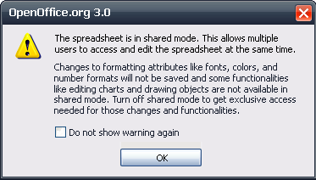Illustration 9: Warning that formatting and drawing objects will be lost
- “Not In Shared” - Notification Dialog Properties |  | Comment
State: | Modal
Type: | Notification Dialog
Closable: | Yes
Resizable: | No
Titel: | $PRODUCTNAME $PRODUCTVERSION | EN-US
- “Notice Text” - Label Properties |  | Comment
Label: | The spreadsheet is in shared mode. This allows multiple users to access and edit the spreadsheet at the same.\n\nChanges to formatting attributes like fonts, colors, and number formats will not be saved and some functionalities like editing charts and drawing objects are not available in shared mode. Turn off shared mode to get exclusive access needed for those changes and functionalities. | EN-US
- Show this warning again” - CheckBox Properties |  | Comment
Enabled: | Always
Disabled: | Newer
Tri-State: | -
Checked: | -
CheckBox Label: | Do not show warning again | EN-US

Dialog #5.1: Resolve Conflicting Changes
The Conflicting changes dialog is resizeable and all nodes are elapsed by default. If a conflict gets selected, the corresponding cell is selected and shown in Calc. The dialog will be closed, if the last conflict has been resolved.
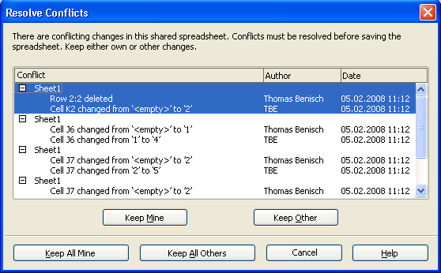Illustration 10: Conflicting changes dialog
If no author (user) name can be determined, the string “Unknown User” is displayed.
- “Resolve Conflicts” - Dialog OR Window Properties |  | Comment
State: | Modal
Type: | Dialog
Closable: | Yes
Resizable: | Yes
Titel: | Resolve Conflicts | EN-US
- “Intro” - Label Properties |  | Comment
Label: | There are conflicting changes in this shared spreadsheet. Conflicts must be resolved before saving the spreadsheet. Keep either own or other changes. | EN-US
- “Conflict” - ListBox Properties |  | Comment
Enabled: | Always
Disabled: | Newer
Max. Row Count:
Rows Visible: | 3,5 entries visible in default dialog size
Items: | - <Sheet_name>  - <Comment string from merge for user A>  - <Comment string from merge for other user (B)> | EN-US
Item Selected: | 1
Sorting by Drag & Drop: | No
Other: | Node and leaves are selected as one. No multi selection of nodes possible.
ListBox Label: |  | EN-US
- “Keep Mine” - Button Properties |  | Comment
Enabled: | Always
Disabled: | Newer
Press: | Currently selected conflict gets resolved by accepting own change.
Button Label: | Keep ~Mine | EN-US
- “Keep Other” - Button Properties |  | Comment
Enabled: | Always
Disabled: | Newer
Press: | Currently selected conflict gets resolved by accepting other users change.
Button Label: | Keep ~Other | EN-US
- “Keep All Mine” - Button Properties |  | Comment
Enabled: | Always
Disabled: | Newer
Press: | All own changes will win and the dialog gets closed.
Button Label: | ~Keep All Mine | EN-US
- “Keep All Others” - Button Properties |  | Comment
Enabled: | Always
Disabled: | Newer
Press: | All other changes will win and the dialog gets closed.
Button Label: | Keep ~All Others | EN-US
- “Close” - Button Properties |  | Comment
Enabled: | Always
Disabled: | Newer
Press: | Dialog gets closed.
Button Label: | Close | EN-US
- “Help” - Button Properties |  | Comment
Enabled: | Always
Disabled: | Newer
Press: | Help system is called.
Button Label: | Help | EN-US

Dialog #5.2: Locked Document Due to Merge in Progress
The following dialog is shown, if a merged spreadsheet could not be saved due to a merge in progress by another user.
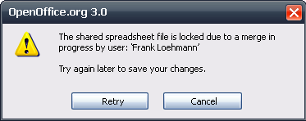Illustration 11: Merge in progress dialog
If no user name can be determined the string “Unknown User” is displayed.
- “Locked Document” - Dialog Properties |  | Comment
State: | Modal
Type: | Dialog
Closable: | Yes
Resizable: | No
Title: | $PRODUCTNAME $PRODUCTVERSION | EN-US
- “Message Text” - Text Properties |  | Comment
Label: | The shared spreadsheet file is locked due to a merge in progress by user: '$USERNAME' | EN-US
- “Text” - Text Properties |  | Comment
Label: | Try again later to save your changes. | EN-US
- “Retry” - Button Properties |  | Comment
Enabled: | Always
Disabled: | Newer
Press: | Retry later to save changes to shared document.
Button Label: | Retry | EN-US
- “Cancel” - Button Properties |  | Comment
Enabled: | Always
Disabled: | Newer
Press: | Close dialog and cancel save operation. Document is still modified.
Button Label: | Cancel | EN-US

Dialog #5.3: Foreign Changes Have Been Added
The following dialog is shown, after a shared spreadsheet has been saved and the local spreadsheet has been updated with changes made by other users.
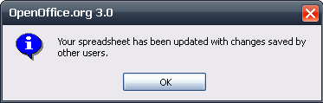Illustration 12: Foreign Changes Have Been Added Notice Dialog
- “Foreign Changes Have Been Added” - Dialog Properties |  | Comment
State: | Modal
Type: | Dialog
Closable: | Yes
Resizable: | No
Title: | $PRODUCTNAME $PRODUCTVERSION | EN-US
- “Message Text” - Text Properties |  | Comment
Label: | Your spreadsheet has been updated with changes saved by another users. | EN-US
- “OK” - Button Properties |  | Comment
Enabled: | Always
Disabled: | Newer
Press: | Close dialog
Button Label: | OK | EN-US

Dialog #5.4: Loose Changes
The following dialog is shown, if the Resolve Conflicts dialog has been canceled and there are already resolved conflicts.
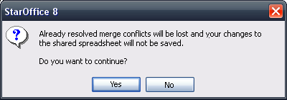Illustration 13: Loose Changes
- “Loose Changes?” - Dialog Properties |  | Comment
State: | Modal
Type: | Dialog
Closable: | Yes
Resizable: | No
Title: | $PRODUCTNAME $PRODUCTVERSION | EN-US
- “Message Text” - Text Properties |  | Comment
Label: | Already resolved merge conflicts will be lost and your changes to the shared spreadsheet will not be saved.\n\nDo you want to continue? | EN-US
- “Yes” - Button Properties |  | Comment
Enabled: | Always
Disabled: | Newer
Press: | Merge in will be aborted
Button Label: | Yes | EN-US
- “No” - Button Properties |  | Comment
Enabled: | Always
Disabled: | Newer
Press: | Resolve Conflicts dialog (#5.1) reappears and already resolved conflicts are kept.
Button Label: | No | EN-US

Dialog #5.5: Document is No Longer Shared When Saving Document
The following dialog is shown, if the shared spreadsheet is not in shared mode anymore.
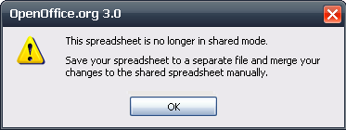Illustration 14: Not a shared spreadsheet dialog
- “No longer shared” - Warning Dialog Properties |  | Comment
State: | Modal
Type: | Dialog
Closable: | Yes
Resizable: | No
Title: | $PRODUCTNAME $PRODUCTVERSION | EN-US
- “Message Text” - Text Properties |  | Comment
Label: | This spreadsheet is no longer in shared mode.\n\nSave your spreadsheet to a separate file and merge your changes to the shared spreadsheet manually. | EN-US
- “OK” - Button Properties |  | Comment
Enabled: | Always
Disabled: | Newer
Press: | Close dialog and Save as dialog is shown pointing to the 'My Documents' folder.
Button Label: | OK | EN-US

Dialog #6.1 Shared Mode Could not be Disabled
The following dialog is shown, if a sharing mode has been turned off by the user, but the shared spreadsheet could not be accessed due to merge in progress.
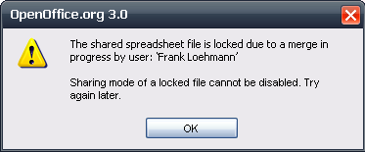Illustration 15: Shared mode could not be disabled – file locked
If no user name can be determined the string “Unknown User”.
- “No longer shared” - Warning Dialog Properties |  | Comment
State: | Modal
Type: | Dialog
Closable: | Yes
Resizable: | No
Title: | $PRODUCTNAME $PRODUCTVERSION | EN-US
- “Message Text” - Text Properties |  | Comment
Label: | The shared spreadsheet file is locked due to a merge in progress by user: '$USERNAME' | EN-US
- “Text” - Text Properties |  | Comment
Label: | Sharing mode of a locked file cannot be disabled. Try again later. | EN-US
- “OK” - Button Properties |  | Comment
Enabled: | Always
Disabled: | Newer
Press: | Close dialog
Button Label: | OK | EN-US

Dialog #6.2: Disable Shared Mode and Save Document?
The following dialog is shown, if the sharing mode has been turned off by the user.
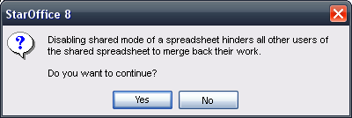Illustration 16: Disable Shared Mode?
- “Disable Sharing Mode?” - Query Dialog Properties |  | Comment
State: | Modal
Type: | Dialog
Closable: | Yes
Resizable: | No
Title: | $PRODUCTNAME $PRODUCTVERSION | EN-US
- “Message Text” - Text Properties |  | Comment
Label: | Disabling shared mode of a spreadsheet hinders all other users of the shared spreadsheet to merge back their work.\n\nDo you want to continue? | EN-US
- “Yes” - Button Properties |  | Comment
Enabled: | Always
Disabled: | Newer
Press: | Save document
Button Label: | Yes | EN-US
- “No” - Button Properties |  | Comment
Enabled: | Always
Disabled: | Newer
Press: | Close dialog. Sharing will not be disabled.
Button Label: | No | EN-US

Dialog #7: Change Password of a Spreadsheet in Shared Mode
The following dialog is shown, if user tries to assign/change a password of a spreadsheet in shared mode.
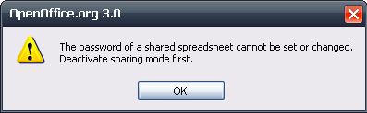Illustration 17: Assign password in shared mode
- “No longer shared” - Warning Dialog Properties |  | Comment
State: | Modal
Type: | Dialog
Closable: | Yes
Resizable: | No
Title: | $PRODUCTNAME $PRODUCTVERSION | EN-US
- “Message Text” - Text Properties |  | Comment
Label: | The password of a shared spreadsheet cannot be set or changed./nDeactivate sharing mode first. | EN-US
- “OK” - Button Properties |  | Comment
Enabled: | Always
Disabled: | Newer
Press: | Close dialog and aborts saving
Button Label: | OK | EN-US

Main Menu Integration
The Tools menu gets extended by the following two entries.
- “Tools” - Menu Properties |  |  |  |  | Comment
Menu Title: | Tools |  |  |  | EN-US
Menu Position: | Main menu of Calc
Menu Items:
Items | Sub Items | Sub Items | KBD Shortcuts | Icon | Comment
Scenarios
-----------------------
S~hare Document... |  |  |  |  | Calls dialog #5.6. (Disabled in read-only)
Merge Documen~t... |  |  |  |  | Calls an open dialog to select a file for merging  (Disabled in read-only)
Protect Document |  | Sheet, Document
-----------------------

Application Window Title
If a spreadsheet is in shared mode, the window title shows the string “(shared)”. See Module Name in Caption Bar specification for details.

Migration
None. New feature.

Configuration
None.

File Format
None.

Open Issues and Change History
Issue | Initials | Date
Technical limitations of the track changes feature in Calc are problematic for the collaboration feature. User has to be prevented from losing data. | FL | January 04, 2008
Share, Protect and Merge 'Document' should be spreadsheet | FL | February 20, 2008
Resolve Conflict on saving does not allow to resolve part of conflicts (Close Button) | FL | February 20, 2008
Ask for user name when not filled in | FL | February 26, 2008
Generic warning dialog should be reworked to a small width and with default spacing to buttons | FL | February 28, 2008
Simplify strings used in accept reject dialog and show only change last made by user A and B | FL | February 28, 2008
Select file to merge into current document | FL | February 28, 2008
Change “Do not show this warning again” to a positively formulated message like “Show this warning again” | FL | February 28, 2008
Show who locked a file when saving failed due to a locked file (Dialog #3.1) | FL | February 28,2008
... and save document when deactivating shared mode note | FL | February 28,2008
Disable drawing tool bar in Collaboration mode. | FL | May 19, 2008
General
Disable functionality which is not recorded by change tracking drawing layer | OC
Don't open Accept/Reject Changes dialog via Tools/Merge Document... | OC | I86679
Locked due to a merge' message box shows 'unknown user' instead of username | OC | I86681
2 Users changes cell to same value => keep mine will restore old value | OC
Calc: merge algorithm
move range and insert content in from range is not merged correctly | OC | I86676
conflict between delete row and insert content is not merged correctly | OC
Calc: enhance change tracking
formatting attributes | OC
Framework: file locking
Implement file locking based on separate lock file (i85794) | OC | I85794
Opening shared document with a non-collaborating version destroys shared mode | OC | I86674
Framework: temp file handling
File/Reload | OC | I86672
File/Save As... | OC
File Recovery | OC | I86677
File Recent documents | OC
Framework: control file handling
change extension for shared control file | OC | I86631
Document Change History
Rev. | Change | Initials | Date
1 | Initial specification | FL | December 14, 2007
2 | Working on TBE's feedback on Scenarios | FL | January 03, 2008
3 | Further work on the scenarios and limitation section | FL | January 04, 2008
4 | Worked on feature requirements section | FL | January 09, 2008
5 | Worked on work flow diagrams | FL | January 14, 2008
6 | Worked on the conflicting changes dialog | FL | January 14, 2008
7 | Worked on work flow diagrams | FL | January 17, 2008
8 | Add dialog #5.2 | FL | February 11, 2008
9 | Add dialog #5.3 and #5.4 | FL | February 19, 2008
10 | Add dialog #1.x | FL | February 19, 2008
11 | Shared Document Dialog | FL | February 21, 2008
12 | Work on file locking | FL | February 22, 2008
13 | Work on dialogs | FL | February 25, 2008
14 | Changed text in dialog | FL | February 27, 2008
15 | Work on workflow to turn off sharing mode | FL | February 28, 2008
16 | Work on review by TBE | FL | February 29, 2008
17 | Set to standard | FL | March 06, 2008
18 | Rework notice in collaboration administration dialog | FL | May 19, 2008
19 | Enable System File Locking in Addition (i95809) | FL | November 14, 2008
20 | Create separate specification for File Locking mechanism | FL | November 18, 2008
21 | Add dialog #7(#91306) | FL | January 6, 2009

Future Feature Description
Not implemented yet!

Future Scenarios
Not implemented yet!

File Save
The following graph shows the workflow when saving an ODF file.
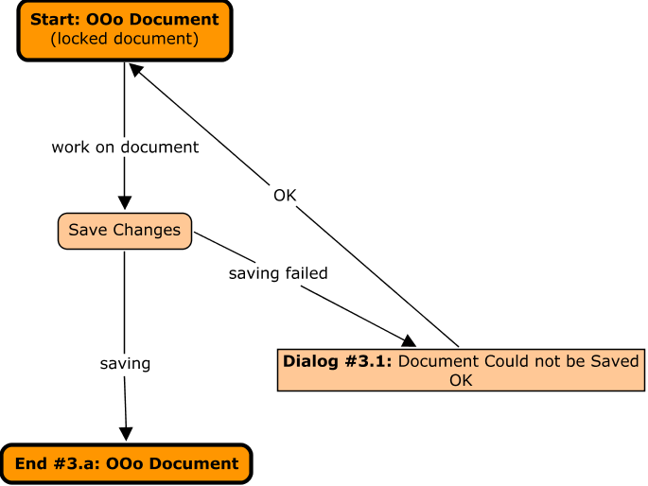
Illustration 18: File Save of a locked file

Future Dialog Mock-ups
Not implemented yet!

Dialog #3.1: Document Could Not be Saved
The following dialog is shown, if a document is locked for editing by another user when saving. The name of that user is shown, if the user meta data is available. Otherwise “Unknown User” is displayed. Then the user could decide to retry saving or save a copy of that document under a new file name or location. Save As... calls the the default Save As dialog showing the current file location. The file name is empty.
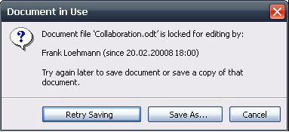Illustration 19: Document in use when saving document
- “Document in Use: Save” - Dialog Properties |  | Comment
State: | Modal
Type: | Dialog
Closable: | Yes
Resizable: | No
Titel: | Document in Use | EN-US
- “Note” - Text Properties |  | Comment
Label: | ????????????????????????????????????????? | EN-US
- “Retry Saving” - Button Properties |  | Comment
Enabled: | Always
Disabled: | Newer
Press:
Button Label: | Open Read-Only | EN-US
- “Save As...” - Button Properties |  | Comment
Enabled: | Always
Disabled: | Newer
Press:
Button Label: | Open Copy | EN-US
- “Cancel” - Button Properties |  | Comment
Enabled: | Always
Disabled: | Newer
Press:
Button Label: | Cancel | EN-US

Dialog #6.2: Disable Shared Mode and Save Document?
The following dialog is shown, if the sharing mode has been turned off by the user.

Scenario Q “Who Is working on that document?”
Scenario R “Remove User from Shared Document”
Scenario S “Join Shared Document”
Scenario I “Access Rights on Table Basis 1”
Scenario G “Merge on Save as...”
Scenario G “Merge on Save as...”
Scenario H “Merge with...”
Scenario M “Automatic Update on Saving Document”
Scenario M “Automatic Update on Saving Document”
Scenario N “Periodic Merge”
Scenario O “Live Update”
Scenario L “Automatic Update on Re-Calc”
This limitation is an open issue to be fixed in upcoming versions.
http://specs.openoffice.org/appwide/fileIO/File_Locking.odt
Technical limitation
Http://specs.openoffice.org/appwide/module_name_in_caption_bar/module_name_in_caption_bar.odt

