Software Specification Document

OpenOffice.org Calc
Automatic Axis Scaling

Specification Status
Last Change | May 14, 2007
Status

Abstract
This document describes how axes are scaled automatically in the new chart module. The goal of automatic axis scaling is to visualize all data points best possible in the available plot area.
i-Team Members
Role | First Name, Last Name, Initials | E-Mail Address
Project Lead | Ingrid Halama (IHA) | ingrid.halama@sun.com
Specification Owner | Daniel Rentz (DR) | daniel.rentz@sun.com
User Experience | Matthias Müller-Prove (MMP) | matthias.mueller-prove@sun.com
Development | Daniel Rentz (DR) | daniel.rentz@sun.com
Quality Assurance | Thomas Klarhöfer (KLA) | thomas.klarhoefer@sun.com
Test Automation | Joerg Sievers | joerg.sievers@sun.com
Documentation | Uwe Fischer (UFI) | uwe.fischer@sun.com
Other roles

Contents
Abstract 1
i-Team Members 1
References and Reference Documents 3
Acronyms and Abbreviations 3
1 Detailed Specification 4
1.1 Linear Scaling 4
1.1.1 Automatic Axis Origin 4
1.1.2 Automatic Positive Maximum, Automatic Negative Minimum 5
1.1.3 Automatic Positive Minimum 5
1.1.4 Automatic Negative Maximum 6
1.1.5 All Values Zero 6
1.1.6 Automatic Axis Main Interval 6
1.2 Logarithmic Scaling 7
1.2.1 Automatic Axis Origin 7
1.2.2 Automatic Positive Maximum, Automatic Negative Minimum 7
1.2.3 Automatic Positive Minimum 8
1.2.4 Automatic Negative Maximum 9
1.2.5 All Values Euqal To 1 9
1.2.6 Automatic Axis Main Interval 9
2 Open Issues 9
Document Change History 9

References and Reference Documents
Reference Document | Check | Location (URL)
Specification Process Entry Check |  | N/A
Product Requirement, RFE, issue (required) |  | Issue 30426
Product Concept Document
Competitive Analysis
Test Case Specification (required) |  | Testcase
Software Specification Rules | N/A | N/A
<Other, e.g. references to related specs>

Acronyms and Abbreviations
Acronym / Abbreviation | Definition
Chart area | The entire area of the chart object containing all objects.
Plot area | The area inside a chart that is used to draw the data series (e.g. bars, lines, pie). Outside the plot area there are e.g. axis labels, titles, and the legend.
Axis main interval | Space between two axis labels and (main) grid lines
Axis origin | The position used to draw the crossing axis. Also, areas of data points are drawn starting from the origin, e.g. in bar charts or area charts.

Detailed Specification
Note: The purpose of automatic axis scaling is to visualize all data points in a diagram and to use the available plot area as good as possible.
Automatic scaling of an axis includes calculation of the minimum and maximum axis limit as well as an appropriate main interval of the axis labels. It depends on the values of all data points that are attached to the axis. Therefore, the first step of this calculation is to determine the minimum and maximum values of the source data. The values of the other data points are not needed after that. Additional space may be added to the axis to avoid that data points are located too close at the lower or upper border of the plot area. That is important for example in bar charts to make the “shorter” bars long enough. The axis limits will be rounded down or up to multiples of the axis main interval.
It is possible to specify manual limits for the axis (minimum and/or maximum) or a manual main interval for the axis labels. In that case, the calculation steps described in the following chapters do not apply for the respective values and have to be skipped.

Linear Scaling

Automatic Axis Origin
The automatic axis origin is 0 (no change to old chart implementation).
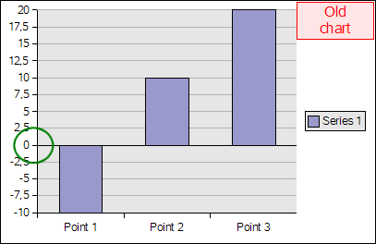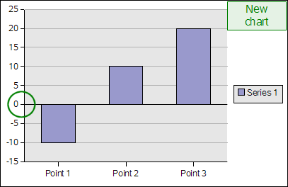
Illustration: Automatic axis origin

Automatic Positive Maximum, Automatic Negative Minimum
If the maximum data point is greater than zero in the 2-dimensional charts bar, line, area, XY and radar and the data point is close to the end of the last main interval, another empty main interval to the upper border of the plot area will be added. The same happens for the minimum data point, if it is less than zero.
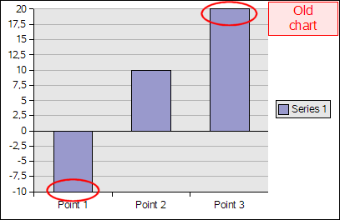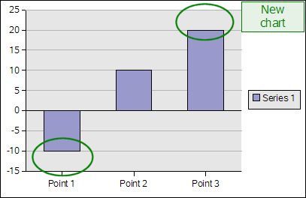
Illustration: Additional space above maximum and below minimum data point
The same is always done for the minimum and maximum of the X axis in 2-dimensional XY charts (regardless if minimum or maximum are positive or negative).
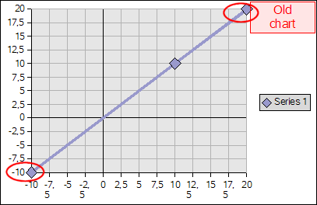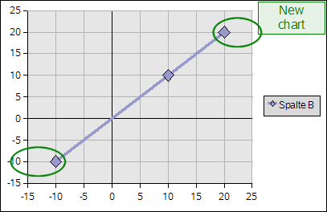
Illustration: Additional space on X axis in XY charts

Automatic Positive Minimum
If there all values in the source data are equal to or greater than zero, the Y axis may or may not start at the value 0, depending on the distribution of the source data.
(1) If all values are close enough to each other (the maximum value of the source data is equal to or less than 120% of the minimum of the source data), the minimum of the Y axis will be close below the minimum data point (distance to bottom of plot area is at least half of the distance between minimum and maximum value).
(2) Otherwise the Y axis will start at the value 0. Special case: If all values are equal, the minimum of the Y axis is always 0.
This is done for the Y axes in all chart types, except for the X axis in XY charts.
Example for (1): Minimum value is 30, maximum value is 34. Maximum is inside the limit of 120% of the minimum (36), therefore the Y axis starts near below the minimum (distance to bottom is at least 2, because distance between minimum and maximum value is 4).
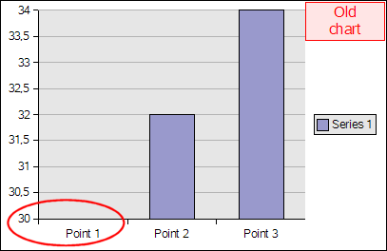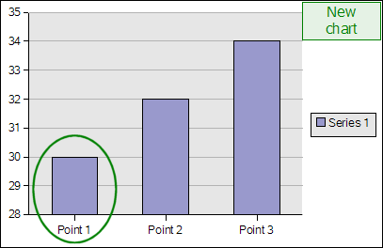
Illustration: Y axis starts close to minimum
Example for (2): Minimum value is 30, maximum value is 40. Maximum is greater than 120% of minimum (36), therefore the Y axis starts at the value 0.
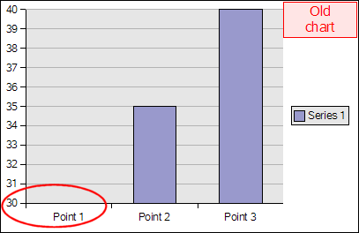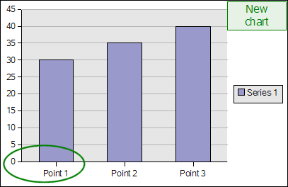
Illustration: Y axis starts at value 0

Automatic Negative Maximum
If there all values in the source data are equal to or less than zero, the behaviour is similar to the case described in chapter 1.1.3, “Automatic Positive Minimum“, but in reversed direction.

All Values Zero
If all values are zero, or if there are no valid values at all, the axis will be scaled to the fixed range [0, 1].

Automatic Axis Main Interval
The axis will be divided into at most 10 intervals. The size of each interval is one of 10^{k}, 2·10^{k}, or 5·10^{k}, k being an integer value. Minimum and maximum axis limits will be rounded down or up to the next multiple of the interval size.
Example: The interval size may be one of 0.01, 0.02, 0.05, 0.1, 0.2, 0.5, 1, 2, 5, 10, 20, 50, 100, 200, 500, and so on. If the interval size is 5, the axis minimum is rounded down to the previous multiple of 5, and the maximum is rounded up to the next multiple of 5.

Logarithmic Scaling
If the axis is set to logarithmic scaling, all source values must be greater than zero. Zero values and negative values will be ignored (omitted).

Automatic Axis Origin
The automatic axis origin is 1.
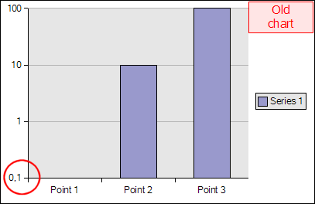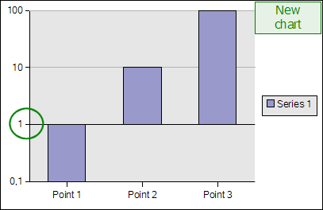
Illustration: Automatic axis origin

Automatic Positive Maximum, Automatic Negative Minimum
If the maximum data point is greater than 1, it may reach the upper border of the plot area. No additional intervals will be added. The same happens for the minimum, if it is less than 1. (no change to old chart implementation)
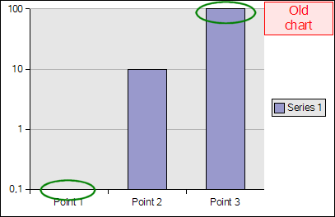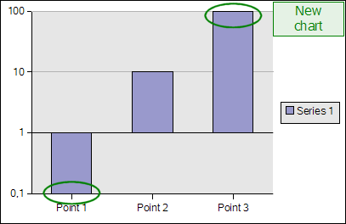
Illustration: No additional space above maximum or below minimum data point
The same applies for the minimum and maximum of the logarithmic X axis in XY charts, no additional space will be added.

Automatic Positive Minimum
If all values in the source data are equal to or greater than 1, the Y axis may or may not start at the value 1, depending on the distribution of the source data.
(1) If all values are equal to or greater than 100,000 and are inside an interval [10^{k}, 10^{k+1}], k being an integer value (e.g. inside [10⁵, 10⁶] or [10⁸, 10⁹]), the minimum of the Y axis will be close below the minimum data point. This is done by adding a single axis main interval at the bottom of the plot area. This includes the case that all values are equal.
(2) Otherwise the Y axis will start at the value 1.
This is done for the Y axes in all chart types (as mentioned above, this does not apply for the X axis in XY charts).
Example for (1): Minimum value is 100,000, maximum value is 1,000,000. Minimum and maximum are inside the range [10⁵, 10⁶], therefore the Y axis starts near below the minimum (one axis main interval added).
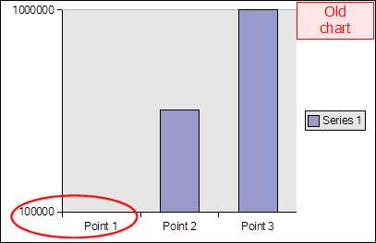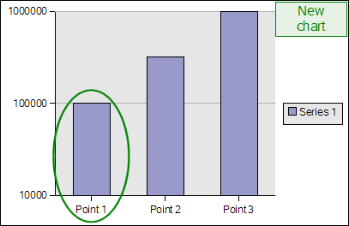
Illustration: Y axis starts close to minimum
Example for (2): Minimum value is 100,000, maximum value is 2,000,000. Minimum and maximum are not inside the range [10⁵, 10⁶], therefore the Y axis starts at the value 1.
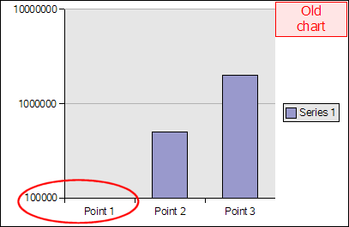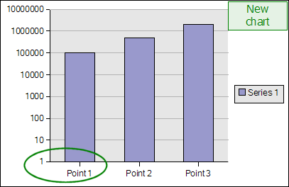
Illustration: Y axis starts at value 1
Example for (2): Minimum value is 100, maximum value is 1,000. Minimum and maximum are inside the range [10³, 10⁴], but the minimum value is less than 100,000, therefore the Y axis starts at the value 1 too.
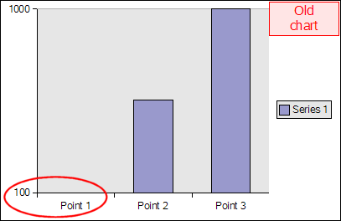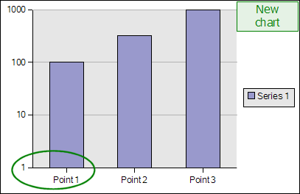
Illustration: Y axis starts at value 1, if there are values less than 100,000

Automatic Negative Maximum
If all values in the source data are equal to or less than 1, the behaviour is similar to the case described in chapter 1.2.3, “Automatic Positive Minimum“, but in reversed direction.

All Values Euqal To 1
If all values are equal to 1, or if there are no valid values at all, the axis will be scaled to the fixed range [1, 10].

Automatic Axis Main Interval
The axis will be divided into at most 10 intervals. The size of each interval is 10^{k}, k being an integer value, k ≥ 1. Each end of an interval represents the value of the interval start multiplied by the interval size. Minimum and maximum axis limits will be rounded down or up to an entire interval size.
Example: The interval size may be one of 10, 100, 1,000 and so on. If the interval size is 10² = 100, the axis minimum is rounded down to a power of 10 with an exponent that is a multiple of 2 (e.g. 0.01, 1, 100, 10,000), and the maximum is rounded up the same way.

Open Issues
Issue | Initials | Date
<State Issue here, State “None”, if all issues are solved> |  | <Format: Dec 31, 2000>

Document Change History
Rev. | Change | Initials | Date
1 | Initial revision | DR | Oct 08, 2006
2 | Review by IHA | DR | Nov 21, 2006
3 | Review by JSI | JSI | Jan 9, 2007
4 | Testcase link | DR | May 14, 2007

