Software Specification Document

OpenOffice.org 3.0
Legend entries and Series Order

Specification Status
Last Change | Sep 22, 2006
Status

Abstract
In charts you can display multiple series of data. Each chart type has it's own way of ordering these series while displaying ( e.g. the first series is displayed left to the second or it is below the second, etc). In addition the series are listed in the legend for most charttypes in a special order. This documents describes how the series are ordered for each charttype.
i-Team Members
Role | First Name, Last Name, Initials | E-Mail Address
Project Lead | Ingrid Halama (IHA) | <iha@openoffice.org>
Specification Owner | Pierre-Andre Galmes | <pagalmes@starxpert.fr>
User Experience | Matthias Müller-Prove (MMP) | <mmp@openoffice.org>
Development | Ingrid Halama (IHA) | <iha@openoffice.org>
Quality Assurance | Thomas Klarhöfer (TK) | <kla@openoffice.org>
Documentation | Uwe Fischer (UFI) | <ufi@openoffice.org>

Contents
Abstract 1
i-Team Members 1
References and Reference Documents 3
Acronyms and Abbreviations 3
1 Detailed Specification 4
1.1 Introduction 4
1.2 Column chart 4
1.2.1 Normal 4
1.2.2 Stacked 5
1.2.3 Percent 5
1.3 Bar chart 5
1.3.1 Normal 5
1.3.2 Stacked 6
1.3.3 Percent 6
1.4 Pie chart 6
1.5 Donut (Rings) 6
1.6 Area 7
1.6.1 Normal 7
1.6.2 Stacked 8
1.6.3 Percent 9
1.7 Line 9
1.8 3D Lines 10
1.9 XY 10
1.10 3D XY 11
1.11 Net 11
1.12 Stock 11
1.12.1 Stock chart 1 11
1.12.2 Stock chart 2 11
1.12.3 Stock chart 3 11
1.12.4 Stock chart 4 11
1.13 Column + Line 11
1.13.1 Combination chart : Lines and columns 11
1.13.2 Combination chart : Lines and stacked columns 11
2 Migration 12
2.1.1 Configuration 12
3 File Format 12
4 Open Issues 12
Document Change History 12

References and Reference Documents
Reference Document | Check | Location (URL)
Specification Process Entry Check |  | N/A
Product Requirement,, RFE, issue (required) |  | <Please enter location here>
Product Concept Document |  | <Please enter location here>
Competitive Analysis |  | <Please enter location here>
Test Case Specification (required) |  | <Please enter location here>
Software Specification Rules | N/A | N/A
<Other, e.g. references to related specs>

Acronyms and Abbreviations
Acronym / Abbreviation | Definition
Series | a series is a set of data represented in a diagram.

Detailed Specification

Introduction
In the following the display order of series and the order of the accessory legend entries are described for all available charttypes. Screenshots are used to define the behaviour. The series displayed with blue color is the first series if not stated otherwise.
The default order in the legend is that the first series is displayed on top of the others if the legend is placed on the left or on the right of the diagram. If the legend is placed on top or at the bottom the first series is displayed in the left of the legend by default.

Column chart

Normal

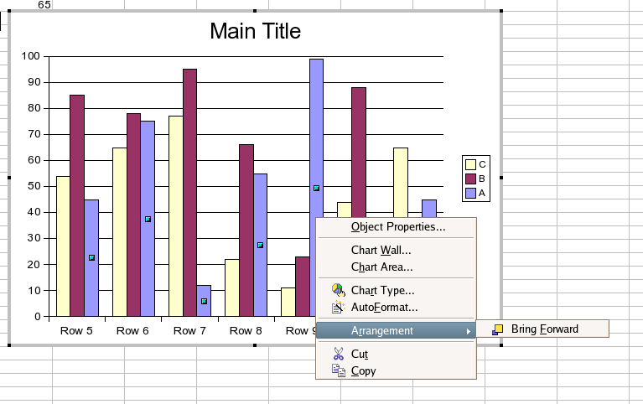Illustration 1: Further right column
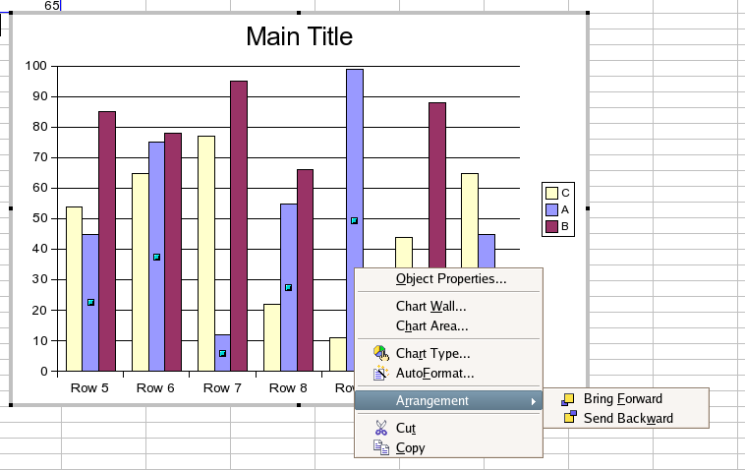Illustration 2: in between columns
Legend: default behaviour

Stacked

Legend: oposite ordering than default behaviour

Percent
The behavior is the same as the “stacked” column diagram.

Bar chart

Normal

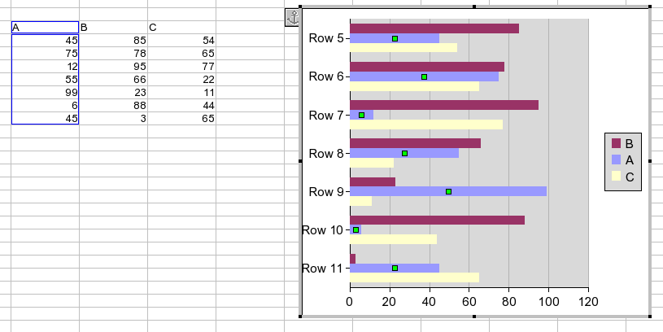Illustration 3: Normal bar chart
Legend: default behaviour

Stacked

Legend: oposite ordering than default behaviour

Percent

Legend: oposite ordering than default behaviour

Pie chart
The pie chart does only display a single series by define, thus nothing is to define about the ordering.
The legend in pie charts do nor display series but single datapoints instead.

Donut (Rings)
The coloring in donut charts is different from the default behaviour. Here all data points with the same index get the same color by default. The first series is displayed as outer ring.

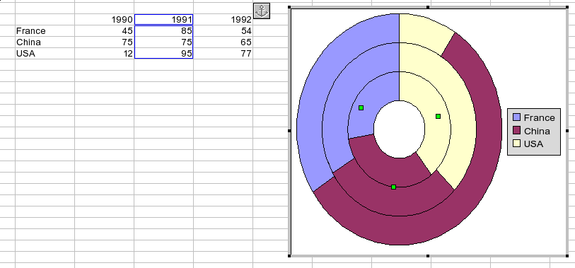
Legend: The legend does not display series, but instead the data points of the first series. The first data point is displayed on top of the others.

Area

Normal

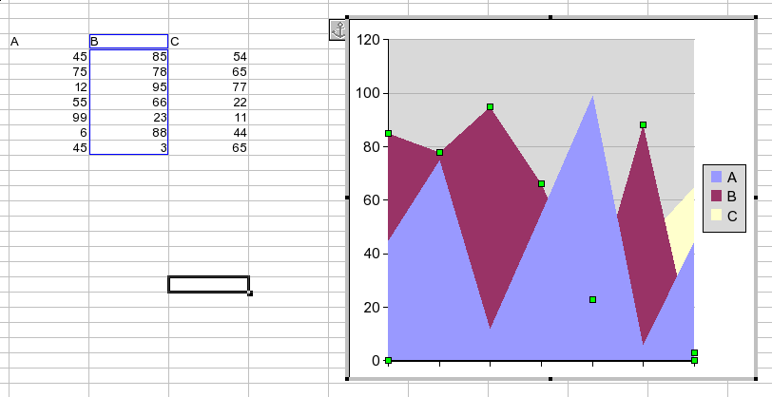Illustration 4: the area of the B series is hidden by the A series
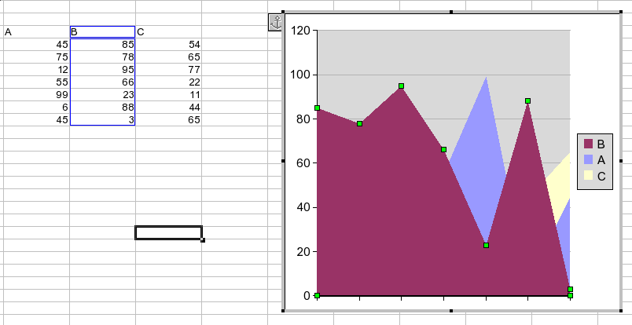Illustration 5: The area related to the B series once bring forward
Legend: default behaviour

Stacked

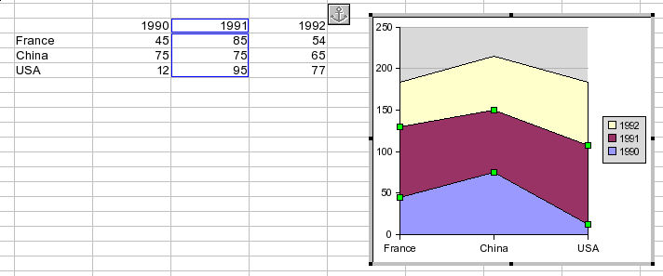Illustration 6: Area in-between not behaving as layers but as a stack element
Legend: oposite ordering than default behaviour

Percent
Identical to the stacked area chart.

Line

Legend: default behaviour

3D Lines

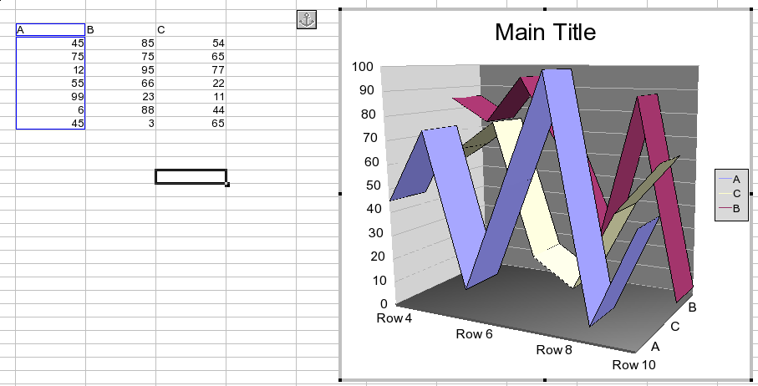
Legend: default behaviour

XY

Legend: default behaviour

3D XY

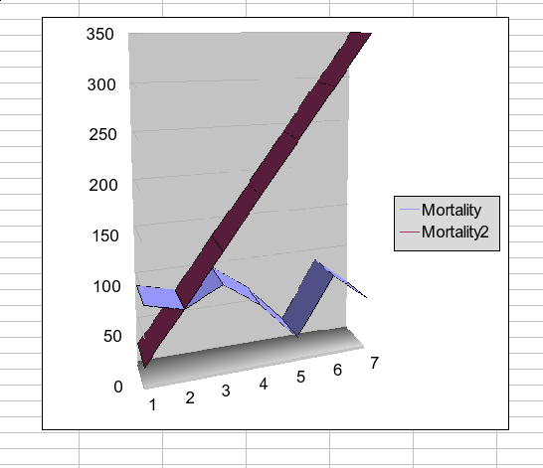
Legend: default behaviour

Net
Legend: default behaviour

Stock

Stock chart 1

Stock chart 2

Stock chart 3

Stock chart 4

Column + Line

Combination chart : Lines and columns

Combination chart : Lines and stacked columns

Migration
<Start typing here ----- If this part is irrelevant state a reason for its absence!>

Configuration
<Start typing here ----- If this part is irrelevant state a reason for its absence!>

File Format
<Start typing here ----- If this part is irrelevant state a reason for its absence!>

Open Issues
Issue | Initials | Date
Issue 64571 |  | Jun 15, 2006
<...>

Document Change History
Rev. | Change | Initials | Date
1 | initial version | pagalmes | <Format: Dec 31, 2000>
2 | review | iha | Jun 15, 2006
3
<...>

