Software Specification Document

OpenOffice.org
Error Bars

Specification Status
Last Change | Feb 25, 2008
Status
Abstract
For some chart types it is possible to add y error bars to data series. An error bar shows a region of values around the measured one to indicate the inaccuracy of the measurement.
i-Team Members
Role | First Name, Last Name, Initials | E-Mail Address
I-Team Lead | Bjoern Milcke (BM) | bm@openoffice.org
Specification Author | Bjoern Milcke (BM) | bm@openoffice.org
User Experience | Christian Jansen (CJ) | cj@openoffice.org
Development | Bjoern Milcke (BM) | bm@openoffice.org
Quality Assurance | Thomas Klarhöfer (TK) | kla@openoffice.org
Documentation | Uwe Fischer (UFI) | ufi@openoffice.org
Test Automation | Joerg Sievers (JSI) | jsi@openoffice.org
<State reason here, if one role is not represented in i-Team.>

Contents
Abstract 1
i-Team Members 1
References and Reference Documents 3
Acronyms and Abbreviations 3
1 Detailed Specification 4
1.1 Inserting Y Error Bars 4
1.2 Modifying Error Bars 10
1.3 Different Error Bar Categories 10
2 Migration 10
3 Configuration 10
4 File Format 10
5 Open Issues 11
Document Change History 11

References and Reference Documents
Reference Document | Check | Location (URL)
Specification Process Entry Check |  | N/A
Product Requirement, RFE, issue [Required] |  | Issue 84801
Product Concept Document |  | <Please enter location here>
Competitive Analysis |  | <Please enter location here>
IDL Specification |  | <Please enter location here>
Test Case Specification [Required] |  | <Please enter location here>
Software Specification Rules | N/A | N/A
Menu Specification |  | http://specs.openoffice.org/chart/menus/MenuStructure.odt
Flexible Source Range Specification |  | http://specs.openoffice.org/chart/dataselection/FlexibleSourceRangeSelection.odt
Acronyms and Abbreviations
Acronym / Abbreviation | Definition
Error Bar | A line pointing into the positive (for y error bars: up) or negative (for y error bars: down) direction of the values. It indices that the value measured is not entirely accurate and the real value may be at any point inside the range spanned by the error bar.

Detailed Specification
An error bar is an indicator line that spans over a range from y – ε_{neg} to y + ε_{pos}. Where y is the value of the data point, or the mean value of the data when standard deviation is selected. ε_{neg} and ε_{pos} are the amounts calculated by the error bar function or given explicitly. For details see section 1.3.
The following chart types support error-bars: bar, column, line, area, scatter. Only two-dimensional charts are supported.

Inserting Y Error Bars
Y error bars for all data series can be added by calling the “Insert/Y Error Bars...” command. To add error bars to a single data series, there is a menu item “Insert Y Error Bars...” in the context menu of a data series.
The “Insert/Y Error Bars...” command opens a dialog (see Figure 1) that allows adding and removing of error bars. It is described below. When using the context menu entry “Insert Y Error Bars...”, a tab dialog opens. This tab dialog contains two tab pages, one for the error bar properties, that is similar to the Insert dialog (Figure 1), except that the error categoy “None” is missing. See Figure 4 for details. The second tab page is the standard line tab page for setting line properties of the error bar indicators.
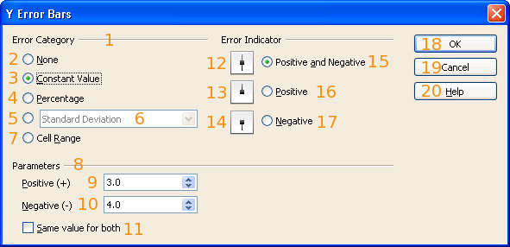Figure 1: The Y Error Bars tab of the object properties of a data series
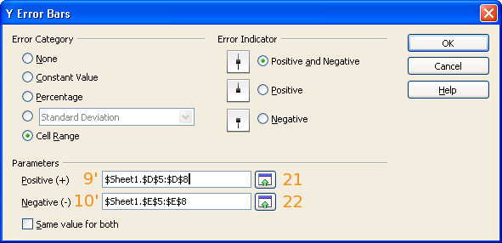Figure 2: The changed / additional controls for Cell Ranges

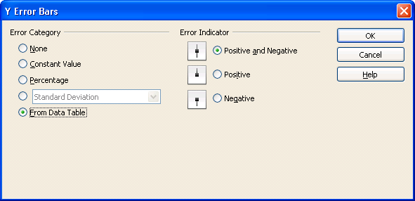Figure 3: The dialog when the Chart has its own Data

- “Y Error Bars” - Dialog Properties |  | Comment
Type: | Dialog
Title: | Y Error Bars | EN-US
- “Error Category” - Fixed Line |  | Comment
Label: | Error category | EN-US
- “None” - RadioButton Properties |  | Comment
Enabled: | Always
Selected: | When a data series has no error bar indicators
RadioButton Label: | ~None | EN-US
- “Constant Value” - RadioButton Properties |  | Comment
Enabled: | Always
Selected: | When the error indicators are calculated using the variance of the data
RadioButton Label: | ~Constant Value | EN-US
- “Percentage” - RadioButton Properties |  | Comment
Enabled: | Always
Selected: | When the error indicators are calculated using the percentage of the data given in #10 in both directions
RadioButton Label: | ~Percentage | EN-US
- “Function” - RadioButton Properties |  | Comment
Enabled: | Always
Selected: | When one of the functions listed in #6 are used for error bars
RadioButton Label: |  | EN-US, empty
- “Function” - DropDown Listbox Properties |  | Comment
Enabled: | When Radio Button #5 is checked
Max. Row Count: | 4
Rows Visible: | 4
Items: | - Standard Error  - Standard Deviation  - Variance  - Error Margin
Item Selected: | The one set in the model, when #5 is selected. Default is 2.
DropDown  ListBox Label: |  | EN-US, empty
- “Cell Range” - RadioButton Properties |  | Comment
Enabled: | Always
Selected: | When the error indicators are taken from the cell ranges given in #9' and #10'. For charts with their own data, the values for the error bars are contained in the data and can be modified with the data editor.
RadioButton Label: | Cell ~Range | EN-US, used for charts with data from the container document
RadioButton Label: | ~From Data Table | EN-US, used for charts with their own data
- “Parameters” - Fixed LineProperties |  | Comment
Label: | Parameters | EN-US
- “Positive” - SpinField Properties |  | Comment
Enabled: | When #3 or #4 is selected. Also, when #5 is selected and in #6 entry 4 is selected.
Invisible: | When button #7 is selected
Min. Value: | 0
Max. Value: | -
Start Value: | The value from the model (model default is 0)
Steps: | The minor step width of the axis rounded down to the next power of 10. (E.g. Major Step Width=1, Minor Subdivision=10 => increment 0.1; Minor Subdivision=15=> increment 0.01)
Measurement Unit: | “%”, if Radio Button #4 is selected, or Error Margin as function: Radio Button #5 is checked and in Listbox #6 the entry Error Margin is selected. Otherwise nothing.
SpinField Label: | P~ositive (+) | EN-US
- “Negative” - SpinField Properties |  | Comment
Enabled: | When #3 is selected, but only when #11 is not checked and #13 is not selected.
Invisible: | When button #7 is selected
Min. Value: | 0
Max. Value: | -
Start Value: | The value from the model (model default is 0)
Steps: | Same as for #9
Measurement Unit: | Same as for #9
SpinField Label: | ~Negative (-) | EN-US
- “Same Value for Both” - CheckBox Properties |  | Comment
Enabled: | When #3 or #7 is selected.
Tri-State: | No (This is just a UI setting without connection to the model)
Checked: | If checked, only the positive value (#9 or #9') can be changed. When it is changed, the same value is set as negative value (#10 or #10').  When entering the dialog, it is checked when the values of #9 (#9') and #10 (#10') are equal.
CheckBox Label: | ~Same value for both | EN-US
- “Both” - Image Properties |  | Comment
Resource: | errorbothverti_30.png |  | regular
Resource: | errorbothverti_30_h.png |  | high contrast
Size: | 30x30
- “Up” - Image Properties |  | Comment
Resource: | errorup_30.png |  | regular
Resource: | errorup_30_h.png |  | high contrast
Size: | 30x30
- “Down” - Image Properties |  | Comment
Resource: | errordown_30.png |  | regular
Resource: | errordown_30_h.png |  | high contrast
Size: | 30x30
- “Both” - RadioButton Properties |  | Comment
Enabled: | Always
Selected: | When both (positive and negative) error indicators are shown
RadioButton Label: | Positive ~and Negative | EN-US
- “Positive” - RadioButton Properties |  | Comment
Enabled: | Always
Selected: | When only positive error indicators are shown
RadioButton Label: | Pos~itive | EN-US
- “Negative” - RadioButton Properties |  | Comment
Enabled: | Always
Selected: | When only negative error indicators are shown
RadioButton Label: | Ne~gative | EN-US
- “OK” - Button Properties |  | Comment
Enabled: | Always | Only in Insert Dialog, not in Property Tab
Press: | Applies the changes and closes the dialog
Other: | Is the default button
Button Label: | OK | EN-US
- “Cancel” - Button Properties |  | Comment
Enabled: | Always | Only in Insert Dialog, not in Property Tab
Press: | Discards the changes and closes the dialog
Other: | Is triggered with Escape
Button Label: | Cancel | EN-US
- “Help” - Button Properties |  | Comment
Enabled: | Always | Only in Insert Dialog, not in Property Tab
Press: | Opens the help content for the diaog
Other: | Standard Help button
Button Label: | ~Help | EN-US
- “Positive Range Chooser” - Button Properties |  | Comment
Enabled: | When the chart gets its data from Calc (from a container that has a com.sun.star.chart2.data.XDataProvider supporting the com.sun.star.sheet.XRangeSelection interface)
Press: | Opens the range chooser to select a cell range for positive errors.
Visible: | When radio button #7 is selected
Button Label: | image
- “Negative Range Chooser” - Button Properties |  | Comment
Enabled: | When the chart gets its data from Calc (from a container that has a com.sun.star.chart2.data.XDataProvider supporting the com.sun.star.sheet.XRangeSelection interface)
Press: | Opens the range chooser to select a cell range for negative errors.
Visible: | When radio button #7 is selected
Button Label: | image
#9' “Positive Range” - TextField Properties |  | Comment
Disabled: | When #17 is selected
Visible: | When #7 is selected.
Read Only: | No
Initial String: | The cell range that is used for positive errors
String Preselected: | No
Caret Position: | 0
Input Allowed: | Only valid cell ranges
Visible: | When check box #7 is checked
TextField Label: | Same as #9 | EN-US
#10' “Negative Range” - TextField Properties |  | Comment
Disabled: | When #16 is selected, or when #11 is checked.
Visible: | When #7 is selected
Read Only: | No
Initial String: | The cell range that is used for positive errors
String Preselected: | No
Caret Position: | 0
Input Allowed: | Only valid cell ranges
Visible: | When check box #7 is checked
TextField Label: | Same as #10 | EN-US

For modifying existing error bars, there is a tab dialog with two tabs as object properties of the error bar object. See figure 4. The only difference to the insertion dialog (figure 1), is that the error category “None” is missing and it cannot have tri-state items.
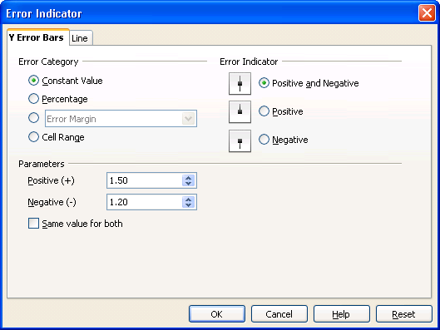Figure 4: The Insert Y Error Bars dialog for adding error bars to all data series

Modifying Error Bars
For modifying existing error bars, you can select them and enter the object properties. When you open the error bars' properties you get the tab dialog in figure 4. This dialog contains a tab for the error bar properties (the one you see in figure 4) and the standard line tab page.

Different Error Bar Categories
The following error bar categories are available:
Error Category | x | ε_{neg} | ε_{pos}
Variance | Data value | The variance of the data of the given data series | Same as ε_{neg}
Standard Deviation | Mean value | The standard deviation of the data of the given data series | Same as ε_{neg}
Percentage | Data value | The percentage given in #9 of the data | Same as ε_{neg}
Error Margin | Data value | The percentage given in #9 of the data nultiplied by the maximum value of the data. | Same as ε_{neg}
Constant Value | Data value | The value in #9 | The value in #10
Cell Range | Data value | The value of the container document referred to by the range in #9' | The value of the container document referred to by the range in #10'
From Data Table | Data value | The error value in the own data sheet shown next to the data value in the column “Positive Y Error Bars” | The error value in the own data sheet shown next to the data value in the column “Negative Y Error Bars”

Migration
Description for existing features. The trendline dialog is new, but all its UI elements existed before in the Statistics dialog.

Configuration
No configuration is involved for this feature.

File Format
See ODF Standard 1.2 section “10.13 Error Indicator” and “16.33 Statistical Formatting Properties”

Open Issues
Issue | Initials | Date
<State Issue here, State “None”, if all issues are solved> |  | <Format: Dec 31, 2000>
<...>

Document Change History
Rev. | Change | Initials | Date
1 | Initial Revision | BM | Jan 9, 2008
2 | First Revision for Review | BM | Feb 25, 2008
3 | New screen shot for figure 3. | BM | Feb 25, 2008
<...>

