Competitive Analysis Document

OpenOffice.org
Competitive Analysis for Chart2

Specification Status
Last Change | Jan 5, 2007

Abstract
n/a

i-Team Members
Role | First Name, Last Name, Initials | E-Mail Address
Document Owner | Matthias Müller-Prove /MMP | mprove@sun.com,

Contents
Abstract 1
i-Team Members 1
References and Reference Documents 3
Acronyms and Abbreviations 3
1 Competitive Analysis 4
1.1 StarOffice 7 4
1.1.1 Step 1 – Define Source 4
1.1.2 Step 2 – Call AutoFormat Chart Dialog 4
1.1.3 Step 3 – AutoFormat Chart: Source Data 4
1.1.4 Step 4 – AutoFormat Chart: Select Main Chart Type 5
1.1.5 Step 5 – AutoFormat Chart: Select Sub-Type of Chart 5
1.1.6 Step 6 – AutoFormat Chart: Choose Options 6
1.1.7 Step 7 – Position of Chart 6
1.1.8 Pros & Cons 6
1.2 MS Excel 2003 6
1.2.1 Step 1 – Define Source 6
1.2.2 Step 2 – Call Chart Wizard 6
1.2.3 Step 3 – Wizard (1/4): Chart Type 7
1.2.4 Step 4 – Wizard (2/4): Chart Source Data 10
1.2.5 Step 5 – Wizard 3/4: Chart Options 12
1.2.6 Step 6 – Wizard 4/4: Chart Location 16
1.2.7 Pros & Cons 16
1.3 MS Excel 2004 16
2 Document Change History 17

References and Reference Documents
Reference Document | Check | Location (URL)
Specification Process Entry Check |  | N/A
Product Requirement,, RFE, issue (required) |  | i20344, i25695 (Spec), i26628 (String Review)  CWS: SRC680/chart2mst3
Product Concept Document |  | <Please enter location here>
Competitive Analysis |  | 6 Competitive Analyses
Test Case Specification (required) |  | <Please enter location here>
Software Specification Rules | N/A | N/A
Concepts for Wizards
Chart Menu Structure

Acronyms and Abbreviations
Acronym / Abbreviation | Definition
OOo | OpenOffice.org
MA (MAP) | The units which are used in this specification are Map AppFont (ma). It is the preferred unit when designing dialogs with the OpenOffice.org API. Map AppFont units are device and resolution independent. One Map AppFont unit is equal to one-eighth of the average character (Systemfont) height and a quart in width.
Spline | http://www.ibiblio.org/e-notes/Splines/Intro.htm

Competitive Analysis

StarOffice 7

Step 1 – Define Source
Select cell(s) in Calc sheet

Step 2 – Call AutoFormat Chart Dialog
StarOffice 7 provides 2 ways to call the AutoFormat Chart Dialog.
- Choose menu item Insert>Chart... or
- Click the Chart button in the main toolbar. This changes the cursor to a drawing cursor to define the position and size of the new chart on the document.

Step 3 – AutoFormat Chart: Source Data
After that the AutoFormat Chart dialog opens to refine the source data.
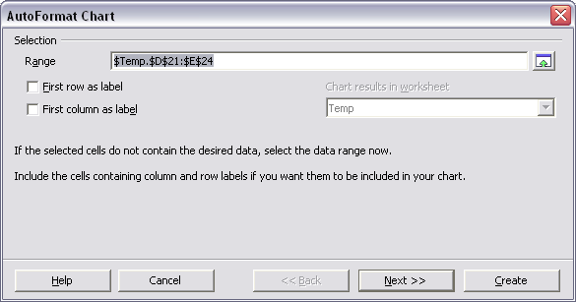Illustration 1 StarOffice 7, AutoForm Chart: step 1

Step 4 – AutoFormat Chart: Select Main Chart Type
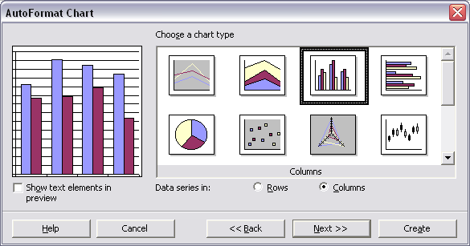Illustration 2 StarOffice 7, AutoForm Chart: step 2

Step 5 – AutoFormat Chart: Select Sub-Type of Chart
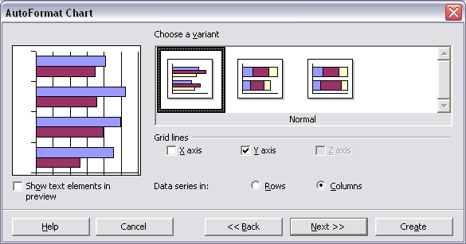Illustration 3 StarOffice 7, AutoForm Chart: step 3

Step 6 – AutoFormat Chart: Choose Options
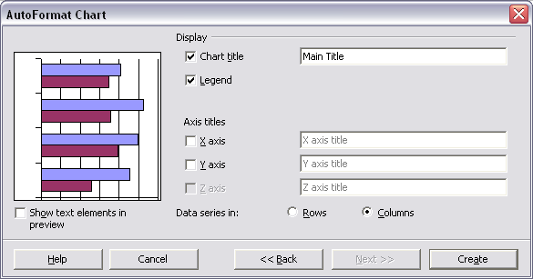Illustration 4 StarOffice 7, AutoForm Chart: step 4

Step 7 – Position of Chart
After clicking the Create button the chart is generated. If the user chose the menu item Insert>Chart... the new chart will be positioned automatically at the bottom right of the source data.

Pros & Cons
+ same size of dialog for all wizard steps
- the Chart button in the main toolbar provides no feedback. The user does not understand what to do after clicking this element.
- selecting the chart type is divided into 2 step. It is also more important than defining the data source and should therefore be an earlier step in the wizard.

MS Excel 2003

Step 1 – Define Source
Select cell(s) in Excel sheet

Step 2 – Call Chart Wizard
Choose menu item Insert>Chart...
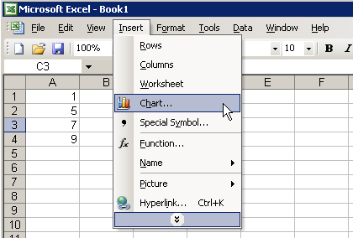Illustration 5 MS Excel 2003: Insert Menu

Step 3 – Wizard (1/4): Chart Type
Chart Wizard pops up. First step – out of 4 – is the selection of a chart type. To the left is a list with 14 main chart types:
- Column
- Bar
- Line
- Pie
- XY (Scatter)
- Area
- Doughnut
- Radar
- Surface
- Bubble
- Stock
- Cylinder
- Cone
- Pyramid
Just the top 10 chart types are visible without scrolling. The right area displays for each chart type a set of large icons with sub types; 7 at max. For each selected sub type the lower right area shows a description.
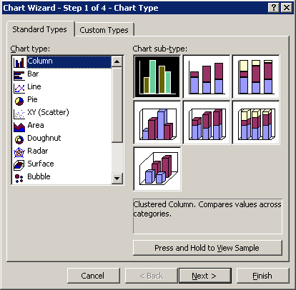Illustration 6 MS Excel 2003: Chart Wizard, step 1

A chart preview is shown while the user presses the Sample button in the area of the sub-types.
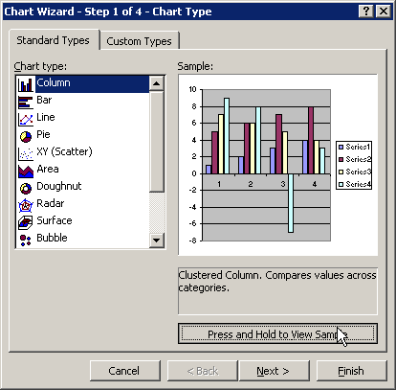Illustration 7 MS Excel 2003: Chart Wizard, step 1. Preview button pressed
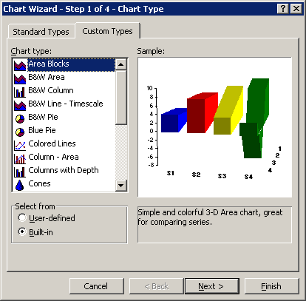Illustration 8 MS Excel 2003: Chart Wizard, step 1. Custom Types tab selected

The Custom Types tab provides the following list of charts:
- Area Blocks
- B&W Area
- B&W Column
- B&W Pie
- Blue Pie
- Colored Lines
- Column – Area
- Columns with Depth
- Cones
- Floating Bars
- Line – Column
- Line – Column on 2 Axes
- Line on 2 Axes
- Logarithmic
- Outdoor Bars
- Pie Explosion
- Smooth Lines
- Stack of Colors
- Tubes

Step 4 – Wizard (2/4): Chart Source Data

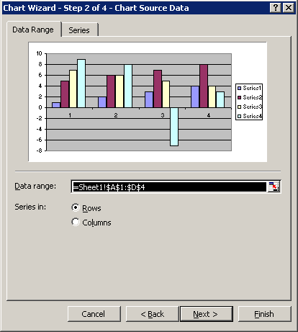Illustration 9 MS Excel 2003: Chart Wizard, step 2
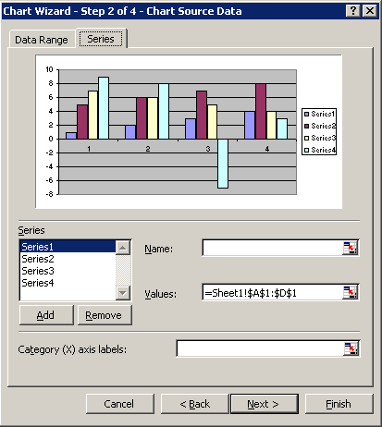Illustration 10 MS Excel 2003: Chart Wizard, step 2. Series tab selected

Step 5 – Wizard 3/4: Chart Options
The Chart Options contains 6 tabs.
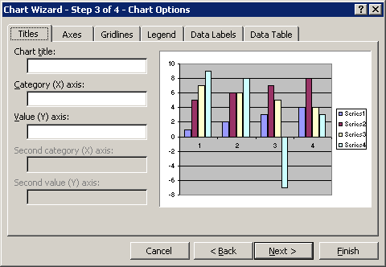Illustration 11 MS Excel 2003: Chart Wizard, step 3
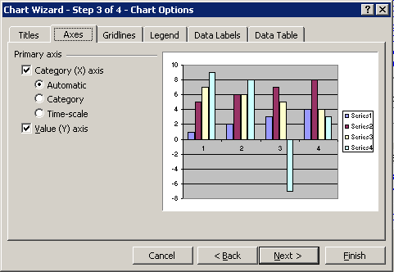Illustration 12 MS Excel 2003: Chart Wizard, step 3. Axes tab selected
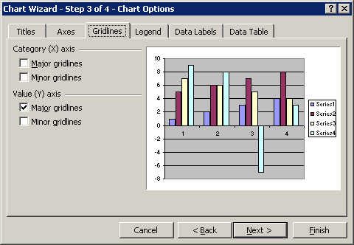Illustration 13 MS Excel 2003: Chart Wizard, step 3. Gridlines tab selected
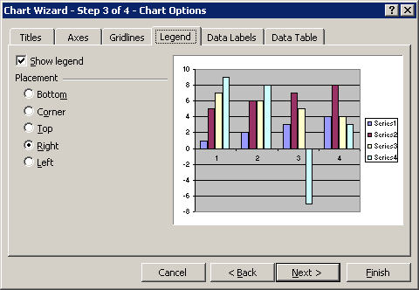Illustration 14 MS Excel 2003: Chart Wizard, step 3. Legend tab selected
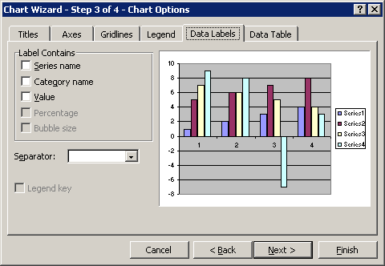Illustration 15 MS Excel 2003: Chart Wizard, step 3. Data Labels tab selected
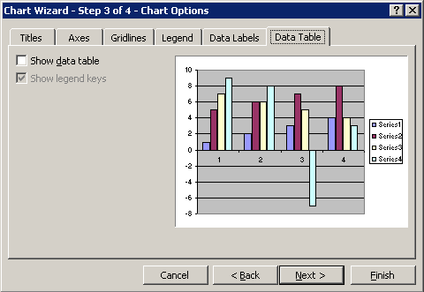Illustration 16 MS Excel 2003: Chart Wizard, step 3. Data Table tab selected

Step 6 – Wizard 4/4: Chart Location
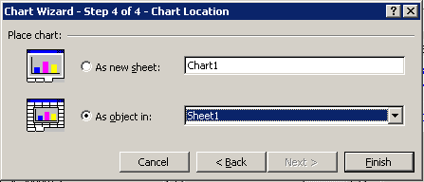Illustration 17 MS Excel 2003: Chart Wizard, step 4

Pros & Cons
+ The wizard provides sufficient feedback, i.e. a preview of the chart with the actual data, although the Press and Hold to View Sample button is a misuse of a push button.
- The wizard has not a fixed size from step to step.

MS Excel 2004
MS Excel 2004 uses the task pane to offer chart functionality.
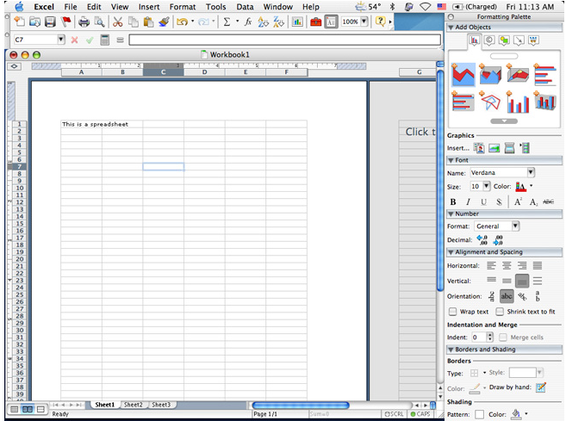Illustration 18 MS Execl 2004 as seen on http://www.appleinsider.com/gallery/office2004.php?image=16
The prominently presented chart types are: Area 2d, Area 3d, Surface 3d, Bar 2d, Bar 3d (or maybe 2d with background), Radar, Column 2d, Column 3d. More chart types can be selected by scrolling down.

Terminology

Terminology in Microsoft Excel 2003
For 2D charts the area spanned by the axes is called “Plot Area”. The entire area – including legend, titles, and axes labels is called “Chart Area”.
In case of 3D charts the “Plot Area” includes the axes labels. The xy plane and yz plane are called “Walls” (Wände). The xz plane is called “Floor” (Bodenfläche).

Illustration 19: 2D Charts in MS Excel

Illustration 20: 3D Charts in Excel

Menus in Microsoft PowerPoint and Word 2003 (aka MS Graph)

View Menu
View main menu
...
Datasheet Opens the Datasheet window to edit chart-internal data.
...

Document Change History
Rev. | Change | Initials | Date
1 | competitive analyses: MS Excel 2004 | MMP | 3/30/04
2 | Created this document | MMP | Dec 13, 2006
3 | moved terminology CA from menu spec here | MMP | Jan 5, 2007

The mouse cursor changes in the content area, but unless the user does not move the mouse to the sheet, she gets no feedback.

