Software Specification Document

StarOffice, OpenOffice
Redesigned picture cropping

Specification Status
Last Change | Feb 20, 2008
Status
Abstract
The current resolution for cropping graphics in documents is not intuitive and hard to handle. The current solution must be replaced to have a wysiwyg-solution like known in many other graphics manipulation programs (for example Gimp). The cropping has to be done on the original graphic to have a live view.

i-Team Members
Role | First Name, Last Name, Initials | E-Mail Address
I-Team Lead | Wolfram Garten, wg | wolfram.garten@sun.com
Specification Author | Wolfram Garten, wg | wolfram.garten@sun.com
User Experience | <First Name, Last Name (Initials)> | <User@openoffice.org>
Development | Christian Lippka, cl | christian.lippka@sun.com
Quality Assurance | Wolfram Garten, wg | wolfram.garten@sun.com
Documentation | <First Name, Last Name (Initials)> | <User@openoffice.org>
Other roles | <First Name, Last Name (Initials)> | <User@openoffice.org>
<State reason here, if one role is not represented in i-Team.>

Contents
Abstract 1
i-Team Members 1
References and Reference Documents 3
Acronyms and Abbreviations 4
1 Detailed Specification 5
2 Migration 7
3 Configuration 7
4 File Format 8
5 Open Issues 8
Document Change History 8

References and Reference Documents
Reference Document | Check | Location (URL)
Specification Process Entry Check |  | N/A
Product Requirement, RFE, issue [Required] |  | i3545<Please enter location here>
Product Concept Document |  | <Please enter location here>
Competitive Analysis |  | <Please enter location here>
IDL Specification |  | <Please enter location here>
Test Case Specification [Required] |  | <Please enter location here>
Software Specification Rules | N/A | N/A
<Other, e.g. references to related specs>
Acronyms and Abbreviations
Acronym / Abbreviation | Definition
<WYSIWYG> | <What You See Is What You Get>

Detailed Specification
The current behavior is altered a bit to make it more simple to crop a picture to the wanted size.
Inserting a picture into a document the picture is kept selected and the picture toolbar comes up.
The picture toolbar contains the crop button:
Illustration 1: Crop Button

Pressing the crop button the cropping frame is generated on the maximum extention of the picture for visual feedback.
The green selection handles change to a purple set of cropping handles. The edge handles become angles.
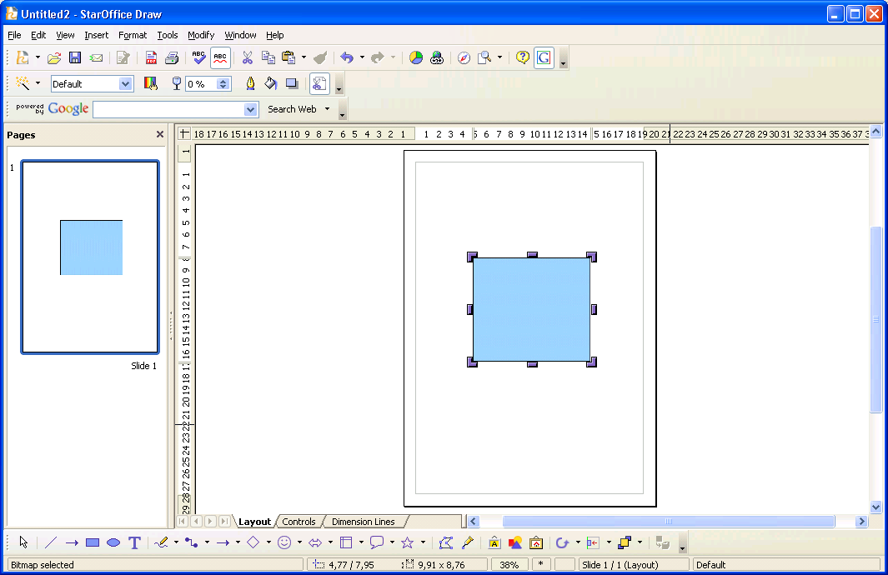Illustration 2: New Cropping handles
The cropping can now be done in two ways:
- Using the mouse the cropping frame can be dragged to a fitting result directly on the picture in the document.
- The second way is to call up the cropping dialog from the context menu of the picture (8th entry between paragraph and alignment) or from the Format menu (after “Text...”) and alter the values via the keyboard in the dialog.

- Closing the dialog with the closer or with CANCEL closes the dialog with discarding the changed values.
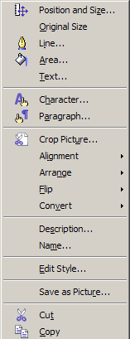Illustration 3: Graphic shape context menu with "Crop Picture..." entry.
Without a graphic in focus the cropping dialog button is not visible because the picture bar is not displayed.
If it is called using the menu the cropping button is greyed out.

Future enhancements
If the so called “primitives” are implemented there could be done some improvement in the cropping function:
Phase 1:
Picture is selected and the cropping button pressed. The dialog comes up, picture is still selected. The cropping frame is drawn at the maximum extent of the picture:
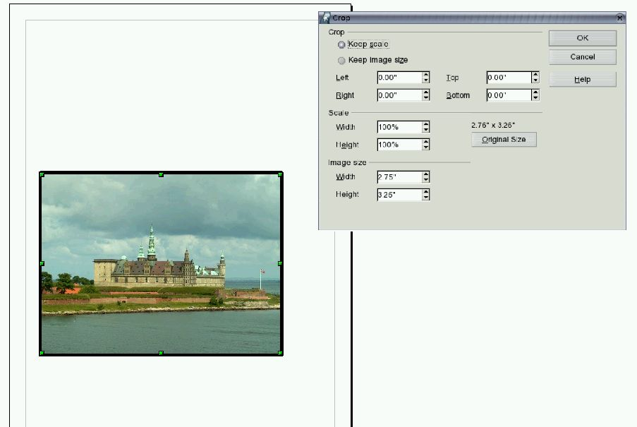Illustration 4: Phase 1 of Picture Cropping
Phase 2:
The cropping frame is dragged to the wanted position. The values are directly taken over into the cropping dialog. The not-wanted area of the picture is being displayed with 50% transparence to make it easier to imagine the final look of the picture.
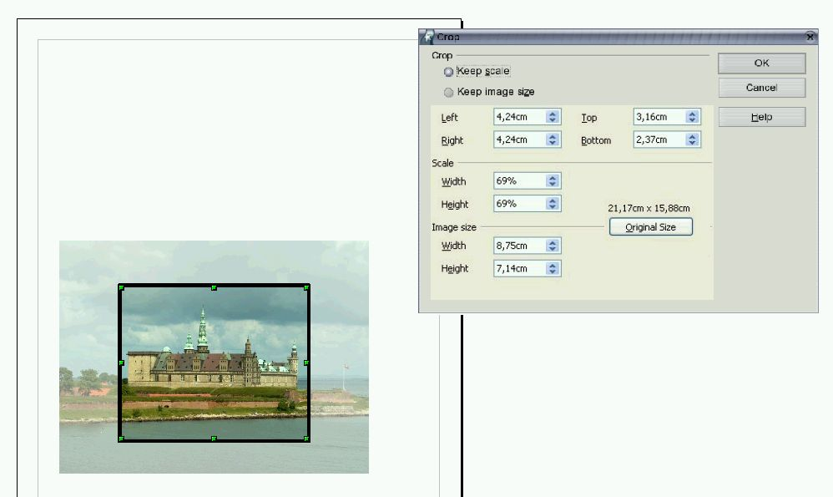Illustration 5: Phase 2: Cropping frame is dragged
Phase 3:
If the frame fits the wanted position of the user he can press OK in the cropping dialog. The picture is being cropped down to the wanted size and the cropping dialog is closed. The picture is still selected. The scale and position is being kept.
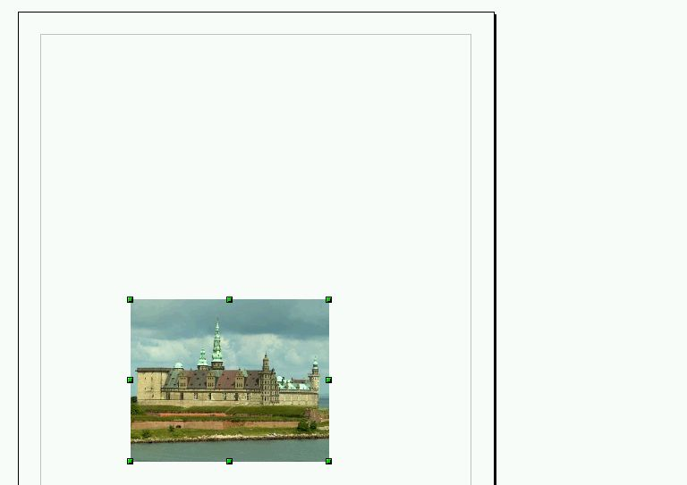Illustration 6: Phase 3: Picture is cropped after pressing OK.

Migration
It is only the way of cropping that is changed and not the result. So cropped picture from earlier versions can be loaded and altered without problems.

Configuration

File Format
This part is not relevant since only the tool is changed and not the result.

Open Issues
Issue | Initials | Date
<State Issue here, State “None”, if all issues are solved> |  | <Format: Dec 31, 2000>
<...>

Document Change History
Rev. | Change | Initials | Date
1 | Wolfram Garten |  | 3.8.2007
2 | Wolfram Garten |  | 6.12.2007
3
<...>

