Software Specification Document

OpenOffice.org 2.0.4 and higher
OpenOffice.org NetBeans Integration: New IDL Type Wizard

Specification Status
Last Change | Feb 26, 2007
Status | - PRELIMINARY  status is the initial conception of a specification.  - STANDARD  A specification with status Standard is considered to be stable and has the approval of the i-Team.  - OBSOLETE  An Obsolete specification is a specification that has been identified unnecessary. For example due to; technology changes or changes in other standards or specifications.

Abstract

With OpenOffice.org NetBeans Integration: New IDL Type Wizard there will be a comprehensive wizard to create IDL files. The intention is to reduce the need to edit IDL files with an editor. This should only be necessary when a file has to change. For creating new files, a complete valid and working IDL file is the result of the usage of this wizard.
i-Team Members

Role | First Name, Last Name, Initials | E-Mail Address
Project Lead | Jürgen Schmidt (jsc) | juergen.schmidt@sun.com
Specification Owner | Steffen Grund (sg) | steffen.grund@sun.com
User Experience
Development | Steffen Grund (sg) | steffen.grund@sun.com
Quality Assurance | Thorsten Bosbach (tbo) | thorsten.bosbach@sun.com
Documentation
Other roles
Based on a verbal agreement between Lutz Höger and Jürgen Schmidt, we decided that a team member of the office user experience team isn't necessary because this specification is off topic of normal office features and address developers only and provides an integration in an external application (NetBeans IDE).

Contents
Abstract 1
i-Team Members 1
Acronyms and Abbreviations 2
1 Detailed Specification 3
2 Open Issues 14
Document Change History 14
References and Reference Documents
Give references to any documentation relevant with regards to this specification.
Before writing a specification make sure that the items of the Specification Process Entry Check have been addressed.
Reference Document | Check | Location (URL)
Specification Process Entry Check |  | N/A
Product Requirement,, RFE, issue (required) |  | <Please enter location here>
Product Concept Document |  | <Please enter location here>
Competitive Analysis |  | <Please enter location here>
Test Case Specification (required) |  | <Please enter location here>
Software Specification Rules | N/A | N/A
<Other, e.g. references to related specs>

Acronyms and Abbreviations
State any acronyms and or abbreviations used in this specification in the table below.
Acronym / Abbreviation | Definition
SDK | Software Development Kit
deploy/deployment | Means the installation of office extension packages into an office installation
nbm | NetBeans module/plugin, comparable with an office extensions package, means a plugin extending the base functionality of NetBeans with some new functions.

Detailed Specification
After starting the wizard, the kind of IDL file that should be created has to be selected. Supported IDL files:
- Services
- Interfaces
- Enumerations
- Structs
- Exceptions
- PolyStructs
- Constants

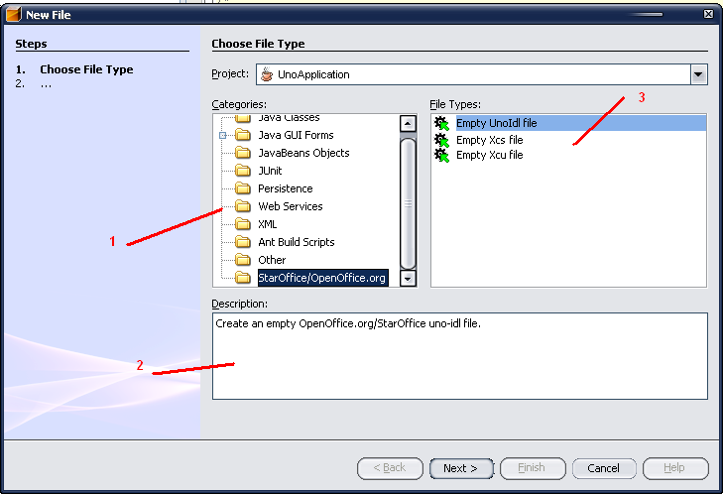Figure 1: Create a new IDL file
Table 1: User Interface elements of Figure 1
# | Type | Properties |  | Comment
1 |  | Control Properties  Features: All File Objects, provided by NetBeans
2 |  | Control Properties  Features: Tooltip, provided by NetBeans
2 |  | String English  Create an OpenOffice.org/StarOffice uno-idl file. | String German
3 |  | Control Properties  Features: File types associated with StarOffice/OpenOffice.org |  |  | Select Empty UnoIdl file for the following
3 |  | String English | String German

Table 2: Tab order of Figure 1
Tab Order | Comment
#1, #2, #3

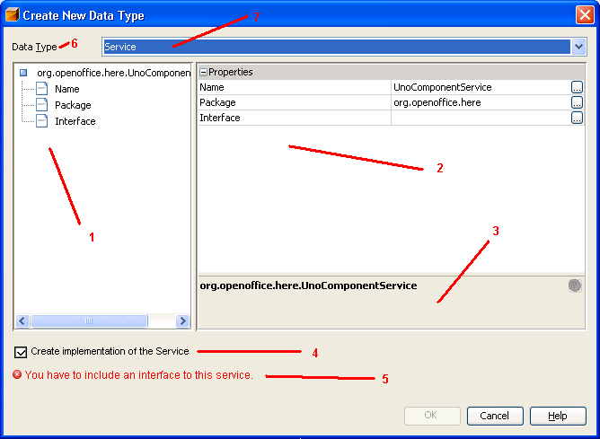Figure 2: Create a new Service
Table 3: User Interface elements of Figure 2
# | Type | Properties |  | Comment
1 |  | Control Properties  Features: Complete service name (including package) with its properties.  Properties are:  - Name  A name for the service, <Name>.idl will be the file name of the service, restrictions for allowed symbols in files and in idl service names apply.  - Package  The name of the package (moduls) of the service. Will be used for creating the subdirectories where the service is located.  - Interface  Since we only support new style services, an Interface must be selcted here. Only (new style) Interfaces from the Office or already created interfaces from the current project may be selected.
2 |  | Control Properties  Features: Show the properties of the service for editing. Editors are not specified here: standard text editors are provided by NetBeans.
2 |  | String English | String German
3 |  | Control Properties  Features: Tool-tip field provided by Netbeans
3 |  | String English | String German
4 |  | Control Properties  Enabled: Yes  Initially Checked: Yes  TriState: No  ToolTip Text: When checked, a Java implementation of the service will be created.  Other...: |  |  | This check-box will determines if a Java implementation of the service will be created or not, meaning skeletonmaker either be started or not.
4 |  | String English  Create implementation of the service | String German
5 |  | Control Properties  Enabled: Yes  Editable: No  Initial Text Inside Field: You have to include an interface to this service.  Drag Enabled: No  Initial Caret Position: -  Characters Allowed: -  Characters not Allowed: -  Selection Starts: -  Selection Ends: -  Selected Text: -  ToolTip Text: -  A11Y Text: -  Other...: -  Password Field Properties -  Echo Character: -  Other...: - |  |  | This field states warnings and errors while the service is created. It is initally there, because all services start in an illegal state with no interface defined.
5 |  | String English | String German
6 |  | Control Properties  Enabled: Yes |  |  | Label for the data type #7
6 |  | String English  Data Type | String German
7 |  | Control Properties  Enabled: Yes  Maximum Row Count: 7  Visible Row Count: 1  Initially Selected Item: Service  ToolTip Text: Select the type of idl file to be created  A11Y Text:  Other...: |  |  | Available items in the box will be Service, Interface, Enumeration, Struct, PolyStruct, Exception, Constant
7 |  | String English  Service | String German

Table 4: Tab order of Figure 2
Tab Order | Comment
#7, #1, #2, #4

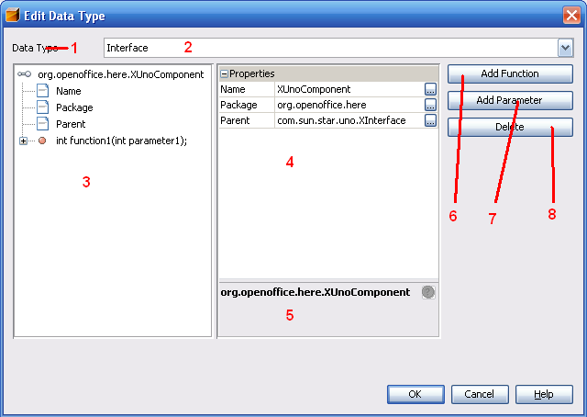Figure 3: Create an Interface

Table 5: User Interface elements of Figure 3
# | Type | Properties |  | Comment
1 |  | Control Properties  Enabled: Yes |  |  | Label for #2
1 |  | Data type | <Enter German String Here>
2 |  | Control Properties  Enabled: Yes  Maximum Row Count: 7  Visible Row Count: 1  Initially Selected Item: Service  ToolTip Text:  A11Y Text:  Other...: |  |  | See comments for this element at Figure 2
2 |  | String English  Interface | String German
3 |  | Control Properties  Features: View of the Interface with properties and defined functions  Properties:  - Name  Name of the Interface, will be <Name>.idl as file-name; should be starting with “X” as naming convention  - Package  Package of the Interface, will be used to create folders  - Parent  A parent interface of this interface; standard is css.uno.XInterface  Defined Functions:  A function defined in an interface is characterized by  - Type  This is either void, a simple type or another Interface  - Name  The name of the function must be unique since overloading of functions is not allowed in idl files.  - Exceptions  Exceptions the function might throw  - Parameters  Parameters:  Parameters are characterized by:  - Name  Unique name of the parameter  - Type  This is either a simple type or another Interface
3 |  | String English | String German
4 |  | Control Properties  Features: Property Sheet provided by NetBeans; edit properties.
4 |  | String English | String German
5 |  | Control Properties  Features: Field for tool-tips for the properties.
5 |  | String English | String German
6 |  | Control Properties  Enabled: Yes  Icon: No  Resizeable: No  Has Menu: No  Menu Items:  ToolTipText:
6 |  | String English  Add Function | String German
7 |  | Control Properties  Enabled: Yes  Icon: No  Resizeable: No  Has Menu: No  Menu Items:  ToolTipText:
7 |  | String English  Add Parameter | String German
8 |  | Control Properties  Enabled: No  Icon: No  Resizeable: No  Has Menu: No  Menu Items:  ToolTipText: |  |  | Is only enabled, when an item that can be deleted is selected in #3: only functions and parameters may be deleted.
8 |  | String English  Delete | String German

Table 6: Tab order of Figure 3
Tab Order | Comment
#2, #3, #4, #6, #7, #8 (if enabled)

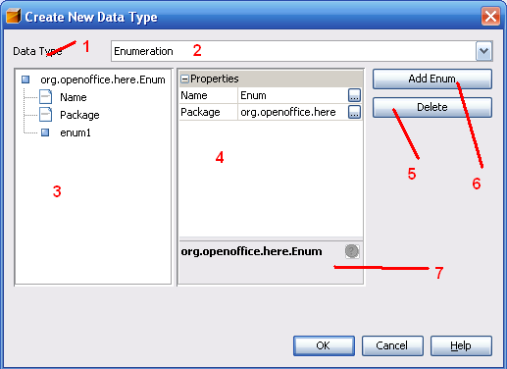Figure 4: Create an enumeration

Table 7: User Interface elements of Figure 4
# | Type | Properties |  | Comment
1 |  | Control Properties  Enabled: Yes
1 |  | Data Type
2 |  | Control Properties  Enabled: Yes  Maximum Row Count: 7  Visible Row Count: 1  Initially Selected Item: Service  ToolTip Text:  A11Y Text:  Other...:
2 |  | String English  Enumeration | String German
3 |  | Control Properties  Features: The enumeration with properties and enumeration items.  Properties:  - Name  Name of the enumeration, <Name>.idl will be created  - Package  Package of the enumeration; will be created as folders  Items:  - Name  Items are only characterized by their name. The order of the names in this field will determine the order of the values.
3 |  | String English | String German
4 |  | Control Properties  Features: Properties of the enumeration
4 |  | String English | String German
5 |  | Control Properties  Enabled: No  Icon: No  Resizeable: No  Has Menu: No  Menu Items:  ToolTipText: |  |  | Delete the selected item of the enumeration; is only enabled when an item is selected.
5 |  | String English  Delete | String German
6 |  | Control Properties  Enabled: Yes  Icon: No  Resizeable: No  Has Menu: No  Menu Items:  ToolTipText: |  |  | Add a new item to the enumeration.
6 |  | String English  Add Enum | String German
7 |  | Control Properties  Features: Tool-tip for the property sheet #4
7 |  | String English | String German

Table 8: Tab order of Figure 4
Tab Order | Comment
#2, #3, #4, #6, #5

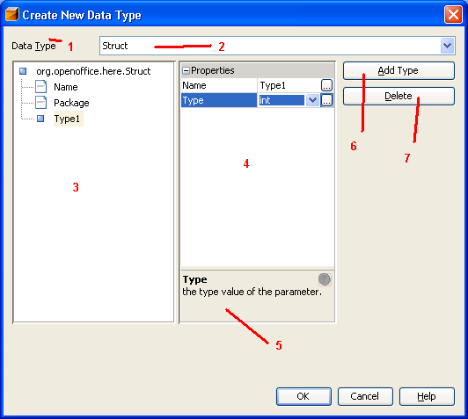Figure 5: Create a new struct

Table 9: User Interface elements of Figure 5
# | Type | Properties |  | Comment
1 |  | Control Properties  Enabled: Yes |  |  | Label for #2
1 |  | Data Type
2 |  | Control Properties  Enabled: Yes  Maximum Row Count: 7  Visible Row Count: 1  Initially Selected Item: Service  ToolTip Text:  A11Y Text:  Other...:
2 |  | String English  Struct | String German
3 |  | Control Properties  Features: Struct with properties and types.  Properties:  - Name  Name for the struct, <Name>.idl will be created  - Package  Package of the struct; will be created as folders  Types:  A type is characterized by name and data type:  - Name  A unique name in the struct  - Type  Either a simple data type or an interface
3 |  | String English | String German
4 |  | Control Properties  Features: Property sheet for the properties of #3
4 |  | String English | String German
5 |  | Control Properties  Features: Tool-tip for the property sheet
5 |  | String English | String German
6 |  | Control Properties  Enabled: Yes  Icon: No  Resizeable: No  Has Menu: No  Menu Items:  ToolTipText: |  |  | Add a new type to the struct
6 |  | String English  Add Type | String German
7 |  | Control Properties  Enabled: No  Icon: No  Resizeable: No  Has Menu: No  Menu Items:  ToolTipText: |  |  | Only enabled when a type is selected in #3.
7 |  | String English  Delete | String German

Table 10: Tab order of Figure 5
Tab Order | Comment
#2, #3, #4, #6, #7

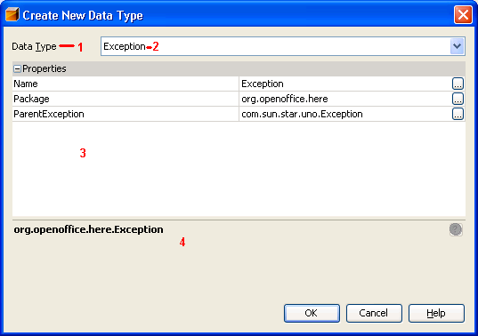Figure 6: Create a new exception
Table 11: User Interface elements of Figure 6
# | Type | Properties |  | Comment
1 |  | Control Properties  Enabled: Yes |  |  | Label for #2
1 |  | Data Type
2 |  | Control Properties  Enabled: Yes  Maximum Row Count: 7  Visible Row Count: 1  Initially Selected Item: Service  ToolTip Text:  A11Y Text:  Other...:
2 |  | String English  Exception | String German
3 |  | Control Properties  Features: Property Sheet for the exception  Properties:  - Name  Exception is saved as <Name>.idl; convention for the name is <descriptio>Exception.  - Package  The package of the exception; used to create folders  - ParentExceptio  The exception where this one is derived from
3 |  | String English  <Enter String Here> | String German  <Enter String Here>
4 |  | Control Properties  Features: Tool-tip for the property sheet
4 |  | String English | String German

Table 12: Tab order of Figure 6
Tab Order | Comment
#2, #3

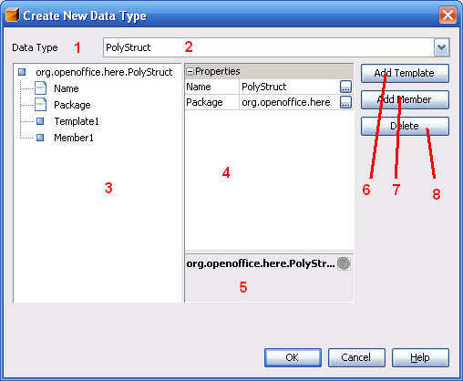Figure 7: Create a new poly-struct
Table 13: User Interface elements of Figure 7
# | Type | Properties |  | Comment
1 |  | Control Properties  Enabled: Yes |  |  | Label for #2
1 |  | Data Type
2 |  | Control Properties  Enabled: Yes  Maximum Row Count: 7  Visible Row Count: 1  Initially Selected Item: Service  ToolTip Text:  A11Y Text:  Other...:
2 |  | String English  PolyStruct | String German
3 |  | Control Properties  Features: Properties and elements of the poly-struct.  Properties:  - Name  Name of the poly-struct; a file <Name>.idl will be created  - Package  The package; will be used to create sub folders.  Template:  These are the template types of the poly-struct. When using the struct, they will be replaced by real UNO-types.  - Name  A name for this template  - Type  A type for this template; the type has to be unique and is only a placeholder for the real type inserted when the ploy-struct is used. Suggested names are T followed by a number: T1, T2...  Member:  - Name  A name of this member variable  - Type  The member types can be of a UNO type, but also of one of the template types created. Both will be available.
3 |  | String English | String German
4 |  | Control Properties  Features: Property Sheet for the poly struct
4 |  | String English | String German
5 |  | Control Properties  Features: Toll-tip for the properties
5 |  | String English | String German
6 |  | Control Properties  Enabled: Yes  Icon: No  Resizeable: No  Has Menu: No  Menu Items:  ToolTipText: |  |  | Add a new template.
6 |  | String English  Add Template | String German
7 |  | Control Properties  Enabled: Yes  Icon: No  Resizeable: No  Has Menu: No  Menu Items: No  ToolTipText: |  |  | Add a new member variable; as type, all template types are available besides of the usual simple types and interfaces.
7 |  | String English  Add member | String German
8 |  | Control Properties  Enabled: No  Icon: No  Resizeable: No  Has Menu: No  Menu Items:  ToolTipText: |  |  | Only enabled, when a template type or member type is selected.
8 |  | String English  Delete | String German

Table 14: Tab order of Figure 7
Tab Order | Comment
#2, #3, #4, #6, #7, #8

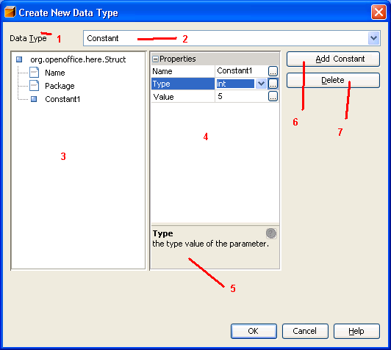Figure 8: Create a new constant group

Table 15: User Interface elements of Figure 8
# | Type | Properties |  | Comment
1 |  | Control Properties  Enabled: Yes |  |  | Label for #2
1 |  | Data Type
2 |  | Control Properties  Enabled: Yes  Maximum Row Count: 7  Visible Row Count: 1  Initially Selected Item: Service  ToolTip Text:  A11Y Text:  Other...:
2 |  | String English  Constant | String German
3 |  | Control Properties  Features: Constant group with properties and types.  Properties:  - Name  Name for the constants, <Name>.idl will be created  - Package  Package of the constants; will be created as folders  Constant:  A constant is characterized by name, data type nad value:  - Name  A unique name for the constant  - Type  A simple data type  - Value  The unchangeable value of the constant
3 |  | String English | String German
4 |  | Control Properties  Features: Property sheet for the properties of #3
4 |  | String English | String German
5 |  | Control Properties  Features: Tool-tip for the property sheet
5 |  | String English | String German
6 |  | Control Properties  Enabled: Yes  Icon: No  Resizeable: No  Has Menu: No  Menu Items:  ToolTipText: |  |  | Add a new type to the struct
6 |  | String English  Add Constant | String German
7 |  | Control Properties  Enabled: No  Icon: No  Resizeable: No  Has Menu: No  Menu Items:  ToolTipText: |  |  | Only enabled when a constant is selected in #3.
7 |  | String English  Delete | String German

Table 16: Tab order of Figure 8
Tab Order | Comment
#2, #3, #4, #7

Open Issues
Questions and unsolved will arise during the creation process of the specification. Make sure that no open issue are left, when the specification gets the state “Standard”
Issue | Initials | Date
I74869: constant file type is not yet supported. | sg | 02/26/07
<...>

Document Change History
Rev. | Change | Initials | Date
1 |  |  | <Format: Dec 31, 2000>
2
3
<...>

