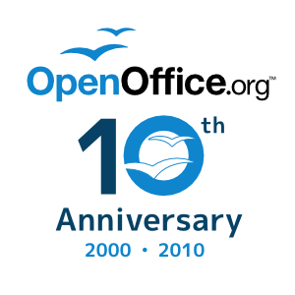

Thank You ….
- Major Supporters: Oracle, (formerly) Sun Microsystems, Novell, Inc., Beijing Redflag CH2000, Red Hat, Inc., IBM Corp., Google Inc.
- Community Developers
- Beta Code Testers
- Community Project Leaders
- Community Contributors
- Book Authors
- … and last, but not least,YOU, our OpenOffice.org users

Thanks to all of you for making
OpenOffice.org
the highly regarded, and highly awarded
open source office suite it is today!

