Software Specification Document

OpenOffice.org
Options Chart Colors

Specification Status
Last Change | Jun 28, 2007
Status
Abstract
With the Tools/Options/Charts/Default Colors dialog a set of default colors can be defined. These default colors are applied to the data series of newly created charts, as well as data series added to existing charts.

i-Team Members
Role | First Name, Last Name, Initials | E-Mail Address
I-Team Lead | Björn Milcke (BM) | bm@openoffice.org
Specification Author | Björn Milcke (BM) | bm@openoffice.org
User Experience | Matthias Müller-Prove (MMP) | mmp@openoffice.org
Development | Björn Milcke (BM) | bm@openoffice.org
Quality Assurance | Thomas Klarhöfer (TK) | kla@openoffice.org
Documentation | <First Name, Last Name (Initials)> | <User@openoffice.org>
Other roles | <First Name, Last Name (Initials)> | <User@openoffice.org>
Help is already available for this dialog. The additional new colors require no additional help.

Contents
Abstract 1
i-Team Members 1
References and Reference Documents 3
Acronyms and Abbreviations 4
1 Detailed Specification 5
2 Migration 7
3 Configuration 7
4 File Format 8
5 Open Issues 8
Document Change History 8

References and Reference Documents
Reference Document | Check | Location (URL)
Specification Process Entry Check |  | N/A
Product Requirement, RFE, issue [Required] |  | Issue 75202
Product Concept Document |  | <Please enter location here>
Competitive Analysis |  | <Please enter location here>
IDL Specification |  | <Please enter location here>
Test Case Specification [Required] |  | http://www.openoffice.org/nonav/issues/showattachment.cgi/46292/default_colors.html
Software Specification Rules | N/A | N/A
Specification for Options Dialog |  | http://specs.openoffice.org/appwide/separate_modules/OptionsDialog.sxw
Acronyms and Abbreviations
Acronym / Abbreviation | Definition
<WYSIWYG> | <What You See Is What You Get>

Detailed Specification
With the menu item Tools/Options... you get the Options Dialog (see Specification). It contains a section “Charts”. In this section there is a dialog page for “Default Colors”. This Specification is about the “Default Colors” dialog page.
With the Default Colors dialog page a set of default colors is defined. These default colors are applied to the data series of newly created charts, as well as data series added to existing charts.
Example: If a loaded chart has three series, and a fourth series is added, the new series gets the color given in “Data Series 4” of the list.

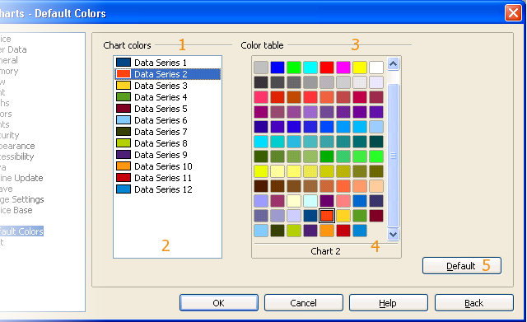Figure 1: The Chart Default Color Option Dialog

- “Chart colors” - Label Properties |  | Comment
Label: | Chart colors |  | EN-US
Label: | Diagrammfarben |  | DE
- “Chart colors” - ListBox Properties |  | Comment
Enabled: | Always
Disabled: | Never
Max. Row Count: | 12
Rows Visible: | 17
Items: | - Data Series %N ; Datenreihe %N | EN-US, DE;  %N is replaced by the item number starting with 1 ending with 12
Item Selected: | 1
Sorting by Drag & Drop: | Disabled
ListBox Label: | See #1
- “Color table” - Label Properties |  | Comment
Label: | Color table |  | EN-US
Label: | Farbtabelle |  | DE
- “Color table” - ColorBox Properties |  | Comment
Enabled: | Always
Disabled: | Never
Max. Row Count: | Unlimited (with current standard colors: 13)
Rows Visible: | 12
Columns Visible: | 8
Items: | The colors contained in the current standard.soc file | EN-US, DE
Item Selected: | The color corresponding the color of the selected item in ListBox #2. If the color of the selected item in ListBox #2 is not contained in the standard.soc list, no color is selected.
Sorting by Drag & Drop: | Disabled
Other: | Text shown below colors: The name of the selected color as it is given in the standard.soc for user defined colors. Otherwise it contains a localized name of the color.
ColorBox Label: | See #3
- “Default” - Button Properties |  | Comment
Enabled: | Always
Disabled: | Never
Press: | Sets the colors for data series to the defaults. See table below for the values.
Button Label: | Default |  | EN-US
Button Label: | Standard |  | e.g. DE

The twelve colors used as default for new charts are as follows. These colors are part of the default standard.soc located at the end of the palette. The Name in EN-US locale is “Chart %N”, where %N is replaced by the index of its appearance in the list. In locale DE it is “Diagramm %N”.
Index | Name in EN-US | Value in RGB Hex | Color
1 | Chart 1 | 0x004586
2 | Chart 2 | 0xff420e
3 | Chart 3 | 0xffd320
4 | Chart 4 | 0x579d1c
5 | Chart 5 | 0x7e0021
6 | Chart 6 | 0x83caff
7 | Chart 7 | 0x314004
8 | Chart 8 | 0xaecf00
9 | Chart 9 | 0x4b1f6f
10 | Chart 10 | 0xff950e
11 | Chart 11 | 0xc5000b
12 | Chart 12 | 0x0084d1

Migration
This dialog already exists in OpenOffice.org. The default colors are new, but apply only to newly created charts or data series. So, no migration is necessary.

Configuration
The default colors for charts are stored in the file Chart.xcu in the path org/openoffice/Office. The schema for the configuration looks like follows:
<?xml version="1.0"?>
<oor:component-schema xmlns:oor="http://openoffice.org/2001/registry" xmlns:xs="http://www.w3.org/2001/XMLSchema" xmlns:xsi="http://www.w3.org/2001/XMLSchema-instance" oor:name="Chart" oor:package="org.openoffice.Office" xml:lang="en-US">
<info>
<desc>Contains settings for the Chart application.</desc>
</info>
<import oor:component="org.openoffice.Office.Common"/>
<component>
<group oor:name="DefaultColor">
<info>
<desc>Specifies the colors for creating new charts.</desc>
</info>
<prop oor:name="Series" oor:type="oor:long-list">
<info>
<desc>Specifies a list of color values to be used for the first n series, where n is the size of the list. For i &gt; n the color used is equal to entry number i modulo n in the list. You should keep the size of the list at 12. Also note that the values are interpreted as unsigned 32bit values, although it is possible to get negative (signed) numbers in this list when being displayed in decimal.</desc>
<label>Chart colors</label>
</info>
<value>0x004586 0xff420e 0xffd320 0x579d1c 0x7e0021 0x83caff 0x314004 0xaecf00 0x4b1f6f 0xff950e 0xc5000b 0x0084d1</value>
</prop>
</group>
</component>
</oor:component-schema>

File Format
Does not apply.

Open Issues
Issue | Initials | Date
<State Issue here, State “None”, if all issues are solved> |  | <Format: Dec 31, 2000>
<...>

Document Change History
Rev. | Change | Initials | Date
1 | New Spec | BM | Jun 19, 2007
2 | Added TCS link, set to standard | BM | Jun 28, 2007
3
<...>

