User Experience Expert Evaluation

Extension Repository July 2007

Status
Last Change | September 11, 2007
Status | final
Abstract
Second user experience expert evaluation of the Extension Repository at http://extensions.services.openoffice.org/ .

Team Members
Role | Member | E-Mail Address
User Experience | Matthias Müller-Prove /MMP | mprove@sun.com

Contents
Abstract 1
Team Members 1
Acronyms and Abbreviations 3
1 Home Page 4
1.1 Header 4
1.2 Left Navigation Area 5
1.2.1 Extensions box 5
1.2.2 Search box 6
1.2.3 Categories box 7
1.2.4 Documentation 7
1.2.5 OpenOffice.org box 7
1.3 Footer 7
2 Browse Page 9
3 Project Page 10
3.1.1 Release Page 11
4 Appendix 1 – MMP's assessment 26-Apr-2007 12
5 Document Change History 13

Acronyms and Abbreviations
Acronym / Abbreviation | Definition
OOo | OpenOffice.org

Home Page
http://extensions.services.openoffice.org/
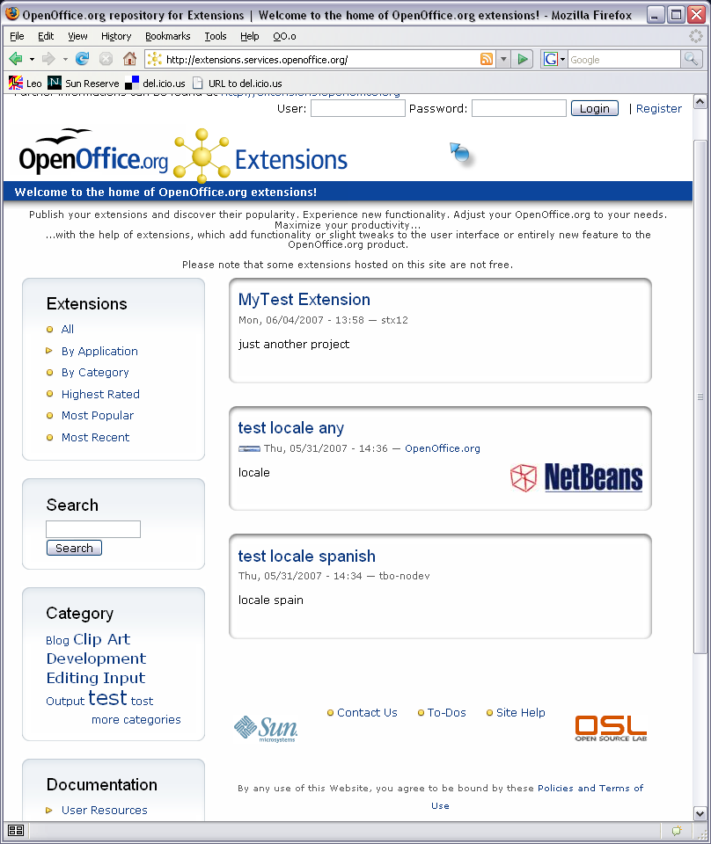

Header
- HTML Title too long
- use a crisp and short title, match it to the visible title of the page
- Suggestion: ”OpenOffice.org Extensions”
Rational: The title is used for (social) bookmarking. Unclear wording makes it harder to recognize the bookmark later on.
- good logo
It is better to use “Extensions” rather than “.ext” . /positive issue
- subtite: “Welcome to the home of OpenOffice.org extension!”
- Don't use “Welcome”. Do not shout “!” at the visitors!
- Shift right the left indent to align with the logo and the boxes below.
- Suggestion: “Expand the functionality of your office suite OpenOffice.org”
- subsubtitle “Publish your extensions...”
- This text should first explain what an extension is and second what this site is about.
- Keep in mind that the majority of the visitors will browse for extensions to extend their office functionality. This should be first user to address. Sharing/publishing extensions is secondary.
- Have a look at https://addons.mozilla.org/en-US/firefox/
- The text breaks strangely if the browser window is too narrow.
- The text is just visible on the home page. This makes the left column jump. Better to use just the right 2/3s content are for the intro text.

Left Navigation Area
- Left column too long
It does not fit on a 1024pixel vertical screen. I suggest to save some space. The issues for the boxes below show how this can be accomplished.
- Indicate what is chosen.
By making the item bold (and removing the link) the user can see what she has selected. This should be considered for the Extensions box and the Documentation box.

Extensions box
- Order of items
- Use a different order
  - Most Popular
  - Highest Rated
  - Most Recent
  - By Applications
  - All Extensions
- (Minor) “By Application > OpenOffice.org” is redundant to “All” it can be removed.
Mathias Michel 24-Jul-2007:
It could be thought as an extension can be useful for OOo back-end (proxy handling, for example) and then is not linked to any module.
Does it make sense?
MMP 27-Jul-2007:
well, maybe. I assume the categorization All, (By Application)OOo, (By Application) Writer, etc. can be confusing. Do you plan to collect extensions at (By Application)OOo that are not linked to any other module? Then maybe renaming it the "Other" or "General" and moving it to the end of the list might be a better solution.
- “By Category” can be removed
Categories are featured by an extra box in the left column anyway.
- Left-align the yellow disclosure triangle with the yellow circles.
right now it looks a bit off a straight column. /fixed

Search box
- The Search field takes up too much space.
Suggestion:
- Put it top right on top of the blue bar.
- Put “Search” inside the text field and remove it once the field gets focus
- Replace the Search button with an icon to save some space.
Comment by Leonard Mada, 26-Aug-2007:
I must express my opposition to this suggestion. basically, the SEARCH-box should be always visible and it should strike out against the background.
So, positioning it somewhere outside the functional-area of the page is a clear *NO*. I always suggest comparing some good web sites:
- http://www.bbc.co.uk => the Search-box in the upper left corner strikes out.
Whatever the news are and you are distracted by those images, you still notice immediately the 'Search'-box
- http://www.apple.com/itunes/ => here the design is slightly different
ALL First-Level Menus are in the top row, therefore, the 'Search'-box has to be in this row, too
BUT it stands clearly out of the background
[Although I feel that the 'Horizontal'-design won't fit the OOo Extension site]
- http://www.adobe.com => same horizontal design as in the previous paragraph
the 'Search'-box stands out
CONCLUSIONS:
The 'Search'-box:
- shall be big enough
- shall be clearly visible and shall stand out against the background
- in a 'Vertical'-design, it should be positioned either above the 'Extensions'-box
or left in place where it is now (though I'll position it above the Extensions box)
BUT definitely below the blue bar

Categories box
- Remove Category Title
The title “Category” is not needed to explain the purpose of the box. If you like to keep it, make it plural.
Are the categories tags? In other words, can an extension be in 2 categories? Then the categories are in fact tags – with respect to my notion of the words.

Documentation
- User Resources
As long as User Resource contains just one item, remove the hierarchy. /fixed

OpenOffice.org box
The link to OpenOffice.org can be part of the footer.

Footer
- Layout of footer
- Move the footer to the bottom and span 100% of the page width. /fixed
- The Sun Logo
- The Sun logo links to OOo page at sun.com – kind of surprise. I expect to link it to sun.com
- Site – Help
- In fact this is a link to the openoffice.org help page. If the visitor clicks this link she probably wants to know something about the extension repository. . /fixed
Comment by Leonard Mada, 26-Aug-2007:
- Delimit the whole footer from the rest of the document:
- one can use a separate color, see e.g. https://addons.mozilla.org/en-US/firefox/browse/type:4
- or use a transparent background (BUT the main area is delimited), see e.g. http://www.adobe.com/
[IF you choose this latter approach, like it currently looks like,
then the whole main-area has to end at the same position, see the Adobe-site!]

Browse Page
http://extensions.services.openoffice.org/project
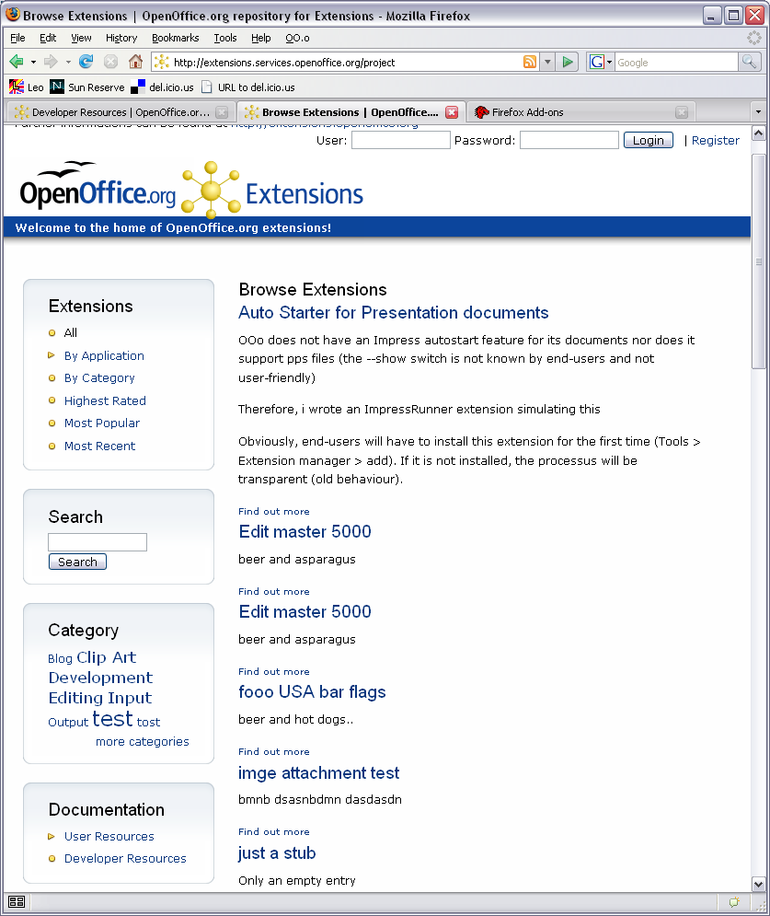
- Find out more
- The link “Find out more” looks like it belongs to the extension below.
- I suggest to add more white space between the extensions.

Project Page
http://extensions.services.openoffice.org/project/swp
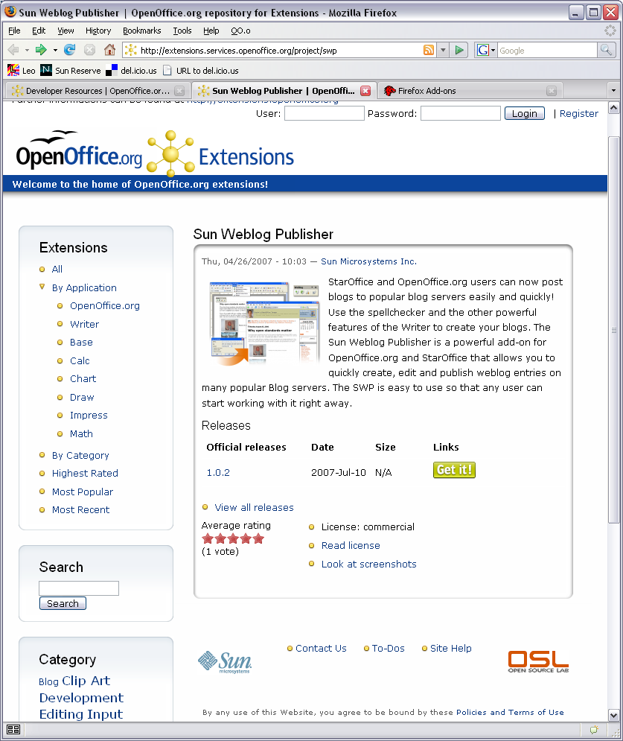

- Visual Design
The graved-in frame look very dominant. It also does not fit the light blue design of the navigation bar.
- Time
There is no need to reveal the time. Date of update is sufficient. . /fixed
- Screenshots
- The thumbnail of the screenshoot could link to a 100% version.
- The link says: Look at screenshots. Can there be more than one?

Release Page
http://extensions.services.openoffice.org/node/27
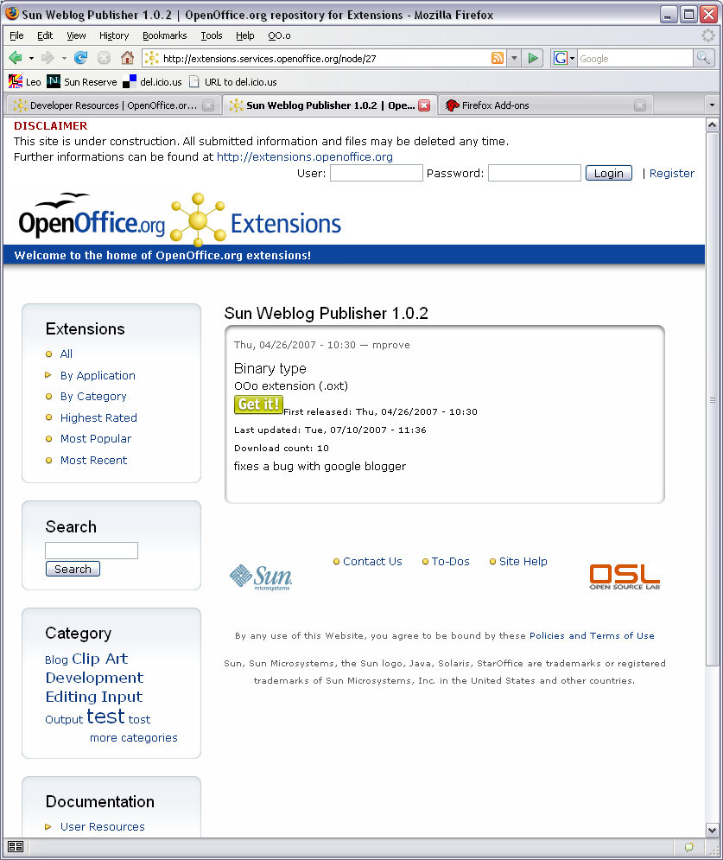
- Clean up the content of the release page.

Appendix 1 – MMP's assessment 26-Apr-2007
Hi Jürgen,
some rough comments:
- Pleasing color scheme. I like it.
- Good legibility of text
- The logo "OO.o ext" is hard to decipher. We decided to use "oxt" as the suffix for extensions. Very techy, indeed./fixed 16-Jul-2007
- Footer does not fit at 980 pixels width; the OSL logo hangs out. I suggest to design a full width footer.
- I like that you can filter for modules (e.g. extension that are only applicable to a certain module). Some issues:
  - Please make the entire app icon clickable. /fixed 16-Jul-2007
  - Promote this cool feature to the left nav bar. (All, Highest Rated, Writer, Calc, Impress, ...) /fixed 16-Jul-2007
  - And do not offer a module filter until there are real extension for that module (e.g. where is a real Math extension?)
  - Introduce a general OOo icon to look for all extensions, once you are drilled down to a specific module.
- Install Guide for Extensions. Starting with OOo 2.2 the file type ".oxt" is registered. This means that you can simply double-click an oxt-extension to install it.
- Header: The link "Get OpenOffice.org" should go to http://download.openoffice.org/index.html
- User creation went smoothly. However, I do not understand why I should get a user account.
- Hey, now I can browse the extensions by application! Do I have to log in to see this part of the site? Why not offer this to all visitors?! /fixed 16-Jul-2007
- http://extensions.services.openoffice.org/taxonomy_menu/4
Can you sort the apps by significance? Start with Writer, Calc, Impress, Draw, Base, remove Math until there is a real Math extension. I expect to have extensions for Chart at some point. And (as mentioned above) a general category for Gallery schemes and templates makes sense.
- Ah, I see, this is browsing by category. Category - Clip Art gets me to the gallery themes. OK.
- Highest Rated. The list of highest rated extensions is not sorted by the rating yet. It is 4 stars - 3 stars - 1 star - 4 stars
- The extension home for USA Flag Collection (as an example).
I have my browser window at a width of 980. The link for "Release Notes" line-breaks. Now it looks like "Download notes" in the column Links, and "Release" stands alone to the right.
- Some extensions have special system requirements. Like OOo 2.3 and higher, or Windows only. Would be great if such info is a) provided and b) can be filtered like category or application
- If I submit an extension,...
  - I am asked to enter the locale. Well, what is this? I have an extension with an English AND German user interface.
  - Categories. Where shoud I put (eg.) a presenter screen for Impress? http://blogs.sun.com/GullFOSS/entry/adding_a_presenter_view_to This does not fit into the list of existing categories.
  - Otherwise: cool functionality!
  - Is it fair that I can rate my own extensions??
  - I do not understand the "Releases" feature.
  - Do I have to upload the extension for each release?
  - When I add a release, then the date is 1970-Jan-01.
  - When I try to download the release (remember, I did no upload), I get the home page at http://extensions.services.openoffice.org/files/
- Product screenshot. It would be great to show a thumbnail of the screenshot on the extension page.
- Do you provide a list of all members?
- My profile page should contain a list of extensions that I have contributed (makes it easy for me to update the info for an extension). And a list of extensions that I have downloaded (and I want to see if there is an update available).
- If I am not logged in, I still have the link to Submit an extension. The page could provide some info like, "In order to submit an extension you have to create a user account first."
- Can I provide a story myself?
Well, it turned out that my rough comments are actually rough, but not short. Please take this as my kudos for the great site that you are developing.
best
Matthias :: User Experience :: Sun Microsystems

Document Change History
Rev. | Change | Initials | Date
1 | Create report | MMP | Jul 16, 2007
2 | fixed some typos | MMP | Jul 24, 2007
3 | add comments from Leonard Mada, 26-Aug-2007 | MMP | Sep 11, 2007

