

Creating Large Documents With OpenOffice.org Writer

Copyright and Trademark Information
The contents of this document are subject to the Public Documentation License, Version 1.0 (the "License"). You may only use this document if you comply with the terms of the license. A copy of the license is available at the end of this document and at: http://www.OpenOffice.org/licenses/PDL.rtf
The original document is “Diplomarbeiten mit StarOffice”. The initial writer of the original document is Werner Roth. © 1999. All Rights Reserved.
Contributors: G. Roderick Singleton, G.Wey (guewey@pathcom.com) for translating and William T. Marchant (wmarchant@eastlink.ca ) for editing.
Portions created by G. Roderick Singleton, Güenter Wey and William T. Marchant are © 2005. All Rights Reserved.
Portions created by Publishing Power (www.pubpow.com) are © 2008. All Rights Reserved.
All trademarks within this guide belong to legitimate owners.
Feedback
Please direct any comments or suggestions about this document to: dev@documentation.OpenOffice.org.
Acknowledgments
<Werner Roth> The original German Language document
<G. Wey> First draft of English Language document
<William T. Marchant> First edition English language document
<Publishing Power> Second English language document
<Sun Microsystems> Third English language document
Modifications and Updates
Version | Date | Description of Change
[0.0] | [2005-02-28] | [gw: Initial English Language translation]
[0.1] | [2005-03-31] | [wtm: Initial English Language edition issued for comment]
[0.2] | [2005-02-28] | [grs: Initial edit and proofing]
[0.3] | [2005-02-28] | [wtm: Final edit and proofing]
[0.4] | [2008-05-12] | [ppi: Edit all text for grammar, reformat layout, reorganize content, update all content and screenshots for OpenOffice 2.4, expand existing content.]
[0.5] | [2009-07-20] | [sm: Update the content and screenshots for OpenOffice.org 3. Modify title.]
[0.6] | [2010-02-11] | [cc: Added Sun/Oracle logo and changed the contact email address]

Table of Contents
Overview 6
Before You Begin 6
Protecting Your Data 6
Automatically Create a Backup Copy 6
Save AutoRecovery Information 6
Create Links to Objects 7
Save Often 7
Printing Your Document 7
Saving in PDF Format 7
Taking OpenOffice with You 7
Templates 8
Planning Your Document 8
Page Styles 8
Creating a New Page Style 8
Applying a Page Style 9
Modifying a Page Style 9
Page Orientation 10
Page Numbering 10
Numbering Formats 11
Resetting Page Numbers 11
Text Layout 13
Headers and Footers 14
Controlling Text Flow 15
Paragraph Styles 16
Creating a New Paragraph Style 17
Modifying a Paragraph Style 18
Numbered Headings 18
Setting Outline Numbering for Headings 20
Cloning a Heading 20
Indenting the First Line of a Paragraph 22
Starting Each Chapter on a New Page 23
Character Styles 23
Creating a New Character Style 23
Applying a Character Style 23
Master Document 24
Creating a Master Document 24
Working in a Master Document 25
Footnotes 26
Customizing the Footnote Area 26
Customizing Footnote Settings 26
Inserting a Footnote 26
Appendices 27
Chapter Numbering for Appendices 27
Listing Appendices in the Table of Contents 28
Cross-referencing 29
Inserting a cross-reference 29
Modifying a Cross-reference 31
Updating a Cross-reference 31
Graphics 32
Inserting Graphics 32
Creating a Link to Graphics 32
Relocating Linked Graphics 33
Breaking Links 34
Creating a Gallery 34
Anchoring Graphics 34
Captions 35
Adding Captions 35
Moving and Editing Captions 35
Formulas 36
Inserting Formula Calculations 36
Inserting Formulas in Symbolic Format 36
Charts 37
Creating a Chart 37
Changing the Chart Type 37
Changing Chart Colors 37
Changing Text Style 37
Customizing Your Charts 37
Tables 38
Creating a Table Format 38
Applying a Table Format 38
Marginalia 39
Indexes 40
Creating Index Entries 40
Editing and Deleting Index Entries 40
Generating an Index 40
Formatting Index Entries 41
Bibliographies 42
Creating a Table of Contents 43
Generating a Table of Contents 43
Editing a Table of Contents 44
Formatting Entries 44
Updating the Table of Contents 44
Deleting the Table of Contents 44
Resources 45
Support and Documentation 45
Extensions 45
Additional Resources 45
Public Documentation License, Version 1.0 46

Overview
Creating a large text document (50 pages or more) should be done using a word processing program with style and template features that help maintain consistency throughout your document. By creating a template with customized styles, you can write large documents from beginning to end without the need to insert page breaks, resize graphics, or adjust fonts—and everything looks just as it was intended.
In this document, we will guide you through the process of creating a customized template using OpenOffice 3 Some topics will be covered in detail while others will refer you to the User Guide for more information. This document assumes you are already familiar with OpenOffice basics, however, even a beginner should be able to conquer some of the more complex tasks by frequently referring to the OpenOffice online User Guide and Help documentation.

Before You Begin
To help speed the process of creating large documents, we strongly suggest that you take the time to carefully plan and organize it in advance. What size and font do you want your headings and text to be? Do you want headings to be numbered? How do you want your headings aligned? Do you want each chapter to start on a new page? Will the first line of each paragraph be indented? Do you have footnotes? How do you want tables to look? Will page numbering be sequential throughout the document? Will your document have an index or appendices?This is just a sampling of the questions you must answer before you begin creating your document. Taking the time to plan ahead can prevent problems from arising, saving you a lot of time and frustration in the long run.

Protecting Your Data
Frequent saving and backing up is a must when dealing with data that may have taken hours to generate. OpenOffice 3 offers several options to help keep your data safe.

Automatically Create a Backup Copy
- From the Tools menu, select Options > Load/Save > General.
- Select Always create backup copy and click OK.
Now, each time you save your document, the previous version of the document is saved to your backup directory.

Save AutoRecovery Information
This command saves the information necessary to restore the current document in case of a crash.
- From the Tools menu, select Options > Load/Save > General.
- Select Save AutoRecovery information every and select the time interval at which you want to automatically save.
- Click OK.

Create Links to Objects
To further protect your data, you should create and save different data types separately. For example, an embedded object such as a graphic should be created and saved as a separate file. Rather than embedding the object into the document, you should place it as a linked object. This helps keep your objects safe and it helps reduce your file size. It also automatically updates itself in the document when changes are made to the original file.

Save Often
You should make it a point to save your work several times a day onto an external data medium, such as a CD or external hard drive. When doing so, be sure to keep more than just the last-saved update as your hardware or software could already have written corrupted data onto the hard drive while otherwise working fine. Only when opened afresh after a completed work session will OpenOffice Writer greet you with the message that the file is corrupted and cannot be read anymore.

Printing Your Document
With Writer you can print your files by just clicking the printer icon or by choosing print from the file menu. By using the print menu you can define exactly which elements of the document you want to print. Exporting the document to PDF is also a good strategy for printing, as PDF is an established standard.

Saving in PDF Format
A PDF file can be viewed and printed on any platform with the original formatting intact, provided that supporting software is installed.
- Click the Export Directly as PDF button on the Standard toolbar.
- Select where you want to save the PDF document.
- Type a name for the document and click Save.

Taking OpenOffice with You
To make it easy for you to work on your document wherever you are, a portable version of OpenOffice is available. This version of OpenOffice runs from a memory stick, so you don't need to worry about whether or not the computer you are working on has OpenOffice installed. For more information about the portable version of OpenOffice, visit: http://portableapps.com/apps/office/openoffice_portable

Templates
A template is a document that contains specific formatting styles for text, graphics, tables, objects, etc. A template can be used as the basis for creating other documents. For example, you can define paragraph and character styles in a document, save the document as a template, and then use the template to create a new document with the same styles. Unless you specify otherwise, every new OpenOffice text document is based on the default template. In this document we will show you how to create your own customized template. OpenOffice.org now has a Template Repository, where you can find useful templates. You can also upload your personal templates there and help other OpenOffice.org users. For further information visit: http://templates.services.openoffice.org/

Planning Your Document
Before starting with the actual writing, you should experiment with a lot of dummy text to come up with a desired layout. Once you are satisfied with the overall look, you can translate your sample into an appropriate array of page, character, and paragraph styles and save it as a template file that can be used as the basis for each chapter of your document. If layout changes are desired when writing the actual document, you can make the appropriate changes to the template and next time a chapter is opened the changes to the template will be noted and you can accept or reject as required.

Page Styles
In most cases, a large document requires several different page structures. For example, the title page needs neither header nor footer. The Table of Contents, which may extend over more than one page, uses Roman page numbering. The actual body of the document uses Arabic page numbering and contains the chapter title in the header.
OpenOffice uses page styles to specify the layout of a page, including the page orientation, background, margins, headers, footers, and text columns. To change the layout of an individual page in a document, you must create and apply a custom page style to the page.

Creating a New Page Style
Page styles are created using the Styles and Formatting feature.
- From the Format menu, choose Styles and Formatting.
- In the Styles and Formatting window, click the Page Styles icon.
- Right-click a page style and select New.
- Type a name for your page style in the Name box.
- Select which page style you want to use for the following page in the Next Style box. For example, if you want to use this page style for more than one page, select its name from the Next Style menu. If you want to apply this page style to just a single page, select your default page style from the Next Style menu. Whichever style you choose is the page style that will be used in all subsequent pages until you manually change the page style.
- Use the tabs in the dialog box to set the remaining styles for the page.
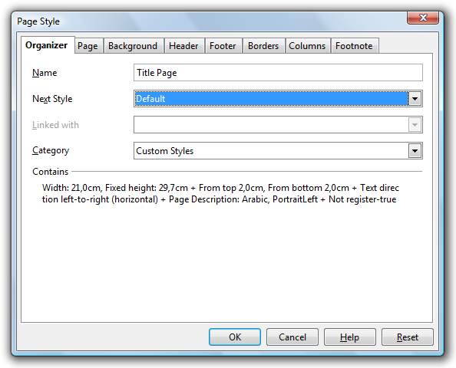Figure 1: Creating a new page style.

Applying a Page Style
The style for each page is indicated at the bottom of the page in the second box from the left on the Status Bar. In this case, the Left Page style is used. To change the style, simply right-click the style and select a new page style from the menu. Use this method cautiously, though, as it will change the page style for all of your pages.
If you need to apply a new page style while maintaining the page styles you have already applied, you must first insert a manual page break. This is particularly useful when applying your default page style after your Title and Table of Contents pages.
- From the Insert menu, choose Manual Break.
- Select Page break.
- Select a page style from the Style menu and click OK.

Modifying a Page Style
You can modify a page style at any time. The easiest way is to double click the page style in the status bar. The Styles and Formatting window automatically displays for that page style. You can also press F11 to open the Styles and Formatting window, right-click the page style you wish to modify, and select Modify.

Page Orientation
OpenOffice uses page styles to specify the orientation of the pages in a document. For example, to change the page orientation of one or more pages in a document from portrait to landscape in a document, you need to create a page style that uses the landscape orientation, and then apply the page style to the pages.
- Follow the instructions above for creating a new page style.
- On the Page tab, select Landscape as the orientation.
- Click OK.
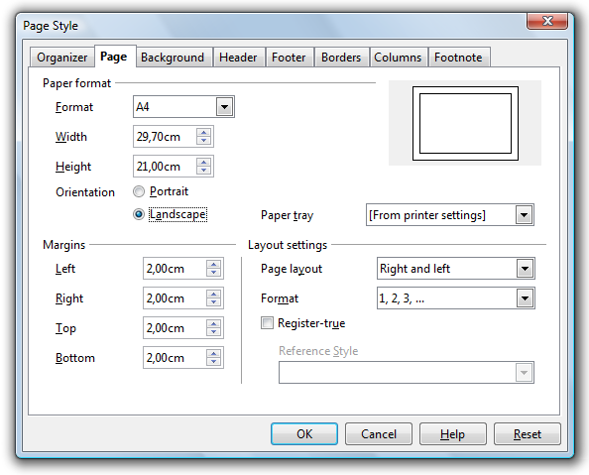Figure 2: Creating a page style with Landscape orientation.
To insert the landscape page:
- Choose Insert > Manual Break at the appropriate location in the document.
- Select the landscape page style from the Style drop down menu.
At the end of the section requiring landscape orientation, another manual page break is needed and a new page style applied.

Page Numbering
When creating large documents, it is standard to use different page numbering for certain page styles. For example, the Table of Contents pages are typically numbered with Roman numerals while the rest of the document uses Arabic numerals.

Numbering Formats
You can set the page numbering format by modifying the page style. You will need a separate page style for each page number format.
- From the Format menu, choose Styles and Formatting.
- Click the Page Styles icon at the top of the Styles and Formatting window.
- Right-click the page style you wish to modify and select Modify.
- Click the Page tab.
- Under Layout Settings, select a Roman numeral style from the Format menu and click OK.
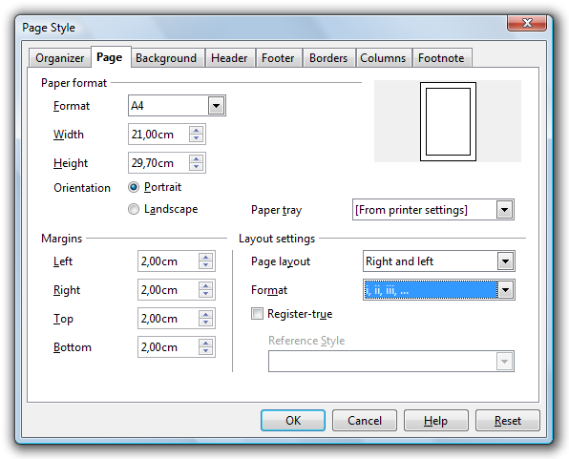Figure 3: Formatting page numbers.

Resetting Page Numbers
If, at any point in the document you want page numbering to start anew again, it should always be done by inserting a manual page break. Changing the number using the Page Number field command will cause problems with Writer's page count mechanism when generating the Table of Contents.
- From the Insert menu, choose Manual Break... > Page break.
- Select the page style you want to insert.
- Check the Change page number box and enter the number at which you want the new page to begin.
- Click OK.
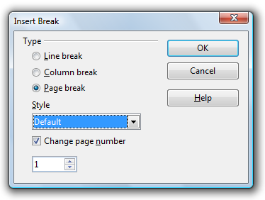Figure 4: Resetting page numbers.
If the first page of the document is to have a page number other than 1 then the paragraph style of the first paragraph has to be accordingly adjusted.
- Place the cursor into the first line of the paragraph and select Format > Paragraph.
- Click the Text Flow tab.
- Under the Breaks section, check Insert.
- Check With Page Style and set the desired page style and page number.
- Click OK.
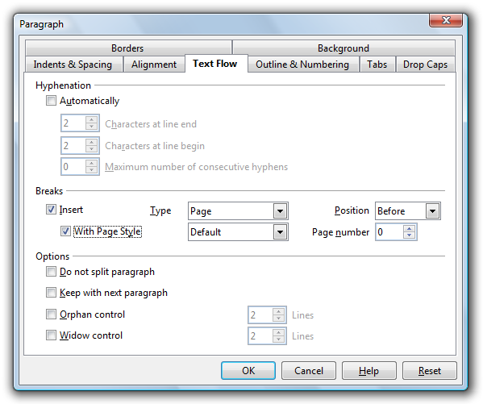Figure 5: Setting page number for first page.

Text Layout
The layout of the text section of a page is defined on the Page tab in the Page Style window.
- From the Format menu, choose Styles and Formatting.
- Click the Page Styles icon at the top of the Styles and Formatting window.
- Right-click the page style you wish to modify and select Modify.
- Click the Page tab.
Note that under the heading Margins, only the text section is defined, headers and footers are placed into the margin areas. From the Page tab, you can also select the page layout: Right and Left, Mirrored, Only Right, or Only Left. If your document is to be organized like a book, you should select Mirrored. Unless it is a prescribed requirement, it is considerably easier to stick with a single-page layout as a double-page layout calls for additional complexities.
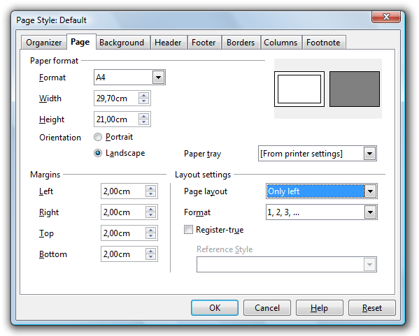Figure 6: Setting text layout using the Page tab.

Headers and Footers
Headers and footers are placed in the margin area of the page using the Header and Footer tabs in the Page Style window. The process is exactly the same whether you are setting a header or a footer. For an example, we will show you how to set the same footer that is used in this document.
To achieve this look, you need a bottom margin of 0.79 inches with a footer for indicating the page number and documents name. You'll need spacing of 0.20 inches between the text layout and the footer. For flexibility, we'll set the size of the footer to automatically adjust depending on the font size you use.
- Specify a bottom margin of 0.79 inches (see the Text Layout section for more detailed instructions). This sets a spacing of 0.79 inches between the bottom of the page and the bottom of the footer box.
- Click the Footer tab.
- Check the Footer on box.
- If you are using a Mirrored page layout, be sure to uncheck the Same content left/right box.
- Enter 0.20 in the Spacing field. This sets the spacing between the bottom of the text layout and the top of the footer box.
- Check AutoFit height in the Height field. The height of the footer box will change to exactly fit the font size you use in the footer.
- Click OK.
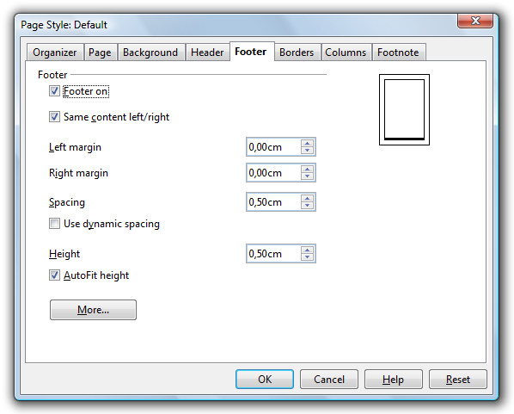igure 7: Inserting a footer.

Controlling Text Flow
The whole text flow of a document should be controlled through the Text body paragraph style or one of its successors.
- From the Format menu, choose Styles and Formatting.
- Click the Paragraph Styles icon at the top of the Styles and Formatting window.
- Right-click the Text body style and select Modify.
- Click the Text Flow tab.
- Check the Automatic hyphenation box. This sets Writer to automatically hyphenate words rather than pushing a whole word to the next line.
- Check the Orphan control box and select at least 2 lines from the drop-down menu. This prevents a single line of a paragraph from being placed at the start or end of a page. Setting orphan control to 2 lines ensures that at least 2 lines of a longer paragraph are placed at the bottom of a page. Otherwise, the paragraph starts at the next page.
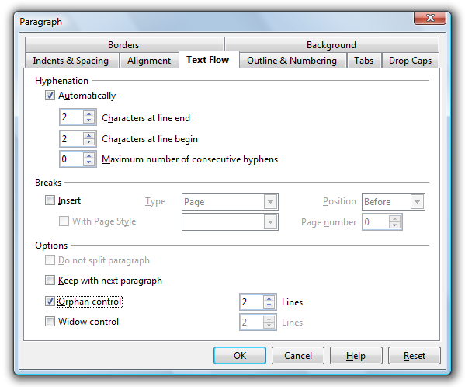Figure 8: Controlling text flow.

Paragraph Styles
The next few sections deal with manipulating paragraphs with paragraph styles. Paragraph styles in OpenOffice Writer are hierarchically organized. You can see the hierarchy of all paragraph styles if you select Hierarchical from the menu at the bottom of the Styles and Formatting window.
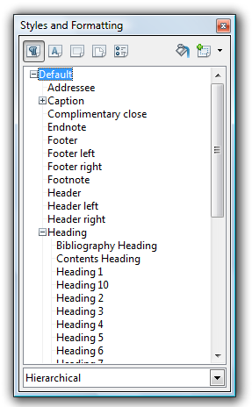Figure 9: Hierarchical view of paragraph styles.
You can see that all paragraph styles are based on paragraph style Default. This means all paragraph styles “inherit” the settings of paragraph style Default unless one or more settings have been modified in a particular paragraph style or in one of its parent paragraph styles. For example, assume the font of paragraph style Default is Times New Roman and the font of paragraph style Heading (the parent of all heading styles) has been set to Arial. If you now change the font of the (hierarchically topmost) paragraph style Default to Garamond, then this change is inherited by all paragraph styles that use the Times New Roman font. However, in all Heading paragraph styles, the font Arial is retained.

Creating a New Paragraph Style
You will need to create a paragraph style for each type of text you want: text body, headings, footers, captions, etc. You do this using Paragraph Styles in the Styles and Formatting window.
- From the Format menu, choose Styles and Formatting.
- Click the Paragraph Styles icon at the top of the Styles and Formatting window.
- Right-click a paragraph style for which you want to base your new style and select New.
- Type a name for your new paragraph style.
- Select a paragraph style you want to follow this style. For example, if you are creating a heading style, you most likely would want your text body style to be the next paragraph style.
- Use the tabs in the dialog box to set the remaining paragraph styles.
- Click OK.
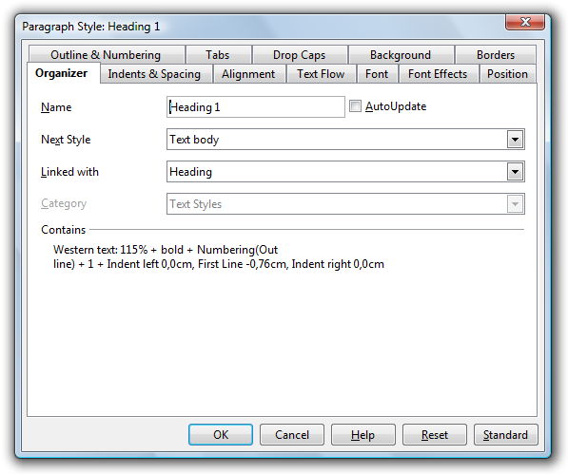Figure 10: Creating paragraph styles.

Modifying a Paragraph Style
If you want to change the font (or any other characteristic) of all heading styles (or whichever style you wish), then you simply make this change in the parent paragraph style Heading.
- From the Format menu, choose Styles and Formatting.
- Click the Paragraph Styles icon at the top of the Styles and Formatting window.
- Right-click the parent style you want to change and select Modify.
- Use the tabs in the dialog box to make the appropriate changes.
- Click OK.
A paragraph style can also be modified by placing the cursor in any paragraph with the desired paragraph style and selecting Edit paragraph style.

Numbered Headings
Using OpenOffice Writer you can automatically number all chapters and sections. To do this, each chapter has to be assigned one of the heading paragraph styles, Heading 1 to Heading 10 with the appropriate numbering style applied. Furthermore you can define the outline level for each paragrapg or paragraph style. This is very helpful when you create an appendix and use letters for the numbering.

Creating a Numbered Heading Style
- From the Format menu, choose Styles and Formatting.
- Click the Paragraph Styles icon at the top of the Styles and Formatting window.
- Right-click a paragraph style for which you want to base your new style and select New.
- Type a name for your new paragraph style.
- Select a paragraph style you want to follow this style. For example, if you are creating a heading style, you most likely would want your text body style to be the next paragraph style.
- Click the Numbering tab.
- Select a Numbering Style from the drop-down menu.
- Click OK.

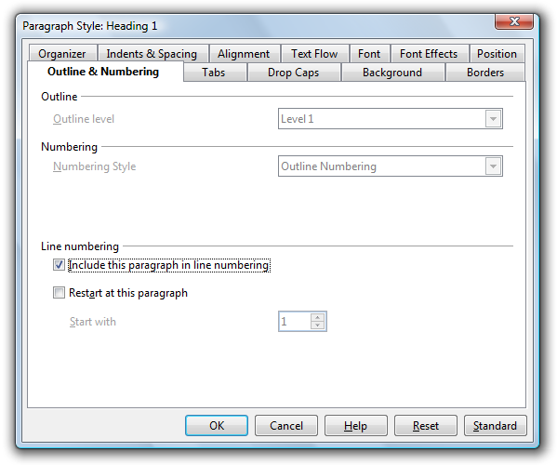Figure 11: Creating a numbered heading

Setting Outline Numbering for Headings
If you've created a custom numbered heading style, you will need to apply the outline numbering to the style so Writer know which outline level each custom head belongs with. For example if you created Head1, Head2, and Head3 styles with numbering, you will need to tell Writer to apply level 1 numbering to Head1 (I.e., 1 Heading), level 2 numbering to Head2 (I.e., 1.1 Heading), etc.
- From the Tools menu, select Outline Numbering.
- On the Numbering tab, select a level and then select the heading that goes with that level.
- Click OK.
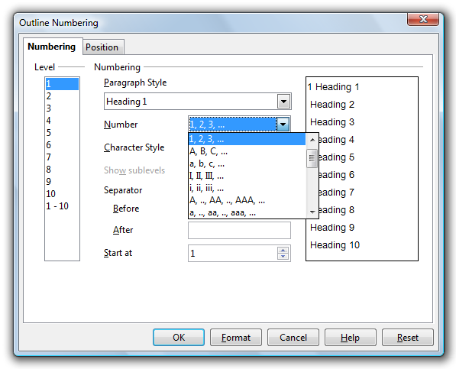Figure 12: Setting outline numbering.

Cloning a Heading
Of course, there are introductions, literature lists, and appendices which are supposed to be treated as headings but either not numbered at all or numbered in a different way. The solution for this problem is cloning a paragraph style. Let's say, for example, that the Introduction is to use the paragraph style Heading 1, but without numbering.
- Set the cursor into the paragraph Introduction and assign paragraph style Heading 1 to it with a doubleclick in the Styles and Formatting window.
- Then click New Style from Selection icon in the top right corner of the Styles and Formatting window.
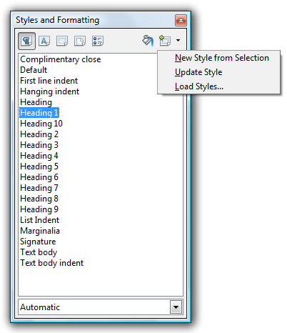Figure 13: Cloning a paragraph style.
- Type a name for the new style (Heading 1 Without Numbering). Note that the new style is now a “child” of style Heading 1. Any modifications made to style Heading 1 will automatically be reflected in style Heading 1 Without Numbering.
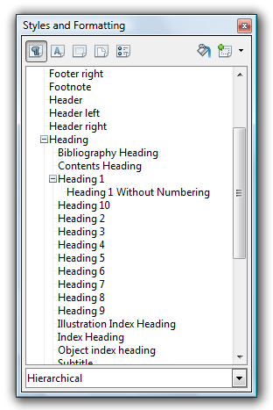Figure 14: Child heading.
- Right-click the Heading Without Numbering paragraph style and select Modify.
- Click the Outline & Numbering tab and select None from the Numbering Style drop-down menu. Set the outline level to level 1 in order to see the unnumbered heading in the document's index.
- Click OK.

Indenting the First Line of a Paragraph
Indenting the first line of a paragraph is standard practice. However, this is often a matter of personal taste, or there may be a standard set.
- From the Format menu, select Styles and Formatting.
- Click the Paragraph Styles icon at the top of the Styles and Formating window.
- Right-click the paragraph style you want to modify and select Modify.
- Click the Indents and Spacing tab.
- De-select Automatic and enter the indent size in the First line box.
- Click OK.
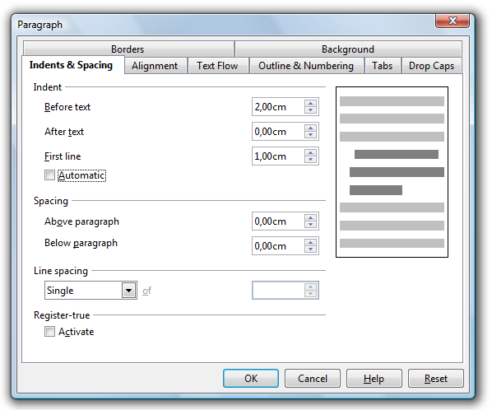Figure 15: Indenting the first line of a paragraph.
Another frequent practice is to indent, but not on the first paragraph after a heading or after an illustration. The best way to accomplish this is to clone the Text body style (see the Cloning a Heading section) and create a Text body indent style (see instructions above). For the Text body paragraph style, choose Text body indent as the Next style. Now, when you style a heading, the first paragraph following the heading will use the Text body style. All paragraphs after the first one will use the Text body indent style.

Starting Each Chapter on a New Page
It's common practice to start each chapter on a new page. To do this, you need to set paragraph style Heading 1 (or whatever style you are using as your chapter head) to start on a new page.
- From the Format menu, choose Styles and Formatting.
- Right click the paragraph style you want to modify and select Modify. You may need to click the Paragraph Styles icon to see all paragraph styles.
- Click the Text Flow tab.
- In the Breaks section, check Insert. Make sure Page is selected as the type and Before is selected as the position.
- Click OK.

Character Styles
For highlighting names of authors or foreign-language phrases, italics can be used. However, a more efficient way is to apply character styles to format single characters or entire words and phrases. By applying character styles you can perform a more focused search for the information you are looking for. For example, rather than searching for all words or phrases in italics, you can search for the exact information you need, such as “author” or “foreign-language phrase”. Using character styles also enables you to easily modify the style at any time. This is particularly important if towards the end of the document you decide you want to change the way you highlight certain text.

Creating a New Character Style
- From the Format menu, choose Styles and Formatting.
- Click the Character Styles icon at the top of the Styles and Formatting window.
- Type a name for the style in the Name field and select the style you wish to link it with. If you do not wish to link to another style, choose None.
- Use the tabs to select the styles you wish to apply to the character style and click OK.

Applying a Character Style
- Select the character, word, or phrase to which you wish to apply the character style.
- Open the Styles and Formatting window by pressing F11 or selecting Format > Styles and Formatting.
- Click the Character Styles icon at the top of the Styles and Formatting window.
- Double-click the style you wish to apply.

Master Document
Thanks to the Master Document feature in OpenOffice Writer, a large document can be written chapter by chapter and, towards the end, joined into a big document. A Master Document incorporates each chapter of a book as an individual OpenOffice Writer file. Using a Master Document is usually not necessary as OpenOffice Writer is stable and powerful enough to manage large documents. A Master Document is more appropriate when a document has several authors, or where individual chapters are created separately and then must be incorporated into a complete work. Benefits of using a Master Document include:
- When you print a master document, the contents of all subdocuments, indexes, and any text that you entered are printed.
- You can create a table of contents and index in the master document for all of the subdocuments.
For consistency, all documents in a Master Document should use the same template. Please note that the Master Document does not allow cross references beyond a subdocument. The master document also does not transfer or share the page, paragraph, etc, styles with the subdocuembts. Thus layout and formatting can only be controlled in the master document. If the document is not beeing edited by multiple authors you may want to reconsider the use of the Master Document.

Creating a Master Document
- From the File menu, choose New > Master Document.
- The Navigator window opens with Text highlighted. Type an introduction or enter some text on the blank page. This ensures that after you edit an existing style in the Master Document you see a changed style when viewing the subdocuments.
- Click and hold the Insert icon.
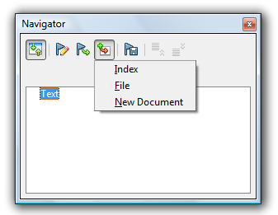Figure 16: Master Document Navigator: Insert icon.
- Choose File to insert an existing file as a subdocument.
- Browse to locate the file you want to insert and click Insert.
- Repeat steps 3-5 until you have inserted all subdocuments.
- Close the Navigator window and save the file.

Working in a Master Document
With the Master document open, you can use the Navigator for rearranging and editing all subdocuments within the Master Document. Following are some of the tasks you can complete using the Master Document Navigator.
- To open a subdocument for editing, double-click the name of the subdocument in the Navigator.
- To remove a subdocument from the master document, right-click the subdocument in the Navigator list and select Delete. The subdocument file is not deleted from your computer, only the entry in the Navigator is removed.
- To add text to a master document, right-click an item in the Navigator list, and then choose Insert >Text. A text section is inserted before the selected item in the Master Document where you can type the text that you want. You cannot insert text next to an existing text entry in the Navigator.
- To reorder the subdocuments in a master document, drag a subdocument to a new location in the Navigator list. You can also select a subdocument in the list, and click the Move down or Move up icon.
- To add an index, such as a table of contents, right-click in the Navigator list, and then choose Insert > Index.
- To update an index in a Master Document, select the index in the Navigator and click the Update icon.

Footnotes
Footnotes reference more information about a topic at the bottom of a page. OpenOffice Writer automatically numbers the footnotes.

Customizing the Footnote Area
You can customize the size and appearance of the footnote area using page style settings.
- From the Format menu, choose Styles and Formatting.
- Click the Page Styles icon at the top of the Styles and Formatting window.
- Right-click a page style to which you want to customize the footnote style and click Modify.
- Click the Footnote tab.
- Select your preferred settings. In general, you should set your footnote area not to exceed the page area. If you choose to set a maximum size for your footnote area you risk having Writer automatically push a footnote reference to the next page.
- Click OK.

Customizing Footnote Settings
You can customize how Writer numbers your footnotes, where footnotes appear in the document (at the end of each page or at the end of the document), and which paragraph style to use for the footnotes.
- From the Tools menu, choose Footnotes.
- Select the options you wish to apply to your footnote.
- Click OK.

Inserting a Footnote
- Click in your document where you want to place the anchor of the note.
- From the Insert menu, choose Footnote.
- In the Numbering section, select the format you want to use. If you are using automatic graphics captions and you chose to number the footnotes, footnotes will not automatically be updated when new footnotes are inserted. To work around this, you can use a special character instead of a number. Select the Character option and either type the character you want to use or click the browse button (...) and select the character that you want to use for the footnote.
- In the Type are, select Footnote.
- Click OK.
- Type the note in the footnote area on your page.
To switch between footnotes and anchors, click the reference for either the note or the anchor.

Appendices
In general, appendices are treated a bit differently than the main body of the document. For example, page numbering is usually different, numbering style for headings is usually different, and you need to set appendix entries to appear in the Table of Contents.

Chapter Numbering for Appendices
Numbering of pages in appendices is continual. However, chapter numbering is not included for appendices. This means you should apply the above-described trick of using paragraph style Heading 1 Without Numbering (see the Cloning a Heading section). Numbering of appendices is most conveniently done by using the number range as described below.
- Insert the word Appendix at the start of the appendix.
- Change the paragraph style to Heading 1 Without Numbering.
- From the Insert menu, choose Fields > Other.
- Click the Variables tab.
- In the Type column, select Number Range.
- In the Format column, select A B C and click OK.
- Repeat for each Appendix.
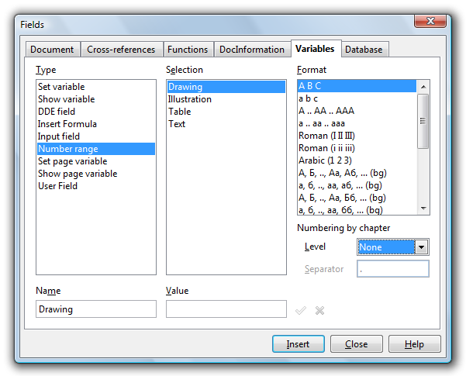Figure 17: Numbering appendices by inserting a variable field.

Listing Appendices in the Table of Contents
In order to have the appendix headings listed in the Table of Contents, every appendix heading has to be selected and registered.
- Place your cursor at the beginning of the appendix chapter heading.
- From the Insert menu, choose Indexes and Tables > Entry.
- Select Table of Contents from the Index menu.
- Type a name in the Entry field.
- Click Insert.
- Click Close.
- Repeat for each appendix chapter.
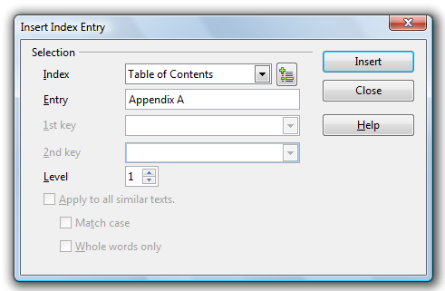Figure 18: Registering an appendix chapter in the Table of Contents.

Cross-referencing
Cross-references allow you to jump to specific text passages and objects in a single document. A cross-reference consists of a target and a reference that are inserted as fields in the document. You can cross-reference text and most objects in your document, such as graphics, drawing objects, OLE objects, and tables, as long as they have a caption. See Adding a Caption in the Graphics section of this document for instructions on how to add a caption to an object.

Inserting a cross-reference
- In your document, place the cursor where you want the cross-reference to appear.

- If the Fields dialog is not open, click Insert > Cross Reference. On the References tab, in the Type list, click the type of item to be referenced, for example Heading, Figure, or Bookmark. You can leave this page open while you insert many cross-references.

- Click on the required item in the Selection list, which shows the bookmarks or references that have been defined. In the Format list, choose the type of reference required. Usually this will be Reference (to insert the full text of the heading or bookmark), Category and Number (to insert the word “Figure” or “Table” and its number), Numbering (to insert the figure or table number without the word “Figure” or “Table”), or Page (to insert the number of the page the referenced text is on). Click Insert.

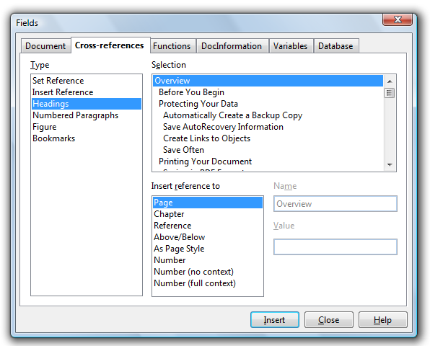Figure 19: Inserting a cross-reference.

Modifying a Cross-reference
- Right-click in front of the cross-reference that you want to modify.
- If you cannot see the field shading of the cross-reference, choose View > Field Shadings or press Ctrl+F8.
- Choose Edit > Fields.
- Set the optns that you want.
- Click OK.

Updating a Cross-reference
Cross-references will automatically update when the document is opened. You can manually update cross-references by pressing F9.

Graphics
Working with graphics is a rather complex subject, therefore we will only cover topics related to inserting graphics into an OpenOffice Writer document.

Inserting Graphics
Individual graphics can be inserted by selecting Insert > Graphics > From File.
Note: Inserting graphics via OLE is not recommended. From the viewpoint of data security it is more meaningful to export the graphic from its originating application and link it to OpenOffice Writer. If data is to be updated, simply export the graphic again from its native application. Sometimes, of course, it is more convenient or even necessary to use OLE. In this case, back up your data! If possible, save data in its native format and into a separate folder. Also it would be prudent to save the actual OpenOffice Writer document in another format, for example, RTF, in order to have at least the text saved separately. Notice also that if an OLE object is scaled without opening the corresponding OLE application, then only the preview will be scaled, which can lead to some rather unpleasant results. Therefore, always open the OLE application before scaling.

Creating a Link to Graphics
Graphics should always be inserted as a link, rather than embedded. This helps ensure that the main document is kept slim, all the graphics are always up-to-date and, in the case of data corruption or loss of the main document, the graphics are stored separately and remain safe.
- From the Insert menu, select Picture > From File.
- Browse to find the picture you want to insert.
- Check the Link box and click Open to insert the picture.
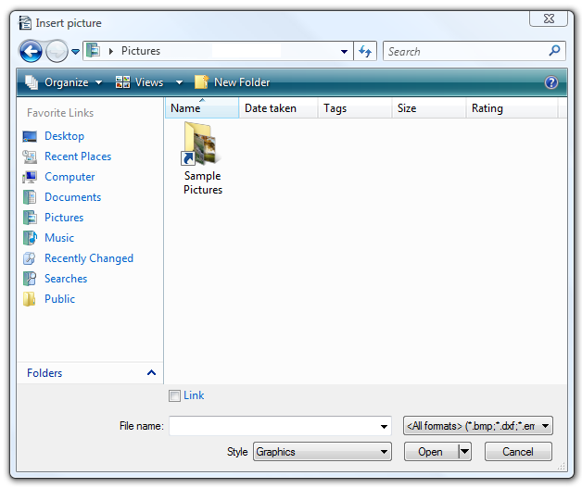Figure 20: Inserting a picture as a link.

Relocating Linked Graphics
Preferably, you should store graphics in a separate folder from your main document. If you want to reorganize your graphics on your hard drive, such as move them into a different folder, you can easily update the links.
- From the Edit menu, select Links.
- Select all links you need to update by holding down the Ctrl key and selecting the links.
- Click Modify.
- Browse and select the new directory.
- Click OK.
- Click Close.

Breaking Links
You can also break links if, for example, you want to send a copy of your document to a lector and want to make sure all graphics arrive correctly.
- From the Edit menu, select Links.
- Select all the link you wish to break.
- Click Break Link.
- Click Yes.
- Repeat for all links you wish to break.

Creating a Gallery
If you have a large number of graphics to insert it may be beneficial to create a custom gallery from which you can drag and drop graphics as needed.
- From the Tools menu, choose Gallery.
- Click the New Theme button.
- On the General tab, type a name for the Gallery.
- Click the Files tab.
- Click Find Files.
- Browse and select the folder where your graphics are stored, click OK. The file names of images in the selected folder are listed on the left side of the window.
- Click Add All and wait for all images to be loaded into the Gallery.
- Click OK.
The Gallery now displays with your images displayed in the Gallery window. Keep the Gallery window open and when you need to insert a graphic, simply drag and drop it into your document from the Gallery.

Anchoring Graphics
If you insert a graphic via Insert > Graphics > From File..., it will be anchored to a paragraph. This means that the graphic is joined to this paragraph and will be moved with the paragraph, yet does not necessarily follow the paragraph. If, at the end of a page, there isn't enough space for the graphic, then text of the next paragraph is pulled up to fill the page and the graphic is placed at the top of the next page. Should that be undesirable, then the graphic should be anchored as character. To anchor the graphic as character is highly recommended. This makes it much easier to handle more than one image in a single paragraph. Images can also be anchored into an empty paragraph so that the paragraph orientation defines the positioning of the graphic.

- Right-click the graphic.
- Select Anchor > As Character. This places the graphic into an empty paragraph and prevents another paragraph from filling in space above it.

Captions
You can add continuously numbered captions to graphics, tables, frames, and drawing objects. You can also edit the text and the number ranges for different types of captions.

Adding Captions
When you add a caption to a picture or to an object, the object and the caption text are placed together in a new frame. When you add a caption to a table, the caption text is inserted as a paragraph next to the table. When you add a caption to a frame, the caption text is added to the text inside the frame, either before or after the existing text.
- Select the item that you want to add a caption to.
- From the Insert menu, choose Caption.
- Type a name for the caption in the empty box at the top of the window.
- Select a caption category.
- Click OK.
A caption is formatted with the paragraph style that matches the name of the caption. For example, if you choose Figure for your caption category, the paragraph style used is called Figure. You can modify the paragraph style as needed.
Note: OpenOffice.org can automatically add a caption when you insert an object, graphic, frame, or table. Choose Insert > Caption > AutoCaption. Select the options you want and click OK. A disadvantage of automatically-generated captions is that no footnotes can be incorporated. If that is a requirement, it is probably best to insert captions manually as you add each graphic.

Moving and Editing Captions
To move both the object and the caption, drag the frame that contains both items. Press F9 to update the caption numbering after you move the frame into place.
You can edit the caption text directly in the document just as you would any other text.

Formulas
Because OpenOffice is a fully integrated productivity suite, you can insert and edit formulas (using OpenOffice Math) in your text document.

Inserting Formula Calculations
You can insert a formula in any text or table area of your document.
- Place your cursor where you want to insert the formula.
- Press F2 to display the Formula Bar.
- Type your formula in the Formula Bar. To specify a range of cells in a table, select the desired cells with the mouse. The corresponding cell references also appear in the input line.
- Click Apply to confirm the entry (the green check mark next to the Formula Bar).
- The calculation displays in your document.

Inserting Formulas in Symbolic Format
OpenOffice Math is used for writing equations in symbolic format. To activate OpenOffice Math, select Insert > Object > Formula. The OpenOffice Math Equation Editor opens. For step-by-step instructions on using Equation Editor, see the Getting Started with Math guide at: http://documentation.openoffice.org/manuals/oooauthors2/0111GS-GettingStartedWithMath.pdf

Charts
OpenOffice 3 Writer includes a powerful chart tool. You can add and modify a variety of charts to meet your needs.

Creating a Chart
- From the Insert menu, choose Object > Chart.
- Right-click the chart and select Chart Data Table.
- Enter the appropriate data in the chart. Use the buttons at the top of the chart to move data within the chart and to add or delete columns and rows as needed.
- Close the Chart Data Table window.

Changing the Chart Type
OpenOffice provides a variety of chart types for you to choose from.
- Double-click the chart until a gray border displays.
- Right-click the chart and select Chart Type.
- Select the type of chart you want and click OK.

Changing Chart Colors
You can easily customize the colors used in any chart type.
- In the chart, double-click the color you wish to change.
- On the Area tab, select the color you want.
- Click OK.

Changing Text Style
You can also modify the fonts used on the chart.
- Double-click the chart.
- Click the Characters tab.
- Select the font style attributes you wish to apply.
- Click OK.

Customizing Your Charts
OpenOffice 3 offers many new features to help you customize your charts. For a list of new features and how to apply them to your charts, see http://blogs.sun.com/GullFOSS/entry/new_chart_features_in_openoffice1

Tables
If your document needs to contain a large number of tables, you should create a custom table format so all of your tables have the same formatting. When creating your template table, the layout will more easily be accepted if you use a table with several rows and columns.
For this section we will assume you already know the basics of inserting and formatting a table.

Creating a Table Format
Use this process to add a new table style to the list of table formats.
- Format a table in your document.
- Select the table, and then choose Table > AutoFormat.
- Click Add.
- In the Add AutoFormat dialog, enter a name for your table format.
- Click OK.

Applying a Table Format
- Click in a table cell in a table you want to format.
- Choose Table > AutoFormat.
- Select the format that you to want to apply.
- Click OK.

Marginalia
If you want to use Marginalia, you can do so with text frames, as shown in the example on the left.
Marginal notes can be put in a frame.
- From the Insert menu, choose Frame.
- Select the size, anchor, and position of the frame and click OK. If you have a two-sided layout, the marginalia must be placed on the outer page margin with the frame anchored to the paragraph.
- Drag the newly placed frame to resize as needed.
If you want to insert another marginalia somewhere else in your text, simply copy the existing one.
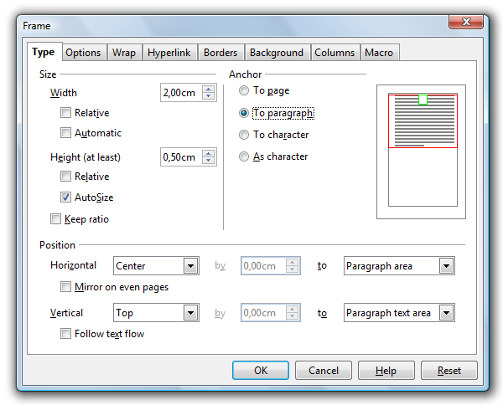Figure 21: Creating a frame for use as marginalia.
Note: Marginalia can also be generated and modified via paragraph styles or frame styles. A paragraph based on a paragraph style with marginalia has a left margin of 4 cm. You have to use a marginalia text frame in conjunction with this paragraph. The marginalia always appears on the left when using this method.

Indexes
Creating an index is a multi-step process. First, you need to create index entries for each word or words you want included in the index. Then, you need to generate the index. Finally, you format the index.

Creating Index Entries
- Click in a word, or select the words in your document that you want to use as an index entry.
- From the Insert menu, choose Indexes and Tables > Entry, and do one of the following:
- To change the text that appears in the index, type the text that you want in the Entry box. The text that you type here does not replace the selected text in the document.
- To add an index mark to similar words in your document, select Apply to all similar texts.
- To add the entries to a custom index, click the New User-defined Index icon, enter the name of the index.
- Click OK.

Editing and Deleting Index Entries
Index entries are inserted as fields into your document. To view fields in your document, choose View and ensure that Field Shadings is selected.
- Place the cursor immediately in front of the index entry in your document.
- Choose Edit > Index Entry, and do one of the following:
- To change the entry, enter different text in the Entry box.
- To remove the entry, click Delete.
To cycle through the index entries in your document, click the next or the previous arrows in the Edit Index Entry window.

Generating an Index
- Click in your document where you want to insert the index.
- From the Insert menu, choose Indexes and Tables > Indexes and Tables.
- On the Index/Table tab, select "Alphabetical Index" in the Type box.
- Set the formatting options for the index, either on the current tab, or on any of the other tabs of this dialog. For example, if you want to use single letter headings in your index, click the Entries tab, and then select Alphabetical delimiter. To change the formatting of levels in the index, click the Styles tab.
- Click OK.
To update the index, right-click in the index, and select Update Index/Table.

Formatting Index Entries
- Right-click in the index and select Edit Index/Table.
- Click the Styles tab.
- Click an index level in the Levels list.
- Click the style that you want to apply in the Paragraph Style list.
- Click the assign button.
- Click OK.

Bibliographies
A small bibliography can be typed directly into the text of the document, but as the bibliography gets larger, more flexibility is obtained by using the database method. The OpenOffice Writer Help and the User Guide both give instructions on making a bibliographic database, and on using this database in the document.
To help you manage your bibliographic entries, the following reference managers integrate with OpenOffice:
- Endnote
- Zotero
- Citavi
- Bibius

Creating a Table of Contents
By default, Writer will generate a Table of Contents based on Heading 1 – Heading 10 styles. You can customize the Table of Contents however you want...from the paragraph styles used to generate the contents to the formatting of the text.

Generating a Table of Contents
- Place the cursor at the location in the document where you want the Table of Contents to start.
- From the Insert menu, choose Indexes and Tables > Indexes and Tables.
- On the Index/Table tab, enter a title (this will be the heading that displays on the Table of Contents page) and select Table of Contents from the Type menu.
- Select how many levels you want to display in your Table of Contents. Typically, 3-4 levels is sufficient, depending on how many levels of headings you use in your document.
- Check the Outline and Index boxes and click the [...] button next to Outline.
- This is where you map your levels to your paragraph styles. For example, if you use a Heading 1 and a Heading 1 Without Numbering, you need to make sure that both headings are mapped to Level 1. You do this by selecting 1 in the Level column and then selecting the paragraph style in the Paragraph Style menu. Writer automatically maps Heading 1 – Heading 10 to the appropriate level, but you will need to map each custom head you have applied in the document and wish to display in the Table of Contents.
- By default, the Table of Contents will have a gray background, because it is wrapped in a read-only section. The gray background will not be printed. Anyway it is possible to disable the read-only mode in the index dialog. You can change the color of the background by clicking the Background tab and selecting a color.
- Click OK.
Note: Unfortunately, the page number formats of the various page styles are not automatically adopted by the Table of Contents. This means that anomalies in the Table of Contents, arising from this cause will have to be corrected manually. Be sure to un-check the Protect against manual changes box to enable the ability to make manual changes to the table.
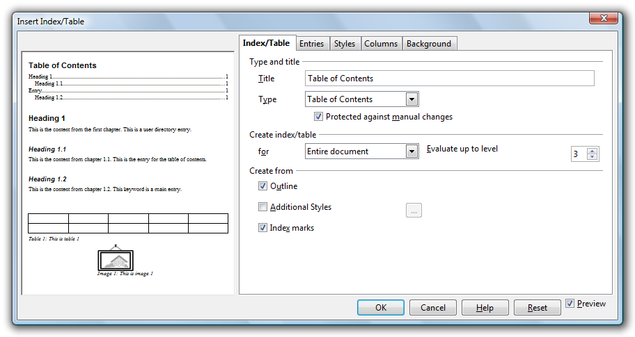Figure 22: Inserting a Table of Contents.

Editing a Table of Contents
- Right-click anywhere in the Table of Contents and select Edit Index/Table.
- Make changes as necessary.
- Click OK to re-generate the table.

Formatting Entries
- Right-click the entry you wish to format and select Edit Paragraph Style.
- Make the appropriate changes to the paragraph style.
- Click OK. Because you changed a paragraph style, all entries that use the same style will automatically update.

Updating the Table of Contents
Right-click anywhere in the Table of Contents and select Update Index/Table.

Deleting the Table of Contents
Right-click anywhere in the Table of Contents and select Delete Index/Table.

Resources
There are many resources available to help you maximum your productivity and get the most from your OpenOffice suite.

Support and Documentation
- Writer Guide: http://documentation.openoffice.org/manuals/oooauthors2/0200WG-WriterGuide.pdf
- Help: From the Help menu, choose OpenOffice.org Help (or press F1).
- Support: http://support.openoffice.org/

Extensions
To help make your life a little easier, there are many extensions (or plug-ins) available to extend the features of OpenOffice. You can view and download extensions from: http://extensions.services.openoffice.org/most_pop_ext

Additional Resources
LaTeX is a document preparation system for high-quality typesetting. It is most often used for medium-to-large technical or scientific documents but it can be used for almost any form of publishing. You can learn more about LaTeX at: http://www.latex-project.org/intro.html

Public Documentation License, Version 1.0

1.0 DEFINITIONS.
1.1. "Commercial Use" means distribution or otherwise making the Documentation available to a third party.
1.2. "Contributor" means a person or entity who creates or contributes to the creation of Modifications.
1.3. "Documentation" means the Original Documentation or Modifications or the combination of the Original Documentation and Modifications, in each case including portions thereof.
1.4. "Electronic Distribution Mechanism" means a mechanism generally accepted for the electronic transfer of data.
1.5. "Initial Writer" means the individual or entity identified as the Initial Writer in the notice required by the Appendix.
1.6. "Larger Work" means a work which combines Documentation or portions thereof with documentation or other writings not governed by the terms of this License.
1.7. "License" means this document.
1.8. "Modifications" means any addition to or deletion from the substance or structure of either the Original Documentation or any previous Modifications, such as a translation, abridgment, condensation, or any other form in which the Original Documentation or previous Modifications may be recast, transformed or adapted. A work consisting of editorial revisions, annotations, elaborations, and other modifications which, as a whole represent an original work of authorship, is a Modification. For example, when Documentation is released as a series of documents, a Modification is:
A. Any addition to or deletion from the contents of the Original Documentation or previous Modifications.
B. Any new documentation that contains any part of the Original Documentation or previous Modifications.
1.9. "Original Documentation" means documentation described as Original Documentation in the notice required by the Appendix, and which, at the time of its release under this License is not already Documentation governed by this License.
1.10. "Editable Form" means the preferred form of the Documentation for making Modifications to it. The Documentation can be in an electronic, compressed or archival form, provided the appropriate decompression or dearchiving software is widely available for no charge.
1.11. "You" (or "Your") means an individual or a legal entity exercising rights under, and complying with all of the terms of this License or a future version of this License issued under Section 5.0 ("Versions of the License"). For legal entities, "You" includes any entity which controls, is controlled by, or is under common control with You. For purposes of this definition, "control" means (a) the power, direct or indirect, to cause the direction or management of such entity, whether by contract or otherwise, or (b) ownership of more than fifty percent (50%) of the outstanding shares or beneficial ownership of such entity.
2.0 LICENSE GRANTS.
2.1 Initial Writer Grant.
The Initial Writer hereby grants
You a world-wide, royalty-free, non-exclusive license to use, reproduce, prepare Modifications of, compile, publicly perform, publicly display, demonstrate, market, disclose and distribute the Documentation in any form, on any media or via any Electronic Distribution Mechanism or other method now known or later discovered, and to sublicense the foregoing rights to third parties through multiple tiers of sublicensees in accordance with the terms of this License.
The license rights granted in this Section 2.1 ("Initial Writer Grant") are effective on the date Initial Writer first distributes Original Documentation under the terms of this License.
2.2. Contributor Grant.
Each Contributor hereby grants You a world-wide, royalty-free, non-exclusive license to use, reproduce, prepare Modifications of, compile, publicly perform, publicly display, demonstrate, market, disclose and distribute the Documentation in any form, on any media or via any Electronic Distribution Mechanism or other method now known or later discovered, and to sublicense the foregoing rights to third parties through multiple tiers of sublicensees in accordance with the terms of this License.
The license rights granted in this Section 2.2 ("Contributor Grant") are effective on the date Contributor first makes Commercial Use of the Documentation.
3.0 DISTRIBUTION OBLIGATIONS.
3.1. Application of License.
The Modifications which You create or to which You contribute are governed by the terms of this License, including without limitation Section 2.2 ("Contributor Grant"). The Documentation may be distributed only under the terms of this License or a future version of this License released in accordance with Section 5.0 ("Versions of the License"), and You must include a copy of this License with every copy of the Documentation You distribute. You may not offer or impose any terms that alter or restrict the applicable version of this License or the recipients' rights hereunder. However, You may include an additional document offering the additional rights described in Section
3.5 ("Required Notices").
3.2. Availability of Documentation.
Any Modification which You create or to which You contribute must be made available publicly in Editable Form under the terms of this License via a fixed medium or an accepted Electronic Distribution Mechanism.
3.3. Description of Modifications.
All Documentation to which You contribute must identify the changes You made to create that Documentation and the date of any change. You must include a prominent statement that the Modification is derived, directly or indirectly, from Original Documentation provided by the Initial Writer and include the name of the Initial Writer in the Documentation or via an electronic link that describes the origin or ownership of the Documentation. The foregoing change documentation may be created by using an electronic program that automatically tracks changes to the Documentation, and such changes must be available publicly for at least five years following release of the changed Documentation.
3.4. Intellectual Property Matters.
Contributor represents that Contributor believes that Contributor's Modifications are Contributor's original creation(s) and/or Contributor has sufficient rights to grant the rights conveyed by this License.
3.5. Required Notices.
You must duplicate the notice in the Appendix in each file of the Documentation. If it is not possible to put such notice in a particular Documentation file due to its structure, then You must include such notice in a location (such as a relevant directory) where a reader would be likely to look for such a notice, for example, via a hyperlink in each file of the Documentation that takes the reader to a page that describes the origin and ownership of the Documentation. If You created one or more Modification(s) You may add your name as a Contributor to the notice described in the Appendix.
You must also duplicate this License in any Documentation file (or with a hyperlink in each file of the Documentation) where You describe recipients' rights or ownership rights. You may choose to offer, and to charge a fee for, warranty, support, indemnity or liability obligations to one or more recipients of Documentation. However, You may do so only on Your own behalf, and not on behalf of the Initial Writer or any Contributor. You must make it absolutely clear than any such warranty, support, indemnity or liability obligation is offered by You alone, and You hereby agree to indemnify the Initial Writer and every Contributor for any liability incurred by the Initial Writer or such Contributor as a result of warranty, support, indemnity or liability terms You offer.
3.6. Larger Works.
You may create a Larger Work by combining Documentation with other documents not governed by the terms of this License and distribute the Larger Work as a single product. In such a case, You must make sure the requirements of this License are fulfilled for the Documentation.
4.0 APPLICATION OF THIS LICENSE.
This License applies to Documentation to which the Initial Writer has attached this License and the notice in the Appendix.
5.0 VERSIONS OF THE LICENSE.
5.1. New Versions.
Initial Writer may publish revised and/or new versions of the License from time to time. Each version will be given a distinguishing version number.
5.2. Effect of New Versions.
Once Documentation has been published under a particular version of the License, You may always continue to use it under the terms of that version. You may also choose to use such Documentation under the terms of any subsequent version of the License published by______________________ [Insert name of the foundation, company, Initial Writer, or whoever may modify this License]. No one other than ________________________[Insert name of the foundation, company, Initial Writer, or whoever may modify this License] has the right to modify the terms of this License. Filling in the name of the Initial Writer, Original Documentation or Contributor in the notice described in the Appendix shall not be deemed to be Modifications of this License.
6.0 DISCLAIMER OF WARRANTY.
DOCUMENTATION IS PROVIDED UNDER THIS LICENSE ON AN "AS IS'' BASIS, WITHOUT WARRANTY OF ANY KIND, EITHER EXPRESSED OR IMPLIED, INCLUDING, WITHOUT LIMITATION, WARRANTIES THAT THE DOCUMENTATION IS FREE OF DEFECTS, MERCHANTABLE, FIT FOR A PARTICULAR PURPOSE OR NON-INFRINGING. THE ENTIRE RISK AS TO THE QUALITY, ACCURACY, AND PERFORMANCE OF THE DOCUMENTATION IS WITH YOU. SHOULD ANY DOCUMENTATION PROVE DEFECTIVE IN ANY RESPECT, YOU (NOT THE INITIAL WRITER OR ANY OTHER CONTRIBUTOR) ASSUME THE COST OF ANY NECESSARY SERVICING, REPAIR OR CORRECTION. THIS DISCLAIMER OF WARRANTY CONSTITUTES AN ESSENTIAL PART OF THIS LICENSE. NO USE OF ANY DOCUMENTATION IS AUTHORIZED HEREUNDER EXCEPT UNDER THIS DISCLAIMER.
7.0 TERMINATION.
This License and the rights granted hereunder will terminate automatically if You fail to comply with terms herein and fail to cure such breach within 30 days of becoming aware of the breach. All sublicenses to the Documentation which are properly granted shall survive any termination of this License. Provisions which, by their nature, must remain in effect beyond the termination of this License shall survive.
8.0 LIMITATION OF LIABILITY.
UNDER NO CIRCUMSTANCES AND UNDER NO LEGAL THEORY, WHETHER IN TORT (INCLUDING NEGLIGENCE), CONTRACT, OR OTHERWISE, SHALL THE INITIAL WRITER, ANY OTHER CONTRIBUTOR, OR ANY DISTRIBUTOR OF DOCUMENTATION, OR ANY SUPPLIER OF ANY OF SUCH PARTIES, BE LIABLE TO ANY PERSON FOR ANY DIRECT, INDIRECT, SPECIAL, INCIDENTAL, OR CONSEQUENTIAL DAMAGES OF ANY CHARACTER INCLUDING, WITHOUT LIMITATION, DAMAGES FOR LOSS OF GOODWILL, WORK STOPPAGE, COMPUTER FAILURE OR MALFUNCTION, OR ANY AND ALL OTHER DAMAGES OR LOSSES ARISING OUT OF OR RELATING TO THE USE OF THE DOCUMENTATION, EVEN IF SUCH PARTY SHALL HAVE BEEN INFORMED OF THE POSSIBILITY OF SUCH DAMAGES.

9.0 U.S. GOVERNMENT END USERS.
If Documentation is being acquired by or on behalf of the U.S. Government or by a U.S. Government prime contractor or subcontractor (at any tier), then the Government's rights in Documentation will be only as set forth in this Agreement; this is in accordance with 48 CFR 227.7201 through 227.7202-4 (for Department of Defense (DOD) acquisitions) and with 48 CFR 2.101 and 12.212 (for non-DOD acquisitions).
10.0 MISCELLANEOUS.
This License represents the complete agreement concerning the subject matter hereof. If any provision of this License is held to be unenforceable, such provision shall be reformed only to the extent necessary to make it enforceable. This License shall be governed by California law, excluding its conflict-of-law provisions. With respect to disputes or any litigation relating to this License, the losing party is responsible for costs, including without limitation, court costs and reasonable attorneys' fees and expenses. The application of the United Nations Convention on Contracts for the International Sale of Goods is expressly excluded. Any law or regulation which provides that the language of a contract shall be construed against the drafter shall not apply to this License.
Appendix
Public Documentation License Notice
The contents of this Documentation are subject to the Public Documentation License Version 1.0 (the "License"); you may only use this Documentation if you comply with the terms of this License. A copy of the License is available at http://www/OpenOffice.org/licenses/PDL.rtf.
The Original Documentation is _________________. The Initial Writer of the Original Documentation is ______________________ (C) ____. All Rights Reserved. (Initial Writer contact(s):_______________[Insert hyperlink/alias].)
Contributor(s): ______________________________________. Portions created by ______ are Copyright (C)_________[Insert year(s)]. All Rights Reserved. (Contributor contact(s):________________[Insert hyperlink/alias]).
Note: The text of this Appendix may differ slightly from the text of the notices in the files of the Original Documentation. You should use the text of this Appendix rather than the text found in the Original Documentation for Your Modifications.

