**error: ‘JAVAEXP’ expected team: 이바딤 다랴 세르지바 리티스 바류카스**

[Location of the Forked Repository](https://github.com/r33tis/pdfbox): https://github.com/r33tis/pdfbox

Hash of the Last Commit: **to be updated to be updated to be updated**

[Commit Hash Before Changes](https://github.com/r33tis/pdfbox/commit/477ea0107bf298e6da5f043037c6256aef06b6ab): 77ea0107bf298e6da5f043037c6256aef06b6ab

**Justification for the selected classes**

We chose to write our unit tests for **COSFloat** and ***COSNumber*** classes because their methods appeared intuitive to understand, did not have many dependencies.

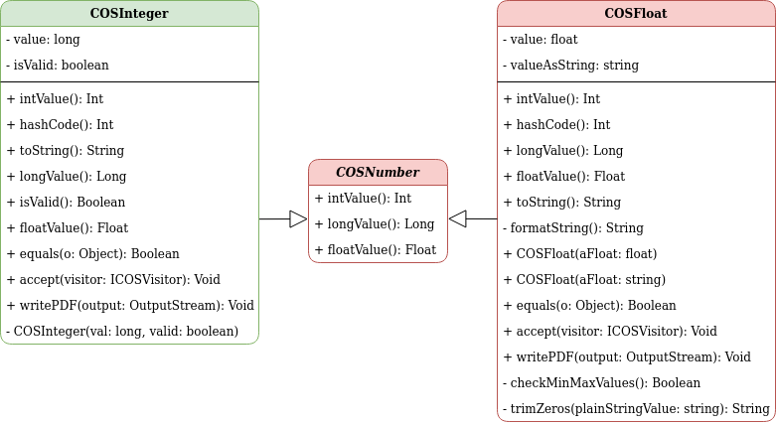

**Figure 1 UML Diagram of COSInteger, *COSNumber* and COSFloat Classes**

Both of these classes were chosen as test targets because each of them had less than three uncovered branches. Before forking the official repository, **COSFloat.java** and ***COSNumber.java*** had 97% and 83% covered lines, respectively.

**Description of why the classes are partially covered**

**Description of how our team have improved the test cases**