Photark Mobile

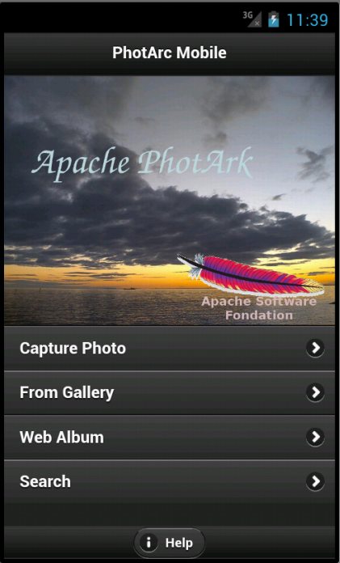

This is a photo manager application for smart phones. This currently includes following capabilities,

- Viewing stored photos
- Capturing new images
- Adding related information to the photos
  - Name – Name given to the photo e.g My School
  - Location – Location of the photo taken. e.g Galle, Southern Province Sri Lanka (Location will be automatically added to photos captured using the app)
  - Date Taken
  - Time Taken
  - A description
- Viewing information of a photo. Location can be viewed on Google Maps
- Tagging – user can tag persons who are in the photo (not visible to other parties. Local environment only)
- Search using information. e.g All photos taken after 01/01/2012 which Alice is in.
- Social Media Integration
- Deleting photos

Architecture

This is build as a hybrid mobile application using Apache Cordova (aka Phonegap). This is written in Javascript and can be ported easily to any platform which Apache Cordova supports including ( Android, iOS, Blackberry, etc.)

Data is stored in a SQLite data base which is the preferred way of Cordova. Database schema is explained below.

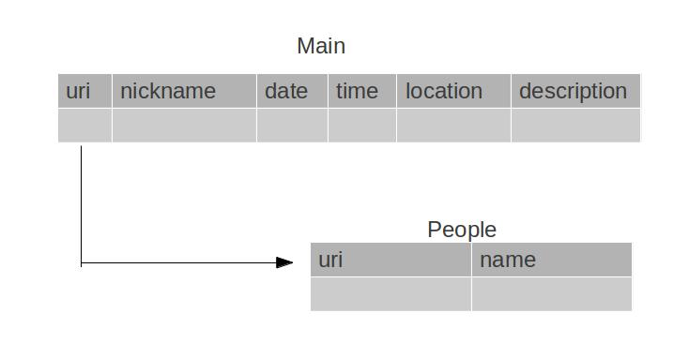

Libraries and dependencies

- Current version is developed using Apache Cordova 1.8. It is preparing for upgrading to Cordova 2.0.
- Jquery Mobile 1.1 is used for develop UI components
- Jquery 1.7.2. This is used in JavaScript code and this also needs as a dependency to Jquery Mobile
- mobiscroll-2.0 is used for implement date and time pickers
- photoswipe-3.0.5 is used for implement full screen image viewing.
- Google Maps API is used to implement location based services
- Jquery UI Map plugin is used for map viewing

