Primix Solutions
Core Labs
Tapestry Tutorial
Core Labs
Tapestry Tutorial
© Primix Solutions
One Arsenal Marketplace
Phone (617) 923-6639 • Fax (617) 923-5139

Tapestry contact information:

Howard Ship <hship@primix.com>
http://sourceforge.net/projects/tapestry

Table of Contents

Introduction 2
Setting up the Tutorial 3
Java Build Environment (JBE) 3
Building the Tutorial 3
Hello World 7
Application Engine 7
Application Servlet 7
Application Specification 8
Home Page Specification 8
Home Page Template 9
Run the Application 9
Dynamic Content 11
Interactive Application 16
Adding Interactivity using Listeners 23
Persistant Page State and Page Pooling 24
Dynamic Page State 25
Tapestry Run Time Errors 26
Stale Sessions 26
Exception Handling 27
Potpourri! 30
The Visit Object 32
The Home Page 33
The Guess Page 36
Limitations 40
Creating Reusable Components 41
The Tapestry Inspector 48
Specification View 49
Components View 50
Template View 51
Properties View 52
Complex Forms and Output 54
Survey 56
SurveyDatabase 60
SurveyEngine 60
SurveyPage 61
Results 69
Localization 77
Home Page 79
Change page 81
Other Options for Localization 83
Further Study 84

Introduction
Chapter
1
Tapestry is a new application framework developed at Primix Solutions.
Tapestry uses a component object model to represent the pages of a web application. This is similar to spirit to using the Java Swing component object model to build GUIs.
Just like using a GUI toolkit, there's some preparation and some basic ideas that must be cleared before going to more ambitious things. Nobody writes a word processor off the top of their head as their first GUI project; nobody should attempt a full-featured e-commerce site as their first attempt at Tapestry.
The goal of Tapestry is to eliminate most of the coding in a web application. Under Tapestry, nearly all code is directly related to application functionality, with very little "plumbing". If you have previously developed a web application using Microsoft Active Server Pages, JavaServer Pages or Java Servlets, you may take for granted all the plumbing: writing servlets, assembling URLs, parsing URLs, managing objects inside the session, etc.
Tapestry takes care of nearly all of that, for free. It allows for the development of rich, highly interactive applications.
This tutorial will start with basic concepts, such as the "Hello World" application, and will gradually build up to more sophisticated examples.
The tutorial uses Jetty, a freely available servlet engine, which is packaged with the Tapestry distribution.
The format of this tutorial is to describe (visually and with text) an application within the tutorial, then describe how it is constructed, using code excerpts. The reader is best served by having an IDE open so that they can look at the code in detail, as well as run the applications.
Setting up the Tutorial
Chapter
2
This document expects that you will have extracted the full Tapestry distribution to your C: drive. This will have created a directory Tapestry-x.x.x and, beneath it, several more directories.
The Tapestry Tutorial will be in C:\Tapestry-x.x.x\Examples\Tutorial.

Java Build Environment (JBE)
In order to execute the tutorial, you must set up the Java Build Environment or JBE, which is also distributed with Tapestry. The file C:\Tapestry-x-x-x\doc\JBE.pdf contains a full description of how to set up the JBE.
Setting up the JBE is required, since it is used to compile the tutorial as well as execute it.

Building the Tutorial
Building the Tutorial is quite easy (once the JBE is set up, and the necessary Jar files installed).
Change to the Tutorial directory, C:\Tapestry-x-x-x\Examples\Tutorial.
Execute the command make war
C:\Tapestry-0.2.8\Examples\Tutorial>make war

*** Cataloging package tutorial.hello ... ***

*** Cataloging package tutorial.simple ... ***

*** Cataloging package tutorial.adder ... ***

*** Cataloging package tutorial.border ... ***

*** Cataloging package tutorial.survey ... ***

*** Compiling ... ***

cd . ; \
C:/jdk1.2.2/bin/javac.exe -d C:/Tapestry-0.2.5/Examples/Tutorial/.build/wapp/WEB
-INF/classes -classpath "C:/Tapestry-0.2.5/Examples/Tutorial;C:/Tapestry-0.2.5/E
xamples/Tutorial/.build/wapp/WEB-INF/classes;C:/Tapestry-0.2.5/lib/Tapestry.jar;
C:/Tapestry-0.2.5/lib/javax.servlet.jar" tutorial/hello/HelloWorldServlet.java t
utorial/simple/Home.java tutorial/simple/SimpleServlet.java tutorial/adder/Adder
Servlet.java tutorial/adder/Home.java tutorial/border/Border.java tutorial/borde
r/BorderApplication.java tutorial/border/BorderServlet.java tutorial/survey/Race
.java tutorial/survey/RaceModel.java tutorial/survey/Results.java tutorial/surve
y/Sex.java tutorial/survey/SexAdaptor.java tutorial/survey/Survey.java tutorial/
survey/SurveyApplication.java tutorial/survey/SurveyDatabase.java tutorial/surve
y/SurveyPage.java tutorial/survey/SurveyServlet.java

*** Copying WEB-INF resources ... ***

Copying: web.xml

*** Copying package resources ...***

Copying: HelloWorld.application Home.html Home.jwc Simple.application Home.html
Home.jwc Adder.application Home.html Home.jwc Border.application Border.html Cre
do.html Home.html Legal.html Border.jwc Credo.jwc Home.jwc Legal.jwc Survey.appl
ication Home.html Results.html SurveyPage.html Home.jwc Results.jwc SurveyPage.j
wc SurveyStrings.properties

*** Copying context resources ... ***

Copying: index.html

*** Building Tutorial.war ... ***

C:/jdk1.2.2/bin/jar.exe cf Tutorial.war -C .build/wapp .

C:\Tapestry-0.2.5\Examples\Tutorial>
That's an awful amount of output. When its done, you can start up the Jetty server just as easily with the make run command:
C:\Tapestry-0.2.5\Examples\Tutorial>make run
C:/jdk1.2.2/bin/java.exe -classpath "C:/Tapestry-0.2.5/lib/Tapestry.jar;C:/Tapes
try-0.2.5/lib/javax.servlet.jar;C:/Tapestry-0.2.5/lib/xerces.jar;C:/Tapestry-0.2
.5/lib/gnu-regexp.jar;C:/Tapestry-0.2.5/lib/com.mortbay.jetty.jar" \
-Dorg.xml.sax.parser=org.apache.xerces.parsers.SAXParser \
com.mortbay.Jetty.Server jetty.xml
20001109221653438GMT EVENT [main]com.mortbay.HTTP.HttpServer.addWebApplicatio
n(HttpServer.java:480)
>>9> Web Application WebApp:Tapestry Tutorial@jar:file:/C:/Tapestry-0.2.5/Exam
ples/Tutorial/Tutorial.war!/ added
20001109221653438GMT EVENT [main]com.mortbay.HTTP.Handler.NullHandler.start(N
ullHandler.java:79)
>>5> Started ServletHandler in WebApp:Tapestry Tutorial@jar:file:/C:/Tapestry-
0.2.5/Examples/Tutorial/Tutorial.war!/
20001109221653438GMT EVENT [main]com.mortbay.HTTP.Handler.ResourceHandler.sta
rt(ResourceHandler.java:151)
>>4> ResourceHandler started in jar:file:/C:/Tapestry-0.2.5/Examples/Tutorial/
Tutorial.war!/
20001109221653438GMT EVENT [main]com.mortbay.HTTP.Handler.NullHandler.start(N
ullHandler.java:79)
>>5> Started ResourceHandler in WebApp:Tapestry Tutorial@jar:file:/C:/Tapestry
-0.2.5/Examples/Tutorial/Tutorial.war!/
20001109221653438GMT EVENT [main]com.mortbay.HTTP.SocketListener.start(Socket
Listener.java:71)
>>3> Started SocketListener on 0.0.0.0/0.0.0.0:8080
Finally, you can access the Tutorials using the URL http://localhost:8080/tutorial
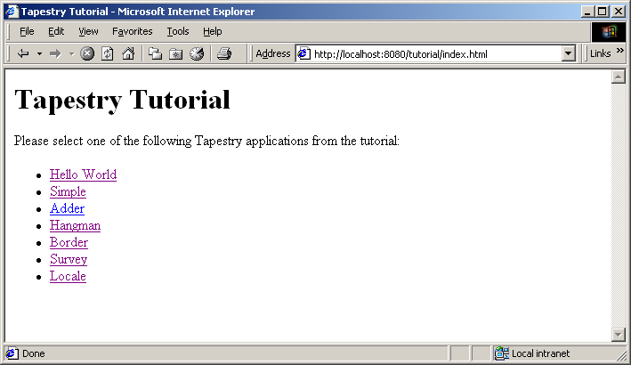

Hello World
Chapter
3
In this first example, we'll create a very simple "Hello World" kind of application. It won't have any real functionality but it'll demonstrate the simplest possible variation of a number of key aspects of the framework.
We'll define our application, define the lone page of our application, configure everything and launch it.
The code for this section of the tutorial is in the Java package tutorial.hello, i.e., C:\Tapestry-x.x.x\Examples\Tutorial\tutorial\hello.

Application Engine
As each new client connects to the application, an instance of the application engine is created for them. The application engine is used to track that client's activity within the application.
The application engine is an instance, or subclass of, the Tapestry class com.primix.tapestry.engine.SimpleEngine.
In these first few examples, we have no additional behavior to add to the provided base class, so we simply use SimpleEngine directly.

Application Servlet
The application servlet is a "bridge" between the servlet container and the application engine. Its job is simply to create (on the first request) or locate (on subsequent requests) the application engine.
The application servlet must subclass com.primix.tapestry.ApplicationServlet and implement the method: getApplicationSpecificationPath(). This method provides the path to the application specification file; the servlet reads this file when it is initialized.

HelloWorldServlet.java
package tutorial.hello;

import com.primix.tapestry.*;

public class HelloWorldServlet extends ApplicationServlet
{
protected String getApplicationSpecificationPath()
{
return "/tutorial/hello/HelloWorld.application";
}

}

Application Specification
The application specification is used to describe the application to the Tapestry framework. It provides the application with a name, and engine class, and a list of pages.
This specification is a file that is located on the Java class path. In a deployed Tapestry application, the specification lives with the application's class files: either in a Jar file, or in the WEB-INF/classes directory of a war (Web Application Archive).
HelloWorld.application
<?xml version="1.0"?>
<!DOCTYPE application PUBLIC "-//Primix Solutions//Tapestry Specification 1.0//EN"
"http://tapestry.sourceforge.net/dtd/Tapestry_1_0.dtd">
<application>
<name>Hello World Tutorial</name>
<engine-class>com.primix.tapestry.engine.SimpleEngine</engine-class>
<page>
<name>Home</name>
<specification-path>/tutorial/hello/Home.jwc</specification-path>
</page>
</application>
Our application is very simple; we give the application a name, use the standard engine, and define a single page, named "Home". In Tapestry, components are specified with the path to their specification file (a file that end with '.jwc').
Page "Home" has a special meaning to Tapestry: when you first launch a Tapestry application, it loads and displays the "Home" page. All Tapestry applications are required to have such a home page.

Home Page Specification
The page specification defines the Tapestry component responsible for the page. In this first example, our component is very simple:
Home.jwc
<?xml version="1.0"?>
<!DOCTYPE specification PUBLIC
"-//Primix Solutions//Tapestry Specification 1.0//EN"
"http://tapestry.sourceforge.net/dtd/Tapestry_1_0.dtd">

<specification>
<class>com.primix.tapestry.BasePage</class>
</specification>
This simply says that Home is a kind of page. We use the supplied Tapestry class com.primix.tapestry.BasePage since we aren't adding any behavior to the page.

Home Page Template
Finally, we get to the content of our application. This file is also a Java resource; it isn't directly visible to the web server. It has the same location and name as the component specification, except that it ends in "html".
Home.html
<!DOCTYPE HTML PUBLIC "-//W3C//DTD HTML 4.0 Transitional//EN">

<html>
<head>
<title>Hello World</title>
</head>

<body>

Welcome to your first <b>Tapestry Application</b>.

</body>
</html>

Run the Application
You should already be running the Jetty server in a window, and have a browser running the tutorials page. Select the first option, Hello World, from the list. You will be presented with the first (and only) page generated by Tapestry for this application:
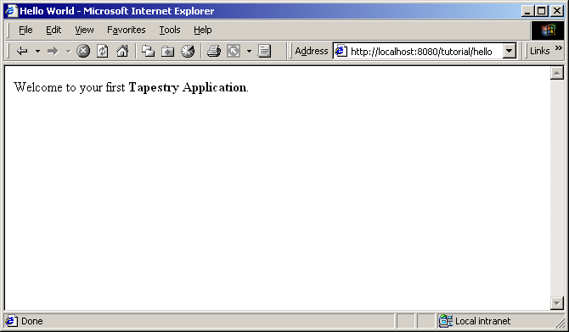
Not much of an application ... there's no interactivity. It might as well be a static web page, but it's a start. Remember, there was no JavaServer page here, and no HTML directly visible to the web server. There was an application consisting of a single component.
In the following chapters, we'll see how to add dynamic content and then true interactivity.
Dynamic Content
Chapter
4
In this section, we'll create a new web application that will show some dynamic content. We'll also begin to show some interactivity by adding a link to the page.
Our dynamic content will simply be to show the current date and time. The interactivity will be a link to refresh the page. It all looks like this:
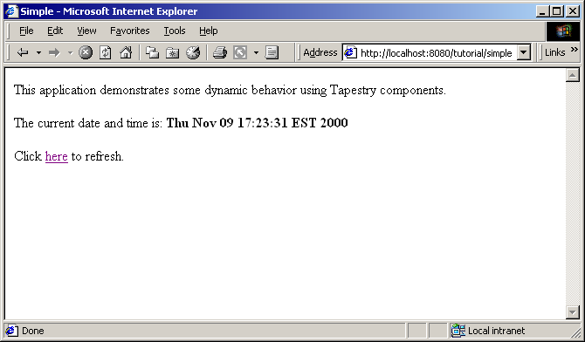
Clicking the word "here" will update the page showing the new data and time. Not incredibly interactive, but it's a start.
The code for this section of the tutorial is in the package tutorial.simple.
We need to create a new servlet and application object, but they're almost identical to our earlier ones (only the parts marked in blue are different). The real action in this section will be the new version of the home page.
SimpleServlet.java
package tutorial.simple;

import com.primix.tapestry.*;
import com.primix.tapestry.app.*;

public class SimpleServlet extends ApplicationServlet
{
protected String getApplicationSpecificationPath()
{
return "/tutorial/simple/Simple.application";
}
}
The bold text identifies the only significant changes from the previous HelloWorldServlet class.
The application specification is also straight forward:
Simple.application
<?xml version="1.0"?>
<!DOCTYPE application PUBLIC
"-//Primix Solutions//Tapestry Specification 1.0//EN"
"http://tapestry.sourceforge.net/dtd/Tapestry_1_0.dtd">

<application>
<name>Simple Tutorial</name>
<engine-class>com.primix.tapestry.engine.SimpleEngine</engine-class>

<page>
<name>Home</name>
<specification-path>/tutorial/simple/Home.jwc
</specification-path>
</page>

</application>
Things only begin to get more interesting when we look at the HTML template for the home page:
Home.html
<!DOCTYPE HTML PUBLIC "-//W3C//DTD HTML 4.0 Transitional//EN">
<html>
<head>
<title>Simple</title>
</head>
<body>
This application demonstrates some dynamic behavior using Tapestry components.

<p>The current date and time is: <b><jwc id="insertDate"/></b>

<p>Click <jwc id="refresh">here</jwc> to refresh.

</body>
</html>
This looks like ordinary HTML, except for the special <jwc> tags (shown in bold). "jwc" is an abbreviation for "Java Web Component"; these tags are placeholders for the dynamic content provided by Tapestry components.
We have two components. The first inserts the current date and time. The second component creates a hyperlink that refreshes the page.
One of the goals of Tapestry is that the HTML should have the minimum amount of special markup. This is demonstrated here ... the <jwc> tags blend into the standard HTML of the template. We also don't confuse the HTML by explaining exactly what an insertDate or refresh is; that comes out of the specification (described shortly). The ids used here are meaningful only to the developer, the particular type and configuration of each component is defined in the component specification.
Very significant is the fact that a Tapestry component can wrap around other elements of the template. The refresh component wraps around the word "here". What this means is that the refresh component will get a chance to emit some HTML (an <a> hyperlink tag), then emit the HTML it wraps (the word "here"), then get a chance to emit more HTML (the </a> closing tag).
What's more important is that the component can not only wrap static HTML from the template (as shown in this example), but may wrap around other Tapestry components … and those components may themselves wrap text and components, to whatever depth is required.
And, as we'll see in later chapters, a Tapestry component itself may have a template and more components inside of it. In a real application, the single page of HTML produced by the framework may be the product of dozens of components, effectively "woven" from dozens of HTML templates.
Again, the HTML template doesn't define what the components are, it is simply a mix of static HTML that will be passed directly back to the client web browser, with a few placeholders (the <jwc> tags) for where dynamic content will be plugged in.
The page's component specification defines what types of components are used and how data moves between the application, page and any components.
Home.jwc
<?xml version="1.0"?>
<!DOCTYPE specification PUBLIC
"-//Primix Solutions//Tapestry Specification 1.0//EN"
"http://tapestry.sourceforge.net/dtd/Tapestry_1_0.dtd">

<specification>
<class>tutorial.simple.Home</class>

<components>
<component>
<id>insertDate</id>
<type>Insert</type>

<bindings>
<binding>
<name>value</name>
<property-path>currentDate</property-path>
</binding>
</bindings>
</component>

<component>
<id>refresh</id>
<type>Page</type>

<bindings>
<static-binding>
<name>page</name>
<value>Home</value>
</static-binding>
</bindings>
</component>
</components>

</specification>
Here's what all that means: The Home page is implemented with a custom class, tutorial.simple.Home. It contains two components, insertDate and refresh.
The two components used within this page are provided by the Tapestry framework.
The insertDate component is type Insert. Insert components have a value parameter used to specify what should be inserted into the HTML produced by the page. The insertDate component has its value parameter bound to a JavaBeans property of its container (the page), the currentDate property.
The refresh component is type Page, meaning it creates a link to some other page in the application. Page components have a parameter, also named page, which defines the name of the page to navigate to. The name is matched against a page named in the application specification.
In this case, we only have one page in our application (named "Home"), so we can use a static binding for the page parameter.
That just leaves the implementation of the Home page component:
Home.java
package tutorial.simple;

import java.util.*;
import com.primix.tapestry.*;

public class Home extends BasePage
{
public Date getCurrentDate()
{
return new Date();
}
}
Home implements a read-only JavaBeans property, currentDate. This is the same currentDate that the insertDate component needs. When asked for the current date, the Home object returns a new instance of the java.util.Date object.
The insertDate component converts objects into strings by invoking toString() on the object. Now all the bits and pieces are working together.
Run the application, and use the View Source command to examine the HTML generated by Tapestry:
<!DOCTYPE HTML PUBLIC "-//W3C//DTD HTML 4.0 Transitional//EN">
<html>
<head>
<title>Simple</title>
</head>
<body>

This application demonstrates some dynamic behavior using Tapestry components.

<p>The current date and time is: <b>Thu Nov 09 17:23:31 EST 2000</b>

<p>Click
<a href="/tutorial/simple/page/Home">here</a> to refresh.

</body>
</html>
This should look very familiar. Text which was generated dynamically, by Tapestry components, is in bold font. As you can see, Tapestry not only inserted simple text (the current date and time, obtained from an java.util.Date object), but the refresh component inserted the <a> and </a> tags, and created an appropriate URL for the href attribute.
Interactive Application
Chapter
5
Now it's time to build a real, interactive application. We'll still use just a single page, but it will demonstrate many of the more interesting features of Tapestry, including maintenance of server side page state.
Our Adder application allows the user to sum up a list of numbers.
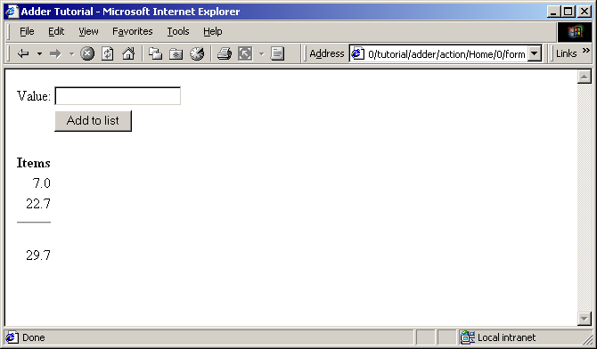
The user enters a number into the value field and clicks "Add to list". The number is added to the list of items and factored into the total.
A Form component containing a TextField component will be used to collect information from the user. A Foreach component will be used to run though the list of items, and Insert components will be used to present each item in the list, as well as the total.
If the user enter in a non-number, then an error message is displayed.
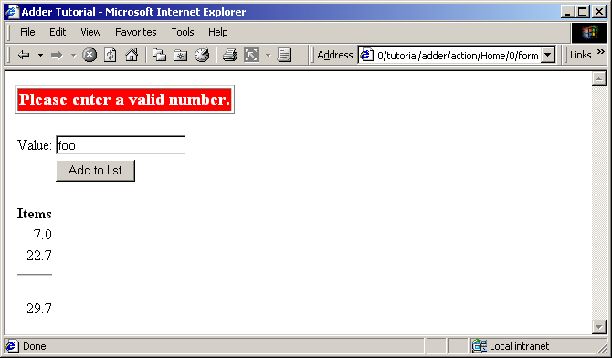
As with the previous examples, the servlet and application objects are simple variations on the previous two sets (they are ommited here).
The application specification is, likewise, a variation on the prior example.
The code for this section is in the tutorial.adder package.
We'll start with the HTML template for the home page:
Home.html
<!DOCTYPE HTML PUBLIC "-//W3C//DTD HTML 4.0 Transitional//EN">
<html>
<head>
<title>Adder Tutorial</title>
</head>
<body>

<jwc id="ifError">
<table border=1>
<tr>
<td bgcolor=red>
<span style="font: bolder 14pt; color:white">
<jwc id="insertError"/>
</span>
</td>
</tr>
</table>
<p>
</jwc>

<jwc id="form">

<table>
<tr>
<td align=right>Value:</td>
<td><jwc id="inputNewValue"/></td>
</tr>
<tr>
<td> </td>
<td><input type=submit value="Add to list"></td>
</tr>
</table>

</jwc>

<table>
<tr> <th>Items</th> </tr>
<jwc id="e">
<tr align=right>
<td>
<jwc id="insertCurrentValue"/>
</td>
</tr>
</jwc>

<tr align=right>
<td>
<hr>
<br><jwc id="insertTotal"/>
</td>
</tr>
</table>

</body>
</html>
Again, Tapestry takes care of most of the details. The form component will turn into an HTML <FORM> element, and the correct URL is automatically generated. The textfield component will become an <INPUT TYPE=TEXT>, with the necessary smarts to collect the value submitted by the user and provide it to the page.
The e component is a Foreach, used for running through a list of elements (supplied as a List, Iterator or an array of Java objects). We've already see the Insert component.
Next we have the specification:
Home.jwc
<?xml version="1.0"?>
<!DOCTYPE specification PUBLIC "-//Primix Solutions//Tapestry Specification 1.0//EN"
"http://tapestry.sourceforge.net/dtd/Tapestry_1_0.dtd">

<specification>
<class>tutorial.adder.Home</class>

<components>

<component>
<id>ifError</id>
<type>Conditional</type>

<bindings>
<binding>
<name>condition</name>
<property-path>error</property-path>
</binding>
</bindings>
</component>

<component>
<id>insertError</id>
<type>Insert</type>

<bindings>
<binding>
<name>value</name>
<property-path>error</property-path>
</binding>
</bindings>
</component>

<component>
<id>form</id>
<type>Form</type>

<bindings>
<binding>
<name>listener</name>
<property-path>formListener</property-path>
</binding>
</bindings>
</component>

<component>
<id>inputNewValue</id>
<type>TextField</type>

<bindings>
<binding>
<name>text</name>
<property-path>newValue</property-path>
</binding>
</bindings>
</component>

<component>
<id>e</id>
<type>Foreach</type>

<bindings>
<binding>
<name>source</name>
<property-path>items</property-path>
</binding>
</bindings>
</component>

<component>
<id>insertCurrentValue</id>
<type>Insert</type>

<bindings>
<binding>
<name>value</name>
<property-path>components.e.value</property-path>
</binding>
</bindings>
</component>

<component>
<id>insertTotal</id>
<type>Insert</type>

<bindings>
<binding>
<name>value</name>
<property-path>total</property-path>
</binding>
</bindings>
</component>
</components>

</specification>
We only want to display the error message if there is one, so the ifText is conditional on there being a non-null error message (the Conditional component treats null as false).
For the form component, all we have to do is supply a listener, an object that is informed when the form is submitted.
For the textfield component, we provide a text parameter that provides the default value for the <INPUT> element, as well as a place to put the value submitted on the form. This must be of type java.lang.String, so we need to do a little translation (in our Java class), since internally we want to store the value as a double.
For the e component, we supply a binding for the source parameter. For each item in the source list, it will update its value property, which is later accessed by the Insert component. The property path components.e.value accomplishes this: the page has a component property, which is a Map of the components on the page. e is the id of a component, and a key in the Map. It has a property named value, which is the current item from the source list.
A Foreach also has a parameter named value. By creating a binding for this parameter, the Foreach can update a property of the page, or some other component. This is more commonly used when the items in the list are business objects and the application needs to invoke business methods on them.
Finally, the Java code for the home page puts everything together:
Home.java
package tutorial.adder;

import com.primix.tapestry.*;
import com.primix.tapestry.components.*;
import java.util.*;

public class Home extends BasePage
{
private List items;
private String newValue;
private String error;

public List getItems()
{
return items;
}

public void setItems(List value)
{
items = value;

fireObservedChange("items", value);
}

public void setNewValue(String value)
{
newValue = value;
}

public String getNewValue()
{
return newValue;
}

public void detach()
{
items = null;
newValue = null;
error = null;

super.detach();
}

public void addItem(double value)
{
if (items == null)
{
items = new ArrayList();
fireObservedChange("items", items);
}

items.add(new Double(value));

fireObservedChange();
}

public double getTotal()
{
Iterator i;
Double item;
double result = 0.0;

if (items != null)
{
i = items.iterator();
while (i.hasNext())
{
item = (Double)i.next();
result += item.doubleValue();
}
}

return result;
}

public IActionListener getFormListener()
{
return new IActionListener()
{
public void actionTriggered(IComponent component, IRequestCycle cycle)
{
try
{
double item = Double.parseDouble(newValue);
addItem(item);

newValue = null;
}
catch (NumberFormatException e)
{
error = "Please enter a valid number.";
}
}
};

}

public String getError()
{
return error;
}
}
That may seem like a lot of code for what we're doing, but in reality, very much is going that we don't have to write:
- Processing the submitted form
- Storing the List of items persistently between request cycles
- Encoding and decoding URLs
- Very robust exception support
Tapestry components, using JavaBeans properties, take care of moving data to and from the HTML form. Our application merely has to supply the logic to properly respond when the form is submitted. In this case, converting the text into a double that can be added to the list.
Because we let Tapestry set the names of our form elements, there's no possibility of mismatched names between the Java code (setting defaults and interpreting the posted request) and the HTML template.
Enter a few values into the text field to see how the application works, adding them together into an ever larger list.

Adding Interactivity using Listeners
To understand the relationship between the home page specification, the home page class and the components used by the home page, it is necessary to understand the JavaBeans properties provided by the home page class.
We implement several JavaBeans properties on this page:
Property name | Type | R / W | Description
newItem | String | R / W | Stores the string entered into the form.
items | List (of Double) | R / W | Items in the list. Persists between request cycles.
formListener | IActionListener | Read Only | Informed when form is submitted.
total | double | Read Only | Total of items; computed on the fly.
This example demonstrates how to provide interactivity to an application. For Tapestry, interactivity is defined as a request cycle initiated by a user clicking on a hyperlink or submitting a form.
In our case, we want to know when the form containing the TextField is submitted so that we can provide application specific behavior -- adding the value enterred in the TextField to the list of items.
This is accomplished using a listener, an object that implements the Java interface IActionListener. This interface defines a single method, actionTriggered(). When the form is submitted, all the components wrapped by the form (in this case, the TextField) are given a chance to retrieve their values from the request and update properties of the application (the TextField sets the currentItem property). The form then gets its listener and invokes the actionTriggered() method.
In the specification, the listener parameter was bound to the formListener property of the page. The code in the getFormListener() method creates an anonymous inner class and returns it.
Inner classes have access to the private fields and methods of the class. In this case, the inner class invokes the addItem() method to add the currentItem (with a value provided by the TextField component) to the items List.
A listener is free to do anything it wants. It can change the state of the application, or can retrieve other pages (by name) from the request cycle object, and can change properties of those pages. It can even chose a different page to render, by invoking setPage() on the request cycle.

Persistant Page State and Page Pooling
The home page of this application uses a persistant page property, a List that contains java.lang.Doubles, the items in the list.
Persistent page state is one of the most important concepts in Tapestry. Each page in the application (and in fact, even components within the page) has some properties that should persist between requests. This can be values such as the user's name and address, or (in this case) the list of numbers enterred so far.
In traditional JavaServer Pages or servlet applications, a good chunk of code must be written to manage this. The values must be encoded in cookies, as hidden form fields, as named attributes of the HttpSession, or stored into a server-side flat file or database. Each servle (or JSP) is directly responsible for managing access to these values … which leads to many half realized, ad-hoc solutions and an avalanche of bugs, and even security holes.
With Tapestry, the framework takes care of these persistence issues. When a persistent property of a page is changed the accessor method also invokes the method fireObservedChange(). This method informs a special object, the page's recorder, about the property and its new value.
When the page is next used, the value is restored automatically. This may not seem natural … an obvious question is: why wasn't the page in the same state? Then answer is that that page instance is shared, and may be used by a different client in the interrum.
Within the Tapestry framework, all of these pages, components, specifications and templates are converted into Java objects. Assembling a page is somewhat expensive: it involves reading all those specifications and templates, creating and initializating component objects, creating binding objects for the components, and organizing the components into a hierarchy.
Creating a page object for just one request cycle only to discard it is simply unacceptible. Pages should be kept around as long as they are needed; they should be re-used in subsequent request cycles, both for the same client session, or for other sessions.
The Tapestry framework accomplishes this by pooling instances of page objects; there could concievably be a handful of different instances being shared by thousands of client sessions. This is a kind of shell game that is important to maintain scalability.
What this means for the developer is some minor extra work. On each request cycle, a different instance of the page object may be used to handle the request. This means that data can't simply be stored in the instance variables of the page between request cycles.
Tapestry seperates the persistent state of a page from the actual page objects. The state is stored seperately, making use of the page recorder objects. When needed, a page can be created or reclaimed from the page pool and have all of its persistant properties set by the page recorder.
The developer has three responsibilities when coding a page with persistant state:
- The property must be serializable; this includes Java scalar types (boolean, int, double, etc.), Strings, common collection classes (ArrayList, HashMap, etc.) and other classes that implement java.io.Serializable.
- When the value of the property changes, the fireObservedChange() method must be invoked, to inform the page recorder about the change.
- When the request cycle ends and the page is returned to the pool, the persistant state must be reset to its initial value (as if the page object was newly instantiated). This is done in the detach() method.

Dynamic Page State
This page has a bit of dynamic state; state that changes as the page is being renderred. The value property of the Foreach component takes on different values from the items List as the page is renderred. Dynamic state is easier to handle than persistant state; for completeness, it must also be reset in the detach() method.
Tapestry Run Time Errors
Chapter
6
0ne of the benefits to developing using Tapestry is its robust exception handling support.
We'll demonstrate these by creating invalid URLs.

Stale Sessions
As we just demonstrated, Tapestry is quite careful about conversational state. What happens if all the conversation state is lost?
Start up adder application then enter a few numbers. Go back to the window executing Jetty and stop it, then restart it.
Now, try to add an additional number to the list.
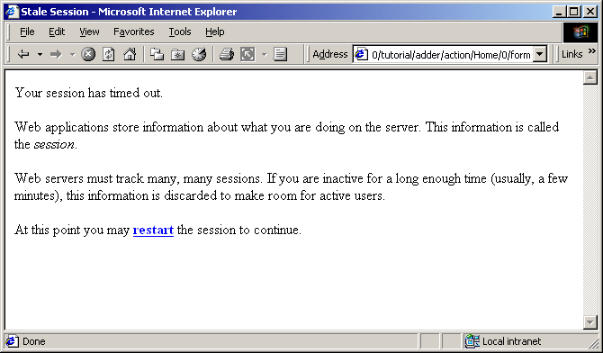
Because Tapestry can't find any information about your session, it assumes the session timed out and was discarded, and so presents the default error page for this situation.
Remember that most Tapestry URLs are very conversational, they only make sense as the most recent request in a series of requests exchanged between the client and the server.
This means that most pages in a Tapestry application can't be bookmarked; the URL that would be stored in the client's web browser is not meaningful. Creating bookmarkable pages is a subject of a later tutorial.

Exception Handling
Tapestry handles exceptions, catching them when they occur and formatting a readable page with all the details. Of course, in your own application, such exceptions will never occur, or will be caught and handled by your own code.
Still, it's nice that Tapestry can assist when debugging during development, when uncaught exceptions may in fact be thrown.
To demonstrate what Tapestry does for exceptions, we need to do a little bit of sneaky work.
First, enter a few numbers into the Adder application:
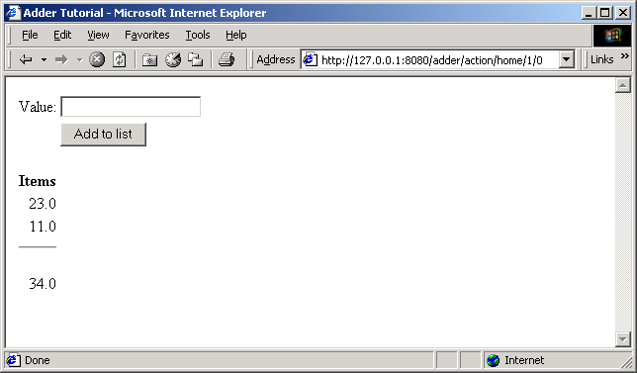
Now, edit the URL in the Address field, and change the word "action" to "acion" (i.e, remove the letter 't') and hit return.
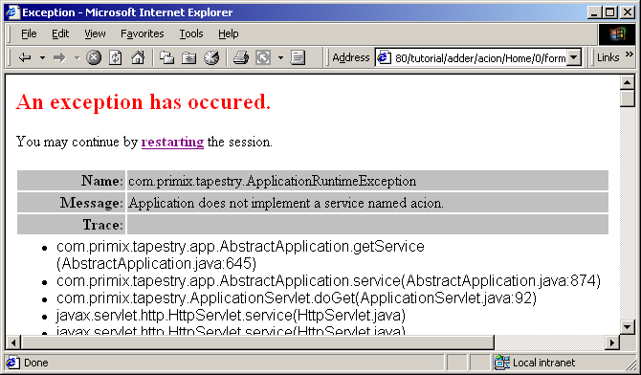
Tapestry has discovered that the URL was invalid ... in this case that the word "action" was changed to "acion". Since Tapestry normally produces all the URLs it must later interpret, it doesn't make an effort to pretty this up (as it does with stale links and sessions), instead it throws an exception which is caught and displayed.
As you may notice, the exception report is extremely complex. Tapestry displays all the information it can about the exception that was thrown ... it can even break apart nested exceptions and dig down to the deepest one. It shows the stack trace where the deepest exception was thrown. It also provides information about the HttpRequest, HttpSession, ServletContext and Java VM.
Finally, it includes a link that will destroy the current HttpSession and restart the application from scratch.

Potpourri!
Chapter
6
Chapter
7
So far, these examples have been a little bit cut-and-dried. Lets do a meatier example that uses a few more interesting components. Let's play Hangman!
Our Hangman application consists of four pages. The home page allows a new game to be started, which includes selecting the difficulty of the game (how many wrong guesses you are allowed).
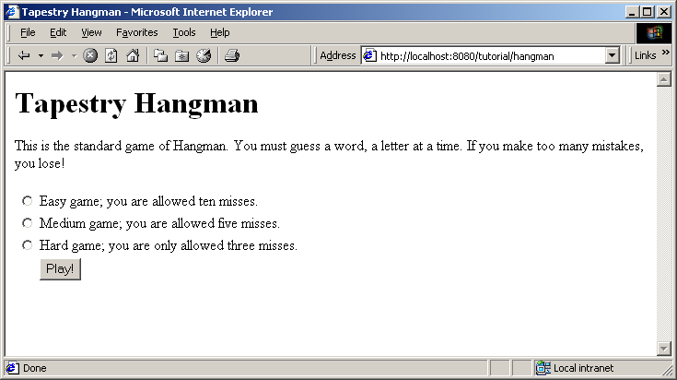
The main page is the Guess page, where the partially filled out word is displayed, and the user can make guesses (from a shrinking list of possible letters):
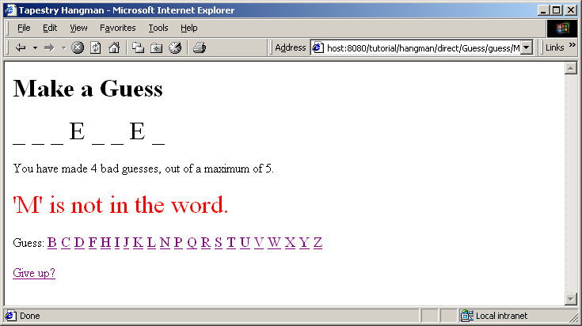
After you give up, or when you make too many mistakes, you get to the Failed page:
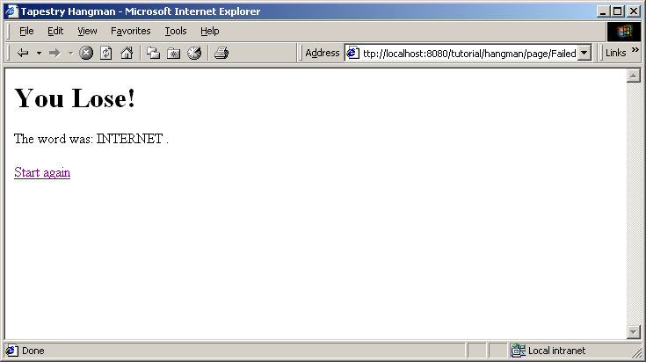
But, if you guess all the letters, you are sent to the Success page:
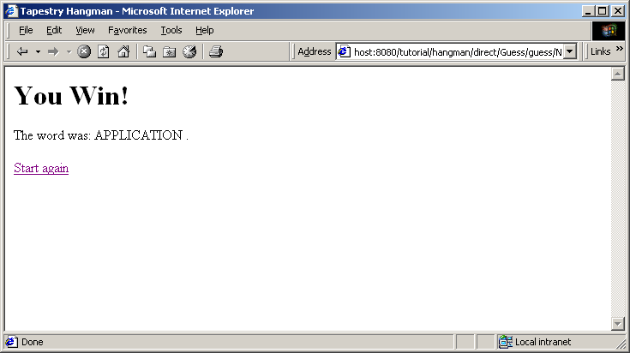

The Visit Object
The center of this application is an object that represents game, an object of class HangmanGame. This object is used to track the word being guessed, the letters that have been used, the number of misses and the letters that have been correctly guessed.
This object is a property of the visit object. What's the visit object? The visit object is a holder of all information about a single client's visit to your web application. It contains data and methods that are needed by the pages and components of your application.
The visit object is owned and created by the engine object. It is serialized and de-serialized with the engine.
The application specification includes a little extra segment at the bottom to specify the class of the visit object.
Hangman.application
<?xml version="1.0"?>
<!DOCTYPE application PUBLIC "-//Primix Solutions//Tapestry Specification 1.0//EN"
"http://tapestry.sourceforge.net/dtd/Tapestry_1_0.dtd">
<application>
<name>Tapestry Hangman</name>
<engine-class>com.primix.tapestry.engine.SimpleEngine</engine-class>
<page>
<name>Home</name>
<specification-path>/tutorial/hangman/Home.jwc</specification-path>
</page>
<page>
<name>Guess</name>
<specification-path>/tutorial/hangman/Guess.jwc</specification-path>
</page>
<page>
<name>Failed</name>
<specification-path>/tutorial/hangman/Failed.jwc</specification-path>
</page>
<page>
<name>Success</name>
<specification-path>/tutorial/hangman/Success.jwc</specification-path>
</page>
<properties>
<property>
<name>com.primix.tapestry.visit-class</name>
<value>tutorial.hangman.Visit</value>
</property>
</properties>
</application>
These properties are simple named values associated with the application specification. When the application engine needs to create the visit object, it creates an instance of the named class.
So, returning from that distraction, the game object is a property of the visit object, which is accessible from any page (via the page's visit property).

The Home Page
The Home page's job is to collect the difficulty and initiate a game:
Home.java
public class Home
extends BasePage
implements IActionListener
{
public static final int EASY = 10;
public static final int MEDIUM = 5;
public static final int HARD = 3;

private int misses;
private String error;

public void detach()
{
misses = 0;
error = null;

super.detach();
}

public int getMisses()
{
return misses;
}

public void setMisses(int value)
{
misses = value;

fireObservedChange("misses", value);
}

public String getError()
{
return error;
}

public IActionListener getFormListener()
{
return this;
}

public void actionTriggered(IComponent component, IRequestCycle cycle)
throws RequestCycleException
{
if (misses == 0)
{
error = "Please select a game difficulty.";
return;
}

Visit visit = (Visit)getVisit();

visit.start(misses);

cycle.setPage("Guess");
}

}
We're seeing all the familiar ideas: The misses property is a persistent page property (which means the page will "remember" the value previously selected by the user).
We use a common trick for simple pages: the page contains a single Form component, so we use the page itself as the form's listener, and have the page implement the IActionListener interface. This saves a bit of code for creating an inner class as the form listener.
Initially, we don't select a difficulty level, and the user can click "Play!" without selecting a value from the list, so we check that.
Otherwise, we get the visit object and ask it to start a new game with the selected number of misses. We then jump to the Guess page to start accepting guesses from the user.
The interesting part of the Home page HTML template is the form:
Home.html (excerpt)
<jwc id="form">

<jwc id="group">

<jwc id="ifError">
<font size=+2 color=red><jwc id="insertError"/></font>
</jwc>

<table>
<tr>
<td><jwc id="inputEasy"/></td>
<td>Easy game; you are allowed ten misses.</td>
</tr>

<tr>
<td><jwc id="inputMedium"/></td>
<td>Medium game; you are allowed five misses.</td>
</tr>

<tr>
<td><jwc id="inputHard"/></td>
<td>Hard game; you are only allowed three misses.</td>
</tr>

<tr>
<td></td>
<td><input type="submit" value="Play!"></td>
</tr>

</table>

</jwc>
</jwc>
Here, the interesting components are group, inputEasy, inputMedium and inputHard. group is type RadioGroup, a wrapper that must go around the Radio components (the other three). The RadioGroup determines what property of the page is to be read and updated (its bound to the misses property). Each Radio button is associated with a particular value to be assigned to the property, when that radio button is selected by the user.
This comes together in the Home page specification:
Home.jwc (excerpt)
<component>
<id>group</id>
<type>RadioGroup</type>
<bindings>
<binding>
<name>selected</name>
<property-path>misses</property-path>
</binding>
</bindings>
</component>
.
.
.
<component>
<id>inputEasy</id>
<type>Radio</type>
<bindings>
<field-binding>
<name>value</name>
<field-name>tutorial.hangman.Home.EASY</field-name>
</field-binding>
</bindings>
</component>
<component>
<id>inputMedium</id>
<type>Radio</type>
<bindings>
<field-binding>
<name>value</name>
<field-name>tutorial.hangman.Home.MEDIUM</field-ame>
</field-binding>
</bindings>
</component>
<component>
<id>inputHard</id>
<type>Radio</type>
<bindings>
<field-binding>
<name>value</name>
<field-name>tutorial.hangman.Home.HARD</field-name>
</field-binding>
</bindings>
</component>
The <field-binding> is very useful in this case; it is similar to a <static-binding> but, instead of supplying the value in place, it uses a reference to a public static field of some class or interface. This is a good thing, since if you decide to make a HARD game only allow two mistakes, you can make the change in exactly one place.
So the end result is: when the user clicks the radio button for a Hard game, the static constant HARD is assigned to the page's misses property.

The Guess Page
This is the page where uses make letter guesses. The page has four sections:
- A display of the word, with underscores replacing unguessed letters.
- A status area, showing the number of bad guesses and an optional error message after an invalid guess
- A list of letters that may be guessed. Letters disappear after they are used.
- An option to give up and see the word, terminating the game.
Let's start with the HTML template this time:
Guess.html (excerpt)
<h1>Make a Guess</h1>

<font size=+3>
<jwc id="insertGuess"/>
</font>

<p>

You have made <jwc id="insertMissed"/> bad guesses,
out of a maximum of <jwc id="insertMaxMisses"/>.

<jwc id="ifError">
<p>
<font size=+3 color=red><jwc id="insertError"/></font>
</jwc>

<p>Guess:
<font size=+1>
<jwc id="e">
<jwc id="guess"><jwc id="insertLetter"/></jwc>
</jwc>
</font>

<p><jwc id="giveUp">Give up?</jwc>
Most of these components should be fairly obvious by now; let's focus on the components that allow the user to guess a letter. This could have been implemented in a number of ways … using more radio buttons, a drop down list, a text field the user could type into. In this example, we chose to simply create a series of links, one for each letter the user may still guess.
Let's look at the specification for those three components (e, guess and insertLetter).
Guess.jwc (excerpt)
<component>
<id>e</id>
<type>Foreach</type>

<bindings>
<binding>
<name>source</name>
<property-path>unused</property-path>
</binding>
</bindings>
</component>

<component>
<id>guess</id>
<type>Direct</type>

<bindings>
<binding>
<name>listener</name>
<property-path>guessListener</property-path>
</binding>

<binding>
<name>context</name>
<property-path>components.e.value</property-path>
</binding>
</bindings>
</component>

<component>
<id>insertLetter</id>
<type>Insert</type>

<bindings>
<binding>
<name>value</name>
<property-path>components.e.value</property-path>
</binding>
</bindings>
</component>
Component e is simply a Foreach, the source is the unused property of the page (we'll see in a moment how the page gets this list of unused letters from the game object).
Component insertLetter inserts the current letter from the list of unused letters. It gets this current letter directly from the e component. On successive iterations, a Foreach component's value property is the value for the iteration.
Component guess is type Direct, which creates a hyperlink on the page and notifies its listener when the user clicks the link. Just knowing that the component was clicked isn't very helpful though … the application needs to know which letter was actually clicked.
Passing that kind of information along is accomplished by setting the context parameter for the component. The context parameter is a string, or array of strings, that will be encoded into the URL. When the component's listener is notified, it is passed the same Strings.
The context is often used to encode primary keys of objects, names of columns or other information specific to the application.
In this case, the context is simply the letter to be guessed.
All of this comes together in the Java code for the Guess page.
Guess.java (excerpt)
public IDirectListener getGuessListener()
{
return new IDirectListener()
{
public void directTriggered(IDirect direct,
String[] context, IRequestCycle cycle)
throws RequestCycleException
{
makeGuess(context[0], cycle);
}
};
}

private void makeGuess(String guess, IRequestCycle cycle)
throws RequestCycleException
{
HangmanGame game = getGame();
char letter = guess.charAt(0);

try
{
game.guess(letter);
}
catch (GameException ex)
{
error = ex.getMessage();

if (game.getFailed())
cycle.setPage("Failed");

return;
}

// A good guess.

if (game.getDone())
cycle.setPage("Success");
}
So the listener for the guess component gets the first String in the context and invokes the makeGuess() method. We pass the guessed letter to the game object which throws a GameException if the guess is invalid.
The method HangmanGame.getFailed() returns true when all the missed guesses are used up, at which point we go to the Failed page to tell the user what the word was.
On the other hand, if an exception isn't thrown, then the guess was good. getDone() returns true if all letters have been guessed, in which go to the Success page.
If all letters weren't guessed, we stay on the Guess page, which will display the word with the guessed letter filled in, and with fewer options in the list of possible guesses.

Limitations
This is a very, very simple implementation of the game. For example, it's easy to cheat … you can give up, then use your browser's back button to return to the Guess page and keep guessing (with accuracy, if your memory is any good).
Creating Reusable Components
Chapter
6
Chapter
8
In this tutorial, we'll show how to create a reusable component. One common use of components it to create a common "border" for the application that includes basic navigation. We'll be creating a simple, three page application with a navigation bar down the left side.
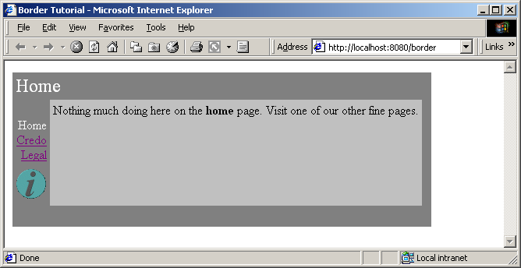
Navigating to another page results in a similar display:
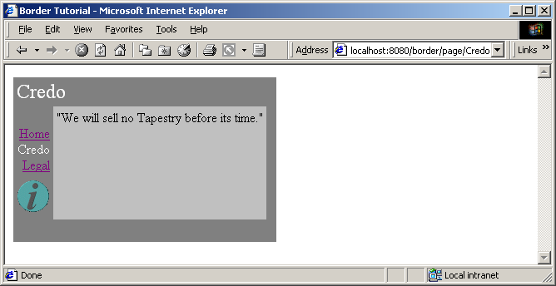
Each page's content is confined to the silver area in the center. Note that the border adapts itself to each page: the title "Home" or "Credo" is specific to the page, and the current page doesn't have an active link (in the above page, "Credo" is the current page, so only "Home" and "Legal" are usable as navigation links).
The "i" in the circle is the Show Inspector link. It will be described in the next chapter.
Because this tutorial is somewhat large, we'll only be showing excerpts from some of the files. The complete source of the tutorial examples is available seperately, in the tutorial.border package.
Each of the three pages has a similar HTML template:
Home.html
<jwc id="border">

Nothing much doing here on the <b>home</b> page. Visit one of our other fine
pages.

</jwc>
Remember that Tapestry components can wrap around other HTML elements or components. For the border, we have an HTML template where everything on the page is wrapped by the border component.
Note that we don't specify any <HTML> or <BODY> tags; those are provided by the border (as well as the matching close tags).
This illustrates a key concept within Tapestry: embedding vs. wrapping. The Home page embeds the border component (as we'll see in the Home page's specification). This means that the Home page is implemented using the border component.
However, the border component wraps the content of the Home page … the Home page HTML template indicates the order in which components (and static HTML elements) are renderred. On the Home page, the Border component 'bats' first and cleanup.
The construction of the Border component is based on how it differs from page to page. You'll see that on each page, the title (in the upper left corner) changes. The names of all three pages are displayed, but only two of the three will have links (the third, the current page, is just text). Lastly, each page contains the specific content from its own HTML template.
Border.html
<jwc id="shell">
<jwc id="body">
<table border=0 bgcolor=gray cellspacing=0 cellpadding=4>
<tr valign=top>
<td colspan=3 align=left>
<font size=5 color="White"><jwc id="insertPageTitle"/></font>
</td>
</tr>
<tr valign=top>
<td align=right>
<font color=white>
<jwc id="e">
<br><jwc id="link"><jwc id="insertName"/></jwc>
</jwc>
</font>
</td>
<td rowspan=2 valign=top bgcolor=silver>
<jwc id="wrapped"/>
</td>
<td rowspan=2 width=4></td>
</tr>
<tr>
<td><jwc id="showInspector"/></td>
</tr>
<tr>
<td colspan=3 height=4>&nbsp;</td>
</tr>
</table>
</jwc>
</jwc>
The insertApplicationName and insertPageTitle components provides the name of the application, and the title of the page within the application.
The e, link and insertName components provide the inter-page navigation links.
The showInspector component provides the button below the page names (the italicized "i" in a circle) and will be explained shortly.
The shell component provides the outermost portions of the page, the <html> and <head> tags.
The body component is a replacement for the <body> tag; it is required to support automatic rollover buttons (such as the showInspector) and will be used by most Tapestry applications.
Lastly, the wrapped component provides the actual content for the page.
The Border component is designed to be usable in other Tapestry applications, so it doesn't hard code the list of page names. These must be provided to the border component. In fact, the application object provides the list.
Border.jwc
<?xml version="1.0"?>
<!DOCTYPE specification PUBLIC "-//Primix Solutions//Tapestry Specification 1.0//EN"
"http://tapestry.sourceforge.net/dtd/Tapestry_1_0.dtd">
<specification>
<class>tutorial.border.Border</class>
<parameters>
<allow-informal-parameters>no</allow-informal-parameters>
<parameter>
<name>title</name>
<java-type>java.lang.String</java-type>
<required>yes</required>
</parameter>
<parameter>
<name>pages</name>
<required>yes</required>
</parameter>
</parameters>
<components>
<component>
<id>shell</id>
<type>Shell</type>
<bindings>
<binding>
<name>title</name>
<property-path>page.application.specification.name</property-path>
</binding>
</bindings>
</component>
<component>
<id>insertPageTitle</id>
<type>Insert</type>
<bindings>
<inherited-binding>
<name>value</name>
<parameter-name>title</parameter-name>
</inherited-binding>
</bindings>
</component>
<component>
<id>body</id>
<type>Body</type>
</component>
<component>
<id>e</id>
<type>Foreach</type>
<bindings>
<inherited-binding>
<name>source</name>
<parameter-name>pages</parameter-name>
</inherited-binding>
<binding>
<name>value</name>
<property-path>pageName</property-path>
</binding>
</bindings>
</component>
<component>
<id>link</id>
<type>Page</type>
<bindings>
<binding>
<name>page</name>
<property-path>pageName</property-path>
</binding>
<binding>
<name>disabled</name>
<property-path>disablePageLink</property-path>
</binding>
</bindings>
</component>
<component>
<id>insertName</id>
<type>Insert</type>
<bindings>
<binding>
<name>value</name>
<property-path>pageName</property-path>
</binding>
</bindings>
</component>
<component>
<id>wrapped</id>
<type>InsertWrapped</type>
</component>
<component>
<id>showInspector</id>
<type>ShowInspector</type>
</component>
</components>
</specification>
So, the specification for the Border component must identify the parameters it needs, but also the components it uses and how they are configured.
We start by declaring two parameters: title and pages. The first is the title that will appear on the page. The second is the list of page names for the navigation area. We don't specify a type for pages because we want to allow all the possibilites (List, Iterator, Java array) that are acceptible as the source parameter to a Foreach.
We then provide the shell component with its title parameter; this will be the window title. We use the application's name, with is extracted from the application's specification.
jumps from the page, to the application, to the application specification and gets the name of the application.
Further down we see that the insertPageTitle component inherits the title parameter from its container, the border component. Whatever binding is provided for the title parameter of the border will also be used as the value parameter of the insertPageTitle component. Using these inherited bindings simplifies the process of creating complex components from simple ones.
Likewise, the e component (a Foreach) needs as its source the list of pages, which it inherits from the Border component's pages parameter. It has been configured to store each succesive page name into the pageName property of the Border component; this is necessary so that the Border component can determine which page link to disable (it disables the current page since we're already there).
The link component creates the link to the other pages. It has an disabled parameter; which, when true, causes the link component to not create the hyperlink (though it still allows the elements it wraps to render). The Java class for the Border component, tutorial.border.Border, provides a method, getDisablePageLink(), that returns true when the pageName instance variable (set by the e component) matches the current page's name.
The showInspector component creates a rollover button (the "i" lights up when the mouse is moved over it):

Clicking on the button raises a second window that describes the current page in the application (this is used when debugging a Tapestry applicaton). The Inspector is described in the next chapter.
The final mystery is the wrapped component. It is used to render the elements wrapped by the border on the page containing the border. Those elements will vary from page to page; running the application shows that they are different on the home, credo and legal pages (different text appears in the central light-grey box). There is no limitation on the elements either … Tapestry is specifically designed to allow components to wrap other components in this way, without any arbitrary limitations.
This means that the different pages could contain forms, images or any set of components at all, not just static HTML text.
The specification for the home page shows how the title and pages parameters are set. The title is static, the literal value "Home" (this isn't the best approach if localization is a concern).
Home.jwc
<?xml version="1.0"?>
<!DOCTYPE specification PUBLIC
"-//Primix Solutions//Tapestry Specification 1.0//EN"
"http://tapestry.sourceforge.net/dtd/Tapestry_1_0.dtd">

<specification>
<class>com.primix.tapestry.BasePage</class>

<components>
<component>
<id>border</id>
<type>Border</type>

<bindings>
<static-binding>
<name>title</name>
<value>Home</value>
</static-binding>

<binding>
<name>pages</name>
<property-path>application.pageNames</property-path>
</binding>
</bindings>
</component>
</components>

</specification>
The pages property is retrieved from the application, which implements a pageNames property:
BorderApplication.java (excerpt)
private static final String[] pageNames =
{ "Home", "Credo", "Legal" };

public String[] getPageNames()
{
return pageNames;
}
How did Tapestry know that the type 'Border' (shown in bold in the page specification) corresponded to the specification /tutorial/border/Border.jwc? Only because we defined an alias in the application specification:
Border.application (excerpt)
<component>
<alias>Border</alias>
<type>/tutorial/border/Border.jwc</type>
</component>
Had we failed to do this, we would have had to specify the complete resource path, /tutorial/border/Border.jwc, on each page's specification, instead of the short alias 'Border'. There is no magic about the existing Tapestry component types (Insert, Foreach, Page, etc.) ... they each have an alias pre-registered into every application specification. These short aliases are simply a convienience.
The Tapestry Inspector
Chapter
9
Unlike scripting systems (such as JavaServer Pages and the like), Tapestry applications are gifted with a huge amount of information about how they are implemented … the same component object model that allows Tapestry to perform so many ordinary functions can be leveraged to provide some unusual functionality.
Since this section was originally written, the Inspector has been reorganized and a new tab, Logging, has been added. This section will be updated once the functionality of the Inspector has stabilized.
Run the border tutorial from the previous chapter and click on the show inspector button (the circle with the italic "i"). A new window will launch, containing the Inspector:
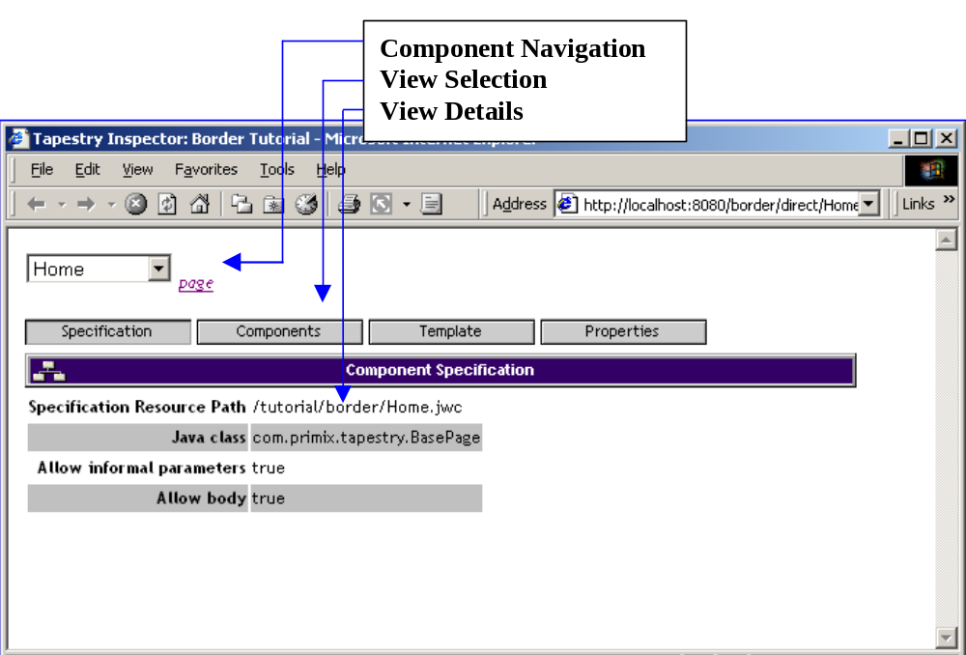
The Inspector displays live information from the running application; in fact, it is simply another part of the application (the drop-down list of pages will include the Inspector page itself). The Inspector is most often used to debug HTML generation by viewing the HTML templates.
The Inspector consists of three sections. The Component Navigation allows the page to be selected (using the drop-down list), and then shows the page, or component on the page, being inspected.
The View Selection selects one of four views of the component to be selected. Finally, the View Details section shows detailed information about the component, as selected.
The ShowInspector component and the Inspector page are built-into the Tapestry framework. Any Tapestry application can make use of the Inspector by simply adding a ShowInspector component to any page. Most commonly, the ShowInspector component is added to a persistent navigation component, such as the Border component (in these examples).

Specification View
The specification tab show the basic information about the component, plus its formal and informal parameters (and how they are bound), and any assets.
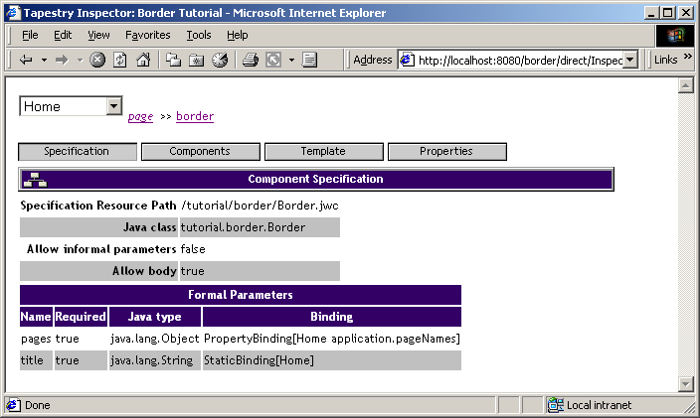
A more complicated component may also show informal parameters and assets.

Components View
The components view provides a list of the components embedded in the currently inspected component. Clicking the name of a component inspects that component.
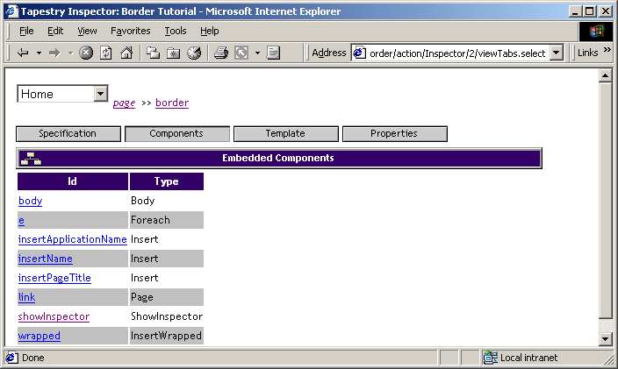

Template View
The template view shows the template (if known) for the component. It is formatted much like the examples in this document, with <jwc> tags in bold. In addition, component names are links, showing the template (if any) for the embedded component.
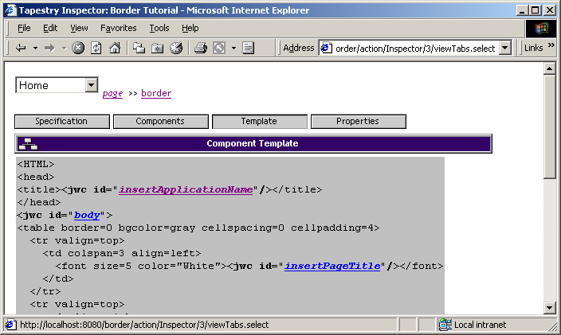

Properties View
The properties view shows all persistent properties for the page.
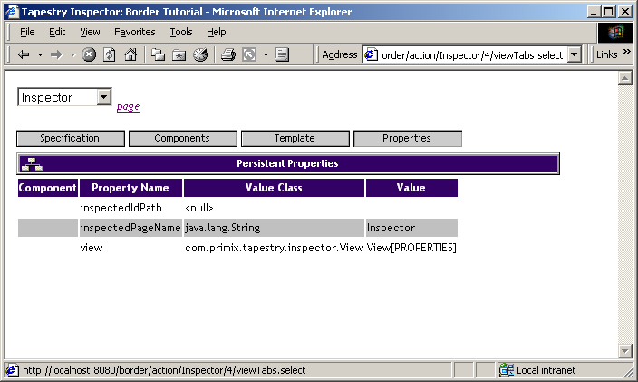
The component column is usually blank, except in the rare case that a component has its own persistent properties, in which case the component's id path is displayed.

Complex Forms and Output
Chapter
9
Tapestry includes a number of components designed to simplify interactions with the client, especially when handling forms.
In this chapter, we'll build a survey-taking application that collects information from the user, stores it in an in-memory database, and produces tabular results summarizing what has been entered.
We'll see how to validate input from the client, how to create radio groups and pop-up selections and how to organize information for display.
The application has three main screens; the first is a home page:
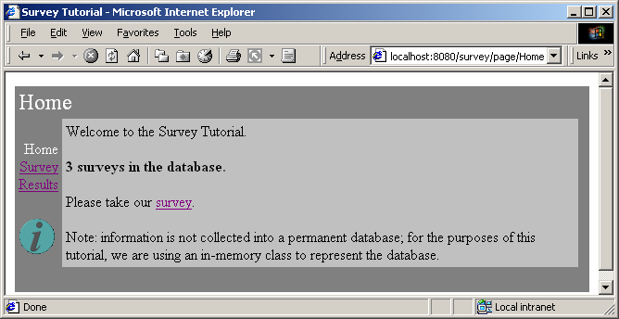
The second page is for entering survey data:
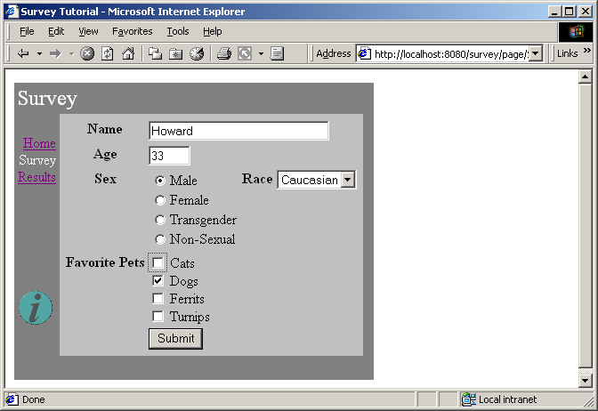
The last page is used to present results collected from many surveys:
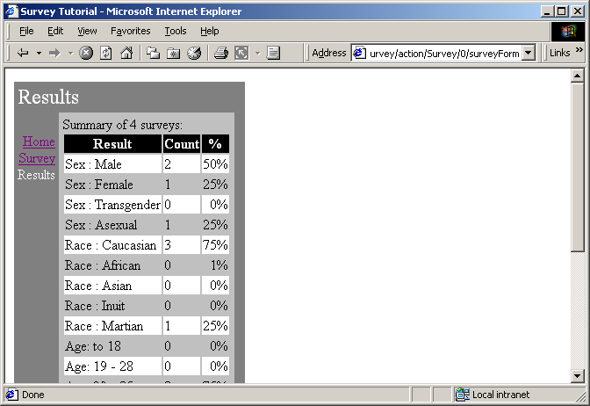
In addition, we are re-using the Border component from the previous chapter.
The application does not use an actual database; the survey information is stored in memory (the amount of work to set up a JDBC database is beyond the scope of this tutorial).
The source code for this chapter is in the tutorial.survey package.

Survey
At the root of this application is an object that represents a survey taken by a user. We want to collect the name (which is optional), the sex and the race, the age and lastly, which pets the survey taker prefers.
Survey.java
package tutorial.survey;

import java.util.*;
import com.primix.tapestry.*;
import java.io.*;

public class Survey implements Serializable, Cloneable
{
private Object primaryKey;
private String name;
private int age = 0;
private Sex sex = Sex.MALE;
private Race race = Race.CAUCASIAN;

private boolean likesDogs = true;
private boolean likesCats;
private boolean likesFerrits;
private boolean likesTurnips;

public Object getPrimaryKey()
{
return primaryKey;
}

public void setPrimaryKey(Object value)
{
primaryKey = value;
}

public String getName()
{
return name;
}

public void setName(String value)
{
name = value;
}

public int getAge()
{
return age;
}

public void setAge(int value)
{
age = value;
}

public void setSex(Sex value)
{
sex = value;
}

public Sex getSex()
{
return sex;
}

public void setRace(Race value)
{
race = value;
}

public Race getRace()
{
return race;
}

public boolean getLikesCats()
{
return likesCats;
}

public void setLikesCats(boolean value)
{
likesCats = value;
}

public boolean getLikesDogs()
{
return likesDogs;
}

public void setLikesDogs(boolean value)
{
likesDogs = value;
}

public boolean getLikesFerrits()
{
return likesFerrits;
}

public void setLikesFerrits(boolean value)
{
likesFerrits = value;
}

public boolean getLikesTurnips()
{
return likesTurnips;
}

public void setLikesTurnips(boolean value)
{
likesTurnips = value;
}

/**
* Validates that the survey is acceptible; throws an {@link IllegalArgumentException}
* if not valid.
*
*/

public void validate()
throws IllegalArgumentException
{
if (race == null)
throw new IllegalArgumentException("Race must be specified.");

if (sex == null)
throw new IllegalArgumentException("Sex must be specified.");

if (age < 1)
throw new IllegalArgumentException("Age must be at least one.");
}

public Object clone()
{
try
{
return super.clone();
}
catch (CloneNotSupportedException e)
{
return null;
}
}
}
The race and sex properties are defined in terms of the Race and Sex classes, which are derived from com.primix.foundation.Enum. Enum classes act like C enum types; a specific number of pre-defined values are declared by the class (as static final constants of the class).
Race.java
package tutorial.survey;

import com.primix.foundation.Enum;

/**
* An enumeration of different races.
*
*/

public class Race extends Enum
{
public static final Race CAUCASIAN = new Race("CAUCASIAN");
public static final Race AFRICAN = new Race("AFRICAN");
public static final Race ASIAN = new Race("ASIAN");
public static final Race INUIT = new Race("INUIT");
public static final Race MARTIAN = new Race("MARTIAN");

private Race(String enumerationId)
{
super(enumerationId);
}

private Object readResolve()
{
return getSingleton();
}

}
This is better than using String or int constants because of type safety; the Java compiler will notice if you pass Race.INUIT as a parameter that expects an instance of Sex ... if they were both encoded as numbers, the compiler wouldn't know that there was a programming error.

SurveyDatabase
The SurveyDatabase class is a mockup of a database for storing Surveys, it has methods such as addSurvey() and getAllSurveys(). To emulate a database, it even allocates primary keys for surveys. Additionally, when surveys are added to the database, they are copied and when surveys are retrieved from the database, they are copied (that is, modifying a Survey instance after adding it to, or retrieving it from, the database doesn't affect the persistently stored Surveys within the database ... just as if they were in external storage).

SurveyEngine
The database is accessed via the SurveyApplication object.
SurveyEngine.java (excerpt)
private transient SurveyDatabase database;

public SurveyDatabase getDatabase()
{
return database;
}

protected void setupForRequest(RequestContext context)
{
super.setupForRequest(context);

if (database == null)
{
String name = "Survey.database";
ServletContext servletContext;

servletContext = context.getServlet().getServletContext();

database = (SurveyDatabase)servletContext.getAttribute(name);

if (database == null)
{
database = new SurveyDatabase();
servletContext.setAttribute(name, database);
}
}
}

The SurveyDatabase instance is stored as a named attribute of the ServletContext, a shared space available to all sessions.

SurveyPage
The SurveyPage is where survey information is collected. It initially creates an Survey instance as a persistent page property. It uses Form and a number of other components to edit the survey.
When the survey is complete and valid, it is added to the database and the results page is used as an acknowledgment.
The SurveyPage also demonstrates how to validate data from a TextField component, and how to display validation errors. If invalid data is enterred, then the user is notified (after submitting the form):
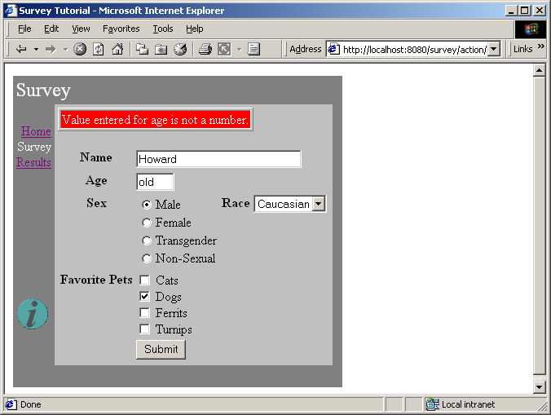
The HTML template for the page is relatively short. All the interesting stuff comes later, in the specification and the Java class.
SurveyPage.html
<jwc id="border">

<jwc id="ifError">
<table border=1>
<tr>
<td bgcolor=red>
<font style=bold color=white>
<jwc id="insertError"/>
</font> </tr> </tr> </table>
</jwc>

<jwc id="surveyForm">

<table border=0>

<tr valign=top> <th>Name</th>
<td colspan=3><jwc id="inputName"/></td></tr>

<tr valign=top> <th>Age</th>
<td colspan=3><jwc id="inputAge"/></td></tr>

<tr valign=top> <th>Sex</th>
<td> <jwc id="inputSex"/>
</td>

<th>Race</th>

<td><jwc id="inputRace"/>
</td> </tr>

<tr valign=top> <th>Favorite Pets</th>
<td colspan=3>
<jwc id="inputCats"/> Cats
<br><jwc id="inputDogs"/> Dogs
<br><jwc id="inputFerrits"/> Ferrits
<br><jwc id="inputTurnips"/> Turnips</td> </tr>
<tr>
<td></td>
<td colspan=3><input type=submit value="Submit"></td> </tr>
</table>

</jwc>
</jwc>
Most of this page is wrapped by the surveyForm component which is of type Form. The form contains two text fields (nameField and ageField), a group of radio buttons (ageSelect) and a pop-up list (raceSelect), and a number of check boxes (cats, dogs, ferrits and turnips).
Most of these components are pretty straight forward: nameField and ageField are setting String properties, and the check boxes are setting boolean properties. The two other components, raceSelect and ageSelect, are more interesting.
Both of these are of type PropertySelection; they are used for setting a specific property of some object to one of a number of possible values.
The PropertySelection component has some difficult tasks: It must know what the possible values are (including the correct order). It must also know how to display the values (that is, what labels to use on the radio buttons or in the pop up).
This information is provided by a model (an object that implements the interface com.primix.tapestry.components.html.form.IPropertySelectionModel), an object that exists just to provide this information to a PropertySelection component.
There's a secondary question with PropertySelection: how the component is rendered. By default, it creates a pop-up list, but this can be changed by providing an alternate renderer (using the component's renderer parameter). In our case, we used a secondary, radio-button renderer. Applications can also create their own renders, if they need to do something special with fonts, styles or images.
First, let's review the specification for the SurveyPage:
SurveyPage.jwc
<?xml version="1.0"?>
<!DOCTYPE specification PUBLIC "-//Primix Solutions//Tapestry Specification 1.0//EN"
"http://tapestry.sourceforge.net/dtd/Tapestry_1_0.dtd">
<specification>
<class>tutorial.survey.SurveyPage</class>
<components>
<component>
<id>border</id>
<type>Border</type>
<bindings>
<static-binding>
<name>title</name>
<value>Survey</value>
</static-binding>
<binding>
<name>pages</name>
<property-path>application.pageNames</property-path>
</binding>
</bindings>
</component>
<component>
<id>ifError</id>
<type>Conditional</type>
<bindings>
<binding>
<name>condition</name>
<property-path>error</property-path>
</binding>
</bindings>
</component>
<component>
<id>insertError</id>
<type>Insert</type>
<bindings>
<binding>
<name>value</name>
<property-path>error</property-path>
</binding>
</bindings>
</component>
<component>
<id>surveyForm</id>
<type>Form</type>
<bindings>
<binding>
<name>listener</name>
<property-path>formListener</property-path>
</binding>
</bindings>
</component>
<component>
<id>inputName</id>
<type>TextField</type>
<bindings>
<static-binding>
<name>displayWidth</name>
<value>30</value>
</static-binding>
<static-binding>
<name>maximumWidth</name>
<value>100</value>
</static-binding>
<binding>
<name>text</name>
<property-path>survey.name</property-path>
</binding>
</bindings>
</component>
<component>
<id>inputAge</id>
<type>TextField</type>
<bindings>
<static-binding>
<name>displayWidth</name>
<value>4</value>
</static-binding>
<static-binding>
<name>maximumWidth</name>
<value>4</value>
</static-binding>
<binding>
<name>text</name>
<property-path>age</property-path>
</binding>
</bindings>
</component>
<component>
<id>inputSex</id>
<type>PropertySelection</type>
<bindings>
<binding>
<name>value</name>
<property-path>survey.sex</property-path>
</binding>
<binding>
<name>model</name>
<property-path>sexModel</property-path>
</binding>
<binding>
<name>renderer</name>
<property-path>components.inputSex.defaultRadioRenderer</property-path>
</binding>
</bindings>
</component>
<component>
<id>inputRace</id>
<type>PropertySelection</type>
<bindings>
<binding>
<name>value</name>
<property-path>survey.race</property-path>
</binding>
<binding>
<name>model</name>
<property-path>raceModel</property-path>
</binding>
</bindings>
</component>
<component>
<id>inputCats</id>
<type>Checkbox</type>
<bindings>
<binding>
<name>selected</name>
<property-path>survey.likesCats</property-path>
</binding>
</bindings>
</component>
<component>
<id>inputDogs</id>
<type>Checkbox</type>
<bindings>
<binding>
<name>selected</name>
<property-path>survey.likesDogs</property-path>
</binding>
</bindings>
</component>
<component>
<id>inputFerrits</id>
<type>Checkbox</type>
<bindings>
<binding>
<name>selected</name>
<property-path>survey.likesFerrits</property-path>
</binding>
</bindings>
</component>
<component>
<id>inputTurnips</id>
<type>Checkbox</type>
<bindings>
<binding>
<name>selected</name>
<property-path>survey.likesTurnips</property-path>
</binding>
</bindings>
</component>
</components>
</specification>
Several of the components, such as inputName and inputTurnips, modify properties of the survey directly. The SurveyPage class has a survey property, which allows for property paths like survey.name and survey.likesTurnips.
The age field is more complicated, since it must be converted from a String to an int before being assigned to the survey's age property ... and the page must check that the user enterred a valid number as well.
Finally, the SurveyPage class shows how all the details fit together:
SurveyPage.java
package tutorial.survey;

import com.primix.tapestry.*;
import com.primix.tapestry.components.html.form.*;
import java.util.*;

public class SurveyPage extends BasePage
{
private Survey survey;
private String error;
private String age;
private IPropertySelectionModel sexModel;
private IPropertySelectionModel raceModel;

public IPropertySelectionModel getRaceModel()
{
if (raceModel == null)
raceModel = new EnumPropertySelectionModel(
new Race[]
{
Race.CAUCASIAN, Race.AFRICAN, Race.ASIAN, Race.INUIT, Race.MARTIAN
}, getBundle("tutorial.survey.SurveyStrings"), "Race");

return raceModel;
}

public IPropertySelectionModel getSexModel()
{
if (sexModel == null)
sexModel = new EnumPropertySelectionModel(
new Sex[]
{
Sex.MALE, Sex.FEMALE, Sex.TRANSGENDER, Sex.ASEXUAL
}, getBundle("tutorial.survey.SurveyStrings"), "Sex");

return sexModel;
}

private ResourceBundle getBundle(String resourceName)
{
return ResourceBundle.getBundle(resourceName, getLocale());
}

public IActionListener getFormListener()
{
return new IActionListener()
{
public void actionTriggered(IComponent component, IRequestCycle cycle)
{
try
{
survey.setAge(Integer.parseInt(age));

survey.validate();
}
catch (NumberFormatException e)
{
// NumberFormatException doesn't provide any useful data

setError("Value entered for age is not a number.");
return;
}
catch (Exception e)
{
setError(e.getMessage());
return;
}

// Survey is OK, add it to the database.

((SurveyApplication)getApplication()).getDatabase().addSurvey(survey);

setSurvey(null);

// Jump to the results page to show the totals.

cycle.setPage("Results");
}
};
}

public Survey getSurvey()
{
if (survey == null)
setSurvey(new Survey());

return survey;
}

public void setSurvey(Survey value)
{
survey = value;
fireObservedChange("survey", survey);
}

public void detach()
{
super.detach();

survey = null;
error = null;
age = null;

// We keep the models, since they are stateless
}

public void setError(String value)
{
error = value;
}

public String getError()
{
return error;
}

public String getAge()
{
int ageValue;

if (age == null)
{
ageValue = getSurvey().getAge();

if (ageValue == 0)
age = "";
else
age = Integer.toString(ageValue);
}

return age;
}

public void setAge(String value)
{
age = value;
}
}
A few notes. First, the raceModel and sexModel properties are created on-the-fly as needed. The EnumPropertySelectionModel is a provided class that simplifies using a PropertySelection component to set an Enum-typed property. We provide the list of possible values, and the information needed to extract the corresponding labels from a properties file, in this case, SurveyStrings.properties:
SurveyStrings.properties
Race.CAUCASIAN=Caucasian
Race.AFRICAN=African
Race.ASIAN=Asian
Race.INUIT=Inuit
Race.MARTIAN=Martian

Sex.ASEXUAL=Non-Sexual
Sex.MALE=Male
Sex.FEMALE=Female
Sex.TRANSGENDER=Transgender
Only survey is a persistent page property. The error property is transient (it is set to null at the end of the request cycle). The error property doesn't need to be persistent ... it is generated during a request cycle and is not used on a subsequent request cycle (because the survey will be re-validated).
Likewise, the age property isn't page persistent. If an invalid value is submitted, then its value will come up from the HttpServletRequest parameter and be plugged into the age property of the page. If validation of the survey fails, then the SurveyPage will be used to render the HTML response, and the invalid age value will still be there.
In the detachFromApplication() method, the survey, error and age properties are properly cleared. The raceModel and ageModel properties are not ... they are stateless and leaving them in place saves the trouble of creating identical objects later.

Results
Displaying results is broken up into two parts. In the first part, the database is queries for all surveys, and totals in a number of categories are prepared.
In the second part, those interrum results are incorporated into the HTML response page.
Results.html
<jwc id="border">

Summary of <jwc id="insertSurveyCount"/> surveys:

<jwc id="e-results">
<jwc id="ifFirst">
<table border=0>
<tr bgcolor=black>
<th><font color=white>Result</font></th>
<th><font color=white>Count</font></th>
<th><font color=white>%</font></th>
</tr>
</jwc>
<jwc id="results-row">
<td>
<jwc id="insertResult"/>
</td>
<td>
<jwc id="insertCount"/>
</td>
<td align=right>
<jwc id="insertPercent"/>
</td>
</jwc>
<jwc id="ifLast">
</table>
</jwc>
</jwc>

</jwc>
This template shows how those results will be provided to a Foreach component (e-results) that will iterate through them, and use a set of three Insert components. The ifFirst and ifLast components are used to generate the start and end of the HTML table (if the results are empty then the table doesn't get rendered at all).
The results-row component will take the place of the normal <TR> element in a table. It exists to vary the HTML bgcolor attribute, alternating between white and grey backgrounds for readability.
Results.jwc
<?xml version="1.0"?>
<!DOCTYPE specification PUBLIC
"-//Primix Solutions//Tapestry Specification 1.0//EN"
"http://tapestry.sourceforge.net/dtd/Tapestry_1_0.dtd">

<specification>
<class>tutorial.survey.Results</class>

<components>
<component>
<id>border</id>
<type>Border</type>

<bindings>
<static-binding>
<name>title</name>
<value>Results</value>
</static-binding>

<binding>
<name>pages</name>
<property-path>application.pageNames</property-path>
</binding>
</bindings>
</component>

<component>
<id>insertSurveyCount</id>
<type>Insert</type>

<bindings>
<binding>
<name>value</name>
<property-path>database.surveyCount</property-path>
</binding>
</bindings>
</component>

<!-- The results is a List of Maps. -->

<component>
<id>e-results</id>
<type>Foreach</type>

<bindings>
<binding>
<name>source</name>
<property-path>results</property-path>
</binding>
</bindings>
</component>

<component>
<id>ifFirst</id>
<type>Conditional</type>

<bindings>
<binding>
<name>condition</name>
<property-path>components.e-results.first</property-path>
</binding>
</bindings>
</component>

<!-- This stands in for the TR element, but handles the bgcolor. -->

<component>
<id>results-row</id>
<type>Any</type>

<bindings>
<static-binding>
<name>element</name>
<value>tr</value>
</static-binding>

<binding>
<name>bgcolor</name>
<property-path>rowColor</property-path>
</binding>
</bindings>
</component>

<component>
<id>insertResult</id>
<type>Insert</type>

<bindings>
<binding>
<name>value</name>
<property-path>components.e-results.value.name</property-path>
</binding>
</bindings>
</component>

<component>
<id>insertCount</id>
<type>Insert</type>

<bindings>
<binding>
<name>value</name>
<property-path>components.e-results.value.count</property-path>
</binding>
</bindings>
</component>

<component>
<id>insertPercent</id>
<type>Insert</type>

<bindings>
<binding>
<name>value</name>
<property-path>components.e-results.value.percent</property-path>
</binding>
</bindings>
</component>

<component>
<id>ifLast</id>
<type>Conditional</type>

<bindings>
<binding>
<name>condition</name>
<property-path>components.e-results.last</property-path>
</binding>
</bindings>
</component>

</components>

</specification>
The presentation relies on the Java class providing a results property. This property is a List of Maps. Each Map has three keys: name, count and percent. The rest of the logic is simply to break apart this List into Maps (as property-path components.e-results.value), and to pull out the values for the three keys.
Creating this results property consumes the bulk of the class:
Results.java
package tutorial.survey;

import com.primix.tapestry.*;
import java.util.*;
import java.text.*;
import java.awt.Color;

public class Results extends BasePage
{
private SurveyDatabase surveyDatabase;
private boolean oddRow = false;
private NumberFormat percentFormat;

public SurveyDatabase getDatabase()
{
if (surveyDatabase == null)
{
SurveyApplication surveyApplication;

surveyApplication = (SurveyApplication)application;

surveyDatabase = surveyApplication.getDatabase();
}

return surveyDatabase;
}

public void detach()
{
super.detach();

surveyDatabase = null;
oddRow = false;
}

public String getRowColor()
{
Color color;
String result;

if (oddRow)
color = Color.lightGray;
else
color = Color.white;

result = RequestContext.encodeColor(color);

oddRow = !oddRow;

return result;
}

public List getResults()
{
int raceAfrican = 0;
int raceAsian = 0;
int raceCaucasian = 0;
int raceInuit = 0;
int raceMartian = 0;
int sexAsexual = 0;
int sexFemale = 0;
int sexMale = 0;
int sexTransgender = 0;
int likesCats = 0;
int likesDogs = 0;
int likesFerrits = 0;
int likesTurnips = 0;
int ageToTeen = 0; // 1 - 18
int ageEarlyAdult = 0; // 19 - 28
int ageToMiddle = 0; // 29 - 35
int ageMiddle = 0; // 36 - 49
int ageOlder = 0; // 50 - 64
int ageRetire = 0; // 65 - 80
int ageOld = 0; // 81 - 100
Survey[] surveys;
Survey survey;
List result;
Race race;
Sex sex;
int count;
int i;
int age;

surveys = getDatabase().getAllSurveys();
if (surveys == null ||
surveys.length == 0)
return null;

count = surveys.length;
for (i = 0; i < count; i++)
{
survey = surveys[i];

race = survey.getRace();
if (race == Race.AFRICAN)
raceAfrican++;

if (race == Race.ASIAN)
raceAsian++;

if (race == Race.CAUCASIAN)
raceCaucasian++;

if (race == Race.INUIT)
raceInuit++;

if (race == Race.MARTIAN)
raceMartian++;

sex = survey.getSex();
if (sex == Sex.MALE)
sexMale++;

if (sex == Sex.FEMALE)
sexFemale++;

if (sex == Sex.TRANSGENDER)
sexTransgender++;

if (sex == Sex.ASEXUAL)
sexAsexual++;

if (survey.getLikesCats())
likesCats++;

if (survey.getLikesDogs())
likesDogs++;

if (survey.getLikesFerrits())
likesFerrits++;

if (survey.getLikesTurnips())
likesTurnips++;

age = survey.getAge();

if (age < 19)
ageToTeen++;

if (age >= 19 && age <= 28)
ageEarlyAdult++;

if (age >= 29 && age <= 35)
ageToMiddle++;

if (age >= 36 && age <= 49)
ageMiddle++;

if (age >= 50 && age <= 64)
ageOlder++;

if (age >= 65 && age <= 80)
ageRetire++;

if (age >= 81)
ageOld++;

}

result = new ArrayList();

result.add(buildResult("Sex : Male", sexMale, count));
result.add(buildResult("Sex : Female", sexFemale, count));
result.add(buildResult("Sex : Transgender", sexTransgender, count));
result.add(buildResult("Sex : Asexual", sexAsexual, count));

result.add(buildResult("Race : Caucasian", raceCaucasian, count));
result.add(buildResult("Race : African", raceAfrican, count));
result.add(buildResult("Race : Asian", raceAsian, count));
result.add(buildResult("Race : Inuit", raceInuit, count));
result.add(buildResult("Race : Martian", raceMartian, count));

result.add(buildResult("Age: to 18", ageToTeen, count));
result.add(buildResult("Age: 19 - 28", ageEarlyAdult, count));
result.add(buildResult("Age: 29 - 35", ageToMiddle, count));
result.add(buildResult("Age: 36 - 49", ageMiddle, count));
result.add(buildResult("Age: 50 - 64", ageOlder, count));
result.add(buildResult("Age: 65 - 80", ageRetire, count));
result.add(buildResult("Age: 80 and up", ageOld, count));

result.add(buildResult("Likes cats", likesCats, count));
result.add(buildResult("Likes dogs", likesDogs, count));
result.add(buildResult("Likes ferrits", likesFerrits, count));
result.add(buildResult("Likes turnips", likesTurnips, count));

return result;
}

private Map buildResult(String name, int count, int total)
{
Map result;

result = new HashMap(3);
result.put("name", name);
result.put("count", new Integer(count));

if (percentFormat == null)
percentFormat = NumberFormat.getPercentInstance(getLocale());

result.put("percent", percentFormat.format((double)count / (double)total));

return result;
}

}
Localization
Chapter
10
One of the most powerful and useful features of the Tapestry framework is the way in which it assists with localization of a web application. This is normally an ugly area in web applications, with tremendous amounts of ad-hoc coding necessary.
Because Tapestry does such a strong job of seperating the presentation of a component (its HTML template) from its control logic (its specification and Java class) it becomes easy for it to perform localization automatically. It's as simple as providing additional localized HTML templates for the component, and letting the framework select the proper one.
However, the static text of an application, provided by the HTML templates, is not all. Applications also have assets (images, stylesheets and the like) that must also be localized … that fancy button labeled "Search" is fine for your English clients, but your French cliensts will require a similar button labeled "Recherche".
Again, the framework assists, because it can look for localized versions of the assets as it runs.
The locale application demostrates this. It is a very simply application that demonstrates changing the locale of a running application.
The Home page of the application allows you to select a new language for the application:
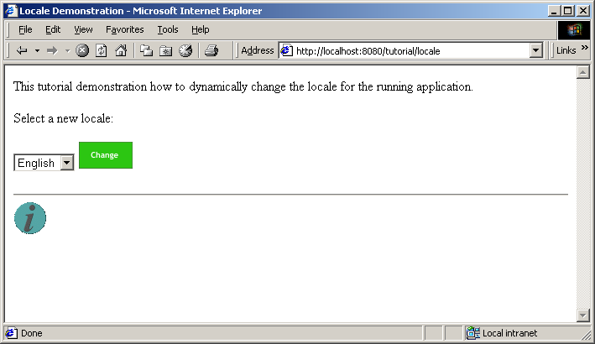
Selecting "German" from the list and clicking the "Change" button brings you to a new page that acknowledges your selection:
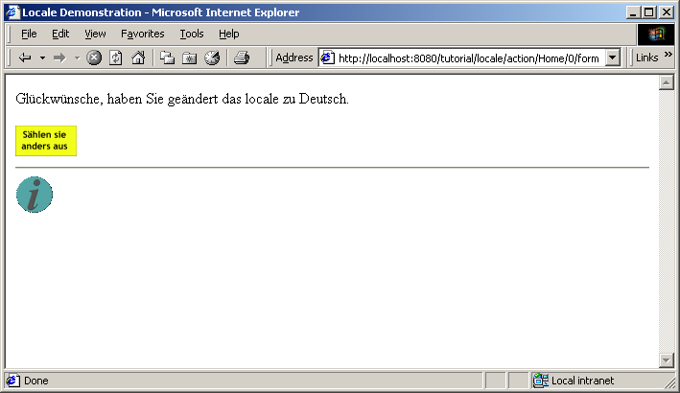
Clicking the button (it's labeled "Select Another" in German) returns you to the Home page to select a new language:
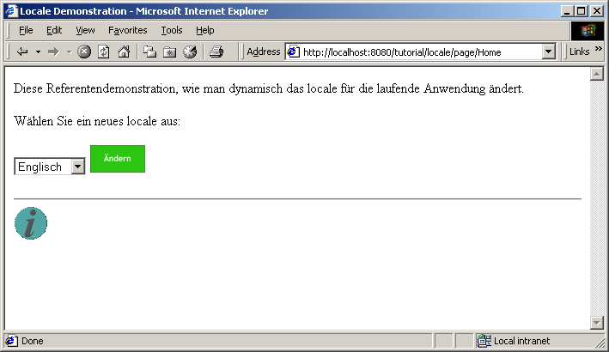
The neat thing here is that the Home page has been localized into German as well; it shows equivalent German text, the options in the popup list are in German, and the "Change" button has been replaced with a German equivalent.

Home Page
The Home page consists of a single component specification, four versions of the HTML template and four image assets.
Home.jwc (excerpt)
.
.
.
<component>
<id>inputLocale</id>
<type>PropertySelection</type>
<bindings>
<binding>
<name>value</name>
<property-path>selectedLocale</property-path>
</binding>
<binding>
<name>model</name>
<property-path>localeModel</property-path>
</binding>
</bindings>
</component>
<component>
<id>changeButton</id>
<type>ImageButton</type>
<bindings>
<binding>
<name>image</name>
<property-path>assets.change-button</property-path>
</binding>
</bindings>
</component>
</components>
<assets>
<private-asset>
<name>change-button</name>
<resource-path>/tutorial/locale/Change.gif</resource-path>
</private-asset>
</assets>
The changeButton component is an ImageButton, a Tapestry version of an <input type="image"> HTML form element. We provide it with an image, and asset that will be used as the src attribute of the HTML element.
The property path assets.change-button is a convienience; each component may have a number of named assets and has an assets property that is a Map of those assets.
We also must define the asset, naming it change-button. We declare it as a private asset, an asset that is not directly visible to the servlet container, but is instead packaged with the Java classes in a JAR or in the WEB-INF/classes directory of a WAR.
In fact, there are four files in that directory, named Change.gif, Change_de.gif, Change_fr.gif and Change_it.gif. Those suffixes (_de, _fr, etc.) identify the locale for which the image is appropriate. More information on those suffixes is available from the java.util.Locale documentation.
When Tapestry is rendering the page, it knows what locale is currently selected for the application (it’s a property of the engine object) and chooses the correct file based on that.
Along with the four images, there are four HTML templates.
Home.html
<jwc id="border">

This tutorial demonstration how to dynamically change the locale
for the running application.

<p>
Select a new locale:

<jwc id="form">
<jwc id="inputLocale"/>
<jwc id="changeButton"/>
</jwc>

</jwc>
The alternate locale versions are named in the same pattern as the image asset files.
Home_de.html
<jwc id="border">

Diese Referentendemonstration, wie man dynamisch
das locale f&#252;r die laufende Anwendung &#228;ndert.

<p>
W&#228;hlen Sie ein neues locale aus:

<jwc id="form">
<jwc id="inputLocale"/>
<jwc id="changeButton"/>
</jwc>

</jwc>
The ids of components are consistent regardless of the locale used … these are internal ids (the equivalent of variable names) and are not shown to the end user. In addition, there's only one specification file and the ids here must match the ids in the specification.
The only real different is the static text which, here, is in German.
Again, when Tapestry is rendering the page, it first chooses the correct localized HTML template. When it is rendering the changeButton component, it finds the correct localized file.
What if there isn't a localization of a template or file? Tapestry will use the more general file. For instance, if we somehow managed to convince the application that we spoke Spanish we would see mostly English text since we didn't provide Spanish localized templates or assets.
The Java code for the Home page is simple enough that we can largely skip it. The only interesting parts are providing a property selection model for the inputLocale component and responding when the form is submitted:
Home.java (excerpt)
public void actionTriggered(IComponent component, IRequestCycle cycle)
throws RequestCycleException
{
getEngine().setLocale(selectedLocale);

cycle.setPage("Change");
}

Change page
After the use selects a language, the application switches to the Change page for a response, which includes a link back to the Home page (as a localized image button).
Change.html
<jwc id="border">

Congratulations, you've changed the locale to <jwc id="insertLocaleName"/>.

<p><jwc id="home"><jwc id="chooseAgainImage"/></jwc>

</jwc>
This template combines with the specification that identifies the images.
Change.jwc (excerpt)
.
.
.
<component>
<id>chooseAgainImage</id>
<type>Image</type>
<bindings>
<binding>
<name>image</name>
<property-path>assets.choose-again</property-path>
</binding>
</bindings>
</component>
</components>
<assets>
<context-asset>
<name>choose-again</name>
<path>/images/locale/ChooseAgain.gif</path>
</context-asset>
</assets>
This is similar to the previous example, in that we've provided four versions of the ChooseAgain.gif image asset.
However, we've put the images in a different place. This time, the asset is a context asset, an asset that is visible to the servlet container. In this example, the file ChooseAgain.gif is located in the /images/locale directory of the WAR. Tapestry makes sure that the correct prefix (/tutorial) is prepended to the path when the HTML is rendered.
Context assets are the most common assets used. Private assets (as used on the Home page) are used mostly when creating libraries of components for reuse. When building an application that stands on its own, context assets are easier and more efficient.
As with the Home page, there are multiple localizations of the Change page.
Change_de.html
<jwc id="border">

Gl&#252;ckw&#252;nsche, haben Sie ge&#228;ndert das locale zu <jwc id="insertLocaleName"/>.

<p><jwc id="home"><jwc id="chooseAgainImage"/></jwc>

</jwc>
As we saw previously, the components in the HTML template are the same, just the static HTML has changed.

Other Options for Localization
In some cases, different localizations of the a component will be very similar, perhaps having only one or two small snippets of text that is different.
In those cases, it may be easier on the developer to not localize the HTML template, but to replace the variant text with an Insert component.
The page can read a localized Strings file (a .properties file) to get appropriate localized text. This saves the bother of maintaining multiple HTML templates.
All components on a page share the single locale for the page, but each performs its own search for its HTML template. This means that some components may not have to be localized, if they never contain any static HTML text. This is sometimes the case for reusable components, even navigational borders.

Further Study
Chapter
11
The preceding chapters cover many of the basic aspects of Tapestry. You should be comfortable with basic Tapestry concepts:
- Seperation of presentation, business and control logic
- Use of JavaBeans properties as the source of dynamic data
- How bindings access JavaBeans properties to provide data to components
- How components wrap each other, allowing for the creation of very complicated components through aggregation.
- Different types of page properties (transient, dynamic, persistent)
Tapestry is capable of quite a bit more. Also available within the Tapestry Examples package (along with the tutorial code and this document) is the Primix Virtual Library application (Vlib).
Vlib is a full-blown J2EE application, that makes use of Tapestry as its front end, and a set of session and entity Enterprise JavaBeans as its back end.
Vlib also demonstrates some of the other aspects of developing a Tapestry application. It shows how to create pages that are bookmarkable (meaning that their URL includes enough information to reconstruct them in a subsequent session). It shows how to handle logging in to an application, and how to protect pages from being accessed until the user is logged in. It has many specialized reusable components for creating links to pages about books and people.

The actual release numbers will change. This document was prepared for Tapestry-0-2-8.
Specifications and templates are generally read just once, then left in memory for susbsequent use.
Direct is kind of an abbreviation for DirectAction. There is another component, Action, that was written first and also creates a hyperlink on the page. This is one of those naming connundrums that has managed to get itself entrenched in Tapestry and is best to accept in the style of a magic incantation.
Translations were done using Bablefish and are probably laughably bad to someone who actually speaks the language.

