Primix Solutions
Core Labs
Primix Virtual Library
Core Labs
Primix Virtual Library
© Primix Solutions
One Arsenal Marketplace
Phone (617) 923-6639 • Fax (617) 923-5139

Table of Contents

An Improved Demonstration 2
Setting up the Application 4
Setup the basic environment 4
Change CLOUDSCAPE_INSTALL 5
Compile the VlibBeans module 5
Compile the Vlib module 6
Configure WebLogic environment 8
Change WebLogic Configuration 9
Setup the Database 10
Launch WebLogic 10
A Tour of the Virtual Library Application 11

An Improved Demonstration
Chapter
1
The Primix Virtual Library is an improved Tapestry demonstration, demonstrating, in a realistic concepts, how Tapestry integrates into a J2EE environment.
The initial Tapestry demonstration, the so-called "blue border" demo, is really more of a test bench for Tapestry during its initial development. Since it didn't access a database, it was very much a toy application.
The Primix Virtual Library is a more full-fledged demostration. It is based on an actual application developed internally at Primix; the idea being to have an application that allows everyone at the company to share their books. A database stores information about the users of the application and the books they own and are borrowing.
Users should be able to connect to the application and begin using it immediately to search for books. If they want to borrow books they must first log in (possibly, registering themselves on the fly).
The goal was to have a useful, streamlined system that couldbe used internally at Primix and to serve as a demonstration of the full power of Tapestry.
The application consists of two modules: VlibBeans which contains the entity and session beans for the application, and Vlib, which contains the Tapestry user interface for the application.
The Virtual Library uses the Cloudscape database to store its data. Cloudscape is an all-Java database. Free developer evaluation copies are available at http://www.cloudscape.com. The Virtual Library was developed using Cloudscape version 3.5.
At the time of this writing, the Virtual Library requires BEA WebLogic server as its Enterprise JavaBeans container. The Virtual Library was developed using WebLogic Server 5.1 Service Pack 4. The Virtual Library makes use of WebLogic's internal container managed persistence, so it is not immediately deployable on other application servers.
Note that WebLogic ships with an earlier version of Cloudscape; it is necessary to change the WebLogic configuration to make use of the more recent version.
An evaluation copy of BEA Weblogic Server is available at http://www.bea.com/products/weblogic/server/index.html.
The Tapestry portion of the Virtual Library can be adapted to any servlet container, though the source code currently available is also designed to work with WebLogic. It should be possible to deploy it on another server by creating a server-specific deployment descriptor.
Finally, all development has been under Windows NT and Windows 2000. We have not yet had a chance to setup under Linux or Solaris.
Setting up the Application
Chapter
2
This discussion assumes that you have already installed WebLogic and the Java Build Environment (JBE). In addition, you must have installed Cloudscape, and have set the CLOUDSCAPE_INSTALL environment variable.

Setup the basic environment
First, you must select a working directory. This document assumes the directory D:\Work.
Create a directory D:\Work\lib. Copy into this directory the following Jar files:
Name | Description
gnu-regexp.jar | GNU Regular Expression Library, available from the Giant Java Tree:  http://www.gjt.org/servlets/JCVSlet/list/gjt/gnu/regexp
j2ee.jar | Java 2 Enterprise Edition libraries, available from Sun:  http://java.sun.com/j2ee/download.html
PrimixFoundation.jar | Utility classes used by Tapestry and EJBs, available (as source) from the Tapestry project:  http://sourceforge.net/projects/tapestry/
Tapestry.jar | Core Tapestry framework, available (as source) from the Tapestry project:  http://sourceforge.net/projects/tapestry/
xerces.jar | Xerces XML parser, available from Apache.org:  http://xml.apache.org/xerces-j/index.html
In addition, extract the contents of the Example archive as D:\Work\Examples. There will be several sub-directories: Tutorial, SessionTracker, TapestryDemo, VlibBeans and Vlib. This document is concerned only with the final two (VlibBeans and Vlib).
To compile VlibBeans, the JBE needs to know where WebLogic was installed. This is done by setting the variable WEBLOGIC_DIR. The best way to do this is by editting the file config/SiteConfig.mk in your JBE directory.
config/SiteConfig.mk
TOOLS_DIR := C:/Cygnus/cygwin-b20/H-i586-cygwin32/bin

JDK_DIR := C:/jdk1.2.2

WEBLOGIC_DIR := C:/WebLogic

Change CLOUDSCAPE_INSTALL
When the Cloudscape package is installed, it sets an environment variable CLOUDSCAPE_INSTALL that points to the install directory.
The default directory is C:\Cloudscape_3.5.
For compatibility with the Vlib makefiles, this must be editted to C:/Cloudscape_3.5, that is, the back slash must be converted to a forward slash.
Environment variables may be changed under Windows NT or Windows 2000 by right clicking the "My Computer" icon and selecting "Properties …".

Compile the VlibBeans module
This module contains the EJBs used by the Vlib web application. It makes use of WebLogic's container managed persistence and includes a WebLogic specific deployment descriptor.
Change to the directory D:\Work\Example\VlibBeans
Execute the command make install:
make install

*** Cataloging package com.primix.vlib.ejb ... ***

*** Compiling ... ***

C:/jdk1.2.2/bin/javac.exe -d .build/classes -classpath "D:/Work/Examples/VlibBeans;D:/Work/Examples/VlibBeans/.build/classes;C:/weblogic/lib/weblogicaux.jar;C:/weblogic/classes;D:/Work/lib/j2ee.jar;D:/Work/lib/PrimixFoundation.jar" com/primix/vlib/ejb/AbstractEntityBean.java com/primix/vlib/ejb/Book.java com/primix/vlib/ejb/BookBean.java com/primix/vlib/ejb/BookQueryBean.java com/primix/vlib/ejb/IBook.java com/primix/vlib/ejb/IBookHome.java com/primix/vlib/ejb/IBookQuery.java com/primix/vlib/ejb/IBookQueryHome.java com/primix/vlib/ejb/IEntityBean.java com/primix/vlib/ejb/IKeyAllocator.java com/primix/vlib/ejb/IKeyAllocatorHome.java com/primix/vlib/ejb/IOperations.java com/primix/vlib/ejb/IOperationsHome.java com/primix/vlib/ejb/IPerson.java com/primix/vlib/ejb/IPersonHome.java com/primix/vlib/ejb/IPublisher.java com/primix/vlib/ejb/IPublisherHome.java com/primix/vlib/ejb/KeyAllocatorBean.java com/primix/vlib/ejb/OperationsBean.java com/primix/vlib/ejb/Person.java com/primix/vlib/ejb/PersonBean.java com/primix/vlib/ejb/Publisher.java com/primix/vlib/ejb/PublisherBean.java com/primix/vlib/ejb/RegistrationException.java

*** Copying META-INF resources ... ***

Copying: ejb-jar.xml weblogic-ejb-jar.xml Book-weblogic-cmp.xml Person-weblogic-cmp.xml Publisher-weblogic-cmp.xml

*** Building VlibBeans.jar ... ***

C:/jdk1.2.2/bin/jar.exe cf VlibBeans.jar -C .build/classes .

*** Creating VlibBeans-deploy.jar ... ***

cd .build ; \
C:/jdk1.2.2/bin/java.exe -classpath "C:/weblogic/lib/weblogicaux.jar;C:/weblogic/classes;D:/Work/lib/j2ee.jar;D:/Work/lib/PrimixFoundation.jar" \
weblogic.ejbc -keepgenerated ../VlibBeans.jar ../VlibBeans-deploy.jar
[EJB]: Creating output jar:../VlibBeans-deploy.jar
*** Installing VlibBeans.jar to ../../lib ***

*** Installing VlibBeans-deploy.jar to ../../lib ... ***

The last step, "Creating VlibBeans-deploy.jar" may take several minutes.
This creates two Jar files: VlibBeans.jar and VlibBeans-deploy.jar. The first is the client jar, used to compile the Vlib application. The second is the deployment jar, that contains the extra classes and resources needed to deploy the EJBs using WebLogic.

Compile the Vlib module
This module contains the Vlib web application as well as a WebLogic deployment descriptor.
Change to the directory D:\Work\Examples\Vlib and execute make install:
make install

*** Cataloging package com.primix.vlib ... ***

*** Cataloging package com.primix.vlib.pages ... ***

*** Cataloging package com.primix.vlib.components ... ***

*** Compiling ... ***

C:/jdk1.2.2/bin/javac.exe -d .build/wapp/WEB-INF/classes -classpath "D:/Work/Examples/Vlib;D:/Work/Examples/Vlib/.build/wapp/WEB-INF/classes;D:/Work/lib/j2ee.jar;D:/Work/lib/xerces.jar;D:/Work/lib/PrimixFoundation.jar;D:/Work/lib/Tapestry.jar;D:/Work/lib/VlibBeans.jar" com/primix/vlib/EntitySelectionModel.java com/primix/vlib/IExternalPage.java com/primix/vlib/Protected.java com/primix/vlib/VirtualLibraryApplication.java com/primix/vlib/VirtualLibraryServlet.java com/primix/vlib/pages/ConfirmBookDelete.java com/primix/vlib/pages/EditBook.java com/primix/vlib/pages/EditProfile.java com/primix/vlib/pages/Home.java com/primix/vlib/pages/Login.java com/primix/vlib/pages/Logout.java com/primix/vlib/pages/Matches.java com/primix/vlib/pages/MyBooks.java com/primix/vlib/pages/NewBook.java com/primix/vlib/pages/PersonPage.java com/primix/vlib/pages/Register.java com/primix/vlib/pages/ViewBook.java com/primix/vlib/components/Book.java com/primix/vlib/components/Border.java com/primix/vlib/components/ExternalLink.java com/primix/vlib/components/Person.java

*** Copying WEB-INF resources ... ***

Copying: web.xml weblogic.xml

*** Copying package resources ...***

Copying: Vlib.application ConfirmBookDelete.html EditBook.html EditProfile.html Home.html Login.html Logout.html Matches.html MyBooks.html NewBook.html PersonPage.html Register.html ViewBook.html ConfirmBookDelete.jwc EditBook.jwc EditProfile.jwc Home.jwc Login.jwc Logout.jwc Matches.jwc MyBooks.jwc NewBook.jwc PersonPage.jwc Register.jwc ViewBook.jwc Border.html Book.jwc Border.jwc Person.jwc

*** Building Vlib.war ... ***

C:/jdk1.2.2/bin/jar.exe cf Vlib.war -C .build/wapp .

*** Installing Vlib.war to ../../lib ***

This creates the file Vlib.war in D:\Work\lib.

Configure WebLogic environment
The Vlib web application requires serveral frameworks to be in the Weblogic class path at execution time (Tapestry.jar, PrimixFoundation.jar, xerces.jar, gnu-regexp.jar). There's also some additional configuration necessary to use Cloudscape 3.0.
This involves executing the wlconfig command to set the necessary parameters. Normally, this is a time consuming and error prone process, but using the JBE we can perform the necessary operations automatically.
In the D:\Work\Example\Vlib directory, execute the command make configure-weblogic:
make configure-weblogic

*** Configuring WebLogic Server options ***

C:/WebLogic/bin/wlconfig.exe -mx128M -mx128M -Dweblogic.class.path="C:/weblogic/
lib/weblogic510sp4.jar;C:/weblogic/license;C:/weblogic/classes;C:/weblogic/lib/weblogicaux.jar;D:/Work/lib/gnu-egexp.jar;D:/Work/lib/xerces.jar;D:/Work/lib/Tapestry.jar;D:/Work/lib/PrimixFoundation.jar" -Dweblogic.system.home=C:/WebLogic -Dcloudscape.system.home="C:\Cloudscape_3.0_Eval/demo/databases" -classpath "C:/w
eblogic/lib/weblogic510sp4boot.jar;C:/Cloudscape_3.0_Eval/lib/cloudscape.jar;C:/
Cloudscape_3.0_Eval/lib/license.jar"
Updating CLASSPATH from:
"C:/weblogic/lib/weblogic510sp4boot.jar;C:/Kawa4.1/cmd/Cloudscape_3.0_Ev
al/lib/cloudscape.jar;C:/Kawa4.1/cmd/Cloudscape_3.0_Eval/lib/license.jar" to
"C:/weblogic/lib/weblogic510sp4boot.jar;C:/Cloudscape_3.0_Eval/lib/cloud
scape.jar;C:/Cloudscape_3.0_Eval/lib/license.jar"
WebLogic new settings are:

CLASSPATH Prefix C:/weblogic/lib/weblogic510sp4boot.jar;C:/Cloudscape_3.0_Eva
l/lib/cloudscape.jar;C:/Cloudscape_3.0_Eval/lib/license.jar
CLASSPATH C:/weblogic/lib/weblogic510sp4boot.jar;C:/Cloudscape_3.0_Eva
l/lib/cloudscape.jar;C:/Cloudscape_3.0_Eval/lib/license.jar;C:\weblogic\jre1_2\l
ib\tools.jar;C:\weblogic\jre1_2\jre\lib\rt.jar;C:\weblogic\jre1_2\jre\lib\i18n.j
ar;C:\weblogic\license;C:\weblogic\classes\boot;C:\weblogic\classes;C:\weblogic\
lib\weblogicaux.jar;C:\weblogic\eval\cloudscape\lib\cloudscape.jar
JAVA_HOME C:\weblogic\jre1_2
WEBLOGIC_LICENSEDIR C:\weblogic\license
WEBLOGIC_HOME C:\weblogic
system properties:
java.security.manager
java.security.policy==C:\weblogic\weblogic.policy
weblogic.system.home=C:/WebLogic
java.compiler=symcjit
weblogic.class.path=C:/weblogic/lib/weblogic510sp4.jar;C:/we
blogic/license;C:/weblogic/classes;C:/weblogic/lib/weblogicaux.jar;D:/Work/lib/g
nu-regexp.jar;D:/Work/lib/xerces.jar;D:/Work/lib/Tapestry.jar;D:/Work/lib/Primix
Foundation.jar
cloudscape.system.home=C:\Cloudscape_3.0_Eval/demo/databases

INITIAL_HEAP 128 MB
MAX_HEAP 128 MB
SERVERCLASSPATH C:/weblogic/lib/weblogic510sp4boot.jar;C:/Cloudscape_3.0_Eva
l/lib/cloudscape.jar;C:/Cloudscape_3.0_Eval/lib/license.jar;C:\weblogic\jre1_2\j
re\lib\rt.jar;C:\weblogic\jre1_2\jre\lib\i18n.jar;C:\weblogic\classes\boot;C:\we
blogic\eval\cloudscape\lib\cloudscape.jar

Type "wlconfig -help" for program usage.
This assumes that you have installed patch SP4 for WebLogic, and that the two path Jars (weblogic510sp4.jar and weblogic510sp4boot.jar) are in C:\WebLogic\lib.
Having done all this, it will be possible launch WebLogic as an NT service or using its Start Menu icon.

Change WebLogic Configuration
Before WebLogic can be run, we must add deployment information for the EJBs and web application, and set up pools and data sources.
Edit the weblogic.proprties file and add the following lines:
weblogic.httpd.webApp.vlib=D:/Work/Examples/Vlib/.build/wapp

weblogic.ejb.deploy=\
D:/Work/lib/VlibBeans-deploy.jar

weblogic.jdbc.connectionPool.com.primix.vlib.Pool=\
url=jdbc:cloudscape:vlib,\
driver=COM.cloudscape.core.JDBCDriver,\
initialCapacity=1,\
maxCapacity=2,\
capacityIncrement=1,\
props=user=none;password=none;server=none

weblogic.allow.reserve.weblogic.jdbc.connectionPool.com.primix.vlib.Pool=everyone
weblogic.jdbc.TXDataSource.com.primix.vlib.DataSource=com.primix.vlib.Pool
In addtion, you should edit the configuration to remove the reference to the Cloudscape install directory (that was set in the previous step), and comment out all the demos that are included with WebLogic.
Due to a WebLogic bug, we can't deploy the Vlib.war file itself, instead we deploy its build image (generated by the JBE), from which the Vlib.war file is generated.

Setup the Database
The database is shipped as a Zip archive.
Open the file D:\Work\Examples\VlibBeans\Vlib.zip.
Extract its contents to C:\Cloudscape_3.0_Eval\demo\databases (this may vary, depending on where you installed Cloudscape).
This will create the directory C:\Cloudscape_3.0_Eval\demo\databases\vlib, which is the Vlib database. It comes with three users and a dozen or so books:
Name | E-Mail | Password
Alternate Test User | alt@primix.com | secret
Howard Ship | hship@primix.com | secret
Test User | test@primix.com | secret

Launch WebLogic
Finally, launch WebLogic from the Start menu. If all the steps have been followed, it will launch without error.
Chapter
3
A Tour of the Virtual Library Application
You can start the Vlib application with the URL:
http://localhost:7001/vlib/app
You'll then see the home page for the application, from which you may search for books.
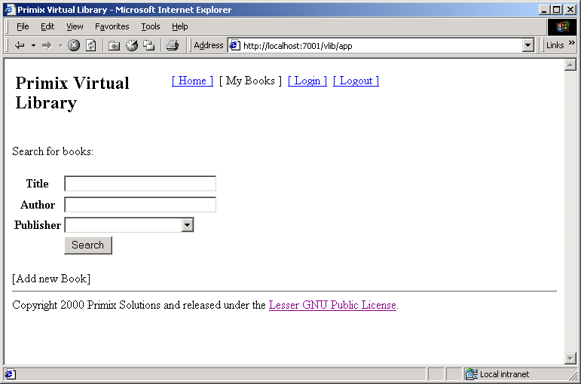
The current version of the Primix Virtual Library is simple, presentation wise. We will shortly be sprucing it up with graphics and colors.

Let's start by finding all the O'Reilly books in the database.
Select "O'Reilly" in the Publisher pulldown, then click the Search button.
You'll get a list of all the books, sorted by title.
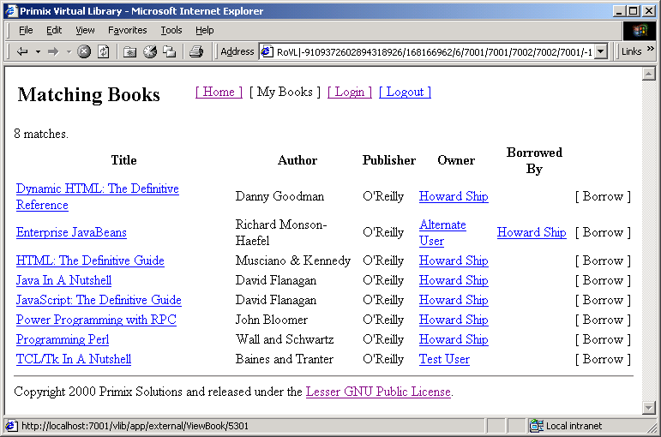
You can click on the title of a book to get more information about that book:
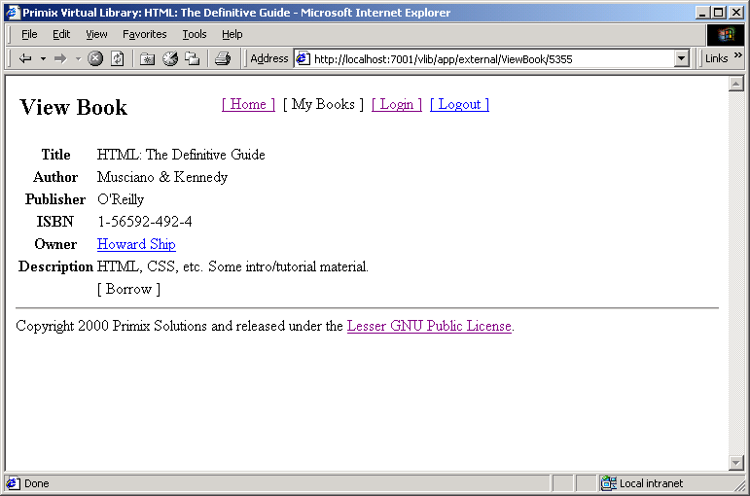
Or, you can click on the name of a person to see the books they own:
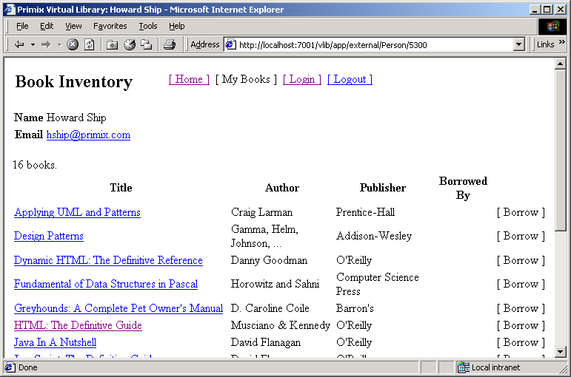
You might notice the "[ Borrow ]" that appears on several pages ... this is the borrow button, and is only enabled once you login. Use the "[ Login ]" button to log into the application.
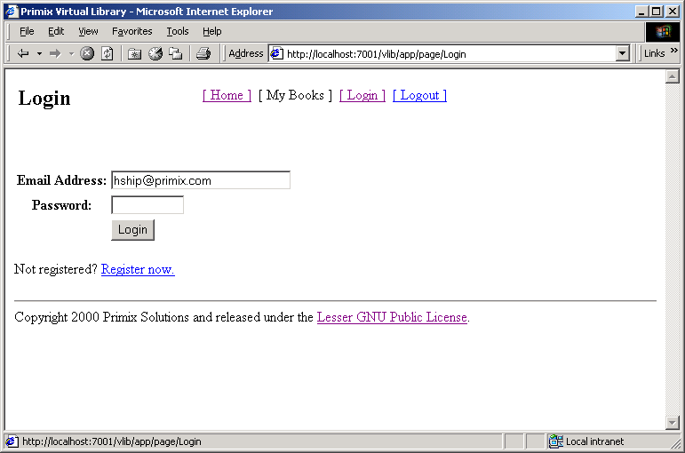
The application uses a cookie to remember your email address (which is used as a unique identity when logging in). Enter the email address "hship@primix.com" and the password "secret".
This brings you to the "My Books" page, where you can manage the books you own:
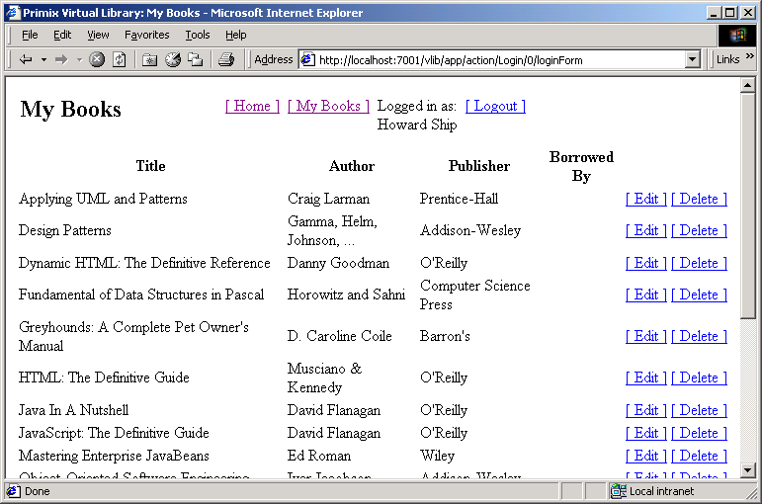
The remainder of the application, adding and editting books, is basically self-explanatory.

The JBE is part of the Tapestry project. It is a set of GNU Makefiles used to compile, build and deply Java projects.
In some application servers, it is possible to create a true client Jar, that contains only the EJB interfaces (and data objects passed as paramters or return values). This client Jar also contains the bean implementation classes, which aren't used by the client.
When WebLogic deploys a War file, it partially unpacks it, extracting all the .class files. Unfortunately, it doesn't unpack all the class resource files Tapestry needs, such as HTML templates and specification files.

