Primix Solutions
Core Labs
Primix Virtual Library
Core Labs
Primix Virtual Library
© Primix Solutions
One Arsenal Marketplace
Phone (617) 923-6639 • Fax (617) 923-5139

Tapestry contact information:

Howard Ship <hship@primix.com>
http://sourceforge.net/projects/tapestry

Table of Contents

Tapestry and J2EE 2
Setting up the Application 3
Install jBoss 3
Configure jBoss 3
Start jBoss 4
Start Jetty 8
A Tour of the Virtual Library Application 11
The Virtual Library in Detail 17

Tapestry and J2EE
Chapter
1
The Primix Virtual Library is a full-fledged demostration of Tapestry and of Tapestry interacting with Enterprise JavaBeans. It is based on an actual application developed internally at Primix; the idea being to provide an application that allows everyone at the company to share their books. A database stores information about the users of the application and the books they own and are borrowing from other users.
Users should be able to connect to the application and begin using it immediately to search for books. If they want to borrow books they must first log in (possibly, registering themselves on the fly).
The goal was to have a useful, streamlined system that could be used internally at Primix and to serve as a demonstration of the full power of Tapestry.
The application consists of two modules: VlibBeans which contains the entity and session beans for the application, and Vlib, which contains the Tapestry user interface for the application.
The Virtual Library requires an application server to host the EJBs. This demonstration works around the open-source jBoss application server, available from http://www.jboss.org/.
The Tapestry portion of the application requires a servlet container. The Tapestry distribution ships with a copy of the Jetty HTTP Servlet server, which is also open source. More information on Jetty is available at http://www.mortbay.com/. The Virtual Library is pre-configured to work with Jetty.
Finally, all development has been under Windows NT and Windows 2000. We have not yet had a chance to setup under Linux or Solaris.
Setting up the Application
Chapter
2
The Tapestry distribution includes pre-compiled copies of the Virtual Library components, as well as the source code and the tools to recompile the source.

Install jBoss
jBoss is not distributed with Tapestry (it's a 4 MB download), but is available from http://www.jboss.org or http://sourceforge.net/projects/jboss. At the time of this writing, the current version of jBoss was 2.2.1.
jBoss is exceptionally easy to setup, simply unpack the distribution (jBoss-2.2.1.zip) to a directory, do some minor configuration (see next section) and its ready to go.

Configure jBoss
Configuring jBoss is easy, as long as you've set up the JBE first. Important: You should have JDK 1.3 installed, and have the JBE configured to use it. The Virtual Library EJBs are configured such that the server and client must both be running JDK 1.3.
You must edit your config/LocalConfig.mk, adding a definition for JBOSS_DIR, which will identify the directory you installed jBoss into (typically, C:/JBoss-2.2.1).
Change to the VlibBeans directory (which should be C:\Tapestry-x.x.x\examples\VlibBeans).
Execute the command make configure-jboss:
C:\Tapestry-0.2.10\examples\VlibBeans>make configure-jboss

*** Installing Primix Vlib database ... ***

*** Splicing changes to jboss.jcml ... ***

*** Setting up JNDI properties ... ***

*** Copying runtime libraries ... ***

*** jBoss is ready to run ***

C:\Tapestry-0.2.10\examples\VlibBeans>
This executes a series of commands that sets up an example copy of the Primix Virtual Library database and changes the jBoss configuration to recognize it (it edits the jboss.jcml file). It also sets up JNDI properties and copies com.primix.tapestry.jar into the jBoss lib/ext directory.
The Primix Virtual Library database is an InstantDB database. Running make configure-jboss again will overwrite the database with a fresh copy.

Start jBoss
Next, start up jBoss with the command make run. This will build the VlibBeans.jar file, deploy it, and start up jBoss.
C:\Tapestry-0.2.10\examples\VlibBeans>make run

*** Cataloging package com.primix.vlib.ejb ... ***

*** Compiling ... ***

cd . ; \
C:/jdk1.3/bin/javac.exe -d C:/Tapestry-0.2.10/examples/VlibBeans/.build/classes -classpath
"C:/Tapestry-0.2.10/examples/VlibBeans;C:/Tapestry-0.2.10/examples/VlibBeans/.build/classes;C:/jboss/l
ib/ext/ejb.jar;C:/jboss/lib/ext/jndi.jar;C:/jboss/lib/jdbc2_0-stdext.jar;C:/Tapestry-0.2.10
/lib/Com.primix.tapestry.jar" com/primix/vlib/ejb/AbstractEntityBean.java com/primix/vlib/e
jb/Book.java com/primix/vlib/ejb/BookBean.java com/primix/vlib/ejb/BookQueryBean
.java com/primix/vlib/ejb/IBook.java com/primix/vlib/ejb/IBookHome.java com/prim
ix/vlib/ejb/IBookQuery.java com/primix/vlib/ejb/IBookQueryHome.java com/primix/v
lib/ejb/IEntityBean.java com/primix/vlib/ejb/IKeyAllocator.java com/primix/vlib/
ejb/IKeyAllocatorHome.java com/primix/vlib/ejb/IOperations.java com/primix/vlib/
ejb/IOperationsHome.java com/primix/vlib/ejb/IPerson.java com/primix/vlib/ejb/IP
ersonHome.java com/primix/vlib/ejb/IPublisher.java com/primix/vlib/ejb/IPublishe
rHome.java com/primix/vlib/ejb/KeyAllocatorBean.java com/primix/vlib/ejb/Operati
onsBean.java com/primix/vlib/ejb/Person.java com/primix/vlib/ejb/PersonBean.java
com/primix/vlib/ejb/Publisher.java com/primix/vlib/ejb/PublisherBean.java com/p
rimix/vlib/ejb/RegistrationException.java

*** Copying META-INF resources ... ***

Copying: ejb-jar.xml jaws.xml jboss.xml

*** Building VlibBeans.jar ... ***

C:/jdk1.3/bin/jar.exe cf VlibBeans.jar -C .build/classes .

*** Deploying VlibBeans.jar ... ***

*** Running jBoss ... ***

cd C:/jboss/bin ; C:/jdk1.3/bin/java.exe -jar run.jar
Using configuration "default"
[Console logging] Initialized
[Classpath extension] Initializing
[Classpath extension] Initialized
[File logging] Initializing
[File logging] Initialized
[Classpath extension] Initializing
[Classpath extension] Initialized
[Classpath extension] Initializing
[Classpath extension] Initialized
[Info] Java version: 1.3.0,Sun Microsystems Inc.
[Info] Java VM: Java HotSpot(TM) Client VM 1.3.0-C,Sun Microsystems Inc.
[Info] System: Windows 2000 5.0,x86
[Classpath extension] Initializing
[Classpath extension] Initialized
[JDBC] Loaded JDBC-driver:org.hsql.jdbcDriver
[JDBC] Loaded JDBC-driver:org.enhydra.instantdb.jdbc.idbDriver
[Webserver] Initializing
[Webserver] Initialized
[Hypersonic] Initializing
[Hypersonic] Initialized
[Naming] Initializing
[Naming] Naming started on port 1099
[Naming] Initialized
[Transaction manager] Initializing
[Transaction manager] Initialized
[JAAS Security Manager] Initializing
[JAAS Security Manager] Initialized
[Simple Realm Mapping] Initializing
[Simple Realm Mapping] Initialized
[Security manager] Initializing
[Security manager] Initialized
[InstantDB] Initializing
[InstantDB] Initialized
[DefaultDS] Initializing
[DefaultDS] Initialized
[Container factory] Initializing
[Container factory] Initialized
[Auto deploy] Watching C:\jboss\deploy
[Auto deploy] Initializing
[Auto deploy] Initialized
[JMX RMI Adaptor] Initializing
[JMX RMI Adaptor] Initialized
[JMX RMI Connector] Initializing
[JMX RMI Connector] Initialized
[Configuration] Initializing
[Configuration] Initialized
[J2EE Deployer] Initializing
[J2EE Deployer] Initialized
[SpyderMQ] Initializing
[SpyderMQ] Initialized
[PrimixVlib] Initializing
[PrimixVlib] Initialized
[Simple Realm Mapping] Starting
[Simple Realm Mapping] Started
[Webserver] Starting
[Webserver] Codebase set to http://hship_2:8083/
[Webserver] Started webserver on port 8083
[Webserver] Started
[Transaction manager] Starting
[Transaction manager] Started
[Naming] Starting
[Naming] Started
[Hypersonic] Starting
[Hypersonic] Server 1.4 is running
[Hypersonic] Press [Ctrl]+[C] to abort
[Hypersonic] Database started
[Hypersonic] Started
[InstantDB] Starting
[InstantDB] XA Connection pool InstantDB bound to java:/InstantDB
Enhydra InstantDB - Version 3.21
[InstantDB] The Initial Developer of the Original Code is Lutris Technologies In
c.
Portions created by Lutris are Copyright (C) 1997-2000 Lutris Technologies, Inc.

All Rights Reserved.
[InstantDB] Started
[PrimixVlib] Starting
[PrimixVlib] XA Connection pool PrimixVlib bound to java:/PrimixVlib
[PrimixVlib] Started
[DefaultDS] Starting
[DefaultDS] XA Connection pool DefaultDS bound to java:/DefaultDS
[DefaultDS] Started
[JAAS Security Manager] Starting
[JAAS Security Manager] Started
[Container factory] Starting
[Container factory] Started
[J2EE Deployer] Starting
[J2EE Deployer] No web container found - only EJB deployment available...
[J2EE Deployer] Cleaning up deployment directory file:/C:/jboss/bin/../tmp/deplo
y/
[J2EE Deployer] Started
[Security manager] Starting
[Security manager] Started
[Auto deploy] Starting
[Auto deploy] Auto deploy of file:/C:/jboss/deploy/VlibBeans.jar
[J2EE Deployer] Deploy J2EE application: file:/C:/jboss/deploy/VlibBeans.jar
[J2EE Deployer] Could not delete temporary file: /C:/jboss/bin/../tmp/deploy/cop
y1001.zip
[J2EE Deployer] Create application VlibBeans.jar
[J2EE Deployer] Installing EJB package: VlibBeans.jar
[J2EE Deployer] Starting module VlibBeans.jar
[Container factory] Deploying:file:/C:/jboss/bin/../tmp/deploy/VlibBeans.jar/ejb
1002.jar
[Verifier] Verifying file:/C:/jboss/bin/../tmp/deploy/VlibBeans.jar/ejb1002.jar
[Container factory] Deploying Person
[Container factory] Deploying Book
[Container factory] Deploying Publisher
[Container factory] Deploying KeyAllocator
[Container factory] Deploying BookQuery
[Container factory] Deploying Operations
[JAWS] Table 'BOOK' already exists
[JAWS] Table 'PERSON' already exists
[JAWS] Table 'PUBLISHER' already exists
[Container factory] Deployed application: file:/C:/jboss/bin/../tmp/deploy/VlibB
eans.jar/ejb1002.jar
[J2EE Deployer] J2EE application: file:/C:/jboss/deploy/VlibBeans.jar is deploye
d.
[Auto deploy] Started
[SpyderMQ] Starting
[SpyderMQ] Testing if SpyderMQ is present....
[SpyderMQ] OK
[SpyderMQ] Starting SpyderMQ...
[SpyderMQ] Started
[JMX RMI Adaptor] Starting
[JMX RMI Adaptor] Started
[JMX RMI Connector] Starting
[JMX RMI Connector] Started
[Default] 23 services and 4 other MBeans started.
[Default] Shutdown hook added
[Default] jBoss 2.0 FINAL Started.
The EJB portion of the application, including the database, is now ready to go. The database has about twenty books owned by three different users:
Name | E-Mail | Password
Dilber CubeDweller | dilbert@bigco.com | secret
Howard Ship | hship@primix.com | secret
Suzy Queue | squeue@bug.org | secret

Start Jetty
The presentation layer of the application is the Vlib module, in C:\Tapestry-x.x.x\Examples\Vlib.
Go to that directory and execute make run. The JBE will build the Vlib.war file, and start Jetty up to service it.
C:\Tapestry-0.2.8\Examples\Vlib>make run

*** Cataloging package com.primix.servlet ... ***

*** Cataloging package com.primix.vlib ... ***

*** Cataloging package com.primix.vlib.pages ... ***

*** Cataloging package com.primix.vlib.components ... ***

*** Cataloging package com.primix.vlib.jsp ... ***

*** Compiling ... ***

cd . ; \
C:/jdk1.3/bin/javac.exe -d C:/Tapestry-0.2.10/examples/Vlib/.build/wapp/WEB-INF/classes -cl
asspath "C:/Tapestry-0.2.10/examples/Vlib;C:/Tapestry-0.2.10/examples/Vlib/.build/wapp/WEB-INF/classes
;C:/jboss/lib/ext/ejb.jar;C:/jboss/lib/ext/jndi.jar;C:/Tapestry-0.2.10/lib/javax.servlet.ja
r;C:/Tapestry-0.2.10/lib/Com.primix.tapestry.jar;C:/Tapestry-0.2.10/lib/VlibBeans.jar" com/primix/servlet/Gateway
Servlet.java com/primix/servlet/HTMLUtils.java com/primix/servlet/HTMLWriter.jav
a com/primix/servlet/IService.java com/primix/servlet/RequestContext.java com/pr
imix/vlib/EntitySelectionModel.java com/primix/vlib/IExternalPage.java com/primi
x/vlib/Protected.java com/primix/vlib/VirtualLibraryApplication.java com/primix/
vlib/VirtualLibraryServlet.java com/primix/vlib/pages/ConfirmBookDelete.java com
/primix/vlib/pages/EditBook.java com/primix/vlib/pages/EditProfile.java com/prim
ix/vlib/pages/Home.java com/primix/vlib/pages/Login.java com/primix/vlib/pages/L
ogout.java com/primix/vlib/pages/Matches.java com/primix/vlib/pages/MyBooks.java
com/primix/vlib/pages/NewBook.java com/primix/vlib/pages/PersonPage.java com/pr
imix/vlib/pages/Register.java com/primix/vlib/pages/ViewBook.java com/primix/vli
b/components/BookLink.java com/primix/vlib/components/Border.java com/primix/vli
b/components/PersonLink.java com/primix/vlib/jsp/BookDelegate.java com/primix/vl
ib/jsp/BookQueryDelegate.java com/primix/vlib/jsp/BookServlet.java com/primix/vl
ib/jsp/HomeDelegate.java com/primix/vlib/jsp/HomeServlet.java com/primix/vlib/js
p/ILoginCallback.java com/primix/vlib/jsp/LoginDelegate.java com/primix/vlib/jsp
/LoginServlet.java com/primix/vlib/jsp/MyBooksDelegate.java com/primix/vlib/jsp/
MyBooksServlet.java com/primix/vlib/jsp/PersonDelegate.java com/primix/vlib/jsp/
PersonServlet.java com/primix/vlib/jsp/VirtualLibraryApplication.java com/primix
/vlib/jsp/VlibDelegate.java com/primix/vlib/jsp/VlibServlet.java

*** Copying WEB-INF resources ... ***

Copying: web.xml

*** Copying package resources ...***

Copying: Vlib.application ConfirmBookDelete.html EditBook.html EditProfile.html
Home.html Login.html Logout.html Matches.html MyBooks.html NewBook.html PersonPa
ge.html Register.html ViewBook.html ConfirmBookDelete.jwc EditBook.jwc EditProfi
le.jwc Home.jwc Login.jwc Logout.jwc Matches.jwc MyBooks.jwc NewBook.jwc PersonP
age.jwc Register.jwc ViewBook.jwc BookLink.html Border.html PersonLink.html Book
Link.jwc Border.jwc PersonLink.jwc

*** Copying context resources ... ***

Copying: index.html Book.jsp Border-trailer.jsp Border.jsp Error.jsp Home.jsp Lo
gin.jsp Matches.jsp MyBooks.jsp Person.jsp

*** Building Vlib.war ... ***

C:/jdk1.3/bin/jar.exe cf Vlib.war -C .build/wapp .
C:/jdk1.3/bin/java.exe -classpath "C:/jboss/lib/ext/ejb.jar;C:/jboss/lib/ext/jnd
i.jar;C:/Tapestry-0.2.10/lib/javax.servlet.jar;C:/Tapestry-0.2.10/lib/Com.primix.tapestry.jar;C:/Tapestry-0.2.10/lib/VlibBea
ns.jar;C:/Tapestry-0.2.10/lib/xerces.jar;C:/Tapestry-0.2.10/lib/gnu-regexp.jar;C:/Tapestry-0.2.10/lib/com.mortbay
.jetty.jar;C:/jboss/conf/default;C:/jboss/client/jboss-client.jar" \
-Dcom.primix.tapestry.enable-reset-service=true \
-Dorg.xml.sax.parser=org.apache.xerces.parsers.SAXParser \
com.mortbay.Jetty.Server jetty.xml
20001120150650884GMT EVENT [main]com.mortbay.HTTP.HttpServer.addWebApplicatio
n(HttpServer.java:491)
.
.
.

Chapter
3
A Tour of the Virtual Library Application
You can start the Vlib application with the URL:
http://localhost:8080/vlib/app

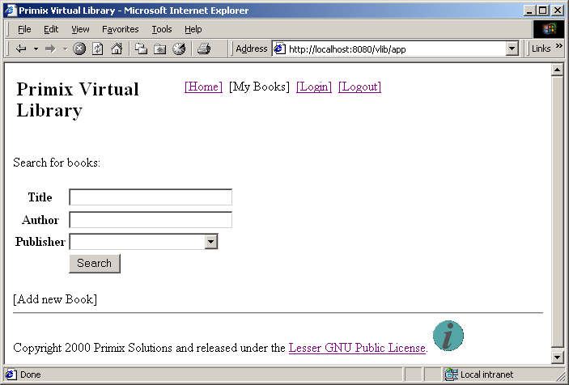
Page Home
The current version of the Primix Virtual Library is simple, presentation wise. We will shortly be sprucing it up with graphics and colors.
Across the top are several navigation options. The Home link returns the user to this search page. The My Books links is activated once a user logs in; it shows the list of books owned by the user. The Login link allows a user to log into the system, or register on the fly. The logout allows the user to exit the system.
Let's start by finding all the O'Reilly books in the database.
Select "O'Reilly" in the Publisher pulldown, then click the Search button.
You'll get a list of all the books, sorted by title.
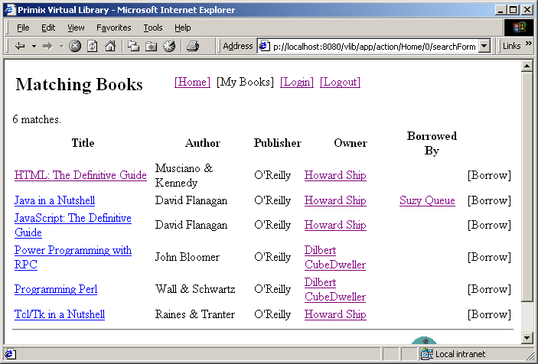
Page Matches
You can click on the title of a book to get more information about that book:
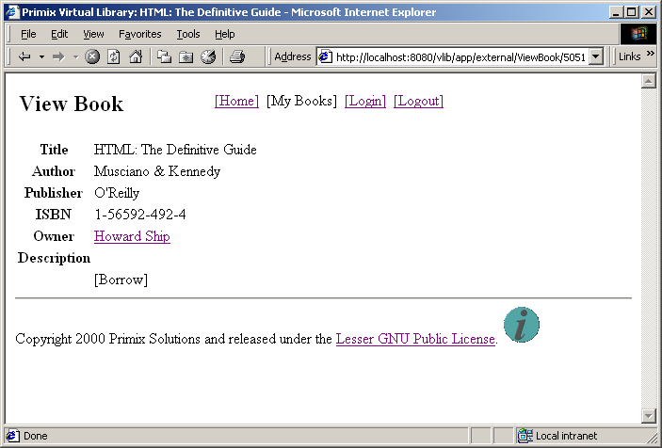
Page ViewBook
Or, you can click on the name of a person to see the books they own:
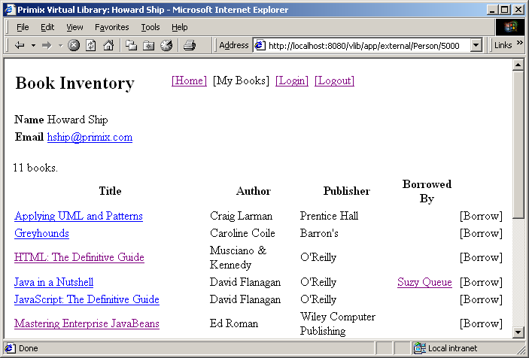
Page Person
You might notice the text "[ Borrow ]" that appears on several pages ... this is the borrow button, and is only enabled once you login. Use the "[ Login ]" button to log into the application.
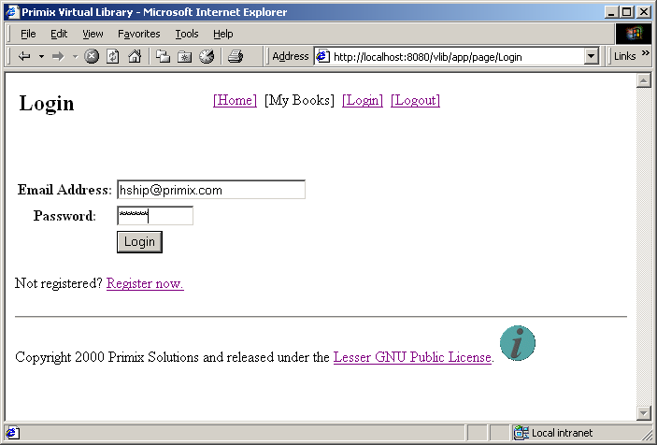
Page Login
The application uses a cookie to remember your email address (which is used as a unique identity when logging in). Enter the email address "hship@primix.com" and the password "secret".
This brings you to the "My Books" page, where you can manage the books you own. It has two sections; the upper section shows the book you own, allowing you to edit or delete them.
The second section shows the books you currently have borrowed, with an option to return each book.
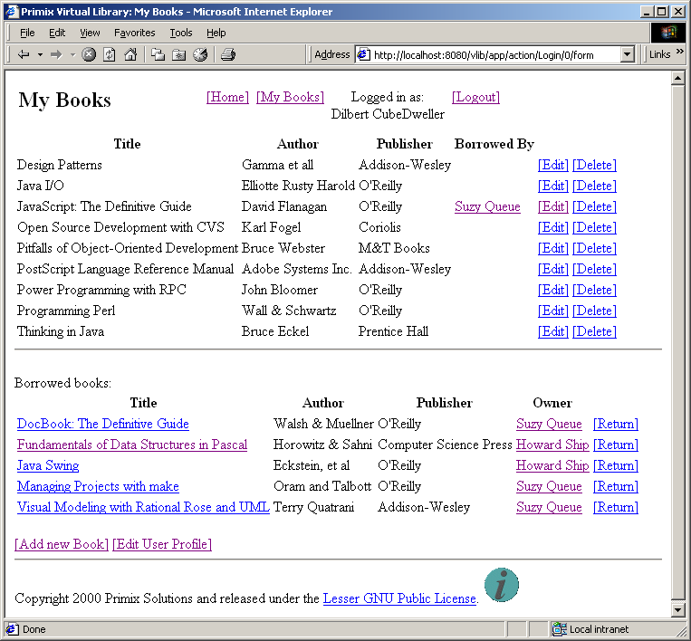
Page MyBooks
The remainder of the application, adding and editting books, is basically self-explanatory.
The Virtual Library in Detail
Chapter
4
The Virtual Library consists of twelve pages, as shown in the web diagram:

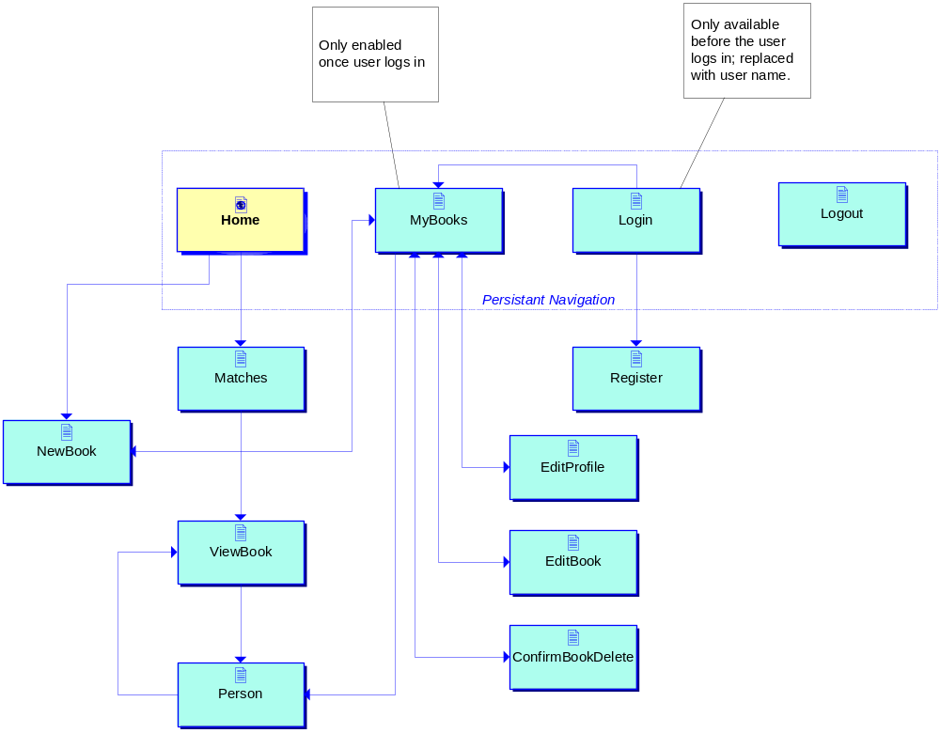
We've already seen several of these pages (Home, Login, MyBooks, Matches, ViewBook and Person).
User's are allowed to register on the fly with the Vlib, by clicking the "register now" link on the Login page.
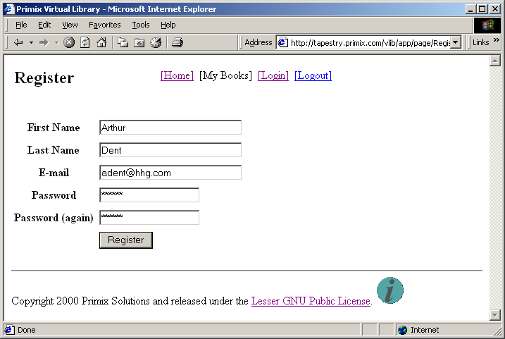
Page Register
The names and e-mail are validated to not be duplicates. A future enhancement to the system will be a more involved system, where the user is sent e-mail with a registration code to unlock access to the Virtual Library.
Once logged in, a user my add a new book (using the button on the Home page, or on the MyBooks page):
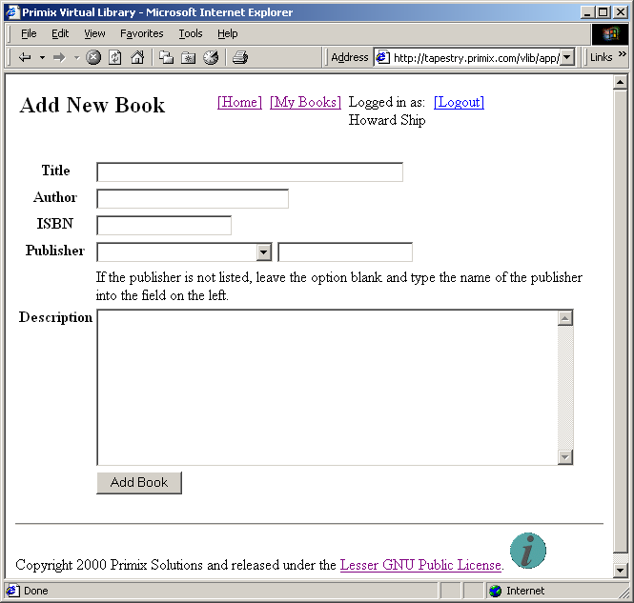
Page NewBook
A logged-in user may also edit their books. This may be to fill in additional data such as the ISBN, to add notes to the description, or to change the holder of the book (after taking the book back from a borrower).
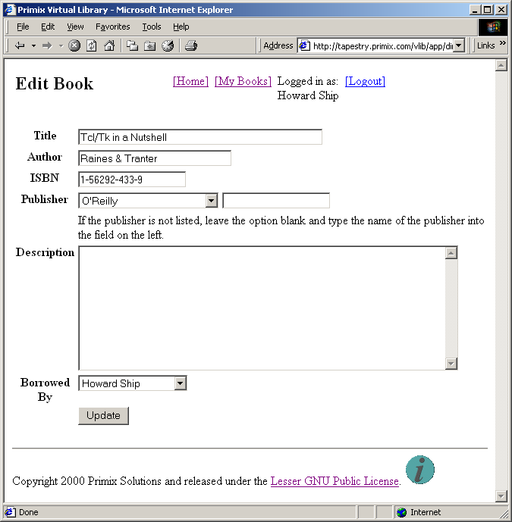
Page EditBook
As user may also edit their profile (including name, email and password) from the MyBooks page.

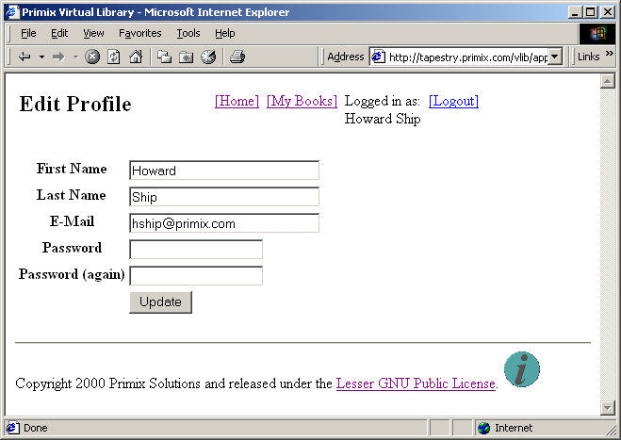
Page EditProfile
Users may also delete books they no longer have (or perhaps, no longer wish to share). This is accomplished by clicking the "[Delete]" button for a book (on the MyBooks page).
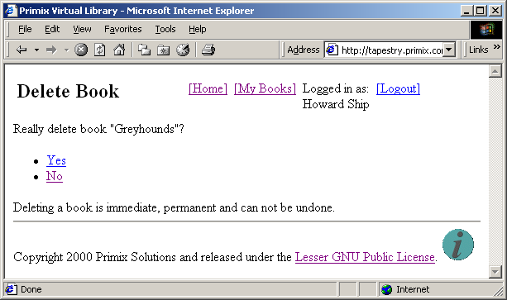
Page ConfirmBookDelete
Finally, a user who is no longer using the system (whether logged in or not), may log out.
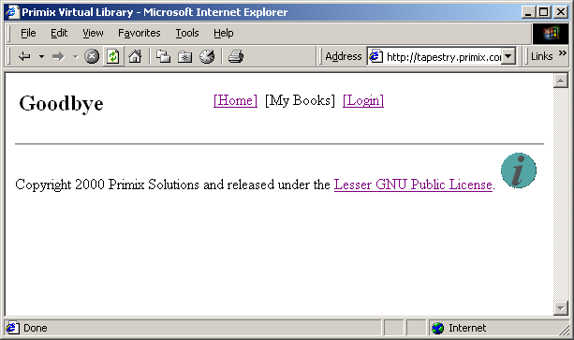
Page Logout

