Primix Solutions
Core Labs
Java Build Environment
Core Labs
Java Build Environment
© Primix Solutions
One Arsenal Marketplace
Phone (617) 923-6639 • Fax (617) 923-5139

Tapestry contact information:

Howard Ship <hship@primix.com>

http://sourceforge.net/projects/tapestry

Table of Contents

Introduction 2
Installation and Configuration 4
Installing Cygwin 4
Environment Variables 9
Configuration 9
Using JBE 11
Jar modules 13
Package Makefiles 15
War modules 15
WebLogic modules 17
jBoss modules 18
Additonal Variables 19
Future development of the JBE 21

Introduction
Chapter
1
As envisioned but most tool makers, the life of a Java developer is a solitary one. Parked at his or her desk, with only his trusty tools, IDEs and the command line, the developer creates the wonderful applets, applications and frameworks possible using Java.
The developer has and requires great freedom; each tool in his or her arsenal may have come from a different company; each tool may have been installed into a directory of his or her liking. This is not a problem because the developer is only accountable to him- or her-self, and these selections of tools and locations will only aftect one person.
Alas, in the real world, developers work on teams and share code using source code repositories. They may be physically located across the hallway, or across the planet. As they work, they may make conflicting changes to code.
In addition, it is good to have precise control over which JDK is used to compile and execute modules. The JBE uses a simple system to allow developers to control exactly which JDK vendor and release is used.
What's needed is a system that can adjust for local differences in developer's environments and allow for "clean builds" of modules directly from source. That's what the Java Build Environment (JBE) is for.
JBE is designed to start with basic Java source and utlimately produce a Java Archive (JAR) or Web Archive (WAR) ready for testing or deployment. This may involve many steps, including compiling Java code, creating RMI stubs and skeletons, using application-server specific tools (such as WebLogic ejbc), combining the results into a JAR file ... even creating Javadoc.
Without JBE, there are three options for doing all this:
- The command line. Developers may simply execute the java and jar commands themselves. This leads to problems when steps are missed, or the commands are in some way dependent on a single developer's environment (for example, the setting of the CLASSPATH variable).
- Batch commands / shell scripts. Hard to develop and debug and non-portable between platforms. Often assembled in a hurry that leads to the same kind of environment problems as using the command line.
- IDE. Some IDEs can assemble JARs, or even interface to an application server to build and deploy EJBs and WARs; however, this will require that the user interactively use the IDE's tools. Also, these tools are idiosyncratic; getting them to package up the correct Java classes and resources is often challenging.
JBE includes many hooks to allow custom directories, compiliation options or other configuration to be specified. Other hooks allow for additional processing, such as signing a JAR.
JBE is designed to be portable, meaning the same source files and Makefiles will work across multiple developer's workstations ... even when using different operating systems (such as Windows, Linux and Solaris).
Because the JBE is based on GNU Make it is extermely adaptable and extensible. JBE Makefiles can do more than simply compile Java files, they can also run tests, launch applications, prepare distributions … virtually any operation that can be done using shell scripts or command macros, though Makefile syntax is cleaner, easier and platform independent.
JBE is most useful with medium to large scale Java projects. It has no support for compiling anything but Java; projects which use native code are beyond its scope.

Installation and Configuration
Chapter
2
JBE is distributed as a part of the Tapestry distribution, in the JBE directory.
Under Windows, it is necessary to perform a separate installation to provide the necessary GNU tools, including GNU Make. JBE was developed under Windows (Windows NT 4.0 Workstation and Windows 2000 Professional), and makes use of the Cygwin tools library.
Future plans include porting it to Solaris (in such a way that Makefiles are automatically portable between the two environments); this will support coding under Windows and deployment on Solaris (including compiling on Solaris).
Because my direct experience is to suffer the indignities of Windows development, the examples in this document use Windows pathnames. Developers using Linux or Solaris should be able to translate to their sensibly named file systems.
On any operating system it is necessary to have a JDK installed. JBE was developed using Sun's JDK 1.2.2 and JDK 1.3. The JDK used by the JBE is configurable (details are below).

Installing Cygwin
Cygwin is a set of GNU tools ported so as to run in the Windows NT or Windows 2000 environments (it may also work under Windows 95/98/ME).
Cygwin is available at http://sources.redhat.com/cygwin/.
Installing Cygwin is very easy; Cygwin starts by downloading a small installer called setup.exe. Running this program allows the user to install any of the many individual packages in Cygwin individually. You should download this program from the Cygnus web site to a safe directory (you use the same program later to update your installation with newer versions of the packages).
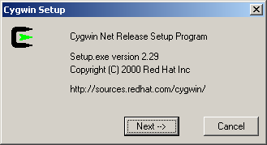
Click the Next button to continue. On this screen, select "Install from Internet". This will cause the installer to download the files and then install them on your workstation.
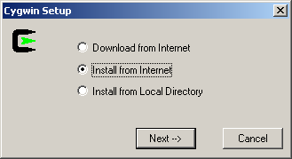
Click Next and select a directory to store the downloaded files.
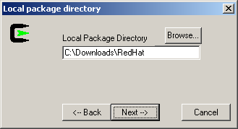
Click Next and choose where to install Cygwin:
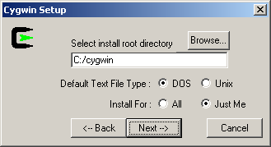
Click Next and tell the installer how to access the files over the Internet:
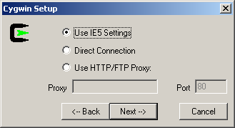
Click Next and select a site to download from:
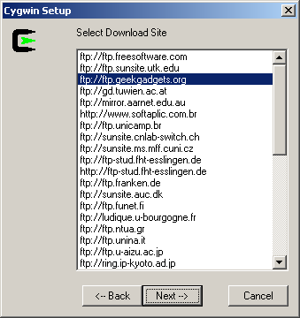
Where you choose is a matter of hunting around for a good connection; you'll do best with a site that is near you.
The installer will download a list of packages that can be installed. If you have a fast connection and about 125MB of disk space, let it install the latest versions of every package.
If you want to be choosy, you can select just which packages to install. Clicking the release number (the text to the right of the double arrows symbol) will cycle through available options, one of which is "Skip".
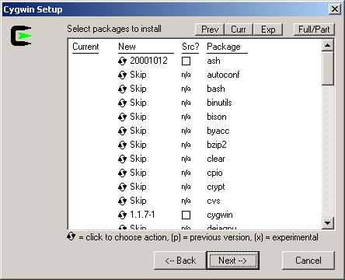
]The JBE requires the following packages:
- ash
- cygwin
- fileutils
- findutils
- gzip
- make
- shellutils
- tar
- textutils
These downloads total approxmately 3 MB. In addition, you may want to install the following additional packages:
- groff
- grep
- less
- man
The optional packages add another 2 MB of downloads.
After making your selections and clicking Next, the installer will download the necessary package files and install them. This may take a few minutes, depending on the speed of your Internet connection. The installer will display its progress as it works, then display the last panel:
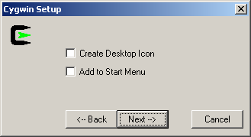
Simply click Next to exit the installer.

Environment Variables
The JBE is packaged with Tapestry; if you are reading this document, then you have probably already unpacked the Tapestry distribtution. The JBE is stored in the JBE subdirectory of the distribution.
It is necessary to create an environment variable, SYS_MAKEFILE_DIR, that points to the directory. Use forward slashes as the path seperator, even under Windows. A typical value for this is "C:/Tapestry-x.x.x/JBE" (depending on which release of Tapestry you downloaded, and where you installed it).

Configuration
Configuration is accomplished by creating additional files used by GNU Make at runtime.
Under the JBE directory will be a config directory. Create a new file, SiteConfig.mk, in the directory. This file is used to specify the platform for the local workstation.
Example:
config/SiteConfig.mk
# Defines the local platform.

SITE_PLATFORM := Cygwin

Platforms correspond to the Platform.name.mk file in the main JBE directory.
This file may also be used to store addtiional, site-wide options (typically, variables that start with the prefix SITE_). Such options will apply to all modules built on the local workstation.
In a multiple-developer environment, all developers on the same platform will use identical copies of the SiteConfig.mk file.
A second configuration file, LocalConfig.mk, is used to establish the directories into which related tools have been installed. For example:
config/LocalConfig.mk
TOOLS_DIR := C:/cygwin/bin

JDK_Sun_1.2.2_DIR := C:/jdk1.2.2
JDK_Sun_1.3_DIR := C:/jdk1.3

WEBLOGIC_DIR := C:/WebLogic
The first variable, TOOLS_DIR, is the directory for the GNU tools. Since this example is for Windows 2000 using Cygwin, the tools directory is the Cygwin bin directory.
The next two variables define the locations of two JDKs installed on the local workstation. The JBE considers a JDK to be a combination of a vendor and a release. You must create a variable JDK_Vendor_Release_DIR for each combination.
Unless overriden in some way, the default JDK is Sun 1.3.
LocalConfig.mk is also a useful place to specify other global variables. In this example, the variable WEBLOGIC_DIR is specified, to identify where the WebLogic application server was installed ... this is only needed you will be creating EJB deployments for Weblogic.

Using JBE
Chapter
3
JBE performs builds on modules. For JBE, a module is a directory which contains a number of Java packages. The source code in all the packages will be compiled and eventually combined into a single JAR file.
JBE requires a master Makefile in the module directory, whose job is to set global options for the entire module, and to identify the list of Java packages. Each package may also have a Makefile, which is used to identify the Java source files, resource files and RMI classes for that package.
The standard directory hierarchy for a module has the module directory as the root of the Java package tree for the module:
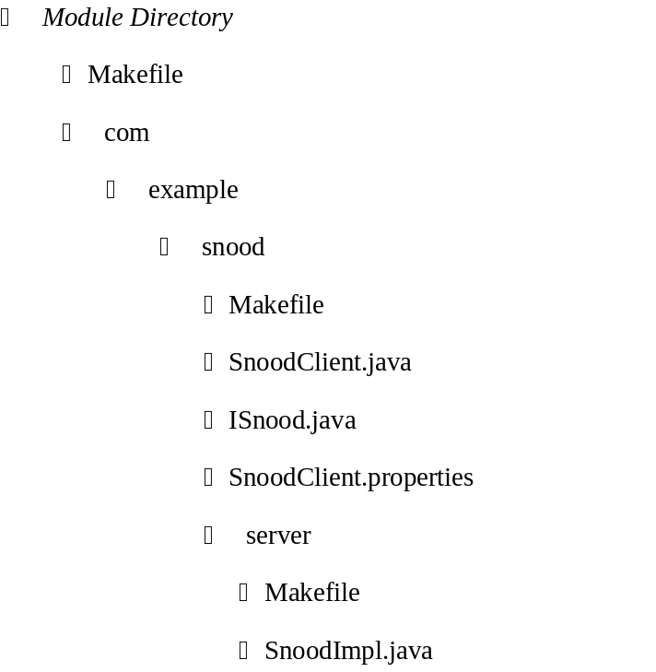
This lays out a module with two package directories. The first, com.example.snood contains the class SnoodClient.java, the interface ISnood.java and a resource file: SnoodClient.properties. The second package, com.example.snood.server contains the class SnoodImpl.java..
A module makefile must provide a name for the module (which is used to name the JAR or WAR file) and a list of packages. It may provide additional options used when compiling, generating Javadoc or installing the JAR.
The module directory doesn't have to be the source code root, by setting the SOURCE_DIR variable, the source code root directory can be moved to another directory. Many developers prefer to put the Java source code in a directory named "src". In other situations, the Java source code may be in a sibling directory to the module directory.
In our example, the module directory is also the root source code directory, so the Makefile is very simple:
Makefile
MODULE_NAME = Snood

PACKAGES = \
com.example.snood \
com.example.snood.server

include $(SYS_MAKEFILE_DIR)/Jar.mk
The last line identifies this module as a Jar module; one that builds a JAR file.
The other two Makefiles identify the Java source files in the package, any resource files that should be copied into the JAR, and any classes that must be compiled with the RMI compiler.
com/example/snood/Makefile
JAVA_FILES = *.java

RESOURCE_FILES = *.properties

include $(SYS_MAKEFILE_DIR)/Package.mk

com/example/snood/server/Makefile
JAVA_FILES = *.java

RMI_CLASSES = SnoodImpl

include $(SYS_MAKEFILE_DIR)/Package.mk
Building this module executes a sequence of commands:
make

*** Cataloging package com.example.snood ... ***

*** Cataloging package com.example.snood.server ... ***

*** Compiling ... ***

C:/jdk1.3/bin/javac.exe -d .build/classes -classpath "D:/Temp/Snood;D:/Temp/Snood/.build/classes" com/example/snood/ISnood.java com/example/snood/SnoodClient.java com/example/snood/server/SnoodImpl.java

*** Compiling RMI stubs and skeletons ... ***

C:/jdk1.3/bin/rmic.exe -d .build/classes -classpath "D:/Temp/Snood;D:/Temp/Snood/.build/classes" \
com.example.snood.server.SnoodImpl

*** Copying package resources ...***

Copying: SnoodClient.properties

*** Building Snood.jar ... ***

C:/jdk1.3/bin/jar.exe cf Snood.jar -C .build/classes .
When a module is first built, JBE catalogs the Java source files, resource files and RMI classes in the packages (this information is kept for subsequent makes). It then uses this information to perform all the remaining work from the module directory.
Here it compiled all the Java files in one pass, built the RMI stubs and skeletons, then copied resource files, and created the final JAR file. On a subsequent build, only files which had changed since the previous build would be recompiled or re-copied.
You can also see that full pathnames are used to access the various GNU and JDK tools. This ensures that the correct JDK is used. It also means the tools are available, even if the user hasn't added the JDK\bin dir to the system PATH.
JBE creates a .build directory in the module directory and directs compilation to this directory as well as copying resource files into it. It just becomes a matter of using the JDK jar tool to create a JAR from the directory. WARs are generated the same way (but with a different structure).

Jar modules
The most basic type of JBE module is the Jar module, which builds a JAR file that can be used as a framework or standalone application. The JAR file is created in the module directory (though it can be removed by make clean).
A Jar module Makefile should define the following values:
Variable | Description
INSTALL_DIR | The directory to which the final JAR should be copied after it is built.
JAVADOC_DIR | The directory to which Javadoc should be written.
JDK_RELEASE | Optional: The release of the JDK to use when compiling.
JDK_VENDOR | Optional: The vendor to use when compiling.
LOCAL_CLASSPATH | A space seperated list of the classpath entries (typically, other JAR files) used when compiling. Absolute or relative pathnames may be used. Use the forward slash as the path seperator (even on Windows).
META_RESOURCES | The names of any resources that should be copied from the module directory into the JAR's META-INF directory. This is optional.
MODULE_NAME | The name used when building the JAR.
PACKAGES | The names of all packages in the module.
SOURCE_DIR | Optional: An alternate directory to serve as the root directory for Java source and Java class resources. If not specified the module directory is treated as the source directory.
A Jar module has a number of standard Make targets:
Target | Description
catalog | Rebuild the catalog of Java files, resource files and RMI classes. Used after adding or removing such files from a package.
clean | Remove JAR and the .build directory.
compile | Compile changed Java source files, then compile any changed RMI classes.
default | Alias for compile.
force | Compile all, not just dirty, then compile all RMI classes
install | jar; then copy JAR to INSTALL_DIR
jar | compile; then copy resources and build JAR
javadoc | Generate Javadoc for the contents of the JAR

Package Makefiles
Package Makefiles are very simple. They are only used when cataloging; they simply declare what types of files are in the package.
The form of a Package makefile is very simple:
JAVA_FILES = list of files

RESOURCE_FILES = list of files

RMI_CLASSES = list of class names

include $(SYS_MAKEFILE_DIR)/Package.mk
As shown in the prior examples, the JAVA_FILES and RESOURCE_FILES may use wild cards (such as "*.java" or "*.properties").
The RMI_CLASSES is simply a list of the class names of RMI implementation classes; just the simple name of the class (no extension, and no package name; the package is known from context).
Package makefiles are optional, if not provided a default makefile is used. The default makefile assumes all files ending in the following extensions are resource files:
- jwc (Tapestry Component Specifications)
- application (Tapestry Application Specifications)
- html (Tapestry HTML templates)
- properties (Java properties files)
- script (Tapestry script files)

War modules
A War module is similar to a Jar module, except that the final file has the extension ".war" instead of ".jar" and the internal layout is different. A Web Application Archive (WAR) is a file that can be deployed into a J2EE compatible application server; it contains servlets and other Java code as well as context resources (images and other assets that are visible to the web server).
In a WAR, classes are stored in the directory WEB-INF/classes, rather than at the root. Context resources go in the root of the WAR (these are images and other files that are accessible by the client web browser). There will deployment descriptor files that must also be copied from the module directory into the WEB-INF directory as well, and a WAR can include libraries of code in its WEB-INF/lib directory.
Variable | Description
CONTEXT_RESOURCES | The names of individual files or directories that should be copied from the module directory into the root of the WAR. Relative pathnames will be maintained when copied. Directories are copied recusively (but directories named 'CVS' are pruned).
INSTALL_DIR | The directory to which the final WAR should be copied after it is built.
INSTALL_LIBRARIES | A space seperated list of libraries that should be installed into the WEB-INF/lib directory. The entries here should be a subset of LOCAL_CLASSPATH.
JAVADOC_DIR | The directory to which Javadoc should be written.
JDK_RELEASE | Optional: The release of the JDK to use when compiling.
JDK_VENDOR | Optional: The vendor to use when compiling.
LOCAL_CLASSPATH | A space seperated list of the classpath entries (typically, other JAR files) used when compiling. Absolute or relative pathnames may be used. Use the forward slash as the path seperator (even on Windows).
META_RESOURCES | The names of any resources that should be copied into the WAR's META-INF directory.
MODULE_NAME | The name used when building the WAR.
PACKAGES | The names of all packages in the module.
SOURCE_DIR | An alternate directory to serve as the root directory for Java source and Java class resources.
WEB_INF_RESOURCES | The names of files that should be copied into the WEB-INF directory. This should include the application-server specific deployment descriptor. The J2EE deployment descriptor, web.xml, is automatically copied.
War modules have similar targets as Jar modules:
Target | Description
catalog | Rebuild the catalog of Java files, resource files and RMI classes. Used after adding or removing such files from a package.
clean | Remove WAR, .build directory (in module and in each package)
compile | Compile changed Java source files, then compile any changed RMI classes.
default | Alias for compile
force | Compile all, not just dirty, then compile all RMI classes
install | war; then copy WAR to INSTALL_DIR
javadoc | Generate Javadoc for the contents of the WAR
war | compile; then copy resources and build WAR

WebLogic modules
The WebLogic module type is a specialization of the Jar type used to create deployable EJB JARS for use with the WebLogic application server version 5.1. To use it, the WEBLOGIC_DIR variable must be set, usually in LocalConfig.mk.
Unless overriden, WebLogic modules are always compiled using Sun's JDK 1.2.2.
The libraries WEBLOGIC_DIR/classes and WEBLOGIC_DIR/lib/weblogicaux.jar are automatically added to the classpath. These add WebLogic's implementations of the J2EE frameworks (JNDI, EJB, etc.).
For the most part, WebLogic modules work the same as Jar modules. However, the jar rule is changed to not only build the normal JAR, but also build the depoyable JAR. It does this by running the WebLogic ejbc command, which provides all the WebLogic specific classes needed to deploy (such as stubs and skeletons for EJBs, and a variety of files to support container managed persistence).
The deployable JAR is called MODULE_NAME-deploy.jar. The install rule copies both JARs to the install directory.
JAR files in the LOCAL_CLASSPATH are treated as dependencies of the deployable JAR. If they change, then the deployable JAR is rebuilt (using ejbc).
The WebLogic module automatically adds the files ejb-jar.xml (the generic EJB deployment descriptor) and weblogic-ejb-jar.xml (the WebLogic specific EJB deployment descriptor) to the list of META_RESOURCES (files copied to the META-INF directory of the JAR).

jBoss modules
jBoss is an open-source J2EE application server available from http://www.ejboss.org/.
The jBoss module type is a specialization of the Jar type used to create EJB JARS for use with the jBoss. jBoss is easier to work with than WebLogic, since it doesn't require the creation of stubs and skeletons, and deployment is as simple as copying the JAR file to a predetermined directory.
To use it, the JBOSS_DIR variable must be set, usually in LocalConfig.mk.
The following libraries are automatically included in the classpath:
- JBOSS_DIR/lib/ext/ejb.jar
- JBOSS_DIR/lib/ext/jndi.jar
- JBOSS_DIR/lib/jdbc2_0-stdext.jar
These three libraries provide the basic J2EE functionality. ejb.jar provices the javax.ejb classes, jndi.jar provides the javax.naming classes and jbdc2_0-stdext.jar provides the javax.sql classes.
For the most part, jBoss modules work the same as Jar modules.
The jBoss module automatically adds the file ejb-jar.xml (the generic EJB deployment descriptor) to the list of META_RESOURCES (files copied to the META-INF directory of the JAR). If you use the auxilliary descriptor files (jboss.xml and/or jaws.xml) you'll need to manually add those to META_RESOURCES.
A jBoss module has a number of standard make targets. Most of these are the same as the Jar module, with the exception of the deploy target.
Target | Description
catalog | Rebuild the catalog of Java files, resource files and RMI classes. Used after adding or removing such files from a package.
clean | Remove JAR and the .build directory.
compile | Compile changed Java source files, then compile any changed RMI classes.
default | Alias for compile.
deploy | jar, then copy the JAR file to the JBOSS_DIR/deploy directory to be hot deployed into the running jBoss server.
force | Compile all, not just dirty, then compile all RMI classes
install | jar; then copy JAR to INSTALL_DIR
jar | compile; then copy resources and build JAR
javadoc | Generate Javadoc for the contents of the JAR
run | deploy, then runs the jBoss server
run-ejx | Run's the jBoss EJX tool (a GUI used to edit deployment descriptors)

Additonal Variables
The behavior of the JBE is controlled by makefile variables. The prior sections identified the minimum variables needed for the different types of modules, this section provides information on variables that are useful in all modules. Typically these supply additional options to existing commands and rules.
Variable | Declared | Description
EJBC_OPT | Makefile or command line | Additional module-specific options for WebLogic ejbc.
JAVAC_OPT | Makefile or command line | Module specific java compiler options.
JAVADOC_OPT | Makefile or command line | Javadoc options.
LOCAL_JAVAC_OPT | config/LocalConfig.mk | Local workstation java compiler options.
LOCAL_RMIC_OPT | config/LocalConfig.mk | Local workstation RMI compiler options.
RMIC_OPT | Makefile or command line | Module specific RMI compiler options.
SITE_EJBC_OPT | config/SiteConfig.mk | Additional site-wide options for WebLogic ejbc.
SITE_JAVAC_OPT | config/SiteConfig.mk | Site-wide java compiler options.
SITE_JDK_PLATFORM | config/SiteConfig.mk | Site-wide default JDK platform. If not specified, the default is 'Win32'.
SITE_JDK_RELEASE | config/SiteConfig.mk | Site-wide default JDK If not specified, the default is '1.3'.
SITE_JDK_VENDOR | config/SiteConfig.mk | Site-wide default JDK vendor. If not specified, the default is 'Sun'.
SITE_PLATFORM | config/SiteConfig.mk | Platform used to locate common tools.
SITE_RMIC_OPT | config/SiteConfig.mk | Site-wide RMI compiler options.
For example, there are several options available to enable on Java debugging support when compiling Java code:
- Set JAVAC_OPT=-g in the module's Makefile, to affect all future compiles for just that module.
- Execute the command make compile JAVAC_OPT=-g to affect just the immediate compiles (this can be combined with the clean or force targets for greater effect).
- Set LOCAL_JAVAC_OPT=-g in config/LocalConfig.mk (or an environment variable) to affect compilation in all modules
- Set SITE_JAVAC_OPT=-g in config/SiteConfig.mk (or an environment variable) to affect all modules
LOCAL_JAVAC_OPT and SITE_JAVAC_OPT would appear to be redundant, but they have different intents. LOCAL_JAVAC_OPT is for setting options specific to the local developer's workstation, whereas options in SITE_JAVAC_OPT will be shared between developers on a team and should not have any local workstation dependencies.

Future development of the JBE
Chapter
4
Like Tapestry, the JBE is an ongoing effort. As new situations arise, it is extended to meet the need.
Future plans include:
- Support for EARs (Enterprise Application Archives).
- Support for more application servers.
- Support for derived source --- that is, compling Java code generated by tools (such as the IDL compiler)
- JAR signing
- Support for Solaris (in progress) and Linux platforms, and for IBM JDKs.

A module is a single collection of Java source files that will be compiled and combined to form a single JAR.
Some would say that this is an uneccesarily conservative step, because of Write Once Run Anywhere, but being a little paranoid never hurt.
As the JBE evolves, the exact commands may alter slightly, but the general pattern will be the same.
If the files change, such as when files are added or removed, the catalog used by make will be out of date. It can be refreshed by building the catalog target, though its often simpler to just do a make clean.
WebLogic 6.0 was recently released; it appears that much of the infrastructure provided by the WebLogic module is no longer necessary, and deployable EJB JARs can be built using the normal Jar makefile.

