Get the credit score for a customer with the social security number
Loan Approval
Credit Check
Interest Rate Quote
Mortgage Calculator
Risk Assessment
Return a year rate based on the loan amount and term as well as the state where the customer lives
Calculate the monthly payment based on the loan amount, term and rate
Assess the risk based on the credit score and debit/income ratio
Approve or reject a loan application submitted by a customer
Mortgage Composite
Credit
Check
(Java)
Interest
Rate
(Java)
Risk
Assessment
(Java)
Mortgage
Calculator
(Java)

Loan
Approval
(Java)
Mortgage
Client
(J2SE or JSP)
Component
Service
Reference
Property
Non-SCA Client
Composite
Legends:
SOAP/HTTP
Mortgage Composite
Credit Composite
ws
Credit
Check
(Java)
Interest
Rate
(Java)
Risk
Assessment
(Java)
Mortgage
Calculator
(JavaScript)

Loan
Approval
(Java)
ws
Mortgage
Client
(J2SE or JSP)
Java
Component
Service
Reference
Property
Non-SCA Client
Composite
Legends:
JavaScript
Component
SOAP/HTTP
Credit Composite
ws
Credit
Check
(Java)
Java
Component
Service
Composite
Legends:

SOAP/HTTP
Mortgage Composite
Tomcat w/ Axis2
CreditCheck
WebService
Interest
Rate
(Java)
Risk
Assessment
(Java)
Mortgage
Calculator
(JavaScript)

Loan
Approval
(Java)
ws
Mortgage
Client
(J2SE or JSP)
Java
Component
Service
Reference
Property
Non-SCA Client
Composite
Legends:
JavaScript
Component
Axis2 Web Service
@Reference
public void setMortgageCalculator(MortgageCalculator mortgageCalculator) {
this.mortgageCalculator = mortgageCalculator;
}

Loan
Approval
@Property(name = "minimumCreditScore")
public void setMinimumCreditScore(int minimumCreditScore) {
this.minimumCreditScore = minimumCreditScore;
}

@Service(LoanApproval.class)
public class LoanApprovalImpl implements LoanApproval {
...
}

<component name="LoanApprovalComponent">
<implementation.java class="mortgage.LoanApprovalImpl" />
<property name="minimumCreditScore">600</property>
<reference name="creditCheck">CreditCheckComponent</reference>
<reference name="interestRateQuote">InterestRateQuoteComponent</reference>
<reference name="riskAssessment">RiskAssessmentComponent</reference>
<reference name="mortgageCalculator">MortgageCalculatorComponent</reference>
</component>

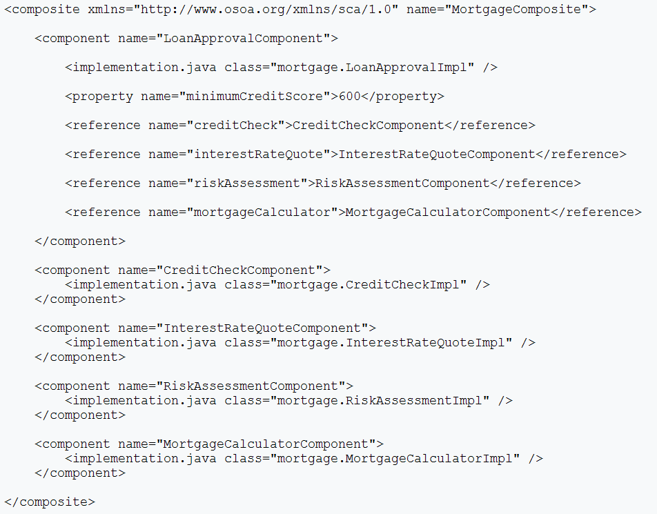
Mortgage Composite
Credit
Check
Interest
Rate
Risk
Assessment
Mortgage
Calculator

Loan
Approval
Component Implementation
(MortgageCalculatorImpl.java)
Component Type
(MortgageCalculator.componentType)
Java
Composite
(default.scdl)

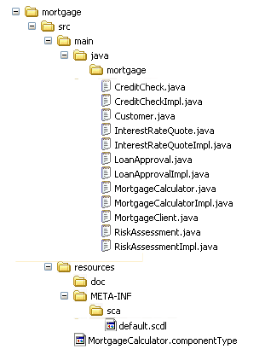
Component Implementation
Composite
Component Type
Component Implementation
Component Implementation

