Distributed OSGi using implementation.osgi

This sample implements a distributed calculator using Distributed OSGi (RFC 119) over SCA. It provides two bundles which, when installed in an OSGi framework, communicate in the following way.

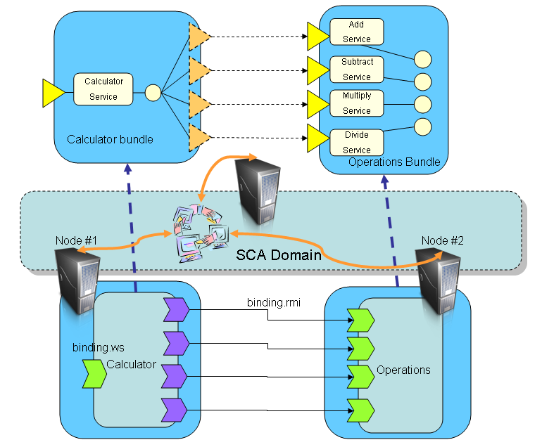

operations-bundle
This bundle provides the calculator add, subtract, multiple, divide operations services.
The bundle Jar can be built using Maven as follows:
cd learning-more/distributed-osgi/dosgi-calculator-operations
mvn
To run the bundle see "osgi" under running-tuscany. In short do the following:
On Windows, run
java -jar ..\..\..\..\modules\osgi-3.5.0-v20090520.jar -configuration ..\..\..\..\features\configuration -clean -console
You should see the osgi console. You can run "ss" command under the osgi> to see the status of the bundles.
osgi> ss
Then you can install and start the bundle that's just been built:
osgi> install file:./target/sample-operations-bundle.jar
This should give rise to a message indicating the bundle ID as follows:

Bundle id is 264

The bundle can then be started using:

osgi> start 264

calculator-bundle
The bundle Jar can be built using Maven as follows:
cd learning-more/dosgi-implementation-osgi/calculator-bundle
mvn
To run the bundle see "osgi" under running-tuscany. In short do the following:
On Windows, run
java -jar ..\..\..\..\modules\osgi-3.5.0-v20090520.jar -configuration ..\..\..\..\features\configuration -clean -console
You should see the osgi console. You can run "ss" command under the osgi> to see the status of the bundles.
osgi> ss
Then you can install and start the bundle that's just been built:
osgi> install file:./target/sample-calculator-bundle.jar
This should give rise to a message indicating the bundle ID as follows:

Bundle id is 264

The bundle can then be started using:

osgi> start 264

