  SNIR 2 SNIR2 | LAN PARTY |     ESLA

Your mission:

You are entrusted with the organization of a LAN party in a sports hall. 300 guests will be present.
The place needs to be equipped with an ADSL box, 188 desktops (connected with RJ45 plugs), and 100 Wi-Fi connected laptops.
Budget: 20k€

- TASK 1: Observe the diagram of an ADSL box and fill in the caption.

- TASK 2; Look at the map of the sports hall and choose the CISCO equipment you will need on https://www.amazon.com
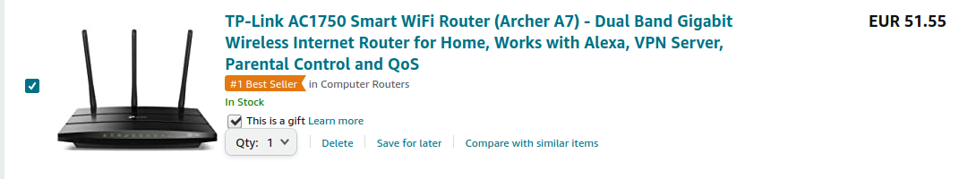
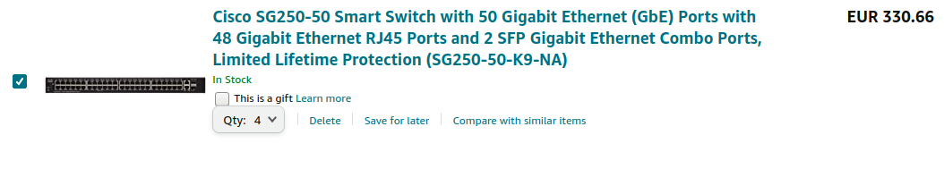
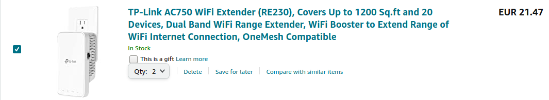

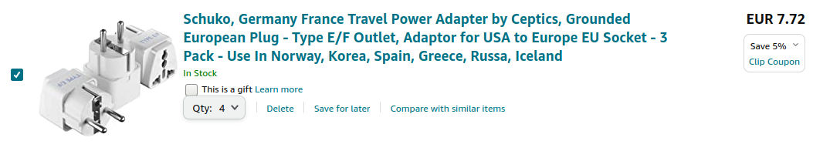
300Wh * 288 = 86400 Wh
86400 → 86,4 Kwh
86.4 * 0.15 = 12.96 € per hour

- FINAL TASK ; Project the map of the sports hall on the white board and use it to explain the solution you have envisaged.

EXTRA HELP:
You may find some help from the following video:
https://www.youtube.com/watch?v=8J00rfZE17Y
The speech delivery being quick, you are exceptionally allowed to use subtitles.

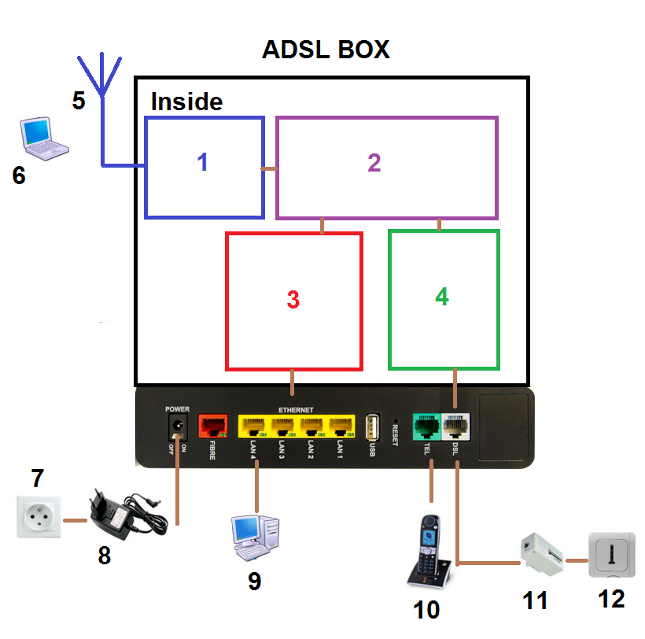
1 → WiFi access Point
2 → router
3 → switch 4 ports
4 → Modem
5 → Wifi signal
6 → laptop (wireless)
7 → wall socket
8 → power cable (power supply)
9 → computer (ethernet)
10 → home phone
11 → adsl filter
12 → phone plug
