* Create an AWS Account and create a user.

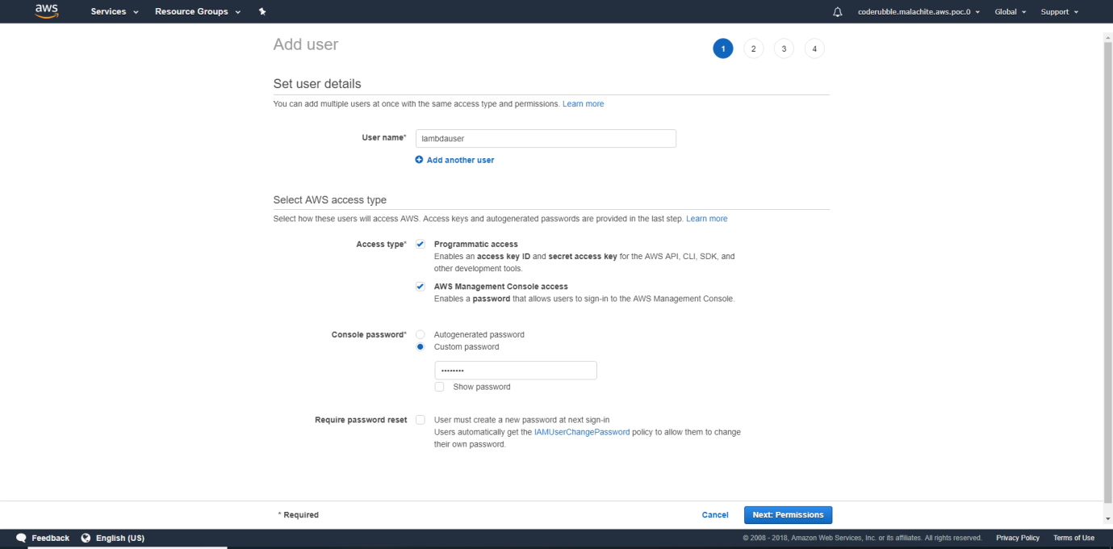

* Make sure the developer is provided Programmatic access. Note down the access key id and secret access key .
* Install AWS CLI for your OS.

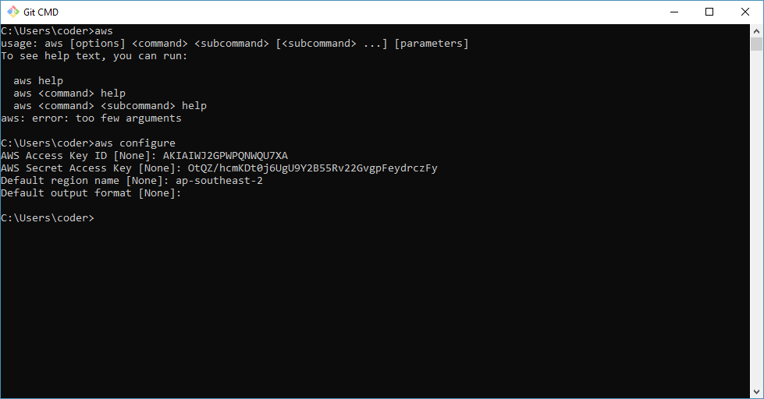

* Install Node and npm.
* Install Serverless as shown below.

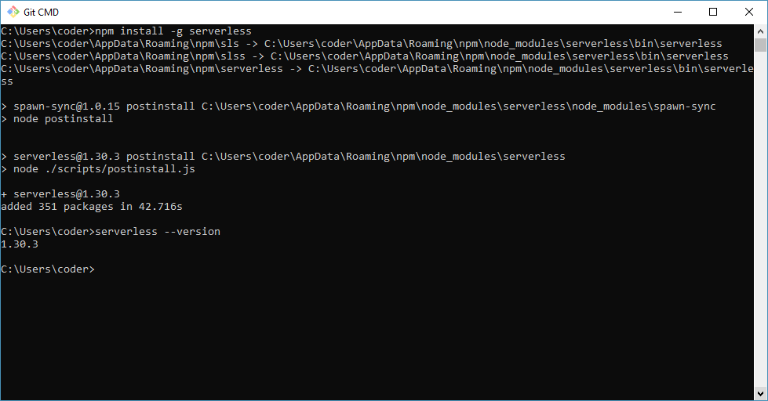

(Optional) To be able to create a new serverless project.

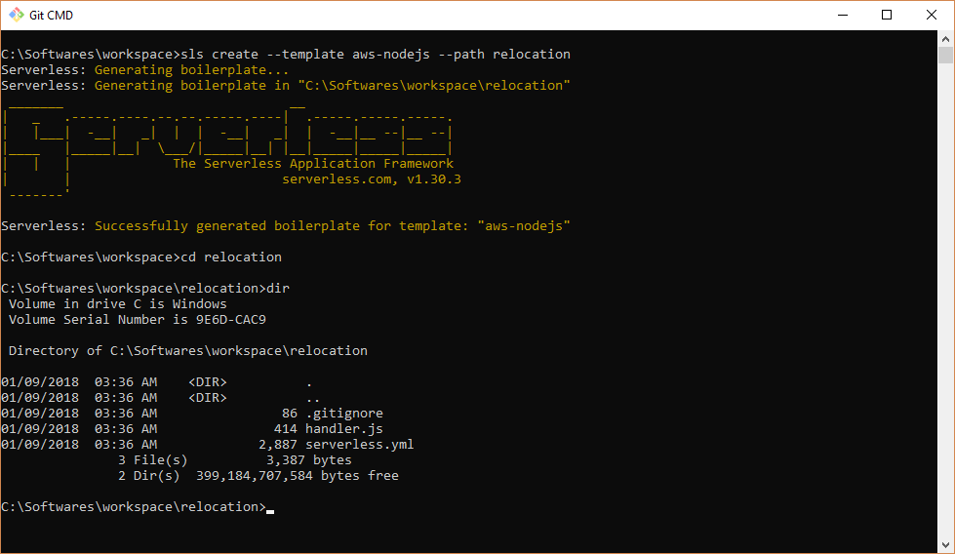

* Alternately git clone from https://github.com/coderubble/relocation.git

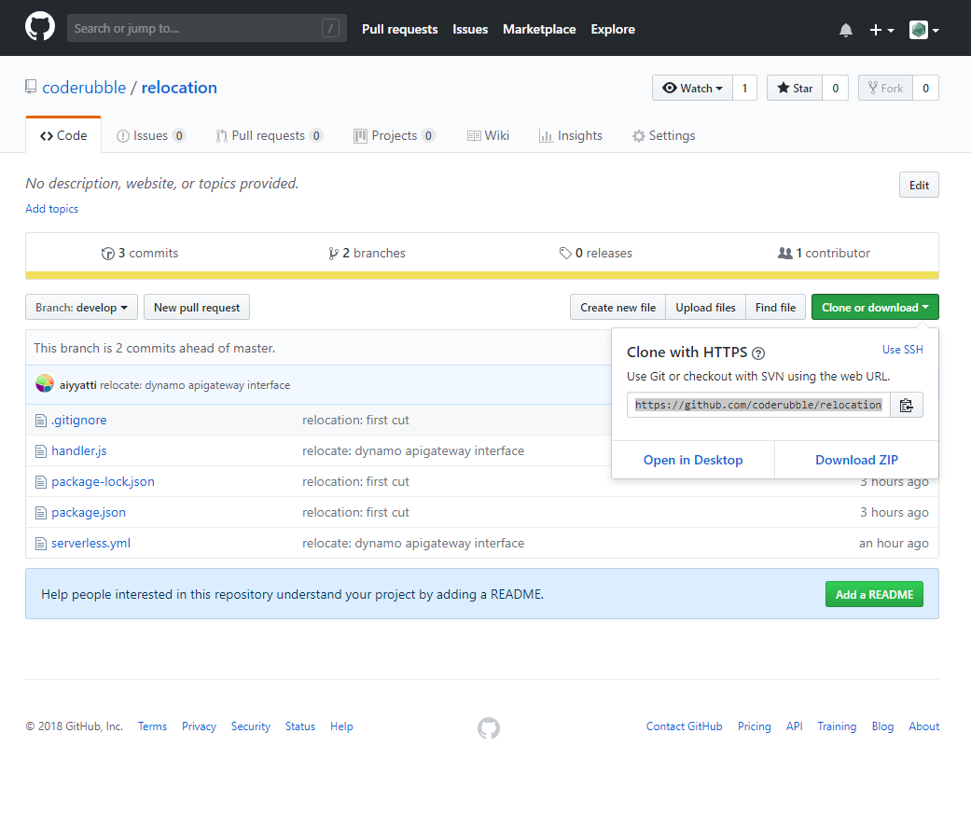

* Create a table in dynamo db with Hash key as Country of type String

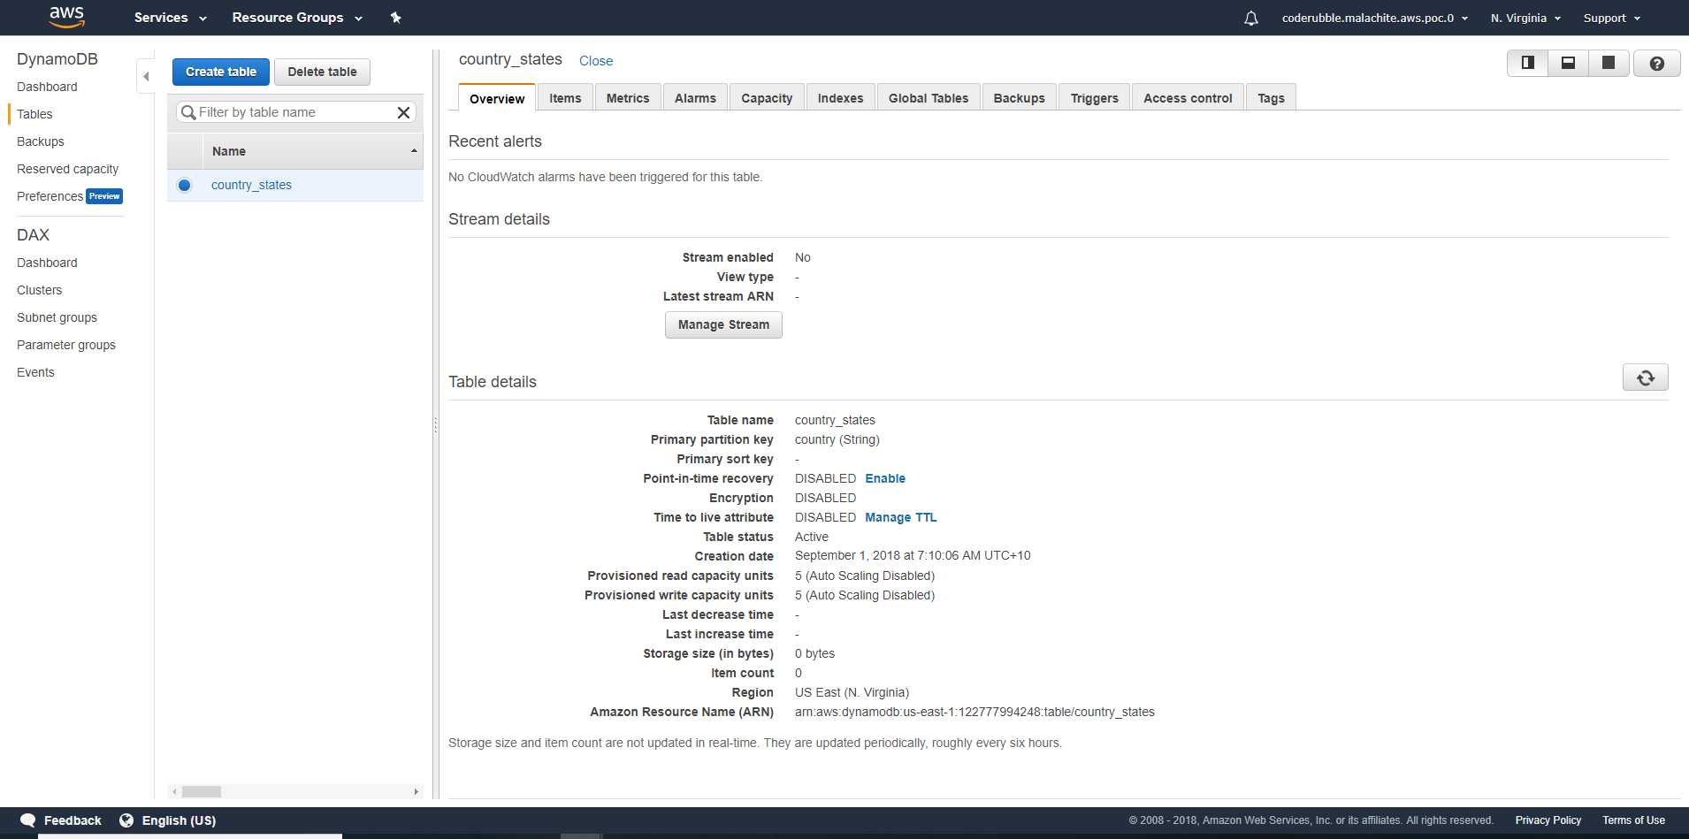

* Run the script that is a part of the code to insert data into dynamo

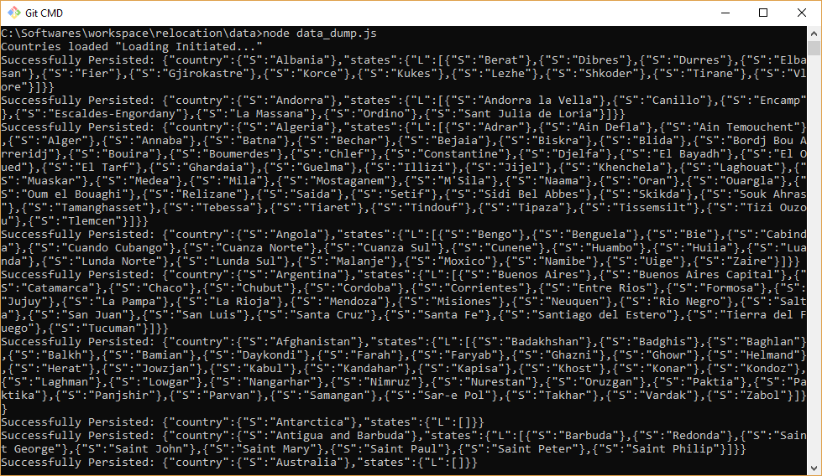

* Check the data via console.

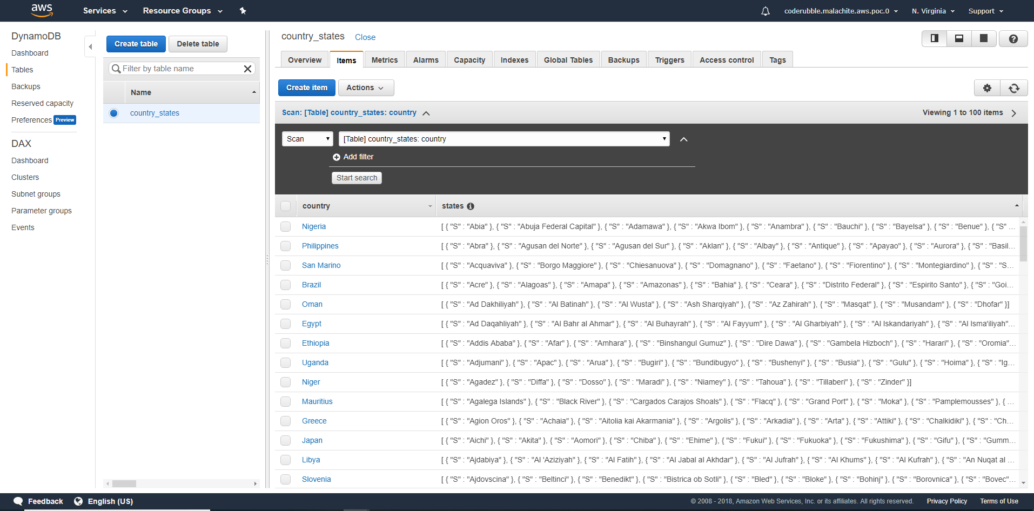

Run npm install and sls deploy – to install and deploy the application to AWS. Internally archive is extracted into S3 and cloud formation templates created and executed to provision the resources. Logs are available in Cloudwatch.

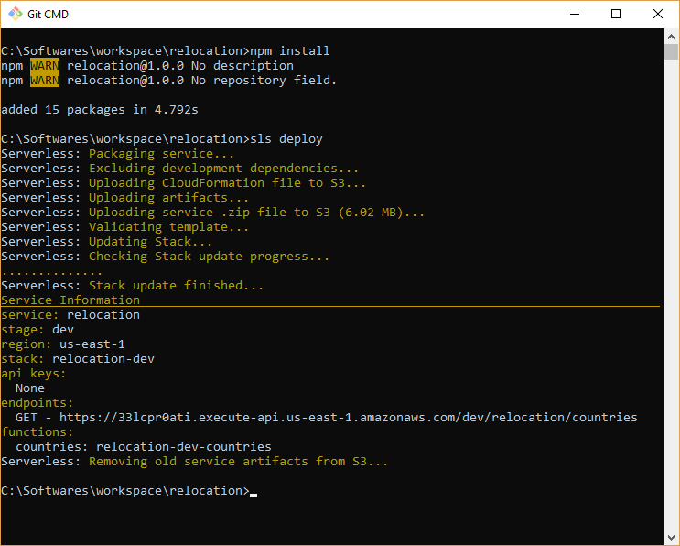

Go the URI shown in the terminal window to access the end point to get the country and state list.

