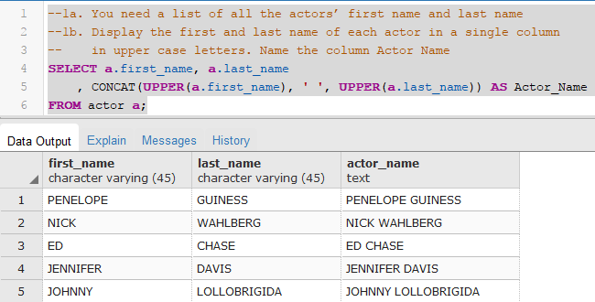

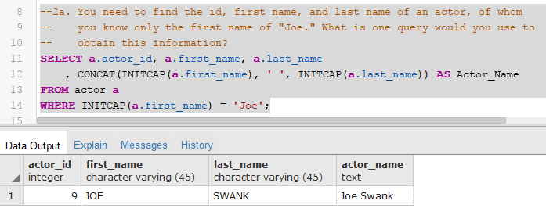

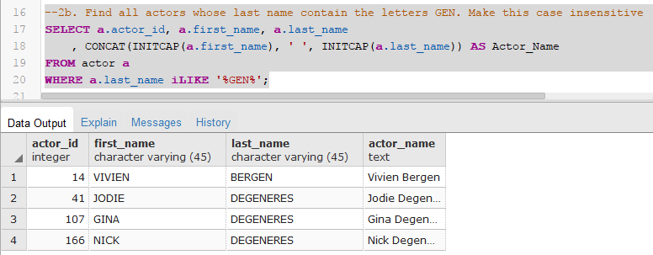

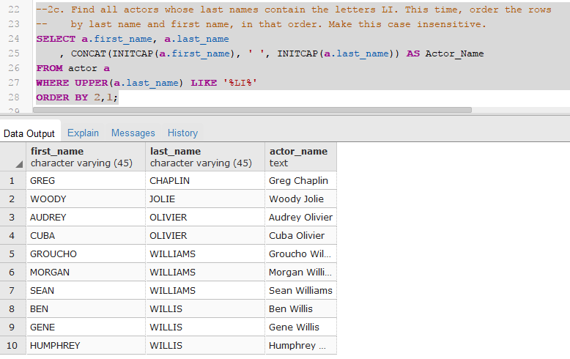

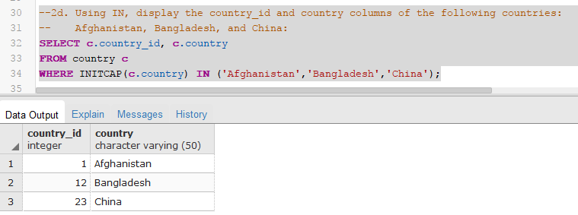

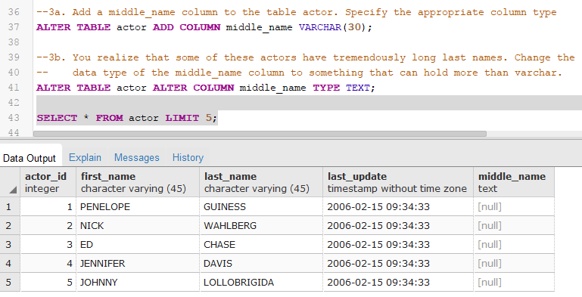

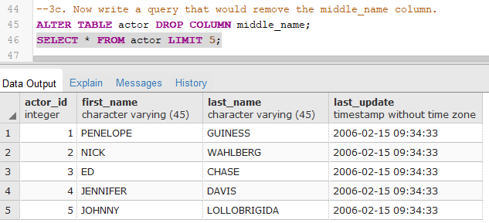

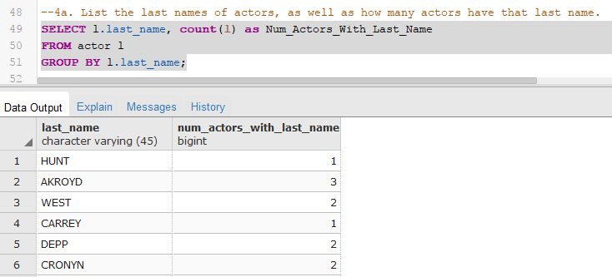

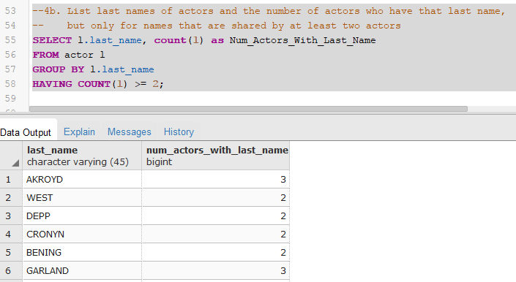

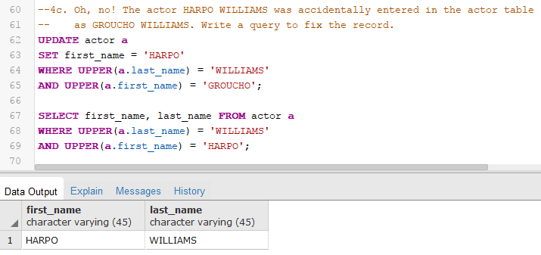

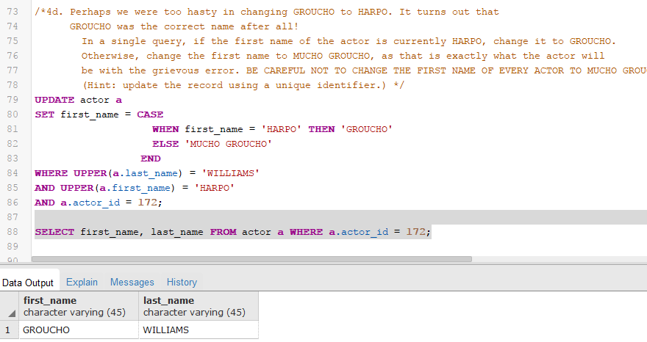

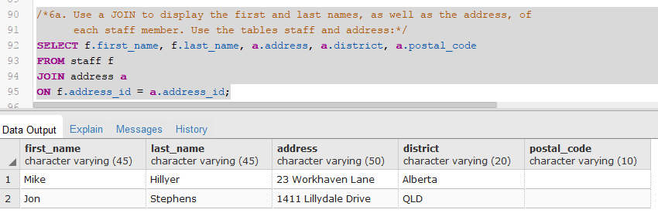

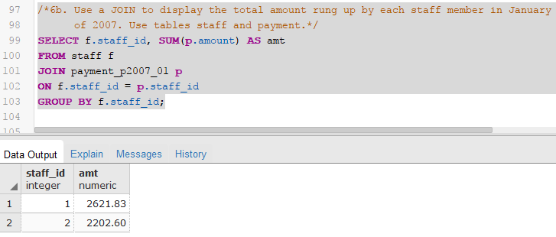

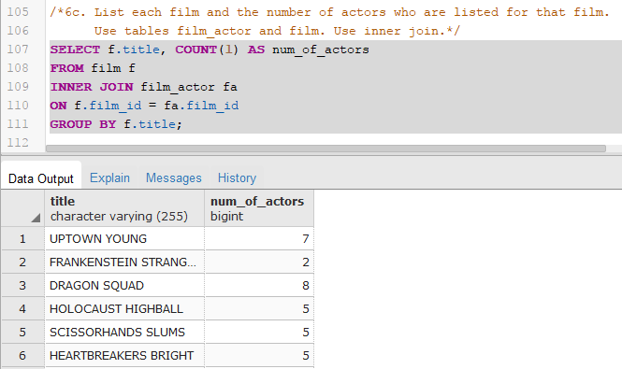

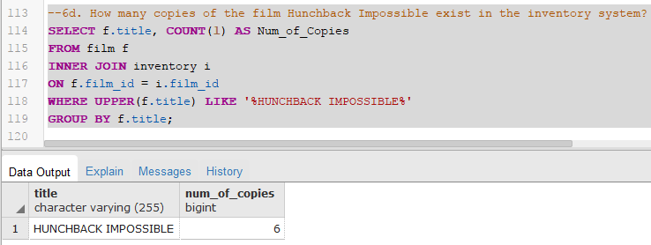

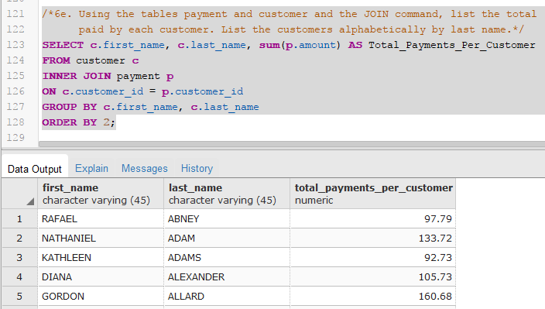

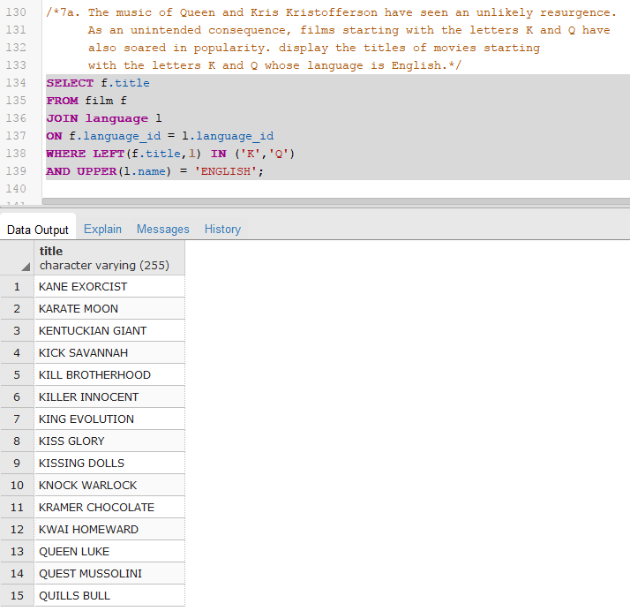

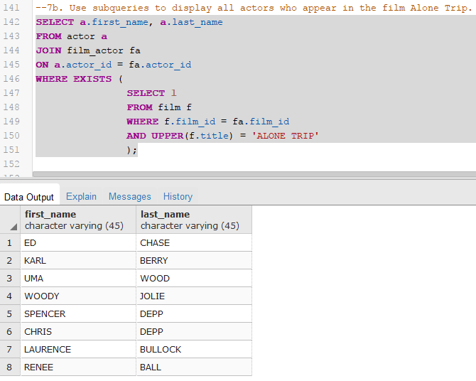

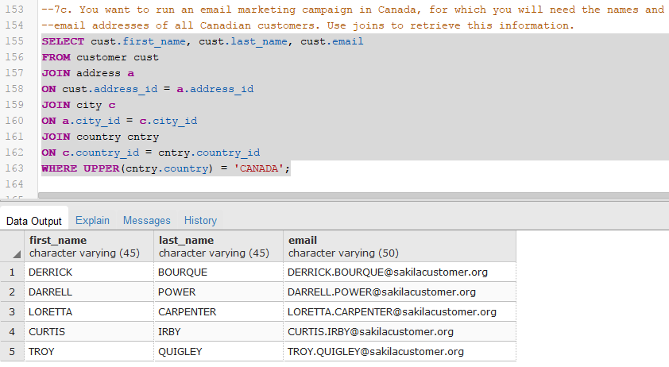

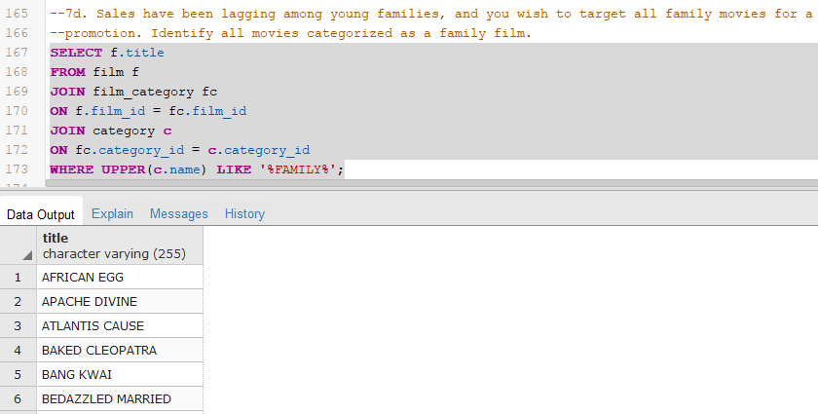

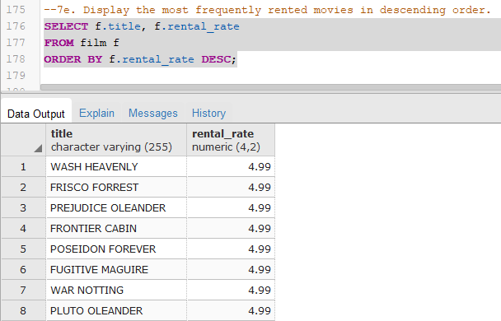

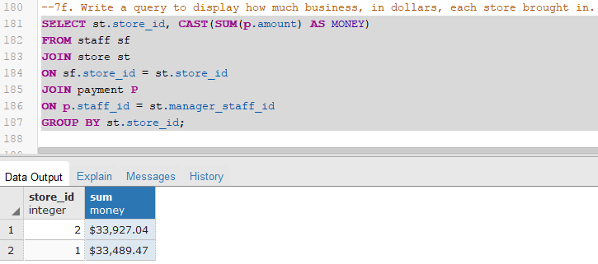

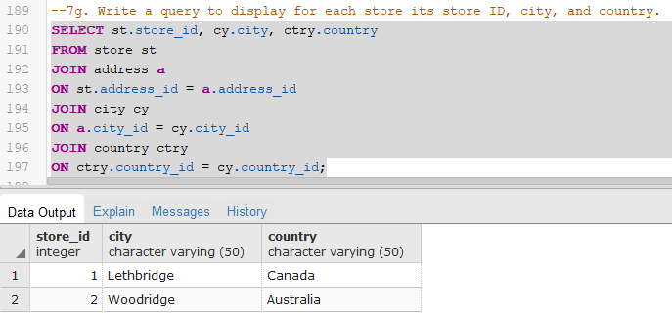

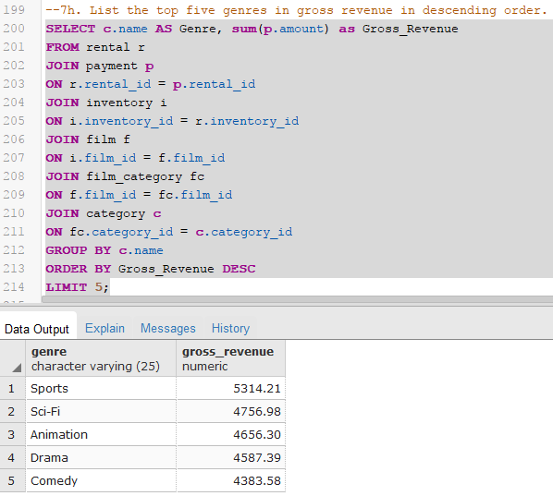

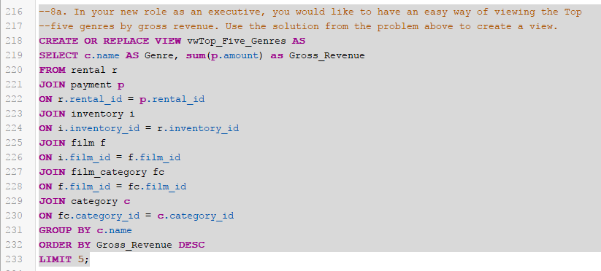

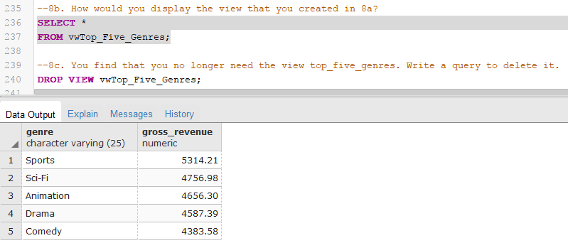

Difference between left and right join – the only difference is the order in which they are appear in the join statement

Difference between Inner and outer join – inner join returns only records that match in both tables while outer returns all the rows

Rank – if you wanted to find out how many students scored perfect scores on an exam

Dense_Rank – if you wanted to award the top three teams with medals

Subquery – Use a subquery if you wanted to get a value from another table and display it as a column in your query

Right join – Use a right join to return all of the records on the right table, regardless if there is a match in the left table

Inner join vs Outer join – Use an inner join to return records that match the criteria in the where or having class from both tables

Left Join vs Left Outer Join – there is no difference, because the ‘OUTER’ keyword is optional when specifying a left join

Group By – Use a group when you are using an aggregate function

Data reformatting – Use data reformatting when you want to convert a data type into another, like formatting an integer into a string

WITH Clause – Use a WITH clause when you create a common table expression to simplify a complex query

Self Joins – Self joins are useful if you wanted to do some data cleanup within the table, like remove duplicates