PROJECT REPORT 08/24/2026
DAMAC West Office — Ground Floor · Demolition & Renovation · Owner Progress Report
LOCATION  Ground Floor · 301 71st St, Miami Beach | REPORT DATE  August 24, 2026 | PREPARED BY  Augusto Padilla, Senior PM — PDG | PREPARED FOR  Mr. Carlos Seliman — DAMAC

1. PROJECT OVERVIEW
This report covers the ground-floor demolition and renovation of the DAMAC West Office at 301 71st Street, Miami Beach (PDG-2026-DWO1), performed under our cost-plus agreement (AIA A103). It has been a strong and productive week: demolition is complete, the bulk of the debris has been cleared, and the site is being handed off to the electrical scope on schedule. Work is being carried out on a night shift to keep the building fully operational during the day, and the crew has worked from 5:00 PM to 11:00 PM with no incidents. Owner-furnished furniture and materials on site remain staged and protected. Overall, the project is advancing well and remains on track.
2. FIELD STATUS — Night Shift of Monday, August 24, 2026
• Demolition: Two electricians completed demolition of the existing electrical and low-voltage systems, preparing the space for the new ceiling grid and framing.
• Debris Removal: A crew of three carried out a bulk trash pickup and cleared the site of debris; the remaining glass panels are scheduled for removal on the next shift.
• Flooring: The carpet vendor visited the site to take measurements and will deliver samples and pricing for the Owner’s selection.
• Night Operations: Field operations are supervised on nights by William “Junior” Ratcliff. The shift ran 5:00 PM to 11:00 PM with no incidents.
• Site & Security: Security was on-site throughout the shift. The east-side gate would not close and was noted in the security guard’s report; PDG did not operate this gate. We are flagging it for the Owner’s awareness so building management can address it.
3. FIELD PHOTOGRAPHY — Night Shift of Monday, August 24, 2026
Documentation of construction progress: electrical and low-voltage demolition with the ceiling opened for the new grid, partition demolition and debris removal, interior areas cleared, and Owner-furnished furniture and materials staged and protected on site.
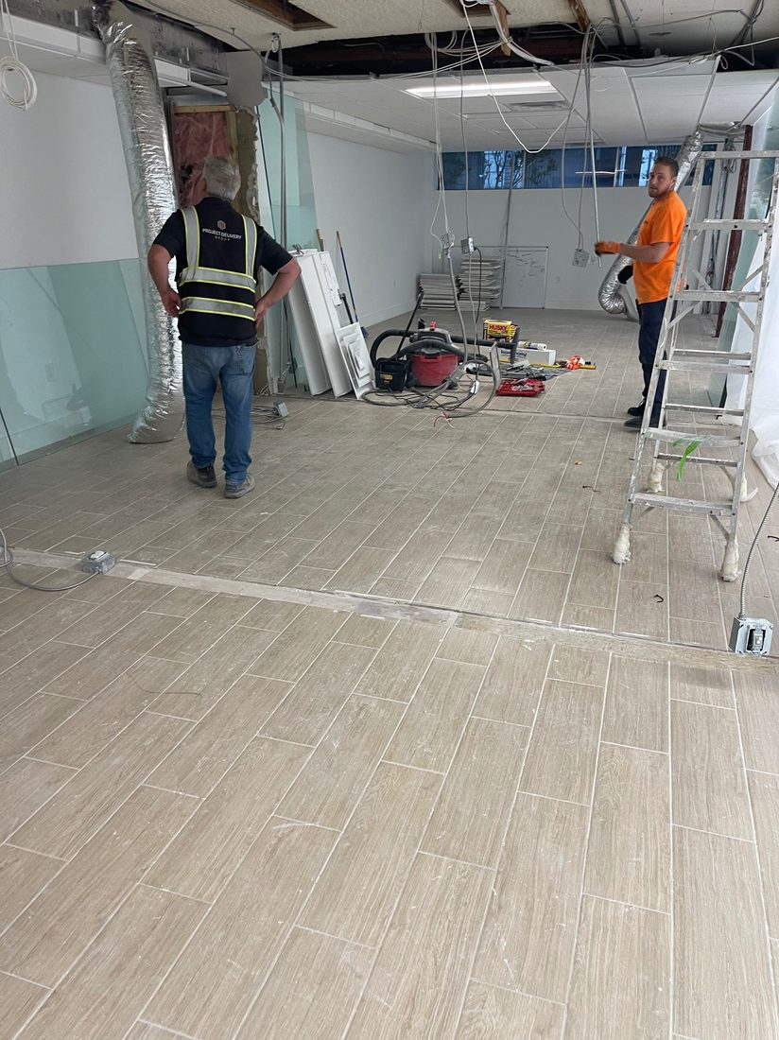  Main Floor — Ceiling Opened; Electrical and Low-Voltage Demolished for New Grid | 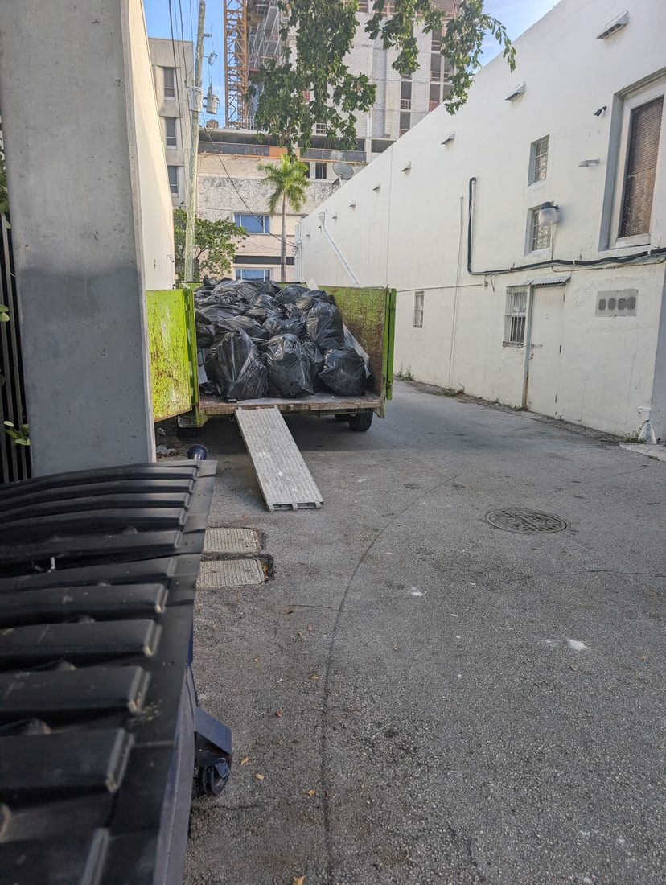  Debris Removal — Loaded Trailer Staged in the Service Alley
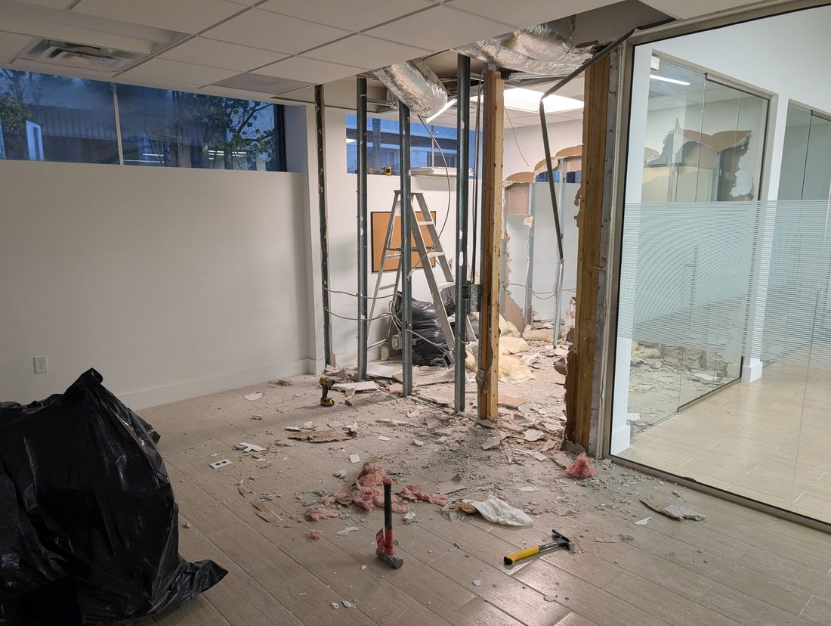  Partition Demolition — Framing Exposed, Drywall Staged for Removal | 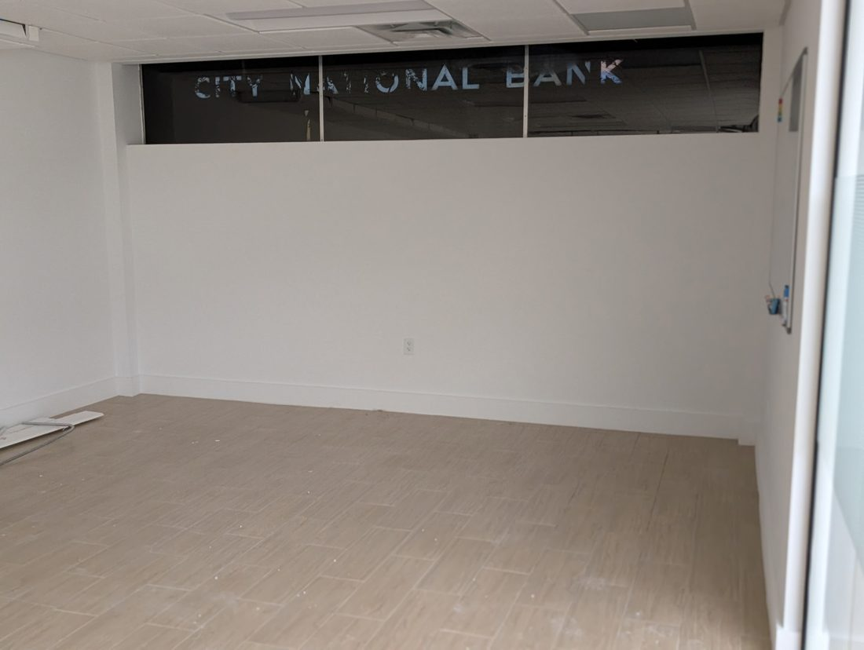  Interior Area Cleared — Existing Transom and Signage Above Demised Wall
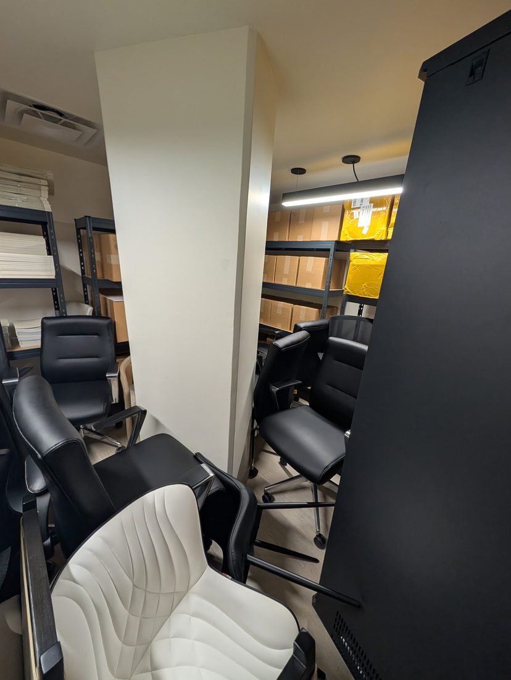  Owner Furniture — Seating Staged and Protected On-Site | 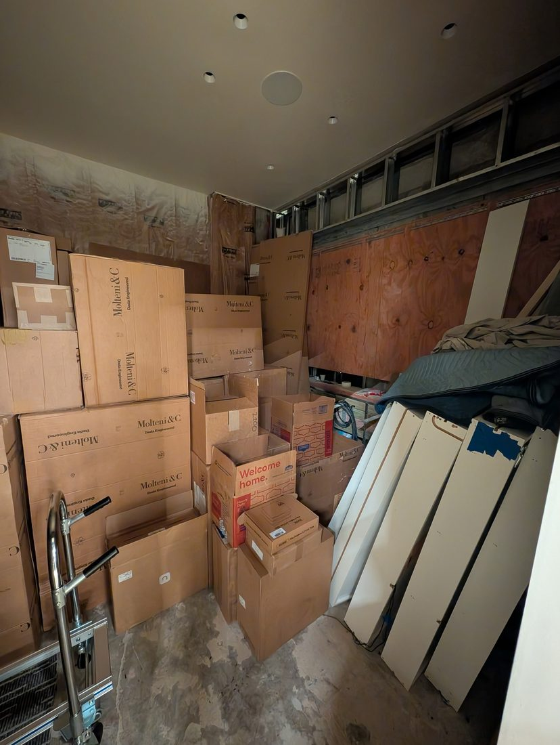  Staged Materials — Delivered Casework and Panels Protected in Storage
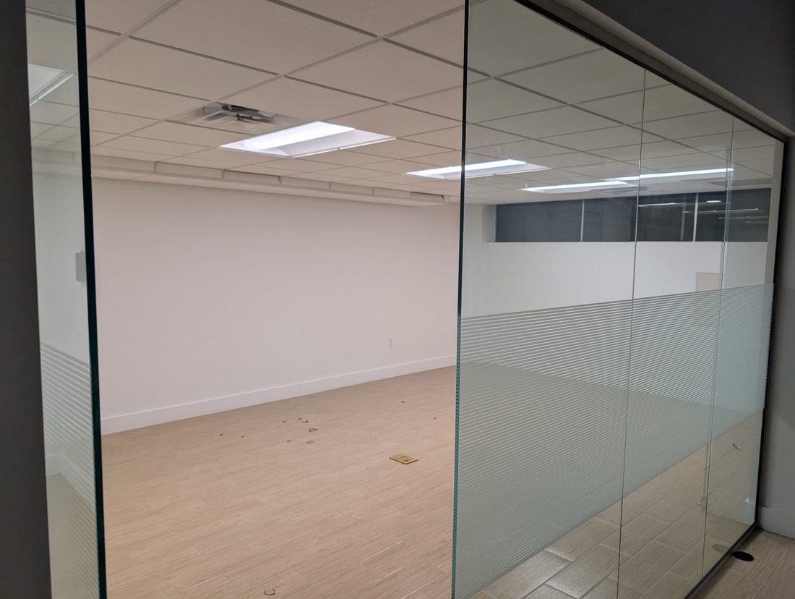
Cleared Office — Floor-Box Location and Glazed Partition
4. KEY MILESTONES THIS WEEK
• Demolition is 100% complete.
• Electrical and low-voltage systems have been demolished and the area is prepared for the ceiling grid and framing.
• The bulk of construction debris has been removed from the site.
• Carpet has been measured; samples and pricing are being prepared for Owner selection.
• Owner-furnished furniture and materials are staged and protected on site.
5. LOOK-AHEAD — Next Work Window
• Complete removal of the remaining debris, including the glass panels.
• Begin the electrical points (floor boxes) immediately after the debris is cleared, subject to Owner confirmation of the workstation outlet locations.
• Present carpet samples and pricing to the Owner for color and specification selection.
6. OPEN ITEMS — Owner Decisions Required
# | Item | Needed By | Responsible | Priority
1 | Electrical floor-box locations — please have the five (5) workstation outlet positions taped on the floor so the electricians can set the boxes ahead of rough-in. | Next shift | Owner / PDG | CRITICAL
2 | Carpet selection — samples and pricing to be presented by the flooring vendor; Owner to confirm color and specification to release the order. | This week | Owner | HIGH
3 | First Application for Payment (Mobilization) — submitted and pending release; PDG available to coordinate with the Owner’s accounting team to expedite. | This week | Owner | HIGH

7. FINANCIAL STATUS
The first application for payment covering mobilization has been submitted and is currently pending release. PDG remains available to coordinate with the Owner’s accounting team to facilitate processing. We appreciate the Owner’s continued confidence in The Project Delivery Group and look forward to carrying this momentum into the next phase of the work.

