Name: _____Addison Padjen______________ Date: ___9/30/26_____________

Your HTML file’s URL:
Image 1 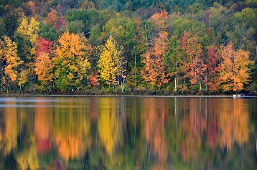
Source page URL: https://madison.citycast.fm/urban-almanac/where-to-see-wisconsin-fall-colors
Public domain or Creative Commons? (List any reserved rights) Creative Commons
©Kevin Revolinski

Image 2 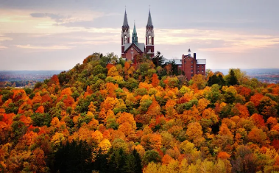
Source page URL: https://www.pinterest.com/pin/wisconsin-scenic--42784265204833168/
Public domain or Creative Commons? (List any reserved rights) Public domain

Image 3 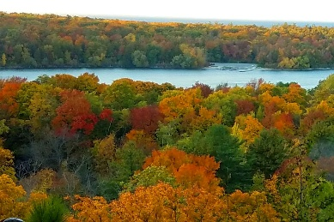
Source page URL: https://dnr.wisconsin.gov/education/fallcolors
Public domain or Creative Commons? (List any reserved rights) Public domain

