Exercise1.4

Anthony Pagan

August 31, 2019

{r setup, include=FALSE} knitr::opts_chunk$set(echo = TRUE)

## Exercise 1.4

Both QQ Plots show that Salary and Expenditure are positively correlated with Total SAT scores

```{r cars} #1.4 data(sat, package=“faraway”)

qqplot(sat $salary,sat$ total) qqplot(sat $expend,sat$ total)

```

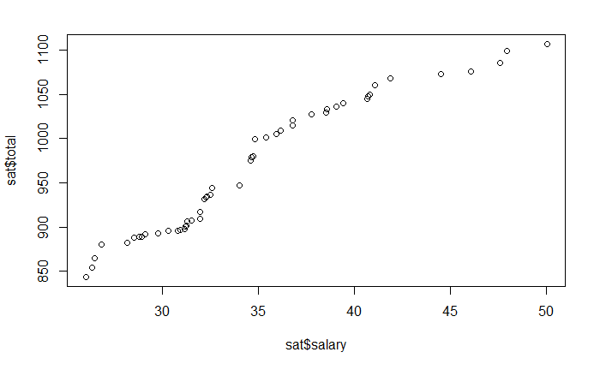

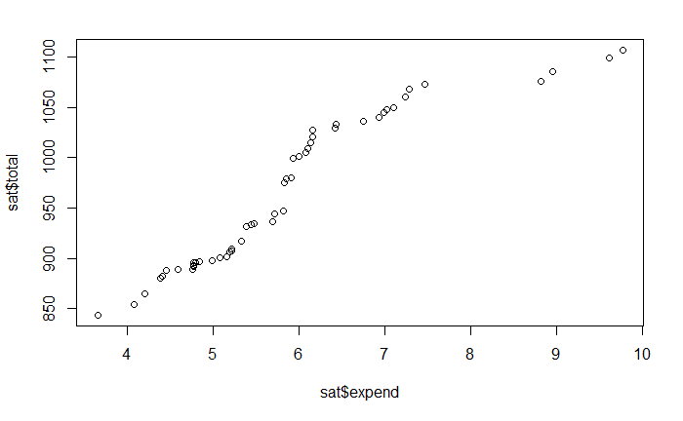

When combining expenditure with Salary with Expendity, Salary seems to be more correlated based on the lower tvalue.

```{r } lm1<-lm(sat $total sat$ expend+sat$salary) summary(lm1)

```

Call:

lm(formula = sat$total ~ sat$expend + sat$salary)

Residuals:

Min 1Q Median 3Q Max

-147.03 -45.50 4.19 42.41 125.34

Coefficients:

Estimate Std. Error t value Pr(>|t|)

(Intercept) 1159.347 60.222 19.25 <2e-16 ***

sat$expend 0.468 14.576 0.03 0.975

sat$salary -5.633 3.343 -1.68 0.099 .

---

Signif. codes: 0 ‘***’ 0.001 ‘**’ 0.01 ‘*’ 0.05 ‘.’ 0.1 ‘ ’ 1

Residual standard error: 69 on 47 degrees of freedom

Multiple R-squared: 0.194, Adjusted R-squared: 0.159

F-statistic: 5.64 on 2 and 47 DF, p-value: 0.00638

GGPLOT shows a combination of salary and expenditure is also strongly correlated with total SAT scores.

ggplot(data= sat) +  
 geom_point(mapping = aes(x = lm1$residuals, y = total, size= total), stat = "identity", position = "identity")+  
 theme(axis.text.x=element_text(size=9))

