Exercise2.4_5

Anthony Pagan

September 8, 2019

# Exercise LMR2.4

A high R-square tells us that data is closer ot the fitted value while a lowe redidual gives the messure of how close the data falls from the regression line.in our plot Stats we can see that as we add more variables the residuals decrease and the R.squred increase. This tells us the data is getting closer to the regression line as we add more variables.

sstat

## res rsq  
## 1 0.8040746 0.5394319  
## 2 0.8039630 0.5444065  
## 3 0.7902322 0.5645183  
## 4 0.7914627 0.5678581  
## 5 0.7781510 0.5868129  
## 6 0.7029589 0.6665122  
## 7 0.7018555 0.6712521  
## 8 0.6997800 0.6768655

plot(sstat)

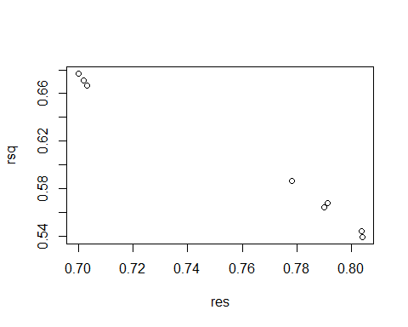

# Exercise LMR2.5

This exercise seems that the regression lines would never intersect could this be correct?

#LMR 2.5  
  
data(prostate, package="faraway")  
fit1<-lm(lpsa~lcavol, data=prostate)  
summary(fit1)

##   
## Call:  
## lm(formula = lpsa ~ lcavol, data = prostate)  
##   
## Residuals:  
## Min 1Q Median 3Q Max   
## -1.67625 -0.41648 0.09859 0.50709 1.89673   
##   
## Coefficients:  
## Estimate Std. Error t value Pr(>|t|)   
## (Intercept) 1.50730 0.12194 12.36 <2e-16 ***  
## lcavol 0.71932 0.06819 10.55 <2e-16 ***  
## ---  
## Signif. codes: 0 '***' 0.001 '**' 0.01 '*' 0.05 '.' 0.1 ' ' 1  
##   
## Residual standard error: 0.7875 on 95 degrees of freedom  
## Multiple R-squared: 0.5394, Adjusted R-squared: 0.5346   
## F-statistic: 111.3 on 1 and 95 DF, p-value: < 2.2e-16

fit2<-lm(lcavol~lpsa, data=prostate)  
summary(fit2)

##   
## Call:  
## lm(formula = lcavol ~ lpsa, data = prostate)  
##   
## Residuals:  
## Min 1Q Median 3Q Max   
## -2.15948 -0.59383 0.05034 0.50826 1.67751   
##   
## Coefficients:  
## Estimate Std. Error t value Pr(>|t|)   
## (Intercept) -0.50858 0.19419 -2.619 0.0103 *   
## lpsa 0.74992 0.07109 10.548 <2e-16 ***  
## ---  
## Signif. codes: 0 '***' 0.001 '**' 0.01 '*' 0.05 '.' 0.1 ' ' 1  
##   
## Residual standard error: 0.8041 on 95 degrees of freedom  
## Multiple R-squared: 0.5394, Adjusted R-squared: 0.5346   
## F-statistic: 111.3 on 1 and 95 DF, p-value: < 2.2e-16

plot(lcavol~lpsa,prostate)  
abline(fit1,col="red")  
abline(fit2,col="blue")

