Data 621 Homework 1

Anthony Pagan

September 25, 2019

Table of Contents

Data Exploration 1

Data Explore - Replace NA Values 1

Data Explore - Remove NA Values 2

Data Preparation 9

Data Prepare - Replace NA values 9

Data Prepart - Remove NA values 10

Build Models 12

Select Models 13

Select Models - Replace NA Values 13

Select Models - Remove NA Values 14

Conclusion 14

Appendix: 16

# Data Exploration

In this exercise we will go with 2 approaches. One approach would be to remove data with NA values and the second approach would be to replace the NA data with a value. We will attempt both approaches and use the one with the best predictions.

## Data Explore - Replace NA Values

The initial review of the data shows 6 columns with incomplete data for 6 Columns

## [1] 2276

## INDEX TARGET_WINS TEAM_BATTING_H TEAM_BATTING_2B   
## NA NA NA NA   
## TEAM_BATTING_3B TEAM_BATTING_HR TEAM_BATTING_BB TEAM_BATTING_SO   
## NA NA NA "NA's :102 "   
## TEAM_BASERUN_SB TEAM_BASERUN_CS TEAM_BATTING_HBP TEAM_PITCHING_H   
## "NA's :131 " "NA's :772 " "NA's :2085 " NA   
## TEAM_PITCHING_HR TEAM_PITCHING_BB TEAM_PITCHING_SO TEAM_FIELDING_E   
## NA NA "NA's :102 " NA   
## TEAM_FIELDING_DP   
## "NA's :286 "

THis is a summary of values for each column that has NA data values. For the most part the mean and median values are close enough to theorize that data of the six columns with NA value are fairly normal. We will attempt a replacement as one approachin in the data preparation section.

## Min. 1st Qu. Median Mean 3rd Qu. Max. NA's   
## 0.0 548.0 750.0 735.6 930.0 1399.0 102

## Min. 1st Qu. Median Mean 3rd Qu. Max. NA's   
## 0.0 66.0 101.0 124.8 156.0 697.0 131

## Min. 1st Qu. Median Mean 3rd Qu. Max. NA's   
## 0.0 38.0 49.0 52.8 62.0 201.0 772

## Min. 1st Qu. Median Mean 3rd Qu. Max. NA's   
## 29.00 50.50 58.00 59.36 67.00 95.00 2085

## Min. 1st Qu. Median Mean 3rd Qu. Max. NA's   
## 0.0 615.0 813.5 817.7 968.0 19278.0 102

## Min. 1st Qu. Median Mean 3rd Qu. Max. NA's   
## 52.0 131.0 149.0 146.4 164.0 228.0 286

## Data Explore - Remove NA Values

If we remove all rows with incomplete rows, there will be a total of 191 rows. We need to decide if using only 0.09% of the data suffice

## Mode FALSE TRUE   
## logical 2085 191

A look at the mean and median values show a larger spread in TB_SO, TP_H and TP_E. The expectation is there will be more outliers in these groups

## INDEX TARGET_WINS TEAM_BATTING_H TEAM_BATTING_2B  
## Median :1270.5 Median : 82.00 Median :1454 Median :238.0   
## Mean :1268.5 Mean : 80.79 Mean :1469 Mean :241.2   
## TEAM_BATTING_3B TEAM_BATTING_HR TEAM_BATTING_BB TEAM_BATTING_SO   
## Median : 47.00 Median :102.00 Median :512.0 Median : 750.0   
## Mean : 55.25 Mean : 99.61 Mean :501.6 Mean : 735.6   
## TEAM_BASERUN_SB TEAM_BASERUN_CS TEAM_BATTING_HBP TEAM_PITCHING_H  
## Median :101.0 Median : 49.0 Median :58.00 Median : 1518   
## Mean :124.8 Mean : 52.8 Mean :59.36 Mean : 1779   
## TEAM_PITCHING_HR TEAM_PITCHING_BB TEAM_PITCHING_SO TEAM_FIELDING_E   
## Median :107.0 Median : 536.5 Median : 813.5 Median : 159.0   
## Mean :105.7 Mean : 553.0 Mean : 817.7 Mean : 246.5   
## TEAM_FIELDING_DP  
## Median :149.0   
## Mean :146.4

The box plots below confirms the outliers as expected ,but TP_E is not as drastic as the others. However te

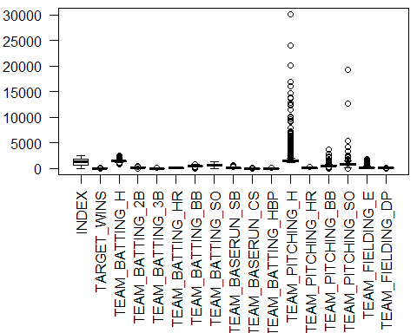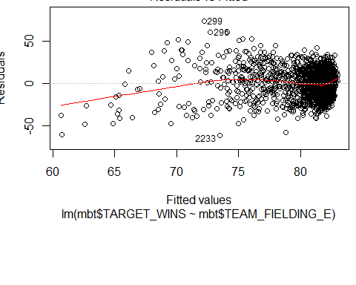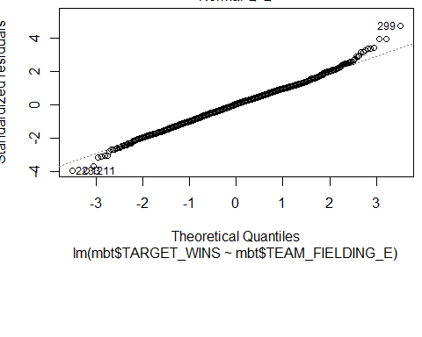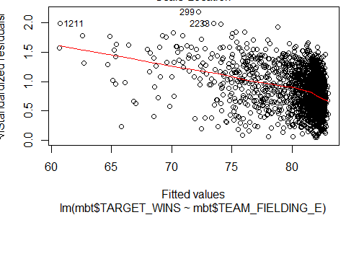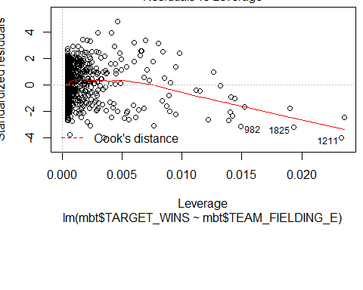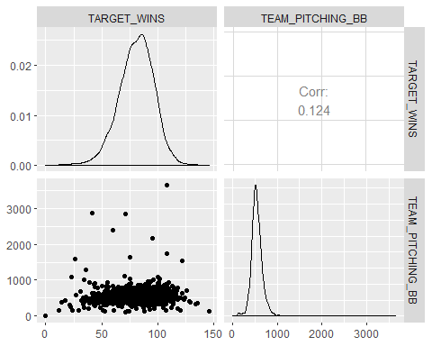

An initial view of the data show that TEAM_FIELDING_E and TEAM_FIELDING_DP have low P value and may have high correlation with team wins.

##   
## Call:  
## lm(formula = TARGET_WINS ~ . - INDEX, data = mbt)  
##   
## Residuals:  
## Min 1Q Median 3Q Max   
## -19.8708 -5.6564 -0.0599 5.2545 22.9274   
##   
## Coefficients:  
## Estimate Std. Error t value Pr(>|t|)   
## (Intercept) 60.28826 19.67842 3.064 0.00253 **   
## TEAM_BATTING_H 1.91348 2.76139 0.693 0.48927   
## TEAM_BATTING_2B 0.02639 0.03029 0.871 0.38484   
## TEAM_BATTING_3B -0.10118 0.07751 -1.305 0.19348   
## TEAM_BATTING_HR -4.84371 10.50851 -0.461 0.64542   
## TEAM_BATTING_BB -4.45969 3.63624 -1.226 0.22167   
## TEAM_BATTING_SO 0.34196 2.59876 0.132 0.89546   
## TEAM_BASERUN_SB 0.03304 0.02867 1.152 0.25071   
## TEAM_BASERUN_CS -0.01104 0.07143 -0.155 0.87730   
## TEAM_BATTING_HBP 0.08247 0.04960 1.663 0.09815 .   
## TEAM_PITCHING_H -1.89096 2.76095 -0.685 0.49432   
## TEAM_PITCHING_HR 4.93043 10.50664 0.469 0.63946   
## TEAM_PITCHING_BB 4.51089 3.63372 1.241 0.21612   
## TEAM_PITCHING_SO -0.37364 2.59705 -0.144 0.88577   
## TEAM_FIELDING_E -0.17204 0.04140 -4.155 5.08e-05 ***  
## TEAM_FIELDING_DP -0.10819 0.03654 -2.961 0.00349 **   
## ---  
## Signif. codes: 0 '***' 0.001 '**' 0.01 '*' 0.05 '.' 0.1 ' ' 1  
##   
## Residual standard error: 8.467 on 175 degrees of freedom  
## (2085 observations deleted due to missingness)  
## Multiple R-squared: 0.5501, Adjusted R-squared: 0.5116   
## F-statistic: 14.27 on 15 and 175 DF, p-value: < 2.2e-16

The qq dot plots do not follow the residual line and fails the normality test

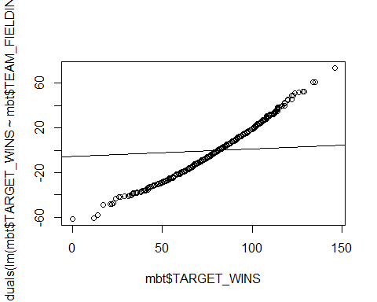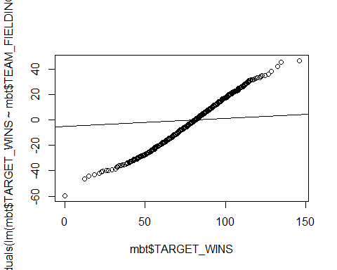

# Data Preparation

As a start, we begin by redjusting the data column headings to shorter column names.

## 'data.frame': 2276 obs. of 17 variables:  
## $ INDEX : int 1 2 3 4 5 6 7 8 11 12 ...  
## $ TARGET_WINS : int 39 70 86 70 82 75 80 85 86 76 ...  
## $ TEAM_BATTING_H : int 1445 1339 1377 1387 1297 1279 1244 1273 1391 1271 ...  
## $ TEAM_BATTING_2B : int 194 219 232 209 186 200 179 171 197 213 ...  
## $ TEAM_BATTING_3B : int 39 22 35 38 27 36 54 37 40 18 ...  
## $ TEAM_BATTING_HR : int 13 190 137 96 102 92 122 115 114 96 ...  
## $ TEAM_BATTING_BB : int 143 685 602 451 472 443 525 456 447 441 ...  
## $ TEAM_BATTING_SO : int 842 1075 917 922 920 973 1062 1027 922 827 ...  
## $ TEAM_BASERUN_SB : int NA 37 46 43 49 107 80 40 69 72 ...  
## $ TEAM_BASERUN_CS : int NA 28 27 30 39 59 54 36 27 34 ...  
## $ TEAM_BATTING_HBP: int NA NA NA NA NA NA NA NA NA NA ...  
## $ TEAM_PITCHING_H : int 9364 1347 1377 1396 1297 1279 1244 1281 1391 1271 ...  
## $ TEAM_PITCHING_HR: int 84 191 137 97 102 92 122 116 114 96 ...  
## $ TEAM_PITCHING_BB: int 927 689 602 454 472 443 525 459 447 441 ...  
## $ TEAM_PITCHING_SO: int 5456 1082 917 928 920 973 1062 1033 922 827 ...  
## $ TEAM_FIELDING_E : int 1011 193 175 164 138 123 136 112 127 131 ...  
## $ TEAM_FIELDING_DP: int NA 155 153 156 168 149 186 136 169 159 ...

## Data Prepare - Replace NA values

In our analysis of the summbary of columns with NA values we noted that median and mean values were close enough to theorize that these column values were fairly normal. As a result, we replace any NAs with the mean value of the column data.

## Index Wins TB_Hits TB_2B   
## Min. : 1.0 Min. : 0.00 Min. : 891 Min. : 69.0   
## 1st Qu.: 630.8 1st Qu.: 71.00 1st Qu.:1383 1st Qu.:208.0   
## Median :1270.5 Median : 82.00 Median :1454 Median :238.0   
## Mean :1268.5 Mean : 80.79 Mean :1469 Mean :241.2   
## 3rd Qu.:1915.5 3rd Qu.: 92.00 3rd Qu.:1537 3rd Qu.:273.0   
## Max. :2535.0 Max. :146.00 Max. :2554 Max. :458.0   
## TB_3B TB_HR TB_BB TB_SO   
## Min. : 0.00 Min. : 0.00 Min. : 0.0 Min. : 0.0   
## 1st Qu.: 34.00 1st Qu.: 42.00 1st Qu.:451.0 1st Qu.: 556.8   
## Median : 47.00 Median :102.00 Median :512.0 Median : 735.6   
## Mean : 55.25 Mean : 99.61 Mean :501.6 Mean : 735.6   
## 3rd Qu.: 72.00 3rd Qu.:147.00 3rd Qu.:580.0 3rd Qu.: 925.0   
## Max. :223.00 Max. :264.00 Max. :878.0 Max. :1399.0   
## TBR_SB TBR_CS TB_HBP TP_H   
## Min. : 0.0 Min. : 0.00 Min. :29.00 Min. : 1137   
## 1st Qu.: 67.0 1st Qu.: 44.00 1st Qu.:59.36 1st Qu.: 1419   
## Median :106.0 Median : 52.80 Median :59.36 Median : 1518   
## Mean :124.8 Mean : 52.80 Mean :59.36 Mean : 1779   
## 3rd Qu.:151.0 3rd Qu.: 54.25 3rd Qu.:59.36 3rd Qu.: 1682   
## Max. :697.0 Max. :201.00 Max. :95.00 Max. :30132   
## TP_HR TP_BB TP_SO TP_E   
## Min. : 0.0 Min. : 0.0 Min. : 0.0 Min. : 65.0   
## 1st Qu.: 50.0 1st Qu.: 476.0 1st Qu.: 626.0 1st Qu.: 127.0   
## Median :107.0 Median : 536.5 Median : 817.7 Median : 159.0   
## Mean :105.7 Mean : 553.0 Mean : 817.7 Mean : 246.5   
## 3rd Qu.:150.0 3rd Qu.: 611.0 3rd Qu.: 957.0 3rd Qu.: 249.2   
## Max. :343.0 Max. :3645.0 Max. :19278.0 Max. :1898.0   
## TP_DP   
## Min. : 52.0   
## 1st Qu.:134.0   
## Median :146.4   
## Mean :146.4   
## 3rd Qu.:161.2   
## Max. :228.0

## Data Prepart - Remove NA values

In this next approach we are removing columns with missing data. We run a linear model with reduced columns and look at the corrrelation charts.

## 'data.frame': 2276 obs. of 10 variables:  
## $ Wins : int 39 70 86 70 82 75 80 85 86 76 ...  
## $ TB_Hits: int 1445 1339 1377 1387 1297 1279 1244 1273 1391 1271 ...  
## $ TB_2B : int 194 219 232 209 186 200 179 171 197 213 ...  
## $ TB_3B : int 39 22 35 38 27 36 54 37 40 18 ...  
## $ TB_HR : int 13 190 137 96 102 92 122 115 114 96 ...  
## $ TB_BB : int 143 685 602 451 472 443 525 456 447 441 ...  
## $ TP_H : int 9364 1347 1377 1396 1297 1279 1244 1281 1391 1271 ...  
## $ TP_HR : int 84 191 137 97 102 92 122 116 114 96 ...  
## $ TP_BB : int 927 689 602 454 472 443 525 459 447 441 ...  
## $ TP_E : int 1011 193 175 164 138 123 136 112 127 131 ...

Now we will run the linear model again with only the columns with complete data.

##   
## Call:  
## lm(formula = Wins ~ ., data = mbt2)  
##   
## Residuals:  
## Min 1Q Median 3Q Max   
## -54.423 -8.867 0.115 8.887 55.548   
##   
## Coefficients:  
## Estimate Std. Error t value Pr(>|t|)   
## (Intercept) 6.738568 3.511940 1.919 0.055140 .   
## TB_Hits 0.048908 0.003251 15.045 < 2e-16 ***  
## TB_2B -0.026239 0.009073 -2.892 0.003865 **   
## TB_3B 0.102433 0.016734 6.121 1.09e-09 ***  
## TB_HR 0.057039 0.026548 2.149 0.031778 *   
## TB_BB -0.001320 0.004840 -0.273 0.785147   
## TP_H -0.001329 0.000369 -3.602 0.000323 ***  
## TP_HR -0.019072 0.023835 -0.800 0.423689   
## TP_BB 0.011387 0.003085 3.691 0.000228 ***  
## TP_E -0.016523 0.002373 -6.963 4.34e-12 ***  
## ---  
## Signif. codes: 0 '***' 0.001 '**' 0.01 '*' 0.05 '.' 0.1 ' ' 1  
##   
## Residual standard error: 13.48 on 2266 degrees of freedom  
## Multiple R-squared: 0.2703, Adjusted R-squared: 0.2674   
## F-statistic: 93.24 on 9 and 2266 DF, p-value: < 2.2e-16

The linear model shows the P values of TB_BB and TB_HR are greater than .05 so we can remove 2 columns and rerun the model.

##   
## Call:  
## lm(formula = Wins ~ ., data = mbt3)  
##   
## Residuals:  
## Min 1Q Median 3Q Max   
## -55.205 -8.802 0.106 8.991 54.965   
##   
## Coefficients:  
## Estimate Std. Error t value Pr(>|t|)   
## (Intercept) 8.515149 3.305595 2.576 0.0101 *   
## TB_Hits 0.048423 0.003207 15.098 < 2e-16 ***  
## TB_2B -0.024217 0.009019 -2.685 0.0073 **   
## TB_3B 0.092961 0.016187 5.743 1.06e-08 ***  
## TP_H -0.001367 0.000325 -4.206 2.70e-05 ***  
## TP_HR 0.030342 0.006918 4.386 1.21e-05 ***  
## TP_BB 0.009720 0.001983 4.902 1.01e-06 ***  
## TP_E -0.017504 0.002229 -7.854 6.15e-15 ***  
## ---  
## Signif. codes: 0 '***' 0.001 '**' 0.01 '*' 0.05 '.' 0.1 ' ' 1  
##   
## Residual standard error: 13.49 on 2268 degrees of freedom  
## Multiple R-squared: 0.2687, Adjusted R-squared: 0.2664   
## F-statistic: 119 on 7 and 2268 DF, p-value: < 2.2e-16

Last we use ggally to get an idea of correlation of the data and run a corr test to get raw correlation statistics. TB_Hits and TB_2B show the highest correlation and graphs show a positive correlation.

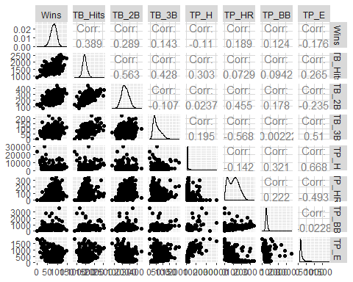

## Wins TB_Hits TB_2B TB_3B TB_HR TB_BB   
## 1.0000000 0.3887675 0.2891036 0.1426084 0.1761532 0.2325599   
## TP_H TP_HR TP_BB TP_E   
## -0.1099371 0.1890137 0.1241745 -0.1764848

# Build Models

For all of the linear models we are extracting the coeficients, r squared values, adjusted r squared, sigma and f statistics. Coeficients provide y intercept, slope ,the t value which gives the standard deviations the estimated coefficients are from zero and p value which gives probability the null hypothesis is true. The multiple r-squred and adjusted r squared lets us know how close our data are to the linear regression model. The F-statistic gives us the relationship between dependent and independent variables. A large F-statistics means a strong relationship.

Our first model uses the data set columns with complete data. The P value is very low. The Rsqured and Adjusted RSqaured values are below .5 and F Statistic is low

* Coefficients: 20.9497811, 6.8736524, 3.0478383, 0.0023316
* RSquared: 0.3192196
* Adjusted RSquared: 0.3147011
* Sigma: 13.0400699
* FStatistic: 70.6479608, 15, 2260

The next model uses the data set columns with columns with high pvalues re data. The P value is als very low. The Rsqured and Adjusted RSqaured values are below .5 and F Statistic is higher

* Coefficients: 23.6666983, 5.2220414, 4.5320779, 6.144647610^{-6}
* RSquared: 0.3186326
* Adjusted RSquared: 0.3153221
* Sigma: 13.0341605
* FStatistic: 96.2482041, 11, 2264 ##Data Prepare - Remove NA Values

This next approach removes NA columns. Our first model uses the data set columns wiht complete data. The P value is slightly above .05. The Rsqured and Adjusted RSqaured values are below .5 and F Statistic is low

* Coefficients: 6.7385676, 3.5119403, 1.9187592, 0.0551403
* RSquared: 0.2702515
* Adjusted RSquared: 0.2673532
* Sigma: 13.4830221
* FStatistic: 93.2421767, 9, 2266

Our next model removes TB_BB and TB_HR from previou dataset. The P value is lower at .01. The Rsqured and Adjusted RSqaured values are below .5 and F Statistic is higher than previous dataset. This tells us the new dataset has a lower probability of null hypothesis being true.

* Coefficients: 13.0083989, 3.1370647, 4.1466786, 3.497324210^{-5}
* RSquared: 0.2509174
* Adjusted RSquared: 0.2492675
* Sigma: 13.6484246
* FStatistic: 152.0747037, 5, 2270

# Select Models

## Select Models - Replace NA Values

In the below models results show comparison of data wih replace NA values. The GGplot below shows a tight cluster with a straight linear line for the NA replacement data.

## Id PredictedWins TargetWins  
## 1 1 61.07615 39  
## 2 2 76.57526 70  
## 3 3 76.21630 86  
## 4 4 72.62603 70  
## 5 5 68.01394 82  
## 6 6 70.35663 75

## Select Models - Remove NA Values

In the below models results show comparison of data wih remove NA values. The GGPlot below shows a scattered cluster with a dispersed linear line for NA Removals

## Id PredictedWins TargetWins  
## 1 9 69.83754 86  
## 2 10 70.48421 76  
## 3 14 78.22330 76  
## 4 47 84.64512 92  
## 5 60 71.16488 107  
## 6 63 70.63571 82

# Conclusion

Both predicuation appear to be similar, hower the replacement of NA values appear to be a better approach. The ggplot conifrms tha values are more correlated.

### REMOVE NA

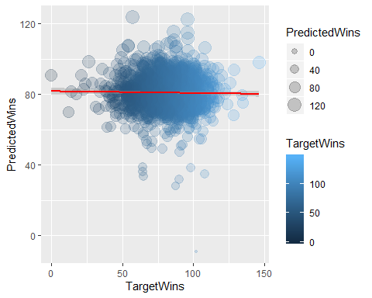

### REPLACE NA

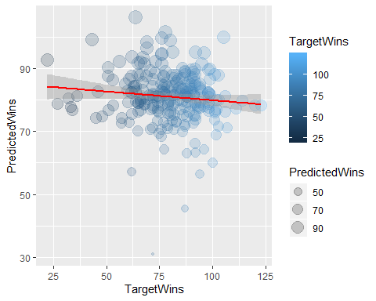

# Appendix:

R Code:

---

title: "Data 608 Homework 1"

author: "Anthony Pagan"

date: "September 15, 2019"

output:

word_document:

toc: yes

toc_depth: '2'

pdf_document:

toc: yes

toc_depth: '2'

html_document:

css: style.css

toc: yes

toc_depth: 2

toc_float: yes

---

#Data Exploration

```{r echo=FALSE, message=FALSE, warning=FALSE}

#GEt the data

library(GGally)

library(dplyr)

mbe <- read.csv("C:\\Users\\apagan\\OneDrive - BizoIT, Inc\\Desktop\\GitHub\\CUNYSPS\\Data621\\HW1\\moneyball-evaluation-data.csv", header= TRUE)

mbt <- read.csv("C:\\Users\\apagan\\OneDrive - BizoIT, Inc\\Desktop\\GitHub\\CUNYSPS\\Data621\\HW1\\moneyball-training-data.csv", header= TRUE)

```

In this exercise we will go with 2 approaches. One approach would be to remove data with NA values and the second approach would be to replace the NA data with a value. We will attempt both approaches and use the one with the best predictions.

##Data Explore - Replace NA Values

The initial review of the data shows 6 columns with incomplete data for 6 Columns

```{r echo=FALSE, message=FALSE, warning=FALSE}

nrow(mbt)

s<-summary(mbt)

s[7,]

```

THis is a summary of values for each column that has NA data values. For the most part the mean and median values are close enough to theorize that data of the six columns with NA value are fairly normal. We will attempt a replacement as one approachin in the data preparation section.

```{r echo=FALSE, message=FALSE, warning=FALSE}

summary(mbt$TEAM_BATTING_SO)

summary(mbt$TEAM_BASERUN_SB)

summary(mbt$TEAM_BASERUN_CS)

summary(mbt$TEAM_BATTING_HBP)

summary(mbt$TEAM_PITCHING_SO)

summary(mbt$TEAM_FIELDING_DP)

```

##Data Explore - Remove NA Values

If we remove all rows with incomplete rows, there will be a total of 191 rows. We need to decide if using only `r round(191/2085,2)`% of the data suffice

```{r echo=FALSE, message=FALSE, warning=FALSE}

summary(complete.cases(mbt))

```

A look at the mean and median values show a larger spread in TB_SO, TP_H and TP_E. The expectation is there will be more outliers in these groups

```{r echo=FALSE, message=FALSE, warning=FALSE}

s[3:4,]

```

The box plots below confirms the outliers as expected ,but TP_E is not as drastic as the others. However te

```{r echo=FALSE, message=FALSE, warning=FALSE}

par(mar=c(9.5,3.5,.5,.5))

boxplot(mbt, las=2)

plot(lm(mbt$TARGET_WINS~mbt$TEAM_FIELDING_E))

ggpairs(data=mbt, columns = c(2,14))

```

An initial view of the data show that TEAM_FIELDING_E and TEAM_FIELDING_DP have low P value and may have high correlation with team wins.

```{r echo=FALSE, message=FALSE, warning=FALSE}

fit<-lm(TARGET_WINS ~.-INDEX, mbt)

summary(fit)

```

The qq dot plots do not follow the residual line and fails the normality test

```{r echo=FALSE, message=FALSE, warning=FALSE}

qqplot(mbt$TARGET_WINS,residuals(lm(mbt$TARGET_WINS~mbt$TEAM_FIELDING_E)))

qqline(mbt$TARGET_WINS,residuals(lm(mbt$TARGET_WINS~mbt$TEAM_FIELDING_E)))

qqplot(mbt$TARGET_WINS,residuals(lm(mbt$TARGET_WINS~mbt$TEAM_FIELDING_DP)))

qqline(mbt$TARGET_WINS,residuals(lm(mbt$TARGET_WINS~mbt$TEAM_FIELDING_DP)))

```

#Data Preparation

As a start, we begin by redjusting the data column headings to shorter column names.

```{r echo=FALSE, message=FALSE, warning=FALSE}

str(mbt)

colnames(mbt)<-c('Index','Wins','TB_Hits','TB_2B','TB_3B','TB_HR','TB_BB','TB_SO','TBR_SB','TBR_CS','TB_HBP','TP_H','TP_HR','TP_BB','TP_SO','TP_E','TP_DP')

```

## Data Prepare - Replace NA values

In our analysis of the summbary of columns with NA values we noted that median and mean values were close enough to theorize that these column values were fairly normal. As a result, we replace any NAs with the mean value of the column data.

```{r echo=FALSE, message=FALSE, warning=FALSE}

mbta <-mbt

mbta$TB_SO[is.na(mbta$TB_SO)] <- mean(mbta$TB_SO,na.rm=TRUE)

mbta$TBR_SB[is.na(mbta$TBR_SB)] <- mean(mbta$TBR_SB,na.rm=TRUE)

mbta$TBR_CS[is.na(mbta$TBR_CS)] <- mean(mbta$TBR_CS,na.rm=TRUE)

mbta$TB_HBP[is.na(mbta$TB_HBP)] <- mean(mbta$TB_HBP,na.rm=TRUE)

mbta$TP_SO[is.na(mbta$TP_SO)] <- mean(mbta$TP_SO,na.rm=TRUE)

mbta$TP_DP[is.na(mbta$TP_DP)] <- mean(mbta$TP_DP,na.rm=TRUE)

s<-summary(mbta)

s

```

## Data Prepart - Remove NA values

In this next approach we are removing columns with missing data. We run a linear model with reduced columns and look at the corrrelation charts.

```{r echo=FALSE, message=FALSE, warning=FALSE}

library(dplyr)

mbt2<-mbt%>%

select(Wins, TB_Hits, TB_2B, TB_3B, TB_HR, TB_BB, TP_H, TP_HR, TP_BB, TP_E)

str(mbt2)

```

Now we will run the linear model again with only the columns with complete data.

```{r echo=FALSE, message=FALSE, warning=FALSE}

fit<-lm(Wins ~., mbt2)

summary(fit)

```

The linear model shows the P values of TB_BB and TB_HR are greater than .05 so we can remove 2 columns and rerun the model.

```{r echo=FALSE, message=FALSE, warning=FALSE}

mbt3 <- mbt2%>%

select(Wins, TB_Hits,TB_2B,TB_3B,TP_H,TP_HR,TP_BB,TP_E)

fit<-lm(Wins ~., mbt3)

summary(fit)

```

Last we use ggally to get an idea of correlation of the data and run a corr test to get raw correlation statistics. TB_Hits and TB_2B show the highest correlation and graphs show a positive correlation.

```{r echo=FALSE, message=FALSE, warning=FALSE}

ggpairs(data=mbt3)

cor(mbt2)[1,]

```

#Build Models

For all of the linear models we are extracting the coeficients, r squared values, adjusted r squared, sigma and f statistics. Coeficients provide y intercept, slope ,the t value which gives the standard deviations the estimated coefficients are from zero and p value which gives probability the null hypothesis is true. The multiple r-squred and adjusted r squared lets us know how close our data are to the linear regression model. The F-statistic gives us the relationship between dependent and independent variables. A large F-statistics means a strong relationship.

```{r echo=FALSE, message=FALSE, warning=FALSE}

fit<-lm(Wins ~.-Index, mbta)

s<-summary(fit)

```

Our first model uses the data set columns with complete data. The P value is very low. The Rsqured and Adjusted RSqaured values are below .5 and F Statistic is low

* Coefficients: `r s$coefficients[1,1:4]`

* RSquared: `r s$r.squared`

* Adjusted RSquared: `r s$adj.r.squared`

* Sigma: `r s$sigma`

* FStatistic: `r s$fstatistic`

```{r echo=FALSE, message=FALSE, warning=FALSE}

fit<-lm(Wins ~.-Index-TBR_CS-TB_HBP-TP_BB-TP_HR, mbta)

s<-summary(fit)

```

The next model uses the data set columns with columns with high pvalues re data. The P value is als very low. The Rsqured and Adjusted RSqaured values are below .5 and F Statistic is higher

* Coefficients: `r s$coefficients[1,1:4]`

* RSquared: `r s$r.squared`

* Adjusted RSquared: `r s$adj.r.squared`

* Sigma: `r s$sigma`

* FStatistic: `r s$fstatistic`

##Data Prepare - Remove NA Values

```{r echo=FALSE, message=FALSE, warning=FALSE}

# Answer Question 1 here

s<-summary(lm(Wins~., mbt2,na.action = na.fail))

```

This next approach removes NA columns. Our first model uses the data set columns wiht complete data. The P value is slightly above .05. The Rsqured and Adjusted RSqaured values are below .5 and F Statistic is low

* Coefficients: `r s$coefficients[1,1:4]`

* RSquared: `r s$r.squared`

* Adjusted RSquared: `r s$adj.r.squared`

* Sigma: `r s$sigma`

* FStatistic: `r s$fstatistic`

```{r echo=FALSE, message=FALSE, warning=FALSE}

l<-lm(Wins~.-TP_BB-TP_HR, mbt3,na.action = na.fail)

s<-summary(l)

```

Our next model removes TB_BB and TB_HR from previou dataset. The P value is lower at .01. The Rsqured and Adjusted RSqaured values are below .5 and F Statistic is higher than previous dataset. This tells us the new dataset has a lower probability of null hypothesis being true.

* Coefficients: `r s$coefficients[1,1:4]`

* RSquared: `r s$r.squared`

* Adjusted RSquared: `r s$adj.r.squared`

* Sigma: `r s$sigma`

* FStatistic: `r s$fstatistic`

##Select Models - Replace NA Values

In the below models results show comparison of data wih replace NA values. The GGplot below shows a tight cluster with a straight linear line for the NA replacement data.

```{r echo=FALSE, message=FALSE, warning=FALSE}

# Answer Question 2 here

mbta1 <- mbta%>%

select(Index,TB_Hits,TB_2B,TB_3B,TP_H,TP_HR,TP_BB,TP_E)

p<-data.frame(mbta$Index,predict(fit, new=mbta),mbta$Wins[mbta$Index])

colnames(p)<-c('Id','PredictedWins','TargetWins')

head(p)

```

##Select Models - Remove NA Values

In the below models results show comparison of data wih remove NA values. The GGPlot below shows a scattered cluster with a dispersed linear line for NA Removals

```{r echo=FALSE, message=FALSE, warning=FALSE}

colnames(mbe)<-c('Index','TB_Hits','TB_2B','TB_3B','TB_HR','TB_BB','TB_SO','TBR_SB','TBR_CS','TB_HBP','TP_H','TP_HR','TP_BB','TP_SO','TP_E','TP_DP')

mbe1 <- mbe%>%

select(Index,TB_Hits,TB_2B,TB_3B,TP_H,TP_HR,TP_BB,TP_E)

p1<-data.frame(mbe$Index,predict(l, new=mbe),mbt$Wins[mbe$Index])

colnames(p1)<-c('Id','PredictedWins','TargetWins')

head(p1)

```

##Conclusion

Both predicuation appear to be similar, hower the replacement of NA values appear to be a better approach. The ggplot conifrms tha values are more correlated.

###REMOVE NA

```{r echo=FALSE, message=FALSE, warning=FALSE}

ggplot(p, aes(TargetWins, PredictedWins,width = 800, height = 300)) +

geom_point(aes(group=TargetWins,size = PredictedWins, color = TargetWins), alpha = 0.2)+

stat_smooth(method = "lm", col = "red")

```

###REPLACE NA

```{r echo=FALSE, message=FALSE, warning=FALSE}

ggplot(p1, aes(TargetWins, PredictedWins,width = 800, height = 300)) +

geom_point(aes(group=TargetWins,size = PredictedWins, color = TargetWins), alpha = 0.2)+

stat_smooth(method = "lm", col = "red")

```